Appendix 3: Other Supplies

Vertical Opening
Horizontal Opening
Electric Connectors

Figure 1: Bayite BYT-7A015 DC 12V solar hot water heater circulation pump. (courtesy of Amazon.com)
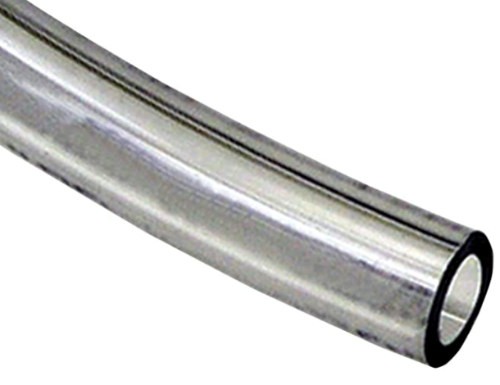
Figure 2: Watts SVIG10 pre-cut 1/2-inch diameter by 3/8-inch clear vinyl tubing. (Image courtesy of Amazon.com)

Figure 3: Stainless steel worm gear hose clamps. (Image: courtesy of Amazon.com)
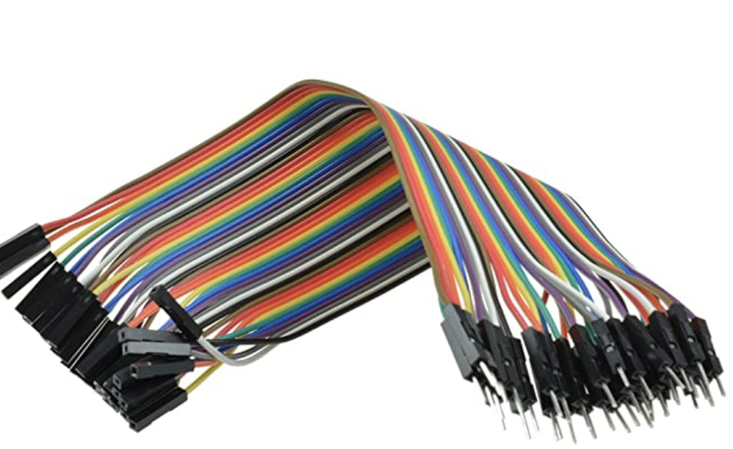
Figure 4: 40-pin male to female wire jumper multicolored ribbon cables. (Image: courtesy of Amazon.com)

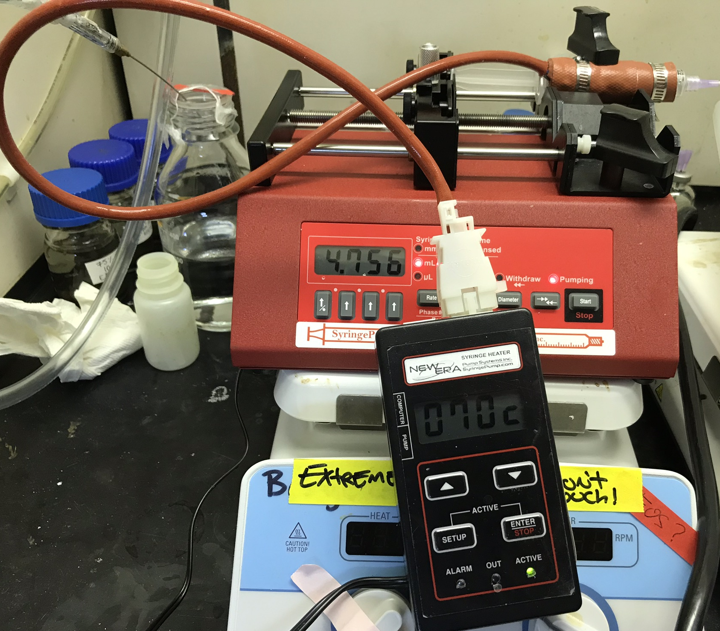
Figure 5: HEATER-KIT-5SP syringe heater along with NE-4000 programmable 2-channel syringe pump.

