Editorial Comments:
Please take this opportunity to thoroughly proofread the manuscript to ensure that there are no spelling or grammatical errors.
Reply: Thank you for your suggestion. The manuscript has been re-revised by native speakers of American Journal Experts to avoid any spelling or grammatical errors (The verification page is https://secure.aje.com/certificate/verify and the verification code is 1E76-DA24-1D96-2A45-B473).

Abstracts: Please provide a summary/short abstract that states the goal of the work in 50 words.
Reply: Abstract has been adjusted within 50 words and now read: A high platform can fix rats without restriction and completely expose the acupoints on the back during acupuncture manipulation. This article describes methods for the fabrication of the high platform, establishes a rat model of asthma and measures changes in respiratory function using a noninvasive and real-time whole-body plethysmography (WBP) system.
Protocol Language: Please ensure that ALL text in the protocol section is written in the imperative voice/tense as if you are telling someone how to do the technique (i.e. “Do this”, “Measure that” etc.) Any text that cannot be written in the imperative tense may be added as a “Note”, however, notes should be used sparingly and actions should be described in the imperative tense wherever possible.
1) Some examples NOT in the imperative: 1.1-1.5, 2.1.1-2.1.2, etc.
Reply: These sentences have been modified in the imperative tense.
- The section of 1.1 now read:
Set the length and width of the supporting device to 86 cm × 17 cm (Figure 1).
- The section of 1.2 now read:
Fix the connecting device vertically to the supporting device. The connecting device should be approximately 30 cm long to prevent the rat from running to the top surface of the high platform and have a width of 14 cm.
- The section of 1.3 now read:
Fix the horizontal pedal (5 cm × 5 cm) to the connecting device, and the suspended height at the bottom of the horizontal pedal should be greater than or equal to 50 cm.
- The section of 1.4 now read:
Note: Depending on the number of experimental rats, multiple horizontal pedals can be used, with one rat placed on each pedal.
- The section of 2.2.1 now read:
Select a box with a lid (the length, width and height are 39 cm × 28 cm × 23 cm), and drill a small hole in the side. Connect the sealed box, nebulizing cup and the compression nebulizer with a rubber tube. The nebulized particle size of the compressed nebulizer is 1 - 5 μm, the nebulization rate is greater than 0.2 mL/min, and the ultimate pressure is 205 KPa.
- The section of 2.2.2 now read:
On the 14th day after sensitization, open the lid of the homemade sealed box and place the rat in the box (the box can accommodate 5 rats), and then put the sealed box in a biosafety cabinet.

Protocol Detail: Please note that your protocol will be used to generate the script for the video, and must contain everything that you would like shown in the video. Please ensure that all specific details (e.g. button clicks for software actions, numerical values for settings, etc) have been added to your protocol steps. There should be enough detail in each step to supplement the actions seen in the video so that viewers can easily replicate the protocol.
Reply: Thank you for your suggestion. The specific details have been added to the protocol steps and now read:
4.2.2 Check the channels: click “calibrate”.
4.3.2 Click “create study options” and select “dose response study”, select “rat” of species.
4.3.3 Select “simple dose list”, set the “number of does” to “6” and click “next”.

1) 2.2.3: Mention nebulizer specifications and describe how it was adapted for small animals.
Reply: The nebulized particle size of the compressed nebulizer is 1-5 μm, the nebulization rate is greater than 0.2 mL/min, and the ultimate pressure is 205 KPa. The nebulizer specifications have been showed in supplementary figure 1.
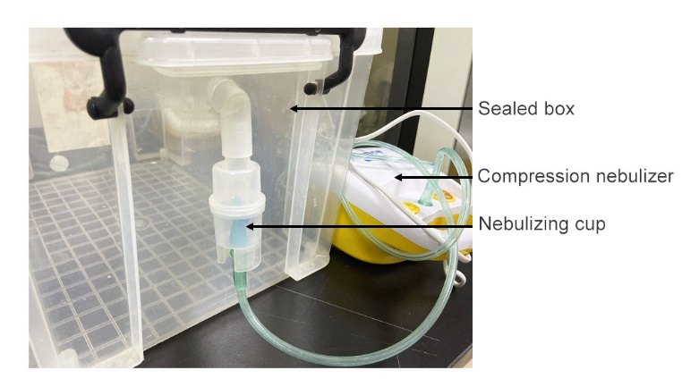
For the detail of the nebulizer can be adapted for small animals: The nebulizing device includes a sealed box, open the lid of the self-made sealed box and place the rat in the sealed box. The corresponding changes have been highlighted in page 6 line 11-15.
2) 3.1: Provide a schematic showing these points. This can be a supplementary figure. How exactly is acupuncture performed? Mention needle specifications.
- Reply: The schematic of these points has been showed in supplementary figure 2.
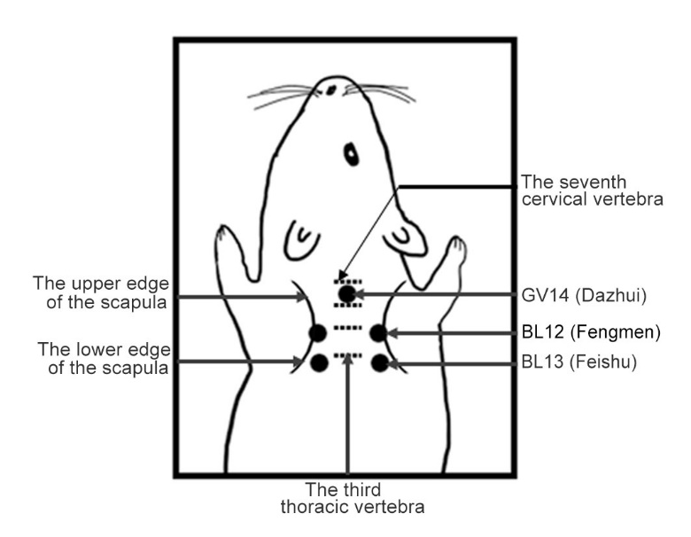
- Acupuncture is performed as follow: Evenly twisted the needles approximately 360° to the left and the right at a rate of 60 times/min for 10 - 20 s, manipulate them every 5 min, and then withdraw them after 20 - 30 min. The schematic has been showed in supplementary figure 4.
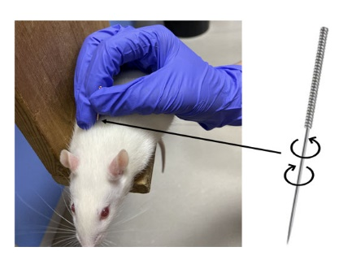
- The needle is disposable stainless-steel needle (0.3 mm × 13.0 mm) and the specifications have been showed in supplementary figure 3.
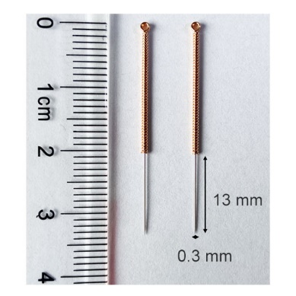

Results: Remove the subheadings.
Reply: The subheadings in the results have been removed.
Discussion: JoVE articles are focused on the methods and the protocol, thus the discussion should be similarly focused. Please ensure that the discussion covers the following in detail and in paragraph form (3-6 paragraphs): 1) modifications and troubleshooting, 2) limitations of the technique, 3) significance with respect to existing methods, 4) future applications and 5) critical steps within the protocol.
Reply: The discussion has covered the above in detail and in paragraph form.
- Modifications and troubleshooting:
The needle may fall off if the rat swings about during the acupuncture. Therefore, needling must be manipulated every 5 min to adjust the depth.
- Limitations of the technique:
The limitations of the technique is that the high platform is suitable for rats, but not for smaller animals, such as mice.
- Significance with respect to existing methods:
We provide detailed methods for the fabrication of a high platforms for fixing rats without restriction during acupuncture. The high platform can well expose the acupoints on the back of the rat.
- Future applications:
Use of the high platform and noninvasive respiratory function measurement can facilitate the study of acupuncture in treating asthma. Studying the therapeutic mechanism of acupuncture on the back may bring new treatments to respiratory diseases such as asthma and chronic obstructive pulmonary disease.
- Critical steps within the protocol:
Several critical steps should be considered when performing these methods. For acupuncture manipulation, the harder the palm of the right hand presses the rat back, the easier it is to insert the needle. For respiratory function measurement, the WBP system measures changes in the Penh that reflect changes in pulmonary resistance in rats in a noninvasive manner and minimizes effects of psychological stress^{1,2}. The effect of the external environment on rats should be minimized. The rat should be placed in the testing room and then covered with a plastic bag to reduce the irritation caused by the external environment.

References: Please spell out journal names.
Reply: The journal names in references have been spell out.

Table of Materials: Please sort in alphabetical order.
Reply: The table of materials have been sorted in alphabetical order.

Reviewers' comments:
Reviewer #1:
Manuscript Summary:
1. Please show and give ethical approval for this research (ethical clearance)
Reply: Ethical approval has been given in page 5 line 16-18 and now read: All animal experiments were reviewed and approved by the Committee on the Ethics of Animal Experiments of Shanghai University of Traditional Chinese Medicine (Ethical clearance number PZSHUTCM190308020).

2. Please rotate right 90º picture number 1, 2, 3 and 5
Reply: The pictures (figure number 1, 2, 3 and 5) have been rotated right 90º.

3. In line 107 = what size of sealed box do you use?
Reply: The length, width and height of sealed box are 39 cm × 28 cm × 23 cm. The information of box size have been added in page 6 line 11.

4. In line 111 = How to connect sealed box with the nebulizer?
Reply: Sealed box has a small hole in it to connect an ultrasonic atomizer with a rubber tube. The corresponding information have been added in page 6 line 11-15 and the specifications have been showed in supplementary figure 1.

5. In line 201 = what is the height of pedal from the ground? You should add the details in this sub or you can attach in figure number 1.
Reply: The height of pedal from the ground is 50 cm and have been attached in figure 1 and new figure 1 is now as follow:
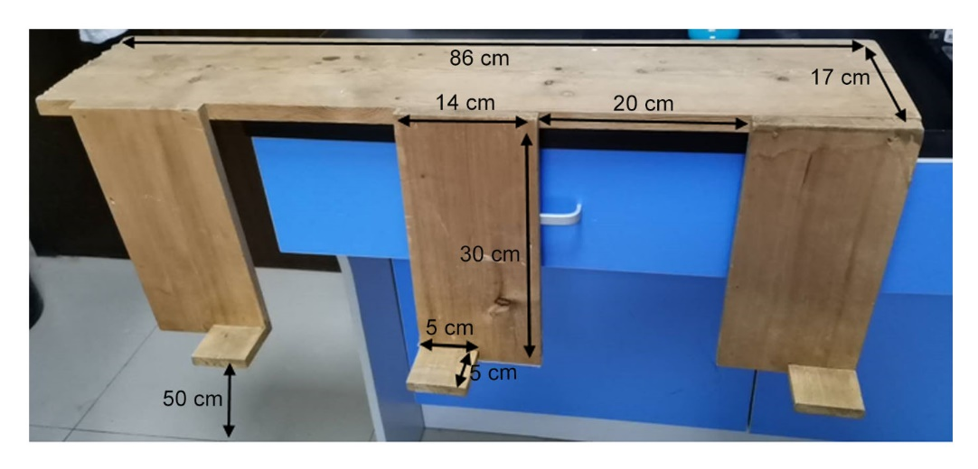
6. In your Introduction/Discussion you should include other recent preclinical research on the effects of acupuncture in mouse model of chronic asthma - please see/cite
- Nurwati I, Purwanto B, Mudigdo A, Saputra K, Prasetyo DH, Muthmainah M. Improvement in inflammation and airway remodelling after acupuncture at BL13 and ST36 in a mouse model of chronic asthma. Acupunct Med. 2019;37(4):228-36.
- Nurwati I, Purwanto B, Mudigdo A, Saputra K, Sutrisno TC. Reduction of interleukin-17 level by acupuncture at Feishu (Bl 13) is strengthened by acupuncture at Zusanli (ST 36) in a mouse model of chronic asthma: An experimental study. Med Acupunct. 2015;27(4):278-82.
Reply: Thank you for your suggestion. The above two references have been cited as reference 7 and 8, the corresponding changes have been highlighted in page 3 line 12-14 and now read: Acupuncture at BL13 and ST 36 (Zusanli) in mice with chronic asthma decreases the level of IL-17 by 40% and decreases the smooth muscle thickness by 33% compared with that of the ovalbumin (OVA) group, and thus relieving inflammation symptoms^{3,4}.
Reviewer #2:
Manuscript Summary:
The manuscript described a detailed method for acupuncture manipulation in rat model of asthma. Major Concerns:
1. The authors should perform acupuncture on the rat model of asthma. However, the panel figure 6 only described the parameters from the asthmatic rat, the control rat and the asthmatic rat received acupuncture treatment should be included and compared using statistics methods.
Reply: Thank you for your suggestion. The experimental results of respiratory function have been showed in our previous article⁵. We highlight corresponding methods here according to the demand of JoVE.
Minor Concerns:
please further check grammars throughout the manuscript.
Reply: Thank you for the suggestion. The grammars have been re-revised by American Journal Experts (The verification page is https://secure.aje.com/certificate/verify and the verification code is 1E76-DA24-1D96-2A45-B473).

Can authors discuss how sham acupuncture can be used and performed in this type of animal study?
Reply: Different kinds of sham acupuncture are widely applied in randomized controlled trials (RCT) to investigate if acupuncture has therapeutic effects beyond the psychological effects in the clinic⁶. However, the pathologic-specific and non-specific physiological effects of acupuncture are usually needed to be examined in animal study^{7,8}. In order to highlight the pathologic-specific effect of acupuncture, it is critical to evaluate and know the physiological background effect of acupuncture (not psychological effect) in animal^{7,8}. Therefore, acupuncture in normal rats has often been selected as control group in this type of animal study^{5,9-11}.

Reviewer #3:
Manuscript Summary:
The MS by Zhou et al. described the work to establish a rat model for acupuncture treatment of asthma. The study design and the goal of this work have sufficient scientific merit, and it would interest the general readers in this field. Minor Concerns:
1. The idea behind the high-platform is to immobilize rats for fear of heights. However, the fear of heights can cause anxiety, stress, and discomfort. Moreover, it has been reported that stress exacerbates clinical symptoms in patients with asthma (Brain, Behavior, and Immunity 21(8), pp. 993-999). So, it may be necessary to consider the effect of fear response itself on asthma in the experiment.
Reply: Thank you for the suggestion. According to the reference “Stress and inflammation in exacerbations of asthma. Brain Behav Immun. 2007; 21(8): 993-999”, stress links to immune system and the directionality can vary depending on the type of stressor. From our investigation, the rats keep quiet and breathe smoothly on the high platform, showing that the high platform is an acceptable environment. In addition, rats in each group are placed on the high platform to unify the operating background. Meanwhile, there are a total of 7 times of acupuncture in high platform, and repeated operations minimize the stress response.

2. The authors described that it is necessary to perform needles every 5 min to adjust the depth and enhance the acupuncture effect with this high-platform system. I am wondering whether repeated acupoints' stimulation under high-platform will also cause allergic or stress reactions in the rat.
Reply: Thank you for your suggestion. Adjust the depth every 5 minutes is to prevent the needle from falling, the movements are gentle and rat remains quiet. So it will not cause allergic or stress reactions in the rat.
References
1 McFadden, E. R., Jr., Luparello, T., Lyons, H. A., Bleecker, E. The mechanism of action of suggestion in the induction of acute asthma attacks. Psychosomatic medicine. 31 (2), 134-143 (1969).
2 Savov, J. D. et al. Ozone-induced acute pulmonary injury in inbred mouse strains. American journal of respiratory cell and molecular biology. 31 (1), 69-77 (2004).
3 Nurwati, I. et al. Reduction of interleukin-17 level by acupuncture at Feishu (BL 13) is strengthened by acupuncture at Zusanli (ST 36) in a mouse model of chronic asthma: An experimental study. Medical acupuncture. 27(4), 278-282 (2015).
4 Nurwati, I. et al. Improvement in inflammation and airway remodelling after acupuncture at BL13 and ST36 in a mouse model of chronic asthma. Acupuncture in medicine. 37 (4), 228-236 (2019).
5 Zhou, D. D. et al. Metallothionein-2 is associated with the amelioration of asthmatic pulmonary function by acupuncture through protein phosphorylation. Biomedicine & pharmacotherapy. 123, 109785 (2020).
6 Jiang, Y. L. et al. Assessments of different kinds of sham acupuncture applied in randomized controlled trials. Journal of acupuncture and tuina science. 9 (4), 199-203 (2011).
7 Yin, L. M. et al. Effects of acupuncture on the gene expression profile of lung tissue from normal rats. Molecular medicine reports. 6 (2), 345-360 (2012).
8 Xu, Y. D. et al. Non-specific physiological background effects of acupuncture revealed by proteomic analysis in normal rats. BMC complementary and alternative medicine. 14, 375 (2014).
9 Yin, L. M. et al. Use of serial analysis of gene expression to reveal the specific regulation of gene expression profile in asthmatic rats treated by acupuncture. Journal of biomedical science. 16 (1), 46 (2009).
10 Xu, Y. D. et al. Proteomic analysis reveals the deregulation of inflammation-related proteins in acupuncture-treated rats with asthma onset. Evidence-based complementary and alternative medicine. 2012, 850514 (2012).
11 Yin, L. M., Yang, Y. Q., Xu, Y. D., Wang, Y., Zhang, Q. H. Gene expression profile of acupuncture in treating asthma and the anti-asthmatic effects of differently expressed gene S100A9. Respirology. 18 (Suppl.1), 13 (2013).

