RESPONSE TO REVIEWERS’ COMMENTS

We appreciate the reviewers’ time and efforts toward the review of our manuscript. The comments provided by the editor and reviewers’ were carefully studied and reflected in the revised manuscript. All comments were taken into consideration in the revision, as described in detail below.

Response to Editor
Editorial Comments:
• Please take this opportunity to thoroughly proofread the manuscript to ensure that there are no spelling or grammatical errors.
Response to Comment) We have carefully checked grammatical mistakes and sentence construction in English by utilizing an academic editing service (https://www.aje.com/), which is reflected in the revised manuscript in blue.

• Protocol details: Please note that your protocol will be used to generate the script for the video, and must contain everything that you would like shown in the video. Please add more specific details (e.g. button clicks for software actions, numerical values for settings, etc) to your protocol steps. There should be enough detail in each step to supplement the actions seen in the video so that viewers can easily replicate the protocol.
Comment 1) 3.1: What is the source of MSCs? How are they cultured and prepared for injection? Mention all media usage and culture conditions. How are the cells counted?
Response to Comment 1) We described the steps for MSC preparation and in vitro culture in “Step 1 and 2”; however, it seems to not cover all of the details necessary to generate the script for MSC-loading and in vitro 3D culture. As noted by the editor, we have explained and clarified additional details for this comment in the revised manuscript as follows.
Q) What is the source of MSCs?
A) Murine bone marrow-derived MSCs were used in this work and we have described it in a note following Step 1.1.
Q) How are they cultured and prepared for injection?
A) The details are described in Step 1.
Q) Mention all media usage and culture conditions.
A) The details are described in Step 1.
Q) How are the cells counted?
A) We counted the cells using an automated cell counter and have explained this in Step 1.3.
Comment 2) 4.1: Mention animal age.
Response to Comment 2) We have added information regarding animal age and weight to Step 4.1.
Comment 3) 4.4: mention surgical tools used.
Response to Comment 3) We have clarified the details of tools used in surgical procedures in Step 4.
Comment 4) 5.1: specify needle gauge.
Response to Comment 4) A dual-syringe with a 26G needle was used in this work and we have added this to Step 5.1.
Comment 5) 6.2, 6.3: Mention transducer specifications and imaging settings
Response to Comment 5) We have changed descriptions of transducer and its associated setting to the revised Step 6.3 and 6.4.
Comment 6) 7.1: cite reference for heart collection and handling.
Response to Comment 6) The reference was added to Step 7.1.
Comment 7) 7.2: reference?
Response to Comment 7) To explain heart tissue preparation and its staining, we have merged Steps 7.2-7.3 into a single Step 7.2 and cited an appropriate reference.
Comment 8) 7.3: Using a microtome? Cite references for standard protocols.
Response to Comment 8) We have added a description of the microtome and cited an appropriate reference in the revised Step 7.2.
Comment 9) 7.4: Step describing imaging is missing. Mention magnification and other settings.
Response to Comment 9) We have added a description of imaging and its associated setting to the revised Step 7.3.
Comment 10) 7.5: Which software?
Response to Comment 10) All image analyses were performed using ImageJ software and this was included in a note in the revised Step 7.3.

• Protocol Highlight: Please highlight ~2.5 pages or less of text (which includes headings and spaces) in yellow, to identify which steps should be visualized to tell the most cohesive story of your protocol steps.
Response to Comment) We have highlighted our selected text in yellow accordingly in the revised manuscript.

• Figures:
1) Fig 2,3: Add scale bars for all micrographs.
Response to Comment) We have added scale bars for all images.
2) Remove text “ use Figure S…” You may specify this information in the figure placeholder instead.
Response to Comment) We have removed and changed all information regarding the figure placeholder.
• Figure/Table Legends: Define all error bars.
Response to Comment) We have added statistics for all data.

• Commercial Language: JoVE is unable to publish manuscripts containing commercial sounding language, including trademark or registered trademark symbols (TM/R) and the mention of company brand names before an instrument or reagent. Examples of commercial sounding language in your manuscript are Zeiss LSM 510, Zoletil, Rompun, Angiocath Plus,
1) Please use MS Word’s find function (Ctrl+F), to locate and replace all commercial sounding language in your manuscript with generic names that are not company-specific. All commercial products should be sufficiently referenced in the table of materials/reagents. You may use the generic term followed by “(see table of materials)” to draw the readers’ attention to specific commercial names.
Response to Comment) We have changed all commercial sounding language into generic names.

• Table of Materials:
1) Please sort in alphabetical order.
Response to Comment) We have changed the table of materials to reflect alphabetical order.

Response to Reviewer #1
Manuscript Summary:
Interesting protocol. Just needs additional detail and clarification to make this more powerful as a learning tool.
Major Concerns:
My biggest concern is that there are an excessive number of minor concerns.
Response to Comment) We appreciate your efforts in reviewing and providing detailed comments for our manuscript. We have addressed the following comments to clarify our claims.
Manor Concerns:
Comment 1. Use of GH acronym in abstract without definition
Response to Comment 1) We are grateful to Reviewer #1 for pointing out our mistake. We have defined the GH acronym in the Abstract.
Comment 2. Line 64: less immunogenicity than what?
Response to Comment 2) To clarify our intention, we rephrased the sentence in the revised manuscript as follows.
“ … and reduced immunogenicity when compared with a wide range of other biomaterials used in biomedical applications.”
Comment 3. Line 90: Protocol is not clear.
Response to Comment 3) As the reviewer pointed out, the details covered in Step 1 seem to be insufficient. Thus, we have clarified and rephrased more details in the revised Step 1.
Comment 4. Line 100-101: If prior step has 10^7 cell/mL, what is diluting this? I think the confusion starts in step one (line 90). Give the two solutions separate names so the reader has any chance of tracking what is where. Then state specifically which two different samples are loaded into this syringe in step 2.1.
Response to Comment 4) As the reviewer suggested, we have rephrased the protocols in the revised Step 1 and Step 2 to clarify our process.
Comment 5. Line 103: how do you know when crosslinking is complete? Time? Some other approach?
Response to Comment 5) The adjustable stiffness and gelation properties of GH hydrogels used in this work have been verified in our previous work [Adv. Funct. Mater. 2014, 24, 6771, ACS Appl. Bio Mater, 2020, 3, 1646]. The scope of this manuscript was focused on intramyocardial transplantation of stem cells with injectable hydrogels and does not extend to detailed gelation properties, such as gelation time and mechanical strength, which can be determined using a vial tilting method and elastic modulus measurement by a rheometer.
Comment 6. Line 126: What magnification and filters should be uses to collect appropriate images for proliferation and morphological studies? No details of proliferation or morphological analysis.
Response to Comment 6) Magnification and filter settings were added to a note in Step 3.6. In regard to fluorescence microscopy, it can simply be speculated that MSCs were well proliferated on the GH hydrogels without any additional description.
Comment 7. Line 150: Again clearly define what is in the dual loaded syringe… concentration of cells and other reagents and total volume in each barrel.
Response to Comment 7) We designed a custom dual syringe that can be effectively used in our lab (see image below). It is equipped with different sized needles and is depicted in Fig. 1. For the loading of the pregel solutions into the syringe, this procedure is conducted in the same manner as explained in the revised Step 1, and we have added an additional Note to address this.
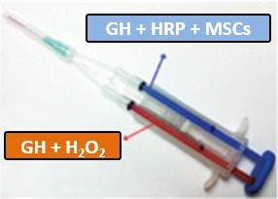
Comment 8. Line 175: No information on how to measure these parameters by Echo. This could be easily achieved by capturing some still images and showing each measurement.
Response to Comment 8) As the reviewer suggested, we have added the information in the revised Step 6.4 and Fig 4. legend.
Comment 9. Line 179-202: Details of histology approach is not clear. It reads as if both H&E and trichrome were done on the same sample. Clarify this and add detail for each.
Response to Comment 9) The authors acknowledge that this wording was confusing. We used MT staining for histology in this manuscript. We have changed this in the revised Step 7.2 and cited the reference for this step.
Comment 10. Line 191: Define what metric you are using to define the infarct zone (color, thickness, other?).
Response to Comment 10) The infarct region is simply defined by scar tissue (colored in dark blue); however, infarcted heart tissue sections usually include both scar and viable tissue in the infarct area. We used midline length measurement to calculate the infarct size based on the details in the original manuscript for the note in Step 7.3. In addition, we cited this reference to provide more details concerning this.
Comment 11. Line 191: Is the histological staining of the collagen in the infarct area specific to collagen and not staining the chemically similar gelatin that was injected?
Response to Comment 11) Since GH hydrogels used in this work is biodegradable, we assume that most of hydrogels are degraded after 28 days in intramyocardial transplantation. This was confirmed in our previous work [ACS Appl. Bio Mater, 2020, 3, 1646].
Comment 12. No protocol given for sample prep of the fluorescent images in Figure 3.
Response to Comment 12) In this video, we elected to omit this step; therefore, we did not include a detailed procedure.
Comment 13. Injection rate not mentioned. The potential for shear damage to cells is significant with these low diameter syringes.
Response to Comment 13) We agree that injection rate is one of the important factors for cell transplantation. In this work, MSC-loading gels were manually injected into the heart tissue using a dual syringe equipped with a 26G needle. It should be performed carefully to avoid cell damage. At the current stage, the research scope was focused on the proof-of-concept of stem cell-loading injectable hydrogels and the results could provide satisfactory transplantation of cell-loading gels without significant cell damages. For more reliable and accurate applications, the more intensive studies including an accurate injection control technique are currently ongoing.
Comment 14. FITC isn't particularly photostable. In your experience, what is the stability of fluorophore labeling? Can it be imaged multiple times or does it photobleach?
Response to Comment 14) Since the isothiocyanate group reacts with the amino terminus and primary amines, FITC is widely used to attach a fluorescent label to proteins, antibodies, peptides, etc. In this work, GH hydrogels were simply labeled with FITC, and these hydrogels provided satisfactory outcomes in vitro and ex vivo without any perturbation to hydrogel properties, such as gelation time and stiffness (data not shown). In addition, the images shown in Fig 3B were obtained from each section, which was harvested from heart tissues at 1, 3, 5, and 7 days under the same conditions following transplantation of fluorescently labeled MSC-loading hydrogels. This is the general method to analyze a change in fluorescence in a time-dependent manner. In this case, we are not concerned about photobleaching because all measurements are processed under the same conditions.
Comment 15. It is not clearly stated which histological approach is used in Figure 5 representative results.
Response to Comment 15) As the reviewer suggested, we have rephrased REPRESENTATIVE RESULTS in the revised manuscript.

Response to Reviewer #2
Comment 1. SUMMARY section, Stem cell-based therapy has emerged as an efficient strategy to repair injured cardiac tissues after myocardial infarction. We provide an optimal in vivo application for cardiac stem cell transplantation using enzymatically cross-linkable gelatin hydrogels. Not cardiac stem cell transplantation, but MSC in this protocol.
Response to Comment 1) We are grateful to Reviewer #2 for pointing out our mistake. We have revised SUMMARY and deleted the highlighted text.
Comment 2. 1.3 Keep a volume ratio of GH:HRP and GH:H2O2 at 9:1. How about the toxicity of H2O2.
Response to Comment 2) We agree that hydrogen peroxide, a known cytotoxic agent, may induce side effects in its application in vitro and in vivo. Thus, we have already addressed concerns regarding toxicity in our previous work [Adv. Funct. Mater. 2014, 24, 6771, ACS Appl. Bio Mater, 2020, 3, 1646] and no issues arising from toxicity were present in this work.
Comment 3. 5.1 To assess the engraftment of MSC-loading GH hydrogels within the infarcted area, MSCs and GH conjugates were pre-labeled with PHK26 and fluorescein isothiocyanate (FITC), respectively. Although authors have published paper, ACS Applied Bio Materials. 3 (3), 1646-1655 (2020), indeed, FITC or PHK26 can leak from gel or cell. Why not use genetic labeling, such as GFP for MSC. According to Fig 3, for hydrogel staining, the green color was not hydrogel, may just dye. HE staining may show the gel in heart.
Response to Comment 3) We agree that fluorescent dyes can leak from the gel or cells. However, it is our opinion that the majority of the signal, as shown in Fig 3, is derived from the MSC/gel because free dye is difficult to retain in beating hearts after 7 days. This is clearly observed when MSCs labeled with PKH26 were applied to hearts in the absence of hydrogel, and no significant signals was present, as shown in the image below (left). This indicates tha the hydrogel can improve MSC retention within hearts. Furthermore, the PKH26 dye is used for general cell membrane labeling and it has been characterized in a number of model systems for in vivo cell tracking [J. Clin. Invest. 2012, 122, 711].
We have already confirmed the integration of transplanted hydrogel by H&E staining, as shown in the image (right), and the result exhibited a similar trend as seen in Fig 3. The purpose of the fluorescent dye used in Fig 3 is not only to observe the improved retention within the infarcted region but also to confirm retention along with colocalization of MSCs and gels, indicating this injectable hydrogel that is cross-linked in situ can be effectively used for in vivo applications.
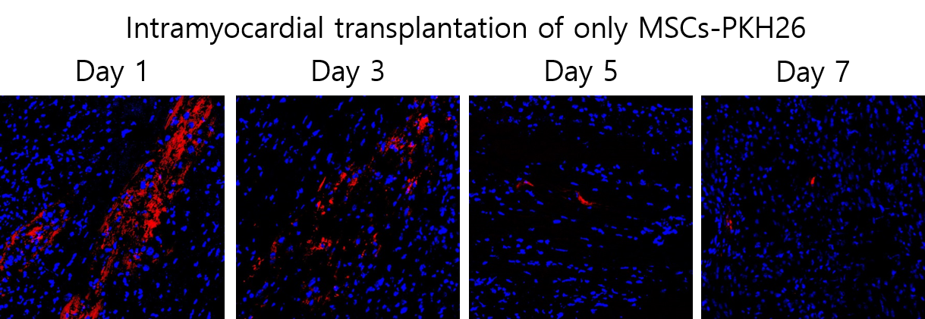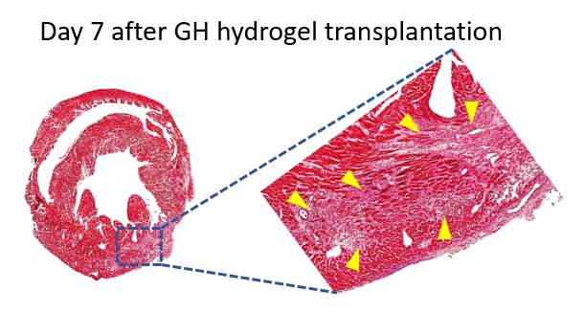

Response to Reviewer #3
Comment 1. Abstract: GH hydrogels full name missing. Needs to be addressed at the first instance.
Response to Comment 1) We are grateful to Reviewer #3 for pointing out our mistake. We have rephrased defined the GH acronym in the Abstract.
Comment 2. Figure 1: The chemistry of in situ gel formation is not clear. It is essential to properly represent the chemical interactions on how gelatin-hydroxyphenyl propionic acid (GH) conjugates are formed. Also how it reacts with HRP or H2O2 to form the gel.
Response to Comment 2) The scope of this manuscript is focused on intramyocardial transplantation of stem cell with injectable hydrogels and does not extend to the detailed mechanisms of GH hydrogel formation. A brief description was explained in the Introduction, and relevant references were cited to allow the reader to track the details.
Comment 3. Some background information is needed to justify how the volume (10-20 µL) of gel was decided for injection to the mice heart.
Comment 4. Similarly, how the number of cell concentration to be injected per heart was decided for in vivo studies.
Response to Comments 3 and 4) We have investigated a wide range of conditions to determine the appropriate injection volume and cell number for a murine model. Based on this, we made a selection and used it in this work.
Comment 5. Include specific information of the dual-syringe's needle size.
Response to Comment 5) We have added this detail in the revised Step 5.1.
Comment 6. Figure 4: B, C, D - Y axis labels missing.
Response to Comment 6) The authors should have been more careful. We have included these labels in the revised Fig 4.
Comment 7. The paper is about "Intramyocardial Transplantation" of gel/cells. So it is important to include a video of how the injection experiment in the heart was done. Basically, the video should demonstrate how the gels were injected with dual-syringe to the two different points at the infarct border zone in mice heart.
Response to Comment 7) We agree with the reviewer’s comment. We will demonstrate the details of how to prepare MSC-loading hydrogels and their subsequent intramyocardial transplantation in infarcted hearts.
Comment 8. The english language grammar and sentence construction needs to be checked.
Response to Comment 8) As the reviewer suggested, we have carefully checked grammatical mistakes and sentence construction in English by using an academic editing service (https://www.aje.com/), which is reflected in the revised manuscript in blue.

