July 30, 2020

Dear Dr. Bajaj,

We are submitting our revised manuscript “Sheath-Preserving Optic Nerve Transection in Rats: A Model to Assess Axon Regeneration and Interventions Targeting the Retinal Ganglion Cell Axonal Compartment,” for publication. Each of the reviewer comments have been addressed.

I had full access to all the data in the study and take full responsibility for the integrity of the data and accuracy of the data analysis as well as the decision to submit for publication.

This manuscript has not been published and has never been under consideration for publication in any other journals. The authors have read and approved the revision in this submission.

Sincerely,
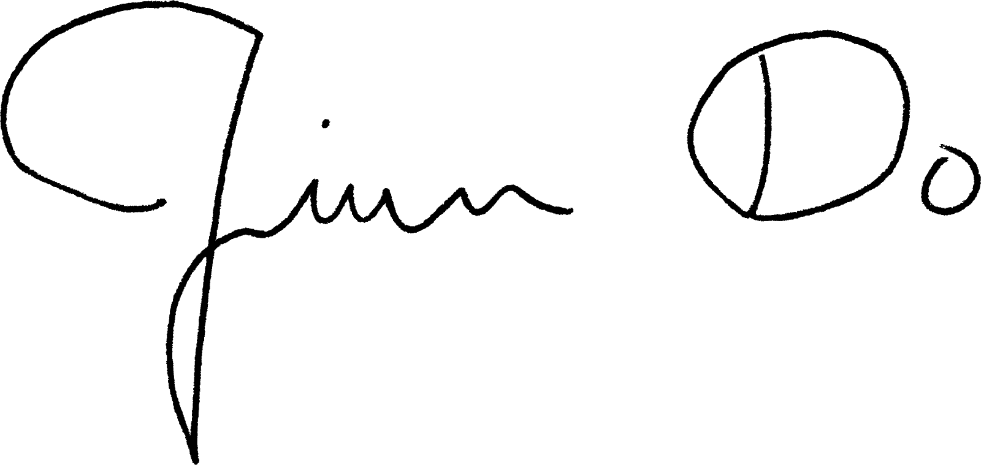

Jiun Do, MD, PhD
Assistant Professor of Ophthalmology
University of California San Diego
Shiley Eye Institute
9415 Campus Point Dr #9046
La Jolla, CA 92093
Tel: (858) 534-6290
Fax: (858) 534-1625
Email: jiundo@ucsd.edu

