MS# JoVE61740 Authors’ Responses to Comments
We thank the editorial and reviewers’ positive comments of our manuscript very much, and appreciate the opportunity to introduce our novel stroke model at The Journal of Visualized Experiments (JoVE). Both reviewers found our stroke model interesting and useful, and provided very constructive comments to improve our manuscript. We have performed new experiments or added information to the revised manuscripts. These major changes are indicated in blue-color fonts. Since the JoVE papers are procedure-oriented, we chose to describe several supplementary results as Note in the manuscript, while providing the experimental data for reviewers’ perusal in this document. Further, we have highlighted the key experimental procedures to be filmed for the video component of publication in response to the editor’s request. The following is a point-by-point summary of our responses to the editor’s and both reviewers’ comments.

Editorial comments
1. Please take this opportunity to thoroughly proofread the manuscript to ensure that there are no spelling or grammatical errors.
Thanks for the reminder. We have carefully proofread the manuscript and slightly edited the text for clarity and /or brevity.

2. Please include at least 6 keywords/phrases.
One keyword, thrombolysis, is added to make the number of keywords/phrases to be 6.

3. Protocol Language: Please ensure that all text in the protocol section is written in the imperative voice/tense as if you are telling someone how to do the technique (i.e. “Do this”, “Measure that” etc.) Any text that cannot be written in the imperative tense may be added as a “Note”, however, notes should be used sparingly and actions should be described in the imperative tense wherever possible. Examples NOT in the imperative: 1.2, 2.6
We have edited the procedures to be in an imperative/command voice, as suggested.

4. Protocol Detail: Please note that your protocol will be used to generate the script for the video, and must contain everything that you would like shown in the video. Currently, the protocol seems incomplete.
1) 3.4: mention drill speed. We have added “burr speed setting at 50% of speed controller”.
2) 3.8: do you mean 0.5 mW? Yes, we have added “with 0.5 mW energy”.
3) 4.2: what is done after this? How are the effects of tPA treatment evaluated? Is any imaging performed? How are the animals handled? How was cerebral blood flow monitored? Describe the steps involved in laser speckle imaging briefly. To evaluate the effect of tPA treatment, the CBF monitor or infarct volume measurement (TTC staining) is applied. Those procedures are added as “step 6) Monitoring the cerebral blood flow (CBF)” and “step 7) Analysis of the infarct size by triphenyl tetrazolium chloride (TTC) staining”.
4) Mention blood clot extraction and immunofluorescence staining steps. We have added “step 8) Analysis of the histological composition of thrombi”.
5) Mention steps for TTC staining briefly. These are now described in “step 7) Analysis of the infarct size by triphenyl tetrazolium chloride (TTC) staining”.
6) When is intravital imaging performed? Please describe the steps, including all settings. The intravital imaging is an optional procedure. We added this optional procedure as “step 4”.

5. Protocol Highlight: Please highlight ~2.5 pages or less of text (which includes headings and spaces) in yellow, to identify which steps should be visualized to tell the most cohesive story of your protocol steps. We have highlighted these key steps in yellow for the JoVE staff to prepare the filming script.

6. Discussion: JoVE articles are focused on the methods and the protocol, thus the discussion should be similarly focused. Please ensure that the discussion covers the following in detail and in paragraph form (3-6 paragraphs): 1) modifications and troubleshooting, 2) limitations of the technique, 3) significance with respect to existing methods, 4) future applications and 5) critical steps within the protocol.
Thanks for the reminder. We have carefully reviewed the Discussion and confirm that it contains all five key components, as suggested by the editor.

7. Commercial Language: JoVE is unable to publish manuscripts containing commercial sounding language, including trademark or registered trademark symbols (TM/R) and the mention of company brand names before an instrument or reagent. Examples of commercial sounding language in your manuscript are Nair and betadine. Please use generic names instead.
Thanks for the reminder. We have edited the manuscript to delete the commercial language, as indicated.

8. If your figures and tables are original and not published previously or you have already obtained figure permissions, please ignore this comment. If you are re-using figures from a previous publication, you must obtain explicit permission to re-use the figure from the previous publisher (this can be in the form of a letter from an editor or a link to the editorial policies that allows you to re-publish the figure). Please upload the text of the re-print permission (may be copied and pasted from an email/website) as a Word document to the Editorial Manager site in the "Supplemental files (as requested by JoVE)" section. Please also cite the figure appropriately in the figure legend, i.e. Page 3 of 3 "This figure has been modified from [citation]."
We have added “This figure is modified with permission from [23]” in the revised manuscript. Reference [23] is our original paper in Blood Advances. We will also upload the permission for reproduction from the journal into the joVE on-line submission system.

Reviewer 1
Manuscript Summary:
The traditional photothrombotic stroke model preferentially induces platelet aggregates that are resistant to tissue plasminogen activator (tPA)-lytic therapy. The authors present a modified photothrombotic model by co-injecting thrombin and photosensitive dye for photoactivation in mice. This thrombin-enhanced photothrombotic model produces mixed platelet/fibrin clots and is highly sensitive to tPA-lytic treatment. We thank this reviewer for succinct and precise summary of the key features/advantages of our stroke model!

Major Concerns: Authors inject RB and thrombin into the retro-orbital sinus, however, even though the RB remains unactivated until laser stimulus in the MCA, thrombin starts to generate clot once injected. How do authors control that thrombus formation does not occur in the retro-orbital sinus? Authors must explain and show data regarding this issue and should include a fibrin control with its corresponding immunohistochemistry of the thrombus content.

We thank this reviewer for this important reminder. We have performed two new experiments to examine this issue. As shown in Figure 1, we used laser speckle contrast imaging to monitor the blood flow in three vasculatures near the orbital cavity where we injected 80 U/kg thrombin into the retro-orbital sinus. Shown are the locations of the 3 labeled (1-3) vascular site and their blood flow from 3 min before to 15 min after thrombin-injection. Quantification showed a similar level of blood flow pre- and post-thrombin injection (n=4 mice for experiments). In Figure 2, we used anti-fibrin(ogen) immunostaining to compare blood-clotting in RB and T+RB photothrombosis. We found that both stroke models induce fibrin deposits ONLY in the ipsilateral cerebral cortex. These results suggest that the addition of 80 U/kg thrombin in the T+RB photothrombotic stroke model does not induce widespread blood clotting and fibrin deposition. Since the focus of JoVE paper is on the model procedures, we added a Note to step 3.6 to describe these findings and the mortality rate data in our pilot experiments. We stated,
Note: In pilot experiments, we examined the mortality rate of increasing doses of thrombin mixed with the standard dose of RB dye (50 mg/kg) for photoactivation. The mortality was 0% for 80 U/kg thrombin (n=13), 43% for 120 U/kg thrombin (n=7), and 100% for both 160 U/kg (n=5) and 200 U/kg thrombin (n=5). A dose of 80 U/kg thrombin was therefore chosen for this model. We also used laser speckle contract imaging to exclude the possibility of rampant blood clotting near the orbital cavity after retro-orbital sinus injection of T+RB, as well as, widespread fibrin deposition in the contralateral hemisphere that was not subjected to laser illumination (data not shown).
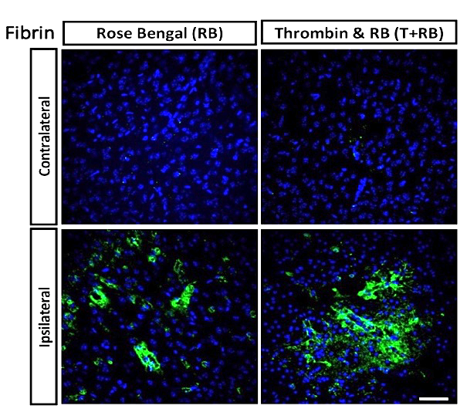
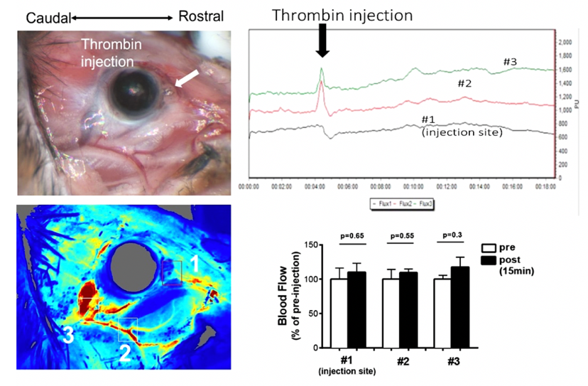
Fig 1. Monitoring the blood flow near the orbital cavity after thrombin injection. Laser speckle contrast imaging was used to track the three vascular sites (1-3, as labeled) after retro-orbital injection of 80 U/kg thrombin. No blood flow reduction was noted at either site (n=4).

Fig 2. Immunostaining showed the lack of fibrin deposits in contralateral hemisphere in the RB and T+RB photothrombosis model (n=4 each, scale bar: 50 μm)
s

Minor Concerns:
1.Authors inject recombinant human tPA through the tail vein with a 50% bolus and 50% over 30 min by infusion pump. Authors should justify it and include some reference.
We thank for this reminder for clarification. Due to reduced potency of human tPA on murine plasminogen, the vast majority of preclinical stroke research has used the dose of 10 mg/kg and a 50/50 bolus/infusion protocol for intravenous rtPA (Alteplase) administration in rodents, as in Su et al., Nat Med. 2008; 14: 731–737 (PMID 18568034, ref#24). We added a Note to step 5.2.
Note: Although the clinical dose of recombinant human tPA for acute ischemic stroke treatment is 0.9 mg/kg, a higher dose (10 mg/kg) is commonly used in rodents to compensate for reduced cross-species tPA reactivity. We also followed the standard protocol of tPA-administration in preclinical stroke models, using 50% as a bolus and 50% infused through the tail vein over 30 min.²⁴

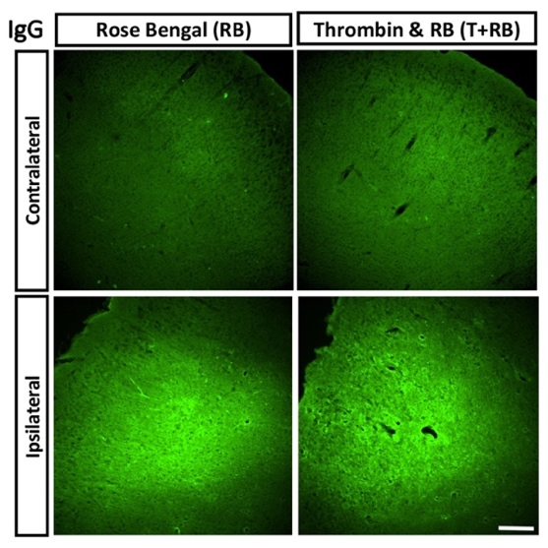
2. Authors should measure the edema index due to the disruption on endothelial integrity with the PT model (Labatgest & Tomasi, 2013).

We thank for this interesting point. We actually have assessed blood-brain-barrier integrity using anti-IgG staining to examine brains at 6 h post-photoactivation in both RB and T+RB models. As shown in the figure on the right, our experiment showed comparable IgG-leakage prior to infarction in both models. However, we opted not to perform brain edema quantification, because it seems less central to our hypothesis of increased fibrin content in the T+RB-induced photo-thrombotic stroke clots. In the revised manuscript, we added the following Note to step 7.4.
Note: We did not use brain edema as an outcome measurement for two reasons. First, the TTC stain measures tissue viability (via the mitochondrial reduction activity) which is a more severe consequence than edema. Second, as infarction proceeds, both vasogenic and cytotoxic edema occur and cannot be easily distinguished by the standard brain edema measurement methods. However, we have used anti-immunoglobin (IgG) labeling to assess the integrity of blood-brain-barrier (BBB), and found comparable IgG-extravasation at 6 h after photoactivation in both RB and T+RB stroke models.

Reviewer 2
Manuscript Summary:
The present study aimed to investigate a new model system called the thrombin-enhanced photothrombotic stroke (PTS) model, which produces mixed platelets. This stroke model consists of fibrin clots and is highly sensitive to tPA lytic, and may be a useful tool to develop better thrombolytic therapies. This is an important and useful stroke model. However, there are some minor concerns that need to be addressed. We thank this reviewer for very positive and helpful comments of our manuscript!

Minor Concerns:
1. What is the mortality rate of the thrombi and RB-combined photothrombosis model?

This is indeed an important point. We thank for this reminder, and have added the data in our pilot experiments as a Note to step 3.6. We stated the following:
Note: In pilot experiments, we examined the mortality rate of increasing doses of thrombin mixed with the standard dose of RB dye (50 mg/kg) for photoactivation. The mortality was 0% for 80 U/kg thrombin (n=13), 43% for 120 U/kg thrombin (n=7), and 100% for both 160 U/kg (n=5) and 200 U/kg thrombin (n=5). A dose of 80 U/kg thrombin was therefore chosen for this model. We also used laser speckle contract imaging to exclude the possibility of rampant blood clotting near the orbital cavity after retro-orbital sinus injection of T+RB, as well as, widespread fibrin deposition in the contralateral hemisphere that was not subjected to laser illumination (data not shown).

2. The authors need to address whether thrombin injection will affect blood coagulation and cause small thrombi in the brain?

This is another excellent point that is similar to Reviewer 1’s Major Concerns. Please see the results for reviewers’ perusal in addressing Reviewer 1’s comments, and we have included the findings as a Note to step 3.6, as stated above.

In conclusion, we are grateful for the positive and constructive comments by the editors and both reviewers, and have strived to improve our manuscript following these comments. We hope the revised manuscript is deemed satisfactory and suitable for publication in JoVE. Thank you!

