Flash Infrared Annealing Method for Perovskite Solar Cell Processing

Supporting Information

Pui Sha Victoria Ling^{1,2}, Anders Hagfeldt^{2*}, Sandy Sanchez,^{2 *}

1: Department of Chemistry, Molecular Sciences Research Hub, Imperial College London, 80 Wood Lane, Shepherd’s Bush, London, W12 0BZ, United Kingdom

2: Laboratory of Photomolecular Science (LSPM), École Polytechnique Fédérale de Lausanne (EPFL), 1015 Lausanne, Switzerland

*Corresponding author:

sandy.sanchezalonso@epfl.ch, anders.hagfeldt@epfl.ch

S1. a) Top view of FIRA‐annealed perovskite films for four annealing times, scale bar: 25 µm. b) Top view of a reference film made by the antisolvent method followed by annealing at 100 °C for 1 h on a standard hotplate. Adapted from¹.

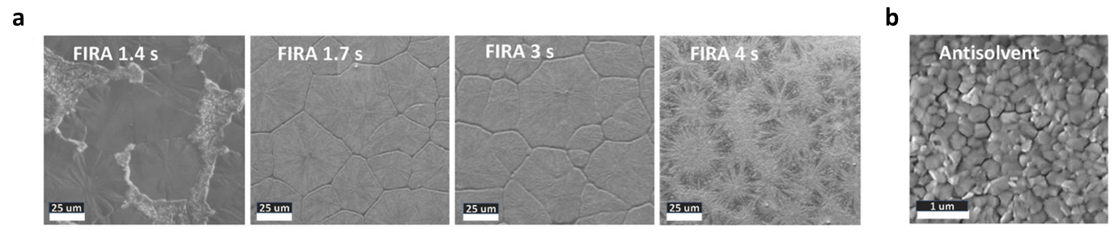

S2. XRD spectra of MAPbI₃ films on FTO glass, annealed with pulses of 0 s to 7 s
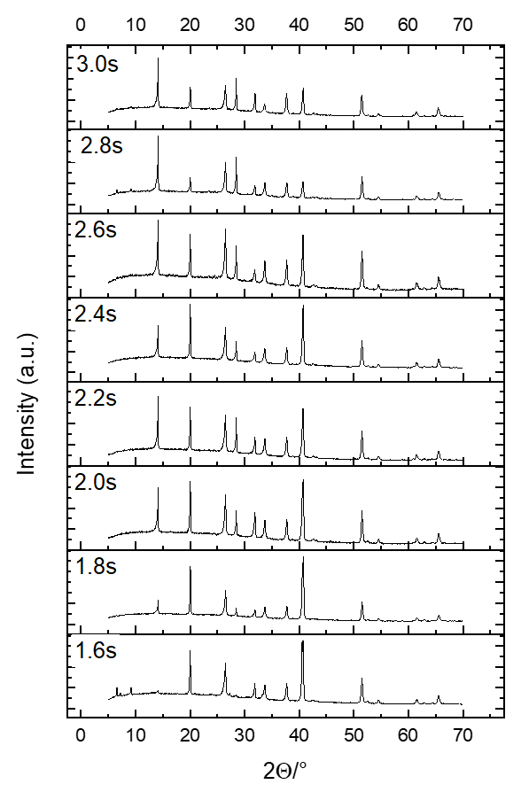
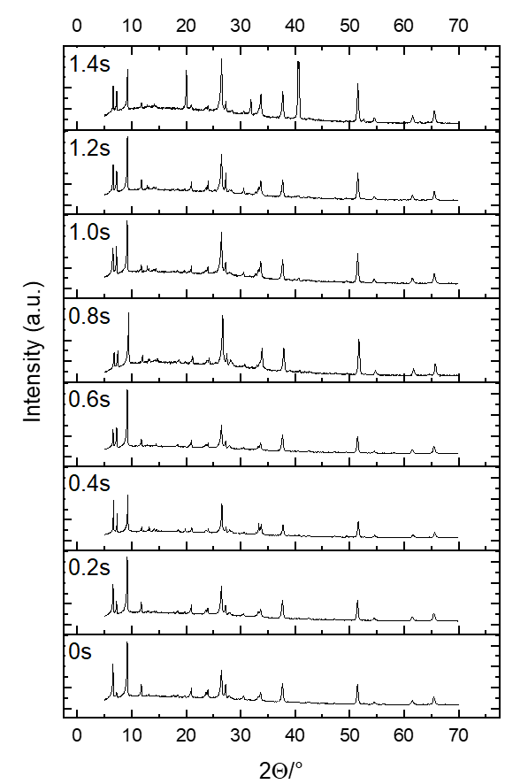

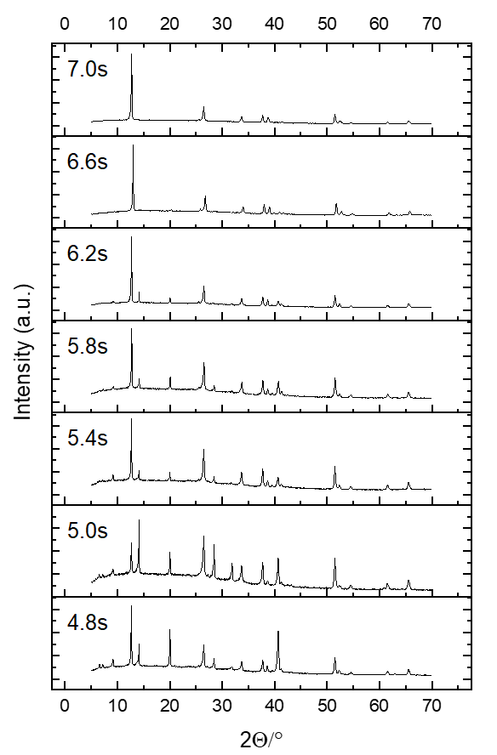
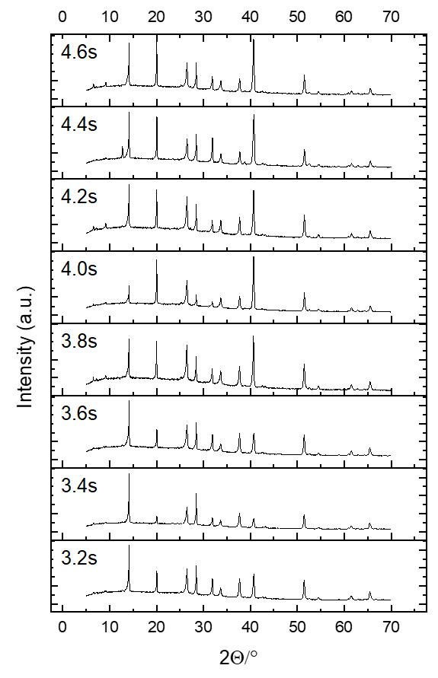

S3. Absorbance spectra of MAPbI₃ films on FTO glass, annealed with pulses of 0 s to 7 s

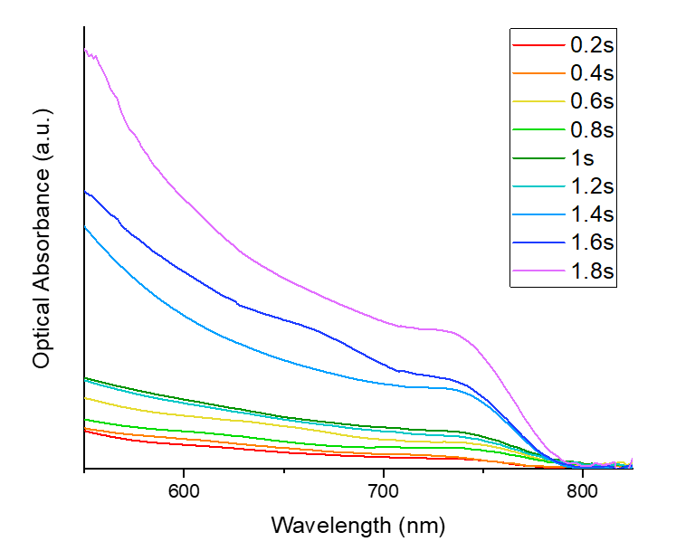
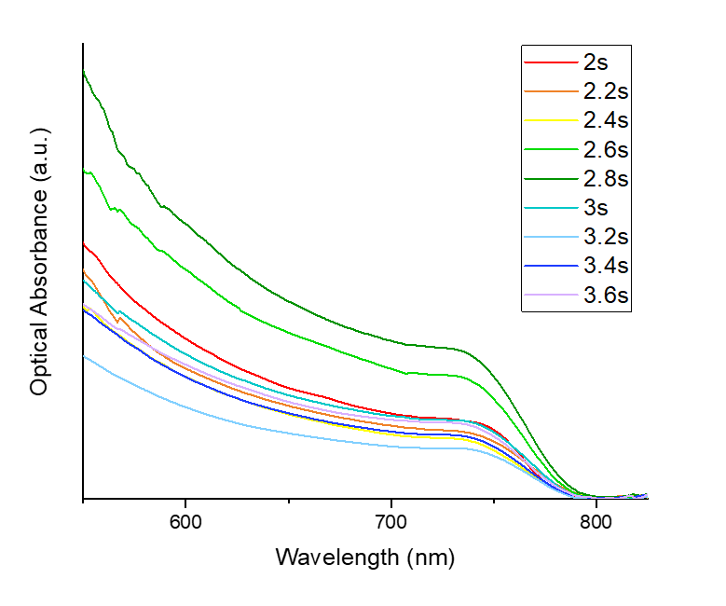
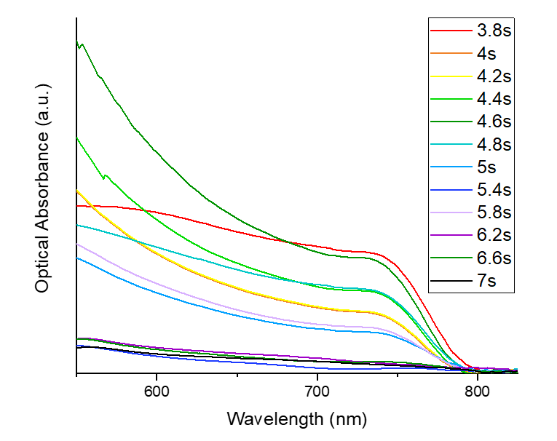

S4. Physical appearance of MAPbI₃ films annealed on PET at various pulse lengths

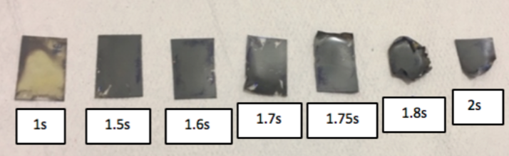

S5. Temperature profile and top-view SEM images of the pristine paper substrate, ITO electrode and mesoporous-TiO₂ layer processed with FIRA

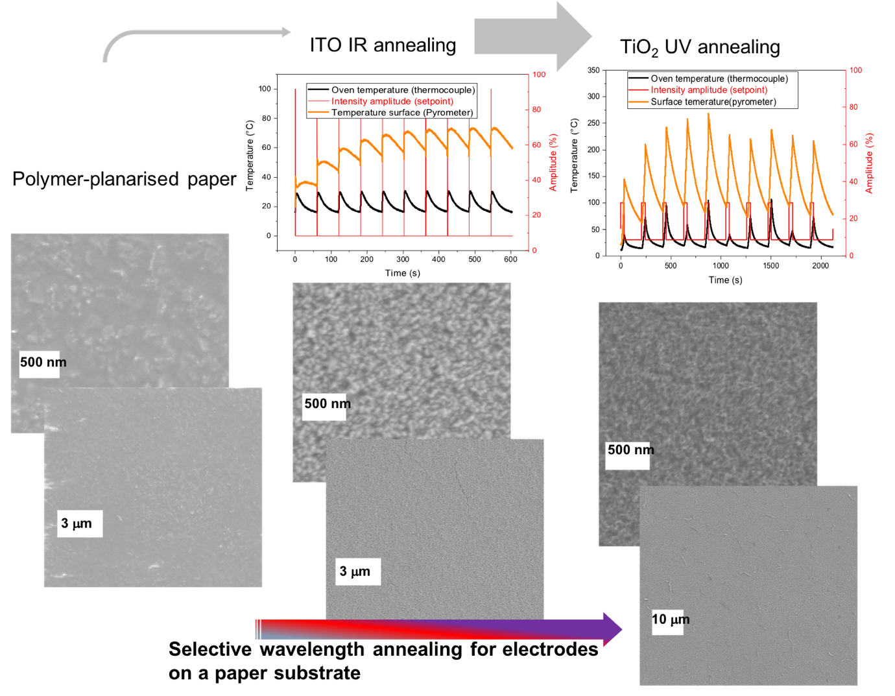

S6. Cross-sectional SEM image of perovskite deposited (via antisolvent method) on a FIRA-annealed ITO/TiO₂ stack.
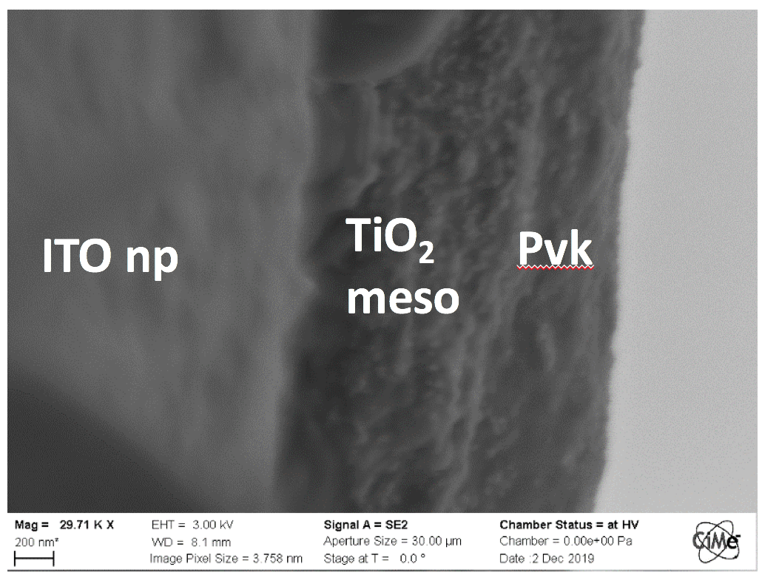
*ITO np = ITO nanoparticles, pvk = perovskite

