Dear Author(s),
This document is divided into sections in which you can add your comments to the video and voiceover. Please be aware that our policy is to do a single complimentary revision, so it is critical that all participants in this project offer their comments collectively. In addition, please make sure that your comments are easily interpreted and transparent.
Have fun!
Protocol Name: Investigating Pain-Related Avoidance Behavior Using a Robotic Arm-Reaching Paradigm
Date: 02-10-2021

Authors and Affiliations
Please fill in any missing author information not included in the video.
Order | Author | Affiliation

Video Comments
Please fill in any comments you wish to make using the table below using the example as a guide. If you need more space to write, please do so below the table. DO NOT ADD CORRECTIONS TO THE NARRATION HERE. PLEASE DO THIS IN THE AUDIO COMMENTS SECTION.
 | Time code | Comment | Requested Change
Example | 2:52 | Onscreen text says use 0.25 mM Fluo-4 | Text should say use 0.50 mM Fluo-4
1. | 0:08 | Label says “Maastricht University” | Please edit to say “Maastricht University & KU Leuven”
2. | 0:19 | Label says “Maastricht University” | Please edit to say “Maastricht University & KU Leuven”
3. | 0:30 | Labels say “Ann Meulders” and “Maastricht University” | Please edit to say “Dr. Ann Meulders” and “Maastricht University & KU Leuven”
4. | 2:59 | Trajectory arches are highlighted with yellow boxes | Please also add trajectory arch labels: shortest trajectory = T1, middle trajectory = T2, longest trajectory = T3
5. | 3:16 | Sensor of robotic arm is not noticeable | Please highlight (e.g. with a circle) the sensor, i.e. the black ball attached at the end of the robotic arm, closest to the participant’s side
6. | 3:39 | Foot with pedals is included as background, and screen with questions as inset | Please change so that screen with questions is included as background, and foot with pedals as inset
7. | 4:54 and 5:04 | Visual stop and start signals (target arch and traffic light turning red and green, respectively) are not very noticeable | Please highlight the target arch and traffic light on the screen at 4:54 and 5:04
8. | 5:09 | Trajectory arches are presented without labels | Please add trajectory arch labels: shortest trajectory = T1, middle trajectory = T2, longest trajectory = T3
9. | 5:14 | Separation of trajectory arches is not immediately evident | Is it possible to begin gradually overlaying the picture of the generalization trajectory arches (presented at 5:19) over the acquisition trajectory arches (presented at 5:09), so that they begin to “fade in” at 5:17?
10. | 5:24 | The onscreen text says “Do not deliver pain stimulus during generalization phase” | Text should say ”Do not deliver the pain stimulus during the generalization phase”
11. | 5:26 | Trajectory arches are presented without labels | Please add trajectory arch labels: leftmost trajectory = G1, middle trajectory = G2, rightmost trajectory = G3
12. | 5:40 | The screen with instructions is not in itself very informative | Would it be possible to show the screen also used at 2:59, and highlight T1, i.e. the shortest movement trajectory (at 5:45), instead?
14. | 5:51 | Onscreen text says “Do not pair T1 with a pain stimulus during the RPE phase” | Text should say “Do not pair T1 with the pain stimulus during the extinction with response prevention phase”
15. | 6:07 | The screen with instructions is not very informative, and there is not enough time to read all the text | Would it be possible to fill the time required for the voiceover at step 6.4.2., by using part of the scene at 2:43, for example?
16. | 6:47 | The highlighting of the higher A data point shifts too early to the lower A data point | The highlighting should only shift at 6:49
17. | 6:52 | The indication of the expected differences is not very clear | Is it possible to use lines to highlight the movements expected of the Yoked Group (blue line in figure 1 in this document), and those expected of Experimental Group (yellow line in figure 1)? Please see figure 1 included at the end of this document.
18. | 6:57 | Too much data is presented at once | Would it be possible to show only the two upper graphs starting at 6:57, and then only show the lower two graphs starting from 7:21?
19. | 6:57 | Data line highlighted too early | Please only highlight at 7:04
20. | 7:06 | All red and yellow data lines are highlighted | Please only highlight red and yellow data lines at ACQ1 and ACQ2 for Experimental Group
 | 7:08 | Green B data lines in upper two graphs are highlighted too early | Please only highlight green B data lines at 7:14
 | 7:21 | Data lines highlighted too early, and wrong part of graph highlighted | Please only highlight red data points labelled with B and C at RPE4 (not entire B/C data line, and not red C data line), and please only highlight at 7:29
 | 7:28 | Data line highlighted too early, and wrong part of graph highlighted | Please only highlight red A/B data points at ACQ2 (not entire line), and please only highlight at 7:32
 | 7:37 | Wrong part of graph highlighted | Please only highlight higher B data point at TEST1 (not entire line)
 | 7:42 | Wrong part of graph highlighted | Please only highlight lower B data point at RPE4 (not entire line)
 | 7:46 | Too much data is presented at once | Please only show lower two graphs
 | 7:49 | Data line highlighted too early, and wrong part of graph highlighted | Please only highlight red C data points at TEST1 (not entire line), and please only highlight at 7:51
 | 7:54 | Data line highlighted too early, and wrong part of graph highlighted | Please only highlight red data points labelled with B and C at RPE4 (not entire B/C data line), and please only highlight at 7:56
 | 8:04 | Label says “Maastricht University” | Please edit to say “Maastricht University & KU Leuven”
 | 8:14 | Labels say “Ann Meulders” and “Maastricht University” | Please edit to say “Dr. Ann Meulders” and “Maastricht University & KU Leuven”

Audio Comments
This section is used to specify the changes that need to be made to the narration. Please follow the example below as a guide to list your changes. If there is a pronunciation change, please provide a phonetic pronunciation key or a web link.
 | Time code | Comment | Step(s) in Shotlist | Rewritten Text or Corrected Pronunciation (highlight in bold)
Example | 1:49 | Original Script Text:  “Then, show the participant their electromyography, or EMG patterns, which correspond to eight specific and unique polar plots.” | 2.2 | Rewritten Script Text:  “Then, show the participant the unique and specific polar plots, which correspond to their electromyography, or EMG (pronounced E-M-G) patterns.”
1. | 2:51 | “Before starting the robotic arm-reaching pain-related avoidance task, provide the Participant with on-screen standardized written instructions of the task, before presenting three arches situated midway through the movement plane.” | 4.1. | “Before starting the robotic arm-reaching pain-related avoidance task, provide the Participant with on-screen standardized written instructions of the task. Program the task such that, three arches are presented, situated midway through the movement plane.”
2. | 2:58 | “Ensure that the shortest arm movement is paired with no deviation or resistance, the middle arm movement is paired with moderate deviation and resistance, and the furthest arm movement is paired with the largest deviation and strongest resistance” | 4.2. | “Ensure that the shortest arm movement, T1, is paired with no deviation or resistance, the middle arm movement, T2, is paired with moderate deviation and resistance, and the furthest arm movement, T3, is paired with the largest deviation and strongest resistance”
3. | 4:16 | “During the avoidance acquisition phase, if the Participant performs the shortest movement trajectory, program the constant current stimulator to always deliver the pain stimulus once two thirds of the movement has been completed” | 5.2. | “During the avoidance acquisition phase, if the Participant performs the shortest movement trajectory, T1, program the constant current stimulator to always deliver the pain stimulus once two thirds of the movement has been completed”
4. | 4:27 | “If the Participant selects the middle movement trajectory, present the pain stimulus 50% of the time, while ensuring that the Participant will have to exert more effort” | 5.3. | “If the Participant selects the middle movement trajectory, T2, present the pain stimulus 50% of the time, while ensuring that the Participant will have to exert more effort”
5. | 4:37 | “If the Participant performs the furthest, most effortful movement trajectory, do not present the pain stimulus but ensure that the Participant will have to exert the most effort to reach the target” | 5.4. | “If the Participant performs the furthest, most effortful movement trajectory, T3, do not present the pain stimulus but ensure that the Participant will have to exert the most effort to reach the target”
6. | 5:05 | “After 3000 milliseconds, present the visual and auditory start signals that indicate that the Participant can start the next trial” | 5.6. | “After 3000 milliseconds, present the visual and auditory start signals, which indicate that the Participant can start the next trial”
7. | 5:22 | “To test for the generalization of avoidance, after the acquisition phase, present three novel, generalization movement trajectories adjacent to the acquisition trajectories.” | 5.8. | “To test for the generalization of avoidance, after the acquisition phase, present the three novel, generalization movement trajectories, G1, G2, and G3, adjacent to the acquisition trajectories.”
8. | 5:40 | “…provide the Participant with standardized written instructions stating that, in the upcoming phase, they can only perform T1.” | 6.1. | “…inform the participant that, in the upcoming phase, they can only perform T1.”
9. | 5:58 | “Thus, you ensure that during the RPE phase, the participant only performs T1.” | 6.3. | “Thus, you ensure that during the extinction with response prevention phase, the participant only performs the shortest movement trajectory, T1.”
10. | 6:52 | The indication of the data is not very clear | 7.1.4. | Is it possible to use lines to highlight the movements expected of the Yoked Group (blue line in figure 1, below), and those expected of the Experimental Group (yellow line in figure 1)? And to time the narration as follows:  “or as compared” during Experimental Group (yellow) line  “to a yoked control group”  during Yoked Group (blue) line  Please see Figure 1 at the end of this document.
11.
12.
13.
14.
15.
16.
17.
18.
19.
20.

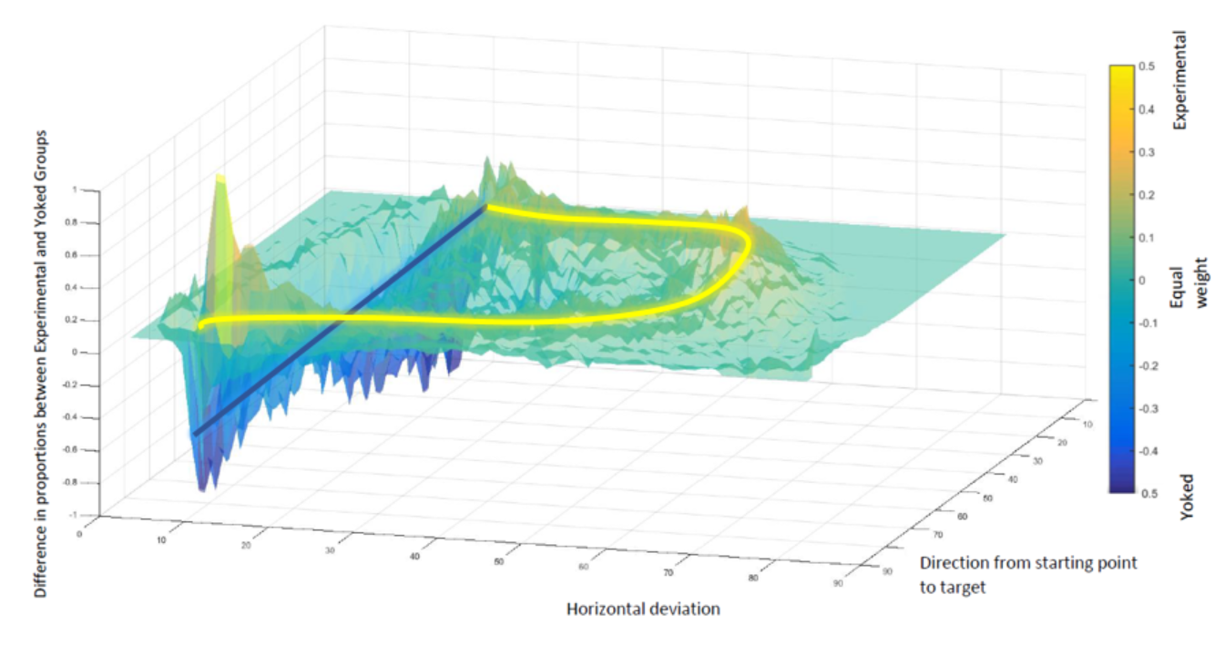
Figure 1.

