Dr. Vineeta Bajaj
Review Editor
Journal of Visualized Experiments

Dear Dr. Bajaj,

Our manuscrit, JoVE 61716 entitled “Techniques for the in vitro evaluation of oncogenic transformation in human mammary epithelial cells” has been revised according the reviewers’ and the editor comments and our submission has been uploaded. Together with our submission, we have also uploaded a separate letter that addresses each of the editorial and peer review comments individually.

We look forward to your reply,

Yours sincerely,
Teresa Anglada and Anna Genescà

Response Letter to the Editorial and the Reviewers

We are thankful for the deep revision of the manuscript by the Editorial, and we have thoroughly revised the concerns addressed. We also appreciate the positive feedback from the reviewers. The followings are our point-by-point responses to the editorial and reviewer’s comments:

Editorial Comments
• Please take this opportunity to thoroughly proofread the manuscript to ensure that there are no spelling or grammatical errors.
Following the editorial advice, we have thoroughly checked grammar and spelling and changes applied can now be tracked on the edited version of the manuscript.

• Protocol Detail: Please note that your protocol will be used to generate the script for the video, and must contain everything that you would like shown in the video. Please ensure that all specific details (e.g. button clicks for software actions, numerical values for settings, etc) have been added to your protocol steps. There should be enough detail in each step to supplement the actions seen in the video so that viewers can easily replicate the protocol.
We understand the editor’s concerns thus we have ensured that all the steps included in the protocol can be filmed and, most importantly, replicated by other researchers.
1) 2.1.6: mention centrifuge speed and duration.
After trypsinization cells are centrifuged at 500 x g for 5 minutes. We omitted this information in the previous version because it was already explained in 1.1.2.9. However, we have now included the centrifuge speed and duration in 2.1.6. in order to avoid confusion.
2) 2.2.9, 2.2.11: mention antibodies and their concentrations
We have added a note in 2.2.8. with detailed information regarding primary and secondary antibodies description and recommended working concentration.
“NOTE: Antibody concentration must be accurately adjusted depending on the cell type and the antibody reference. As a guide, for BPECs use primary anti-Cytokeratin 14 and anti-Claudin-IV antibodies (see Table of Materials) at a working solution concentration 1:100 and secondary anti-Mouse and anti-Rabbit antibodies (see Table of Materials) at 1:500 working solution concentration.”

3) 2.2.15: Provide microscope magnification, fluorescence excitation and emission filter settings etc.
Following the editorial advice, we have included the microscope configuration parameters in 2.2.15.

“NOTE: Confocal microscope configuration must be accurately determined depending on the equipment used and the antibodies applied to the sample. As a guide, with the equipment and reagents detailed in the Table of Materials use a 40x objective and the following laser and detector settings:
- DAPI: excitation with a 405 laser (5%), detection with a PMT detector (800V, Offset: -10) and a spectral band from 410 nm to 500 nm.
- A488 (Claudin-IV): excitation with a 488 laser (10%), detection with a PMT detector (800V, Offset: -20) and a spectral band from 490 nm to 550 nm.
- Cy3 (Cytokeratin 14): excitation with a 555 laser (10%), detection with a PMT detector (800V, Offset: -35) and a spectral band from 560 nm to 600 nm.”

• Protocol Highlight:
1) 1.2 is not filmable, please unhighlight.
We think that step 1.2. is essential for a complete understanding of the methodology. If we omit this part, the protocol regarding the obtention of the number of cells after subculture (1.1.) loses its sense. When we decided to highlight this part we thought that we could record our screen while doing the calculations of the accumulated population doubling. We have now reduced the highlighted length but we are wondering if it is possible to reconsider to include part of step 1.2. in the video.

2) 3.3.3, 3.3.4: unhighlight these due to low filmable content.
According to the editorial comment steps 3.3.3, 3.3.4 have been unhighlighted.

3) The highlighted steps should form a cohesive narrative, that is, there must be a logical flow from one highlighted step to the next.
Thanks for the comment, we have ensured that the highlighted steps follow a cohesive narrative. To do so, we have highlighted/unhighlighted some words or sentences and changes applied can now be tracked on the edited version of the manuscript.
4) Please re-evaluate the length of your protocol section. Please highlight ~2.5 pages or less of text (which includes headings and spaces) in yellow, to identify which steps should be visualized to tell the most cohesive story of your protocol steps.
According to the editorial comment, we have re-evaluated the length of the protocol section and we consider that all steps included now are necessary for the reproduction of the protocol by other researchers. We have made sure that the protocol section does not exceed the length limit (10 pages maximum). Regarding the highlighted text, we have verified that it is no longer than recommended.
• Discussion: JoVE articles are focused on the methods and the protocol, thus the discussion should be similarly focused. Please ensure that the discussion covers the following in detail and in paragraph form (3-6 paragraphs): 1) modifications and troubleshooting, 2) limitations of the technique, 3) significance with respect to existing methods, 4) future applications and 5) critical steps within the protocol.
Since we provide a set of tools to evaluate the oncogenic transformation of cells, we thought the best way to discuss the methodology presented was to do it tool by tool. Thus, we addressed all points required to be covered in a single paragraph for each tool. If a researcher only wants to use 1 or 2 of the tools presented it is easier to follow up all the discussion for this specific tool continuously and not have to jump from one paragraph to the next. We have added an extra paragraph to discuss some points in a more transversal way across the different tools.

Here we provide an example of a paragraph discussing the 3D technique with the required topics highlighted following a color code:
1) modifications and troubleshooting,
2) limitations of the technique,
3) significance with respect to existing methods,
4) future applications and
5) critical steps within the protocol.

[...]
The 3D culture in basement membrane matrix allows the assessment of cell distribution within a whole functional entity, the acinus. An altered organization is indicative of an intercellular communication impairment that could lead to a loss of function, a characteristic of tumoral tissues. The fact that some acini present non-polarized organization indicates that some cells have initiated the transformation process. Regarding technical issues, it is important to accurately determine the optimal concentration of seeded cells and the concentration of the matrix. These two parameters can influence the number and size of the resulting acini and this could interfere their organizational capacity. Also, manipulation of basement membrane matrix requires a certain degree of experience as it must be gently handled. Despite being a laborious technique, the growth of cells in 3 dimensions resembles the physiological context of these cells and allows the evaluation not only of the distribution of breast lineage markers (LaBarge et al., 2013 JOVE; Repullés et al., 2019) but also of other structures that provide information about tumoral features, such as the disruption of the basement membrane (Zubeldia-Plazaola et al. 2018). 3D cell cultures represent the future in cell culture research. In fact, 3D growths can give rise to more physiological and interesting findings, taking into account microenvironment elements and providing us with a lot of different studies as well as therapeutical targets identification and evaluation, cell to cell interactions or stem cell investigations.
[...]
• Commercial Language: JoVE is unable to publish manuscripts containing commercial sounding language, including trademark or registered trademark symbols (TM/R) and the mention of company brand names before an instrument or reagent. Examples of commercial sounding language in your manuscript are Primaria, Matrigel, Vectashield, MilliQ,
1) Please use MS Word’s find function (Ctrl+F), to locate and replace all commercial sounding language in your manuscript with generic names that are not company-specific. All commercial products should be sufficiently referenced in the table of materials/reagents. You may use the generic term followed by “(see table of materials)” to draw the readers’ attention to specific commercial names.
We have replaced the commercial language in our manuscript for generic names. Changes applied are detailed below and can be tracked on the edited version of the manuscript.
· Primaria → modified surface
· Matrigel → basement membrane matrix
· Vectashield → antifade mounting medium
· MilliQ → ultrapure water
· Parafilm → laboratory wrapping film
• Table of Materials:
1) Please revise the table of the essential supplies, reagents, and equipment. The table should include the name, company, and catalog number of all relevant materials/software in separate columns in an xls/xlsx file. Please include items such as antibodies and RRIDs,
We have revised the Table of Materials and Equipment and we have confirmed that it includes all the essentials. We have added the company and reference number to a couple of reagents where it was missing. However, in some cases, it cannot be provided because we have done it ourselves (e.g. humid chamber) or it is of general usage (e.g. Pipette Aid, heat resistant gloves). For other products, we have detailed the properties required on a comments/description column (e.g. 100 ml glass bottle: with cap, autoclavable). Antibodies used were already listed, however, we have now included the word “antibody” in their description to make them more easily found. RRIDs have been added where applicable.

2) Please remove the registered trademark symbols TM/R from the table of reagents/materials.
Registered trademark symbols have been removed from the Table of Materials.

3) Please sort in alphabetical order.
Done
• If your figures and tables are original and not published previously or you have already obtained figure permissions, please ignore this comment. If you are re-using figures from a previous publication, you must obtain explicit permission to re-use the figure from the previous publisher (this can be in the form of a letter from an editor or a link to the editorial policies that allows you to re-publish the figure). Please upload the text of the re-print permission (may be copied and pasted from an email/website) as a Word document to the Editorial Manager site in the "Supplemental files (as requested by JoVE)" section. Please also cite the figure appropriately in the figure legend, i.e. "This figure has been modified from [citation]."
Please, find attached a supplemental file with the permission request. Where applicable, the citation is included in the figure legend.

Reviewers' comments:
Reviewer #1:
Manuscript Summary:
Although the in vitro transformation assay represents a historical approach to study the oncogenic transformation, it still retains some values in cancer research. Hence, the protocol here presented is of some interest. Enclosed my specific points
PDi Population doubling of the seeded cells. It should be better explained how to get it.
We thank the reviewer for this suggestion as we agree that a better explanation of this parameter was convenient. The variable PDi refers to the number of Populations Doublings accumulated by the cells on the previous counting made. Since PD is the accumulated population doubling for a specific time point, the number of population doublings that these cells already achieved must be taken into consideration.
We have clarified this issue in the manuscript as follows: “PD_{i}: Number of population doublings achieved by the cells until the previous subculture (it refers to the PD accumulated on the previous subculture)”
I am wondering whether fixation with methanol:acetone (1:1, v/v) is the only options?
We thank the reviewer for raising this issue since, as a general rule, the fixative for immunofluorescent labeling depends on the target epitope. However, when working with Matrigel attention must be paid to the fixation step because some fixatives, as PFA, may cause de-polymerization of the matrix and the consequent loss of 3D structures on the following washing steps. The addition to 1% glutaraldehyde helps to solve the de-polymerization problem when using PFA, although it may produce background fluorescence. From our experience, better results are obtained with methanol:acetone in comparison to PFA for all the antibodies we have tested.
Besides, in our experiments, cells used for acini formation were previously transduced with exogenous genes along with reporter genes encoding for fluorescent proteins (mCherry and EGFP) to be able to select transduced cells by fluorescence-activated cell sorting. Thus, the removal of intrinsic fluorescence was crucial to then perform immunofluorescent labeling of the proteins of interest. This was achieved with the fixation of the samples with methanol:acetone, as commented on the NOTE of 2.2.5.
In figure 6A transformed acini show a sort of inverted polarization. Any comments?
We understand that the first impression may be of an inverted pattern of polarization. However, despite in the non-polarized acinus of figure 6A most of the cells with Cl-IV (green) occupy a peripheral location, some K14 (red) positive cells remain on the periphery. This picture was chosen because it shows a very good example of a non-polarized acinus, which is characterized by the high number of Cl-IV (green) cells capable to surpass the K14 (red) peripheral belt. However, it's not always so evident. Acini can be classified as no-polarized even when a single Cl-IV positive cell is placed on the periphery of the acinus because it is indicative that the regulation of cellular localization has been lost. Here we provide another example of a non-polarized acinus where there is a cell in the 3rd stack in the central position that is clearly Cl-IV (green) positive. Also, in the following slices, there are some K14 (red) positive cells in the periphery. We have also added a note in the figure legend of figure 6A to clarify this issue.
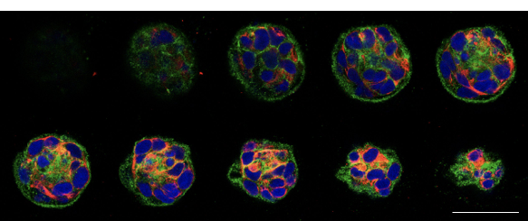
Figure 1. Example of a non-polarized acinus. Each image corresponds to a z-stack. Positive cells for Cl-IV (green) and K14 (red) are located both in middle and peripheral positions. Scale bar: 50 μm.

Figure 6B shows that the vast majority of transformed cells still retain polarized acini. Any comments?
We thank the reviewer for raising this point. Matrigel provides a 3D environment that allows cells to survive, grow and move freely. Compared to soft-agar assay, the culture of cells in Matrigel keeps them in less strict conditions and allows the proliferation, not only of those cells capable to form colonies in suspension, but of all of them.

It is known that, only a subset of cells are able to start a neoplastic process. In this experimental approach, even if cells from both lineages (luminal and myoepithelial) have been transduced, only some of them may have acquired mutations providing high fitness and thus being able to give rise to a tumor. Moreover, it is important to note that acini are formed from the aggregation of different cells, and even if a cell is capable to form a tumor, more time should be needed for a unique cell to affect the polarization of a whole acini which is mainly formed by cells with less fitness. Therefore, from our point of view, it is not surprising that the majority of cells present in acini are still capable of forming organized structures. Taking this into account, it is worth noting that we still observe a reduction of nearly 35% of polarized acini compared to their non-transduced counterparts.

The image in figure 7B is too dark and of low quality. Please, improve it. A color image could help.
The reviewer is right and the brightness and contrast have been adjusted. We believe a color image will not improve the quality of the image since colonies after MTT staining are dark. We hope such images give researchers an idea of how colonies are seen by the naked eye.

The same point for figure 10B.
The same approach has been followed. We hope the inset in these images provides an idea of the colonies’ magnitude depending on the condition analyzed.
The question of discriminating between partially transformed and fully transformed cells is important.
We completely agree with the reviewer. The analysis of colony size offers valuable information to obtain conclusions on the degree of cellular transformation. As shown in the Results section (figure 10A), taking into consideration the number of colonies alone is not always enough to discriminate intermediate stages of cellular transformation (D = 278 colonies vs T = 243 colonies). However, the information on the colony size makes it possible to differentiate them. More details regarding this topic can be found in the last paragraph of the Representative Results section.

Can they resolve this point through a detailed analysis of colonies dimensions? Yes, the mean diameter of D is 83 μm while for T is 114 μm, which is significantly bigger. Not only the average diameter of all colonies but also the presence of colonies with much bigger dimensions are indicative of a higher degree of transformation.

Can they identify a percentage of increasing (surface) between the two conditions?
Considering the average diameter of colonies for the two conditions the surface can be calculated as follows:
Data:
Mean diameter for D: 83 μm
Mean diameter for T: 114 μm

Calculation considering 2D colonies:
Area = π · r²
Area D: 5,410.61 μm²
Area T: 10,207.03 μm²
There is an increase of 4,796 μm² on average for T compared to D, which means that T have almost doubled the surface of the D.

The same approach can be followed to calculate surfaces in 3D dimensions.

Calculation considering 3D colonies:
Volume = 4/3 · π · r³
Volume D: 299,386.97 μm³
Volume T: 775,734.62 μm
There is an increase of 476,347.65 μm³ on average for T compared to D, which means that T have more than doubled the volume of the D.

Frequently as they show in figure 10A there is a certain degree of heterogeneity in soft-agar foci dimension. Can they comment this point?
The reviewer’s observation is interesting. Heterogeneity comes from the fact that the agar prevents the free movement of cells, making it difficult to form large colonies and preventing the fusion of different colonies. In a fully transformed cell line, some of the colonies can be small but what is important is their capacity to form some colonies of bigger dimensions. In order to detect these bigger colonies it is important to score a large number of colonies and for this reason we recommend to score the colonies formed all over the plate. Also, in order to draw conclusions from agar experiments we recommend taking into account both the number and size of the colonies.
In the soft agar assay branched cells emerge from the border of the foci. Can the authors comment this point?
We are not sure to understand the point of the reviewer since we did not observe branched cells emerging from colonies in our experiments. If the reviewer refers to filaments that protrude from the main body of the colony once MTT applied we want to make clear that it often appears as a result of converting MTT to crystal formazan. For example, in figure 2 the area inside the yellow line corresponds to a colony of cells metabolically active. The branches outside this yellow area appear as a result of crystallization and are not considered in the colony size measurement.
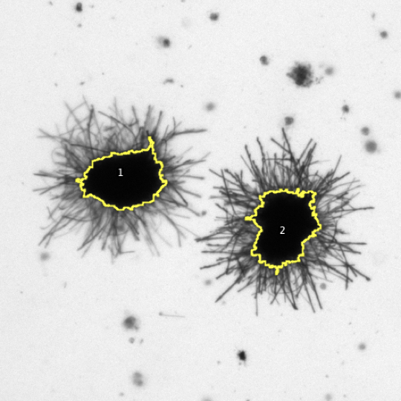

Figure 2. Representative image of MTT-positive colonies.

Reviewer #2:
Manuscript Summary:
Genesca et al. Has described a method to evaluate the transformation of normal cells into oncogenic cells after genetic manipulation. These tools include both cellular assays and image analysis.
Minor Concerns:
1) In 2.1 please mention what kind of plates have been used for matrigel experiment. The amount of matrigel matters to type of plates used.
We thank the reviewer for the comment. We have moved the type of plates used (24 well plates) from step 2.1.1. in the protocol section to a NOTE in 2.1 to make it easy for the readers to find this information. We have also indicated with a comment in the Table of Materials that the plates must have a flat bottom.

2) Instead of MTT assay, have you evaluate using crystal violet? IS there a difference in calculating colonies?
While MTT assay measures the metabolic activity of cells as an indicator of cell viability, crystal violet assay is not able to distinguish live and dead cells. Viable cells with an active metabolism can reduce the yellow tetrazolium salt (MTT) to purple formazan crystals that are microscopically visible. Otherwise, death cells lose this ability and crystals are not formed. In contrast, the crystal violet is a triarylmethane dye with an affinity for DNA. This assay assumes that cells attached to the plate are alive and that dead cells have been detached. Thus, although crystal violet is recommended for assays with adherent cells it is not a good option for agar assays because death cells will continue embedded in the agar. That is why we believe MTT is a better choice to measure cell survival and proliferation in agar assays.

3)Line 468/469, how long does it take for STASIS to occur?
STASIS generally occurs towards the second week after cell culture is established from breast samples. During STASIS cells display senescent-like features and they do not divide. This period is considered to be overcome when cells start to divide again, as evidenced by an increased slope on growth curves. In figure 3 we have represented the accumulation of population doublings with time of cells derived in our lab from two different donors. For both donors, STASIS started at week 2, and despite the exact duration of this stage depended on the donor, by the 4th week of culture cells started to divide again.
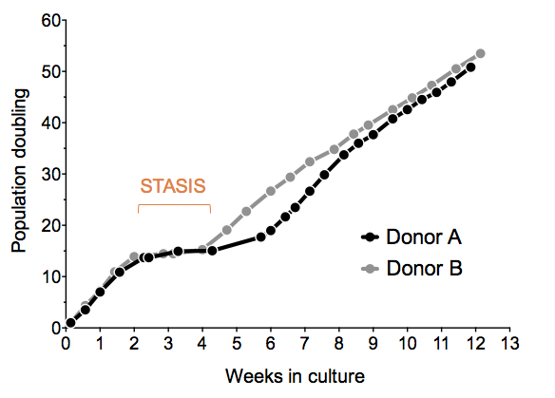

Figure 3. Representative growth curves of cells from two donors. STASIS period is indicated.

In order to clarify this point in the manuscript, a better explanation of STASIS has been now added to the REPRESENTATIVE RESULTS section: “After overcoming STASIS (stress or aberrant signaling induced-senescence, a phenomenon typically observed in mammary epithelial cells in vitro that is overcome around 4 weeks after cell culture establishment), cells were…”

4) Line 506, can you confirm the transformation via growth independence of contact with basal lamina via any staining?
The most widely used test to assess the anchor-independent cell growth is the soft-agar assay. If individualized cells in agar can still divide and form colonies some weeks after being seeded, they will become positive colonies after MTT assay. As far as we know, there is no specific staining that identifies cells that can grow with independence of contact with basal lamina and distinguishing them from those that cannot. Cells that can survive in an anchor-independent manner alter the transcription pattern when they are forced to live without anchorage (Sekiguchi and Yamada 2018. DOI:10.1016/bs.ctdb.2018.02.005). Thus, it is probably necessary to force them to live under these circumstances to manifest their ability.

5)may be provide a table for optimal seed counting and amount matrigel based on your experience?
We thank the reviewer for this suggestion as choosing the optimal plating conditions is a critical point. In the protocol section, we provide the optimal conditions for the formation of 3D structures of mammary cells in 24 well plates (growth area of 1.9 cm²): 100 µl of Matrigel + 500 µl containing 100.000 cells in medium with 4 % Matrigel per well.
The volume of Matrigel required depends on the size of the well, although an important consideration has to be taken into account: the formation of a meniscus. That is why we highly recommend researchers to use a 24 well plate (or the equivalent well size in the 4 well plate format). As shown in figure 4, wells of lower dimensions (e.g. 96 well plates) require less volume of matrix but the hydrophobic walls cause the Matrigel to form a meniscus. This results on an uneven surface that can alter 3D formation and makes it difficult to examine cells or acini under a microscope. Wells of bigger dimensions than 24 well plates are not commonly used due to the high volume of matrix required, which is expensive (more than 300 € for a 10 ml bottle).
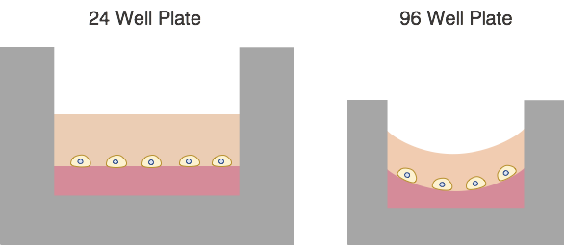

Figure 4. Schematic representation of the basement membrane matrix behavior in wells of different dimensions.

