June 18th, 2020
Vineeta Bajaj, PhD
Review Editor
JoVE,

Dear Dr. Bajaj,

We appreciate your thorough review of our manuscript entitled ‘Choroid Sprouting Assay: An Ex Vivo Assay of Ocular Microvascular Angiogenesis’. We have revised our manuscript according to the reviewers’ suggestions. We feel that the article has been much improved with the revisions. New text added to the manuscript is in red, and the reviewers’ original questions are in blue text in this document. We believe that the revision fully addresses the comments raised by you and the reviewers and hope that it will be published in JoVE.

Sincerely yours,
Corresponding author:
Lois E.H. Smith, MD, PhD
Institution: Boston Children’s Hospital/ Harvard Medical School
Address: Children's Hospital, 300 Longwood Ave, Boston, MA 02115
Phone number: 617-919-2529, Email: Lois.Smith@childrens.harvard.edu

Editorial comments:
Changes to be made by the Author(s):
1. Please take this opportunity to thoroughly proofread the manuscript to ensure that there are no spelling or grammar issues. The JoVE editor will not copy-edit your manuscript and any errors in the submitted revision may be present in the published version.
Thank you for your comments. We checked it again and modified it.

2. Please revise the table of the essential supplies, reagents, and equipment. The table should include the name, company, and catalog number of all relevant materials in separate columns in an xls/xlsx file. Please sort the Materials Table alphabetically by the name of the material.
I have checked it and revised it.

3. Unfortunately, there are a few sections of the manuscript that show overlap with previously published work. Though there may be a limited number of ways to describe a technique, please use original language throughout the manuscript. Please see lines: 60-62, 77-81, 86-88, 89-93, 187-188, 196-201, 239-242,
Thank you very much for pointing out them. We have changed them all.

4. Figure 1: Please include a space between all numbers and the corresponding unit. Please avoid the use of commercial terms (Matrigel). Please use genetic terms whenever possible.
I have changed them. We describe Matrigel as Basal membrane extract (BME).

5. Please remove the figure labeling from the figures. Figure 4 has a label for Figure 3.
I removed the figure label in the figures.

6. JoVE cannot publish manuscripts containing commercial language. This includes trademark symbols (™), registered symbols (®), and company names before an instrument or reagent. Please remove all commercial language from your manuscript and use generic terms instead. All commercial products should be sufficiently referenced in the Table of Materials and Reagents.
I have changed it.

7. Please revise the text to avoid the use of any personal pronouns (e.g., "we", "you", "our" etc.).
I have changed it.

8. Please obtain explicit copyright permission to reuse any figures from a previous publication. Explicit permission can be expressed in the form of a letter from the editor or a link to the editorial policy that allows re-prints. Please upload this information as a .doc or .docx file to your Editorial Manager account. The Figure must be cited appropriately in the Figure Legend, i.e. “This figure has been modified from [citation].”
We have changed and uploaded the approval document.

9. Please do not abbreviate journal titles.
We are not now using abbreviate in the journal titles.

Reviewers' comments:
Reviewer #1:
Manuscript Summary:
The manuscript by Tomita et al described the experiments for mouse choroid sprouting assay. Over it is well presented, and the paper was well written. Major Concerns:
Some comments are as follows:
(1) Can the authors show some sections and staining pictures, so that the identity and organization of the cells that are sprouting can be confirmed.
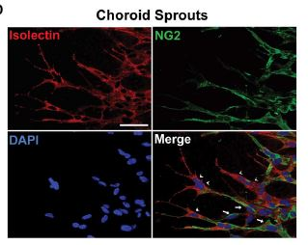
Thank you for your valuable comment. It is very difficult to make cross sections of embedded Matrigel but we have (in whole mounts) previously stained with isolectin and NG2, microvascular marker for macrophages and endothelial cells and for pericytes respectively, see left figure [1]. This figure showed that the extending growth cone resembles vascular tube formation in vivo and stains positively with isolectin GS (arrow head) surrounded by chondroitin sulfate proteoglycan neuron-glial antigen 2 (NG2) positive pericytes (arrow).
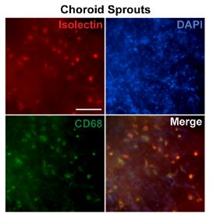

We also showed that a population of isolectin and CD68-positive cells was also detected in the sprouts adjacent to planted choroidal tissue as left figure. These isolectin and CD68-positive cells exhibited monocyte/macrophage-like cell morphology [1].

(2) If not all the sprouting cells are EC cell, how can the sprouting of the ECs be quantified?
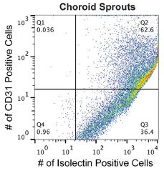

We previously examined CD 31, a marker of ECs, with flow cytometry [1]. The left figure showed flow cytometry analysis of choroid sprouting cell populations. About 60% of the cell population from the choroid sprouts stained positive for both CD-31 and isolectin, indicating ECs/macrophages. 36% of the cell population is isolectin-positive but did not stain for CD-31.

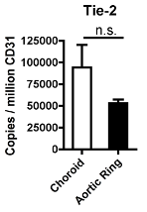
Furthermore, compared to the aortic ring assay, the choroidal sprouts expressed similar quantities of endothelial markers (i.e. VE-cadherin and Tie-2) when normalized to CD31 as left figure [1].

(3) The code for the macro image J plug-in should be listed in the paper, or available for download from public domain.
The macros are available to academic institutions through the authors. We added the comments in the manuscript as below.

P3 line 149-151
A computerized method to measure the area covered by growing vessels was developed which is available free to academic institutions through the authors. A macro plugin to ImageJ software is needed prior to quantification (see supplemental information for further detail)

References
1. Shao Z, Friedlander M, Hurst CG, Cui Z, Pei DT, Evans LP, Juan AM, Tahiri H, Duhamel F, Chen J, Sapieha P, Chemtob S, Joyal JS, Smith LE (2013) Choroid sprouting assay: an ex vivo model of microvascular angiogenesis. PLoS One 8 (7):e69552. doi:10.1371/journal.pone.0069552

Reviewer #2:
This manuscript is well-written and the study is well-designed. The choroid sprouting assay are performed correctly and the results are presented well without identifiable errors.
Great work and excellent manuscript. I recommend proceeding with publication.

Following is only one suggestion to improve the manuscript,
1) Is it possible to perform the choroid sprouting assay using rabbit and even human eye?
Thank you very much for addressing this important point. We previously published rat choroidal explant assay as below (figure A) [1]. In addition, Zhou, et al. performed human choroid sprouting assay as below (figure B) [2]. We added passage in the manuscript.

Page 5 line 231-232
The reproducible choroidal sprouting assay aids research in neovascular AMD. Choroid explants can be isolated from mice as well as rats and humans.
B
A
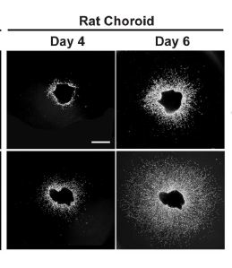
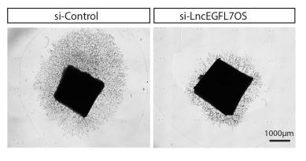

References
1. Shao Z, Friedlander M, Hurst CG, Cui Z, Pei DT, Evans LP, Juan AM, Tahiri H, Duhamel F, Chen J, Sapieha P, Chemtob S, Joyal JS, Smith LE (2013) Choroid sprouting assay: an ex vivo model of microvascular angiogenesis. PLoS One 8 (7):e69552. doi:10.1371/journal.pone.0069552
2. Zhou Q, Yu B, Anderson C, Huang ZP, Hanus J, Zhang W, Han Y, Bhattacharjee PS, Srinivasan S, Zhang K, Wang DZ, Wang S (2019) LncEGFL7OS regulates human angiogenesis by interacting with MAX at the EGFL7/miR-126 locus. Elife 8. doi:10.7554/eLife.40470

Reviewer #3:
Manuscript Summary:
In this method article, Tomita et al. describe an ex vivo choroid sprouting assay. Overall, the study has the merit to look at an interesting topic. Indeed, ex vivo cultures represent an interesting tool that allow the maintenance of the complexity of the tissue structure. In addition, the model implemented by Tomita and colleagues, allow the study of the pathological mechanisms of choroidal neovascularization and may be exploited for the testing of drug candidates. I found the protocol clear and well described. However, I have few concerns, listed here below.

Major Concerns:
1) Introduction: the authors make a comparison between their choroid assay and the aortic ring model. I understand that aortic ring assay represents the most widely used ex vivo angiogenesis model, but since here we are speaking about ocular diseases, I think it would be more interesting to compare their model with the ex vivo retina models actually used.
I really appreciate your comments. Although several studies about ocular disease have used aortic ring model [3,4], ex vivo retina model [5,6] is also used as ocular disease model as you said. We added the comments in the introduction.

Page1 line 75-77
Recently a group published an ex-vivo retinal assay. Although, it is suitable for retinal neovascular disease, it is not as appropriate for choroidal neovascularization seen in AMD.
2) Representative results: in the text the authors refer to Figure 1, 2 and 3. Anyway, there are 4 figures. I am also confused regarding the concordance between Fig 2 and Fig 3 and their legends. Are they correct? Please, fix these discrepancies.
We are sorry for this discrepancy. I have edited them.

Minor Concerns:
I would suggest the authors to choose better images for Figure 4 a-c (first column)
Thank you very much for your suggestion. We have added better images.

References
3. Gong Y, Fu Z, Edin ML, Liu CH, Wang Z, Shao Z, Fredrick TW, Saba NJ, Morss PC, Burnim SB, Meng SS, Lih FB, Lee KS, Moran EP, SanGiovanni JP, Hellstrom A, Hammock BD, Zeldin DC, Smith LE (2016) Cytochrome P450 Oxidase 2C Inhibition Adds to omega-3 Long-Chain Polyunsaturated Fatty Acids Protection Against Retinal and Choroidal Neovascularization. Arterioscler Thromb Vasc Biol 36 (9):1919-1927. doi:10.1161/ATVBAHA.116.307558
4. Gong Y, Shao Z, Fu Z, Edin ML, Sun Y, Liegl RG, Wang Z, Liu CH, Burnim SB, Meng SS, Lih FB, SanGiovanni JP, Zeldin DC, Hellstrom A, Smith LEH (2016) Fenofibrate Inhibits Cytochrome P450 Epoxygenase 2C Activity to Suppress Pathological Ocular Angiogenesis. EBioMedicine 13:201-211. doi:10.1016/j.ebiom.2016.09.025
5. Rezzola S, Belleri M, Ribatti D, Costagliola C, Presta M, Semeraro F (2013) A novel ex vivo murine retina angiogenesis (EMRA) assay. Exp Eye Res 112:51-56. doi:10.1016/j.exer.2013.04.014
6. Rezzola S, Belleri M, Gariano G, Ribatti D, Costagliola C, Semeraro F, Presta M (2014) In vitro and ex vivo retina angiogenesis assays. Angiogenesis 17 (3):429-442. doi:10.1007/s10456-013-9398-x

