Manuscript JoVE61669

We are very grateful for the positive reception of our manuscript. We are also grateful for the Reviewers’ comments which have enabled us to improve the manuscript. We performed required changes in the manuscript according to the Reviewers’ suggestions, which include new data from additional experiments. In addition, we corrected small typographic and grammar errors and made some subtle changes.

Reviewer #1:
Major concerns:
As this particular technique is a commercially available kit, more emphasis needs to be placed on the aspects of the project that go beyond a repetition of the protocol accompanying this kit. In this regard that may be the consideration of orientation of the tags to ensure the correct cytoplasmic localisation. This is discussed at various points in the manuscript as a whole, but could be given more attention at point 1.1 of the protocol. This should also be emphasised with an explanatory figure accompanying the results figure, demonstrating in a visual sense why it is necessary to perform the experiment with each potential tag orientation.
Consideration of orientation of the tags has been given more attention in the protocol and an explanatory figure has been included in the manuscript.
Minor concerns:
The first paragraph of the introduction is a bit vague. The protocol has been tested against NSTs, and also other Golgi-resident type III membrane proteins, but which is the focus of this manuscript? Why is the data only satisfactory?
The data presented in the manuscript refer to nucleotide sugar transporters, but we are fully convinced that the proposed approach would also work for other proteins with a similar topology and subcellular localization, although the corresponding results are not provided. The entire paragraph was slightly rephrased.
The discussion of the advantages of NanoBiT in the introduction is appropriate, but should also include some disadvantages, including the decreased quality of subcellular imaging that would be available when compared with FRET or BiFC.
The decreased quality of subcellular imaging of bioluminescent samples is now mentioned as one of disadvantages of the proposed approach in the discussion part (we decided not to mention this aspect in the introduction part as the bioluminescent imaging is not the focus of the manuscript). We agree with the Reviewer that the quality of images obtained for bioluminescent samples is worse than images obtained for fluorescent samples, however, it still improves the proposed approach in terms of ability to monitor the subcellular localization of the PPI of interest in general (e.g. Golgi-derived signals should be easily distinguished from the ER-derived ones), although without specific details that can be only captured upon fluorescent imaging.
The figure is quite hard to interpret. It might be better to include the full labelling of each construct, rather than making the reader refer to the explanation in the legend. There is ample room.
The figure and the corresponding caption have been modified.
In the discussion, it would be better to focus upon the benefit of NanoBiT over FRET due to the difficulty of image acquisition, and for BiFC because of the reversible nature of NanoBiT. There are existing examples of quick, high-content measurements for both FRET and BiFC that make the speed of data acquisition less of a distinct advantage for NanoBiT.
The corresponding part of discussion has been slightly modified. We decided not to refer to image acquisition, since it is not the focus of the manuscript.
Reviewer #2:
Major concerns:
1) The authors use the cytoplasmic HaloTag as their negative control. This is not an appropriate negative control. As the authors are investigating ER and Golgi resident proteins, the negative control should be a protein that likewise resides in the ER or Golgi (with a tagged cytoplasmic tail) that is known not to interact with the proteins of interest.
We agree with the Reviewer that a specific, topologically compatible negative control should be included in each experiment. However, design and validation of such control is quite challenging, as the lack of interaction should be confirmed by several independent approaches. Establishment of such a control in our laboratory is still on the way. However, as an alternative, we have included data showing a dose-dependent decrease of luminescence triggered by an extra copy of one of the proteins of interest, whose expression is driven by a strong, constitutive promoter, thus at the moment of measurement it is present in a large excess comparing with proteins tagged with NanoBiT fragments. This copy competes with its SmBiT- or LgBiT-tagged counterpart in interacting with the second of the proteins of interest and partially abolishes NanoLuc reconstitution. Therefore, a decrease in luminescent signal indicates that the interaction of interest is specific and may be regarded as a sort of control, making the results obtained using HaloTag as a reference more reliable.
2) In their representative results, the authors use all possible combinations for tagging their proteins of interest. Some work, some don't and there does not seem to be a pattern for which ones work and which ones don't. The authors make little attempt to ascertain why this is the case. Importantly, no western blots are run to determine if tagged proteins are expressed normally. This is an important control and may explain the inconsistent results.
The two combinations that worked in our hands consisted of SLC35A3 tagged with LgBiT and SLC35A2 tagged with SmBiT. Therefore, it appears that SLC35A3 and SLC35A2 strictly require tagging with LgBiT and SmBiT, respectively, in order to reconstitute NanoLuc upon their mutual interaction. Opposite tagging at the same proteins’ termini does not seem to work at all. Besides, data presented here and our unpublished results show that when the two NSTs are tagged at their C-termini with NanoBiT fragments, NanoLuc reconstitution cannot be achieved. This may mean that in an NST heterodimer C-termini are too far from each other to make physical contacts. However, it is difficult to make conclusions on protein orientation within the heterodimer, since three-dimensional structures of SLC35A2 and SLC35A3 have not been deciphered yet. Overall, there seems to be some correlation between the way of tagging and the obtained results.
Immunodetection of fusion proteins tagged with NanoBiT fragments is challenging, as there is no commercial antibody available that would specifically detect SmBiT. However, we attempted to detect the overexpressed SLC35A2 tagged with NanoBiT fragments using antibody targeting the C-terminal fragment of SLC35A2. We were able to detect N-terminally tagged protein variants upon their expression in Lec8 cells, which are deficient in SLC35A2 activity, using immunofluorescent staining (Wiertelak et al., 2020, Anal Biochem, 593:113599). Importantly, the fusion proteins were properly localized in the Golgi apparatus and fully restored galactosylation.
We attempted to determine the correctness and the level of expression of SLC35A2 fused with NanoBiT fragments using Western blotting (results presented below). The SLC35A2 protein level was related to a wild type counterpart as well as its HA-tagged SLC35A2 splice variant 1 expressed by the cells transfected with the expression plasmid constructed using the pSelect vector (HA-UGT1, Maszczak-Seneczko et al., 2015, J Biol Chem, 290, 15475-15486). We were not able to detect any signal derived from the fusion proteins when transiently expressed in HEK293T cells. Theoretically, the size of SLC35A2 fused with LgBiT would be ~58 kDa. However, we observed no signals in the corresponding area of the membrane, although the signals derived from the wild type protein could easily be detected. In addition, transient expression of the pSelect-HA-UGT1 plasmid resulted in a strong signal, which confirms that the transfections were successful. Nevertheless, it has to be emphasized that pSelect contains a strong EF1α/HTLV promoter, whilst NanoBiT plasmids contain a relatively weak herpes simplex virus thymidine kinase (TK) promoter that allows for a low-level expression. It appears that the NanoBiT fusion proteins are expressed at sub-endogenous levels that often fall below the limit of immunodetection. This is actually a great advantage, as high expression levels are likely to result in false positives.
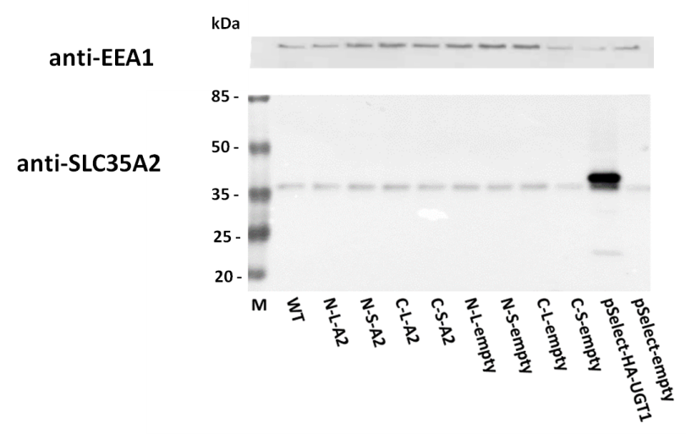
Western blotting analysis of whole cell lysates derived from HEK293T cells transiently overexpressing SLC35A2 variants. WT, wild type; N-L-A2, vector encoding SLC35A2 N-terminally tagged with the large NanoLuc subunit; N-S-A2, vector encoding SLC35A2 N-terminally tagged with the small NanoLuc subunit; C-L-A2, vector encoding SLC35A2 C-terminally tagged with the large NanoLuc subunit; C-S-A2, vector encoding SLC35A2 C-terminally tagged with the small NanoLuc subunit; N-L-empty/N-S-empty/C-L-empty/C-S-empty, empty vetors; pSelect-HA-UGT1, vector encoding SLC35A2 N-terminally tagged with the HA fusion peptide, EEA1 - early endosome antigen 1.

Minor concerns:
The analysis of data could be explained in more detail.
We have added a more detailed explanation of how the data were analyzed.
Reviewer #3:
Major Concerns:
There is a critical control missing from the analysis. The authors should include an irrelevant membrane protein as control, where the control protein is fused to one or both of the split NanoLuc components.

We agree with the Reviewer that a specific, topologically compatible negative control should be included in each experiment. However, design and validation of such control is quite challenging, as the lack of interaction should be confirmed by several independent approaches. Establishment of such a control in our laboratory is still on the way. However, as an alternative, we have included data showing a dose-dependent decrease of luminescence triggered by an extra copy of one of the proteins of interest, whose expression is driven by a strong, constitutive promoter (CMV), thus at the moment of measurement it is present in a large excess comparing with proteins tagged with NanoBiT fragments. This copy competes with its SmBiT- or LgBiT-tagged counterpart in interacting with the second of the proteins of interest and partially abolishes NanoLuc reconstitution. Therefore, a decrease in luminescent signal indicates that the interaction of interest is specific and may be regarded as a sort of control, making the results obtained using HaloTag as a reference more reliable.
Minor Concerns:
1) Why are clear plates used rather than white plates? White plates recommended for measuring luminescence.

We use plates with white sides and clear bottom, as specified in the protocol. The clear bottom allows to monitor the density and morphology of the cells to be transfected.
2) Why is serum exchange/removal done? The NanoLuc live cell substrate reagent works just fine in the presence of serum.

Serum enhances the autofluorescence of furimazine, which is used as a substrate for the detection of the NanoLuc activity. Its removal prior to luminescence readout keeps the luminescence background at a low level, thus improving signal-to-noise ratio.
3) The authors describe that a downside of the methodology is it may not work well with difficult to transfect cells. Though true in a way, the problems with difficult to transfect cells have nothing to do with the use of genetic reporters inside cells. Rather, this is a concern for any cell-based assay that involves transfection for the purpose of expressing recombinant protein in a transient fashion; an additional point here, it felt strange that the authors spoke of how very little expression of the split NanoLuc system is required for successful assays, but at the same time talk about how the system may not work in some settings because of low expression caused by inefficient transfection of difficult cells. The sensitivity of the split NanoLuc should actually be a benefit for difficult to transfect cells because it gives such an intense signal strength.

We agree with the Reviewer that high sensitivity of the approach should be an advantage when using cell lines difficult to transfect. The corresponding fragments were rephrased.

