Tulln, July 10th 2020

REF: JoVE61661, Response to reviewers

Dear Vineeta Bajaj,
We were very happy to receive such positive and constructive feedback on our manuscript entitled “Two-dimensional visualization and quantification of labile, inorganic plant nutrients and contaminants in soil”. Please find a point by point response to all editorial and reviewer comments below.
We look forward to your positive response.

On behalf of all co-authors from Austria,

Yours sincerely,
Stefan Wagner and Jakob Santner

Editorial comments
Changes to be made by the Author(s):
1. Please take this opportunity to thoroughly proofread the manuscript to ensure that there are no spelling or grammar issues. The JoVE editor will not copy-edit your manuscript and any errors in the submitted revision may be present in the published version.
Done.
2. Please format the manuscript as: paragraph Indentation: 0 for both left and right and special: none, Line spacings: single. Please include a single line space between each step, substep and note in the protocol section. Please use Calibri 12 points
Done.
3. Please include a university/institution affiliation for the second author - Christoph Hoefer.
A university affiliation is now provided for Christoph Hoefer.
4. Please define all abbreviations during the first-time use.
Done.
5. Please ensure that the long Abstract is within 150-300-word limit and clearly states the goal of the protocol.
Done. Abstract is 271 words.
6. For in-text formatting, corresponding reference numbers should appear as numbered superscripts after the appropriate statement(s) without brackets.
Done.
7. Please ensure that all text in the protocol section is written in the imperative tense as if telling someone how to do the technique (e.g., “Do this,” “Ensure that,” etc.). The actions should be described in the imperative tense in complete sentences wherever possible. Avoid usage of phrases such as “could be,” “should be,” and “would be” throughout the Protocol. Any text that cannot be written in the imperative tense may be added as a “Note.”
Done.
8. The Protocol should contain only action items that direct the reader to do something.
Done.
9. Please ensure that individual steps of the protocol should only contain 2-3 actions sentences per step.
Done.
10. Please add more details to your protocol steps. Please ensure you answer the “how” question, i.e., how is the step performed?
Done in agreement with the reviewers’ comments (see below).
11. There is a 10-page limit for the Protocol, but there is a 2.75-page limit for filmable content. Please highlight 2.75 pages or less of the Protocol (including headings and spacing) that identifies the essential steps of the protocol for the video, i.e., the steps that should be visualized to tell the most cohesive story of the Protocol.
Done.
12. There is a 10-page limit for the Protocol, but there is a 2.75-page limit for filmable content. Please highlight 2.75 pages or less of the Protocol (including headings and spacing) that identifies the essential steps of the protocol for the video, i.e., the steps that should be visualized to tell the most cohesive story of the Protocol.
See above.
13. Please obtain explicit copyright permission to reuse any figures from a previous publication. Explicit permission can be expressed in the form of a letter from the editor or a link to the editorial policy that allows re-prints. Please upload this information as a .doc or .docx file to your Editorial Manager account. The Figure must be cited appropriately in the Figure Legend, i.e. “This figure has been modified from [citation].”
Appropriate citation has been checked. The representative results (Figure 6) have been reproduced from previous publications, all of which are licensed under CC BY and therefore free to share and adapt under the given terms of conditions (https://creativecommons.org/licenses/by/4.0/).
14. Please include all the Figure Legends together at the end of the Representative Results in the manuscript text.
Done.
15. As we are a methods journal, please ensure that the Discussion explicitly cover the following in detail in 3-6 paragraphs with citations:
a) Critical steps within the protocol
b) Any modifications and troubleshooting of the technique
c) Any limitations of the technique
d) The significance with respect to existing methods
e) Any future applications of the technique
Done.
16. Please remove commercial terms from the text and from the figure and use generic term instead e.g., LA system, LA software etc.
Done.

Reviewers’ comments
Reviewer #1
Manuscript Summary:
This manuscript reports a visual determination and quantification of inorganic contaminants and nutrients using LA-ICP-MS. The authors have achieved sub millimeter level spatial resolution and has effectively applied for to track nutrient and cations contaminant diffusion near the rhizosphere of terrestrial plants. The sampling was done using diffusive gradients in thin films (DGT) using rhizotrons prior to LA-ICP-MS analysis. It appears that many of the related research works have been previously presented in various publications and cited in this manuscript (i.e. see Ref 3 & 25). The novelty of this article is a detailed discussion and potential video presentation of methodological steps related to 2D visualization and quantification of contaminants or nutrients, and their migration through soil-root rhizosphere interface.

The paper is well written and rich content. The experimental design is well thought out. The results are visually very interesting. I believe this contribution is beneficial to the plant and soil science community. However, authors must attend to following queries and revisions so that the quality of the manuscript could be strengthened. This implies that the manuscript needs a major revision.
Thank you for the positive and constructive feedback on our manuscript.
Major & Minor Concerns:
Title: OK
Abstract: This is a fine summary of the article.
Thank you.
Line 43: Give few examples of these nutrient and contaminants.
Few examples for nutrients (e.g. P, Fe, Mn) and contaminants (e.g. As, Cd, Pb) were added.
Line 93: include the charge of the anion: NO3-
Thank you, charge was added.
1. Introduction:
Introduction is well written, analytical problems are defined and relevant bases are covered.
Thank you for the positive feedback.
2. Protocol:
Line 216: Fix_ S1 & S2
The sentences referring to the Supporting Information were combined. The new sentence reads now as follows: “Laboratory procedures for trace element analysis, as well as detailed fabrication procedures of all presented HR-DGT gels are described in the Supporting Information (SI) section S1 and S2.” (lines 213-215)
Line 221: Incorrect formula! Zirconium hydroxide formula is zirconium (IV) hydroxide, Zr(OH)4
Thank you, was corrected to “zirconium (IV) hydroxide” throughout the manuscript.
Line 224: spell out first HR-MBG
Abbreviations for the high resolution (HR)-DGT binding gels (HR-MBG, HR-ABG, and HR-CBG) are now spelled out before their first use.
Line 226: Zr(OH)4 or simply write zirconium (IV) hydroxide here as well as elsewhere.
Corrected, see comment above.
Line 228: What are these solids? Soil alone? anything else?
Yes, we refer to the mass of dry soil in the rhizotron. To clarify this, we adapted the symbol and its definition: “the mass of dry soil in the rhizotron, $m_{d, soil rt}$ (g)” (line 272). In response to the comment of Reviewer #3, we further added equation Eq. 1, showing the exact calculation of $m_{d, soil rt}$ (line 275).
Line 465: Can you do this experiment with 213 nm laser? Must address here. What are the limitations if any?
Yes, the analysis of DGT binding gels can be accomplished using lasers with a wavelength of 213 nm or also 266 nm. This is now explicitly stated in the protocol, lines 471-472: “Alternatively, nanosecond 213 nm or 266 nm solid-state LA systems can be applied36,39-43.” Generally, the laser wavelength is a primary control for the sample penetration depth (Gonzalez et al., 2002), as well as the particle size distribution of the generated aerosol (Guillong et al., 2003). Previous work where laser ablation of NIST glass standards using wavelengths of 193 nm, 213 nm and 266 nm was directly compared, while other LA-ICP-MS parameters were kept constant, demonstrated that 193 nm lasers generate the smallest particle size, leading to decreased noise and thus enhanced precision and stability of the transient signals (Guillong et al., 2003). Considering that the signal stability is a primary contributor to the combined measurement uncertainty (u_{c}) in LA-ICP-MS (Luo et al., 2007; Kreuzeder et al., 2015), the use of 193 nm lasers may improve the analytical precision in DGT ablation analysis. However, the typically ~2-fold higher uncertainty in LA-ICP-MS analysis of DGT gels (relative combined uncertainty (U_{rel}, k = 2) of 34.4-90.5%;) (Kreuzeder et al., 2015) compared to the uncertainty in LA-ICP-MS analysis of NIST glass standards (U_{rel} of 6.4-42.9%, k = 2) (Luo et al., 2007) indicates that the comparatively low signal stability in DGT LA-ICP-MS analysis is dominantly affected by other means such as the complex polymer matrix and inhomogeneities in the embedded resin distribution (Kreuzeder et al., 2015). We therefore suppose that the effect of the laser wavelength on the measurement uncertainty is negligible in LA-ICP-MS analysis of DGT gels.
Line 497: Have you used He gas to enhance the signal? If so what is the volume? What are the limitations and advantages?
Yes, He was used as an aerosol carrier gas from the LA cell to the ICP-MS at a flow rate of 900 mL min⁻¹. The He gas stream was then mixed with an Ar gas stream from the ICP-MS via a two-way Y connector prior to its introduction into the ICP-MS. This was also explicitly stated in the Supporting Information chapter S5 (“Coupling the LA system to the ICP-MS”), lines 506-507 and lines 514-517: “S5.2. Connect N2 as purge gas to ‘N2 PRG GAS IN’ and He as carrier gas to ‘MFC 1 GAS IN’ at the gas panel of the LA system.”; “S5.3. Connect the ‘ONLINE GAS OUT’ He carrier gas flow of the LA system and the ‘NEB’ Ar nebulizer gas flow of the ICP-MS to the ICP interface via a PTFE-coated Tygon tubing (Table of Materials) equipped with a two-way Y connector and a torch adapter fitting to the ICP injector (Figure 5C).” In the associated note (lines 510-512), we provide a reference (Günther and A. Heinrich, 1999) for an in-depth discussion of the limitations and advantages of using He or Ar (or mixtures of both) as carrier gas in LA-ICP-MS: “NOTE: The present protocol uses He as the aerosol carrier gas. Alternatively, Ar can be used as carrier gas. See Günther and Heinrich11 for a detailed discussion of the effects of using either He or Ar as carrier gas.” We provide this information in the Supporting Information to keep the focus of the main manuscript protocol on the practical implementation of the 2D DGT sampling and the operations of the LA-ICP-MS line-scan imaging, assuming an already established LA-ICP-MS coupling.
Line 504-506: Give a typical example calculation here to a novice reader.
A typical example calculation was added. This reads now as follows (lines 510-511): “For example, when setting a spot diameter of 200 µm and a total ICP-MS scan cycle duration of 0.25 s, the scan speed should be ≤800 µm s⁻¹.”
Line 512-513; Include a line pattern in a cartoon figure.
Thank you for pointing out that a schematic representation of the line-scan pattern was missing. We prepared a new Figure (Figure 6), which will help the reader to better understand and visualize the associated dimensions and parameters:
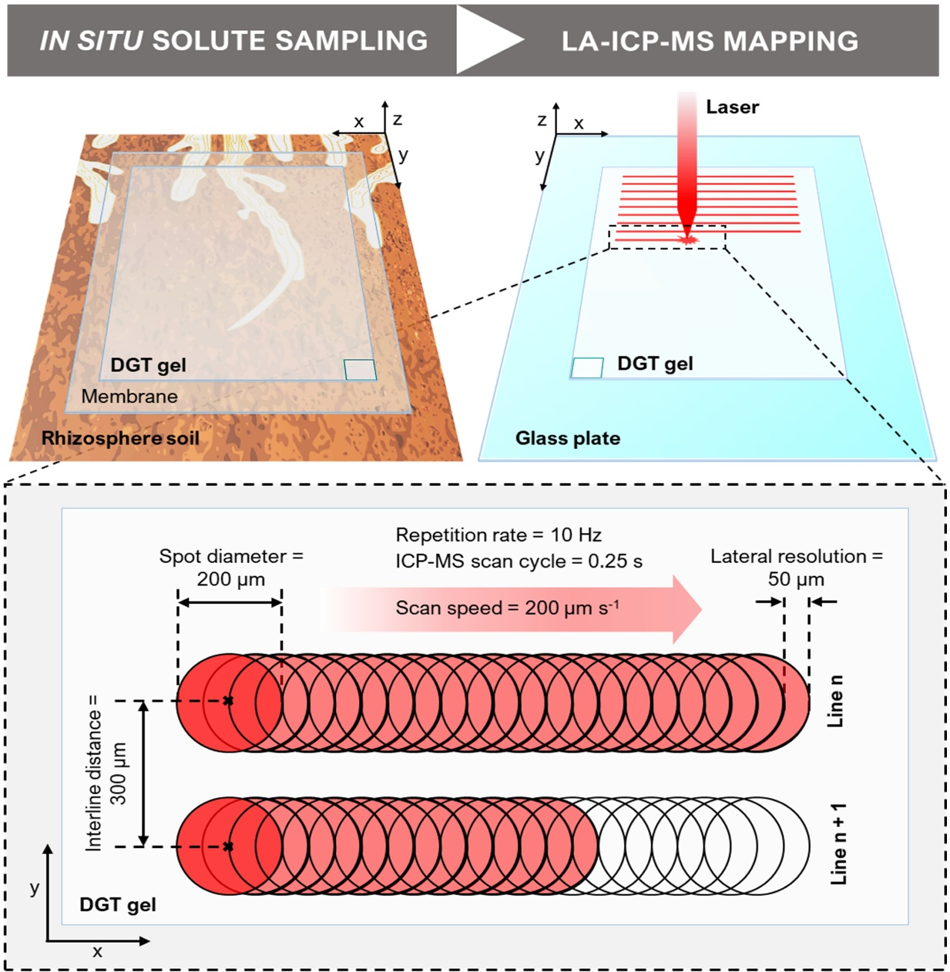
“Figure 6: Schematic of the DGT LA-ICP-MS experimental design (not to scale). The illustration depicts the DGT-based in situ solute sampling in the rhizosphere and the LA-ICP-MS mapping of the solute distribution on the gel surface, including a close-up showing exemplary line-scan dimensions and parameters. Note that the DGT gel is horizontally flipped when transferred from the rhizosphere soil onto the glass plate, as indicated by the position of the rectangle at the bottom corner of the DGT gel.”
Line 520-522: Suggestion: Give an example or show in the video clearly.
An example is now provided in the new line-scan figure (Figure 6).
Line 525: Some LA-ICP-MS literature say 13C is not a good internal standard. Any comments? also and address this issue?
Internal standardization of the analyte signals with a stable reference signal can be effective in improving the analytical precision by correcting for temporal changes in the measurement condition and resulting sensitivity drifts. This is particularly important in DGT ablation analysis because measurement times of individual DGT gels are significant (typically 3-6 h for gel areas of 5-15 cm²) and replicate measurements may be performed over the course of several days or weeks.
Carbon is a major component in biological materials and polymers and therefore one of the most applied elements for signal normalization in LA-ICP-MS (Walas et al., 2014). In DGT gels, carbon represents the major matrix element accounting for ~41 and ~51 mass percent in the polyurethane and polyacrylamide matrix, respectively. Several studies have demonstrated that ¹³C is well applicable for internal normalization in the LA-ICP-MS analysis of the HR-MBG (Kreuzeder et al., 2013; Kreuzeder et al., 2018; Wagner et al., 2020), HR-ABG (Guan et al., 2015) and HR-CBG gels (Gao and Lehto, 2012; Lehto et al., 2012; Williams et al., 2014; Hoefer et al., 2015; Lehto et al., 2017). The approach gives relative standard deviations (RSD) for ¹³C over 10 mm line-scan ablations of typically ~5% (S. Wagner, J. Santner and T. Prohaska, manuscript in preparation).
An alternative approach is to use dual-layer DGT gels where a second gel layer underneath the actual sample gel is loaded with known amounts of internal standard elements (Warnken et al., 2004a). Laser parameters are adjusted to ensure penetration of the laser beam through the first gel layer and thus ablation of both gel layers simultaneously. Using this approach, Warnken et al. (2004a) evaluated the use of Sc, In, Ba, La, Ce and Tb as internal standards. Of the investigated elements, Ba showed the best precision (≤10%) but could not be used as an internal standard due to its relatively high and variable presence in natural soils and sediments. Therefore, ¹¹⁵In was applied for internal standardization, showing a substantially higher RSD (~10%) compared to ¹³C, indicating that the preparation of spiked dual-layer DGT gels is unnecessarily complex. Moreover, the dual-layer DGT approach requires spot ablation to ensure penetration through the sample gel into the internal standard gel. Line-scan ablation is not possible, thereby leading to a decreased lateral resolution, decreased sensitivity, increased limits of detection and a 30% increase of the measurement time and gas consumption of the analysis (Gao and Lehto, 2012). Moreover, the introduction of additional sample preparation steps will generate additional sources of uncertainty in DGT ablation analysis.
In conclusion, internal normalization using ¹³C is the method of choice in high resolution DGT LA-ICP-MS analysis to date. The different approaches for internal normalization in DGT LA-ICP-MS analysis have been discussed in detail in previous reviews on the DGT LA-ICP-MS technique (Santner et al., 2015; Santner and Williams, 2016). We therefore prefer not to re-address this issue in this method protocol.
Line 560-561: Why explain? How to minimize these laser fluency variations? Explain to the audience.
The laser fluence, or energy density, is the total energy contained within the laser light per unit area (J cm⁻²) and thus determines the energy arriving at the sample surface. The stability of the laser fluence thereby directly reflects the stability of the material ablation process, i.e. the higher the variation in laser fluency, the higher the variation in the amount of ablated material. If the laser fluency would be highly variable, this would either indicate a degraded laser source and/or mirror system, leading to variable energy densities arriving at the sample surface. Laser fluency variations can be effectively minimized by regular technical service of the laser source and mirror system. To provide this context for the reader, we added the following sentence to the protocol, lines 566-568: “4.2.15. Monitor the laser fluence (J cm-2) during analysis to assess the laser stability. If the fluence varies largely, abort the analysis and verify that the laser source and/or its mirror system are fully functional.”
Line 588: ... intensity ratio... This ratio is a unitless (a dimensionless quantity) parameter
Thank you, the unit was removed.
Line 589: …compute the calibration function (y =ax + b) using a linear regression…
Thank you, “(y = ax + b)” was added.
Line 594: … notice cps cps-1 cancels out! Thus, a unitless parameter_ Fix.
Thank you, the unit was removed.
Line 615-618: Include a cartoon of this scan depicting these dimensions and conditions.
A line-scan cartoon figure (Figure 6) was added. The dimensions and conditions in the text were slightly adapted to match with those shown in Figure 6.
Representative Results/Discussion
Although, it appears that the material has been presented in various publications previously but this is a good discussion for a "how to do type video journal article." It also discusses advantages, limitations, artifacts and practical hints to improve rhizotron studies, including potential pitfalls.
Line 859: Correct this dimensionless parameter: Pb images show 13C-normalized intensity ratio (cps cps-1).
Thank you, the unit was removed.
Line 861; include copyright clearance numbers and citations clearly here: …. are reproduced from the cited articles (Refs) licensed under CC-BY
Thank you, citations were added to make this clearer.
Figs. 2 & 3 label important devices/parts in Figs 2&3 just like you did in Fig. 1
Important components in Figures 2, 3 and 4 are now labelled:
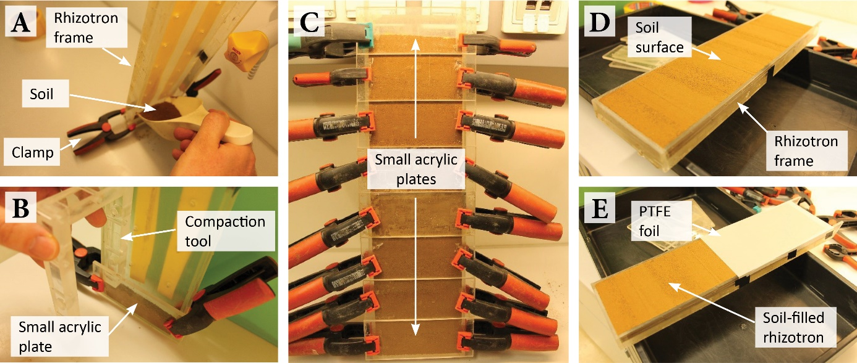
“Figure 2: Rhizotron assembly and filling to grow plants in soil for solute imaging in the rhizosphere. (A) Soil filling into the rhizotron. (B) Compaction of the filled soil using a compaction tool. (C) Soil-filled rhizotron with small acrylic plates and clamps. (D) Soil-filled rhizotron with exposed soil surface. (E) Soil-filled rhizotron with a protective PTFE and plastic foil cover.”
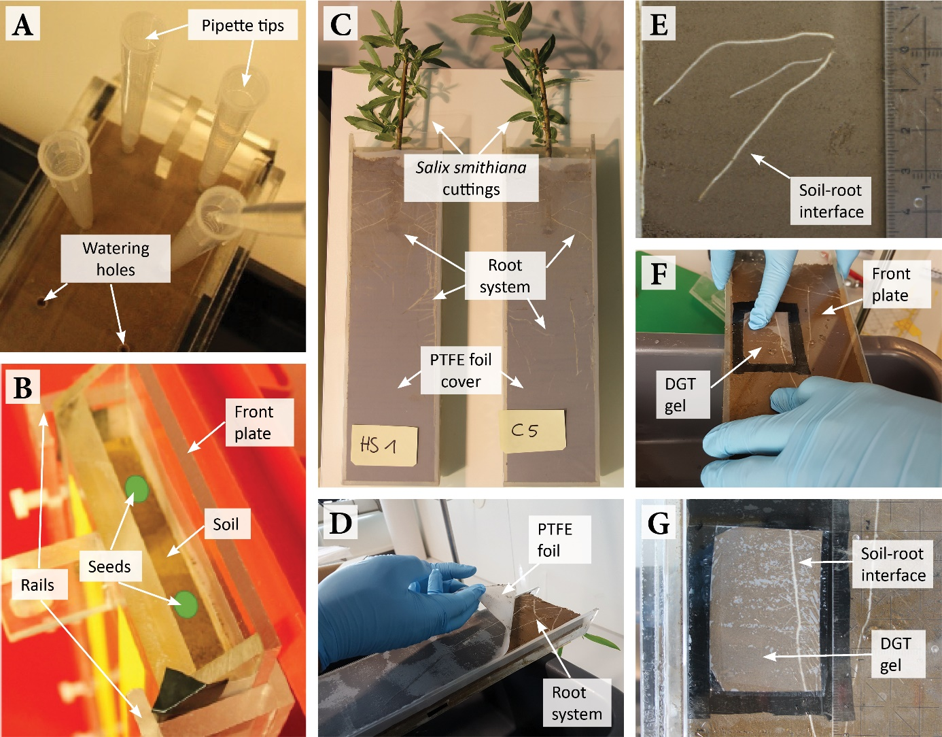
“Figure 3: Rhizotron handling and DGT gel application. (A) Soil watering using 10 mL pipette tips in the watering holes in the back of the rhizotron. (B) Planting of seedlings (indicated as green spots) into the soil-filled and closed rhizotron. (C) Rhizotron planted with Salix smithiana cuttings and removed front plate and plastic foil cover. (D) Carefully peeling off the PTFE foil cover before DGT gel application. (E) High-resolution photo of the soil-root interface ROI. (F) Application of the front plate equipped with the DGT gel onto the rhizotron. (G) Photo of the ROI with the DGT gel applied during solute sampling.”
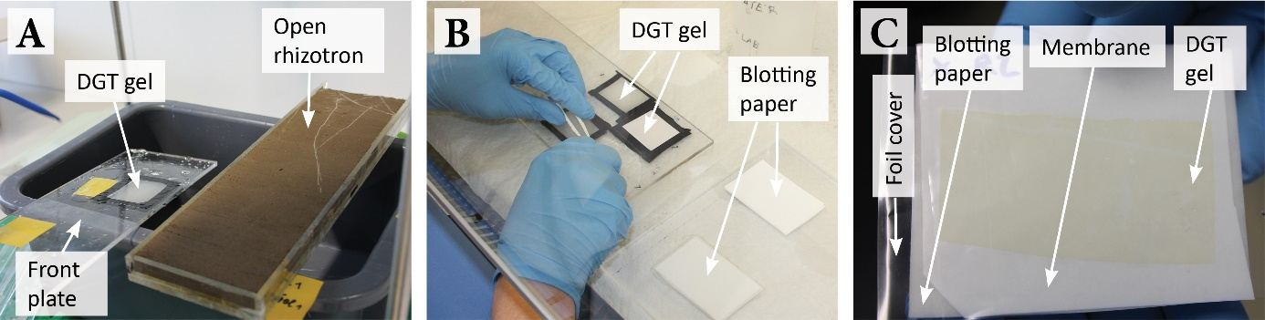
“Figure 4: DGT gel retrieval and preparation for drying upon solute sampling. (A) Plate with the DGT gel and rhizotron directly after solute sampling. (B) Retrieval of the DGT gel from the plate in a laminar flow bench. (C) Stack of gel blotting paper/polyethersulfone membrane/DGT gel/plastic foil cover for gel drying. Note that the gel is slightly colored after its deployment on soil.”
Reviewer #2
Manuscript Summary:
In this manuscript, the authors described an effective method to visualize and quantify inorganic nutrient and metal elements in soil adjacent to plant roots by combing the technologies of DGT and a highly sensitive LA-ICP-MS. The details for making DGT gels, cultivating plant, sampling of solute and chemical analysis were well explained. This method can be widely used to visually quantify inorganic elements in various fields.
Thank you for the positive feedback.
Minor Concerns:
How can you ensure the samples you concerned were totally bound to the gel?
Quantitative sampling of labile anionic and cationic solutes by the presented DGT gels has been characterized and validated in detail in the original gel development publications (Warnken et al., 2004b; Kreuzeder et al., 2013; Guan et al., 2015). This published data shows linear accumulation of the target solute species over time if the resin binding sites in the DGT gels are not saturated. This aspect is explicitly stated in the Supporting Information, lines 335-336: “Verify that the total gel analyte loading (i.e. $\sum{Γ_{DGT}}$) of the highest calibration standard is well below the total analyte binding gel capacity (≤80 %).” Thus, we ensure quantitative solute sampling by maintaining the total DGT gel analyte loading below 80 % of its total analyte binding capacity.

Reviewer #3
Manuscript Summary:
The authors describe in detail the method for 2D visualization of elements (e.g., inorganic nutrients and contaminants) in soil using diffusive gradients in thin films (DGT) and laser ablation inductively coupled plasma mass spectrometry (LA-ICP-MS). The spatial resolution is sub-mm, which enables inspection of the rhizosphere. Images can be quantitative by relative normalization within the sample or compared to an external standard, creation of which is described within the text. It appears that a reader could follow these steps and attain the results suggested. This detailed method and photographs will be greatly helpful for others that would like to use DGT. The method can complement other methods/applications described in the literature, and will be useful for investigating soil rhizosphere questions.
Thank you for the positive feedback.
Major Concerns:
In regard to controls, is there a way to check that DGT is working as anticipated (or in contrast, did not work correctly)? Are there checkpoints along the way that authors can suggest to assure the method (e.g., preparation of gels) was done correctly (e.g., to mimic soil/nutrient diffusion system)? For example, if at the end the images do not produce expected are there ways the reader could assess
that they performed the method correctly (i.e., discern error made in the method vs. result of the specific soil system).
The correct chemical functionality of the DGT imaging technique can be verified by several means:
1) Correct gel preparation can be simply checked by visual inspection of the fabricated gels for areas of inhomogeneous material distribution. If prepared correctly, the binding gels enable quantitative sampling of the target solute species if the gel loading is kept below capacity thresholds (Davison, 2016).
2) Quantitative solute sampling is verified during the DGT standard preparation experiment as outlined in the Supporting Information, chapter S4 (“Preparation of DGT LA-ICP-MS calibration standards”). Here, gel standards are prepared in quadruplicates by controlled loading of the DGT gels with the target analytes following the DGT theory based on Fick’s first law of diffusion (Davison, 2016). The analyte loading is then assessed in three gel replicates by gel elution (HR-ABG and HR-CBG) or complete digestion (HR-MBG) followed by analyte quantification using an established analytical technique (e.g. ICP-MS) in combination with metrological validation using certified liquid reference materials. If the experimentally determined gel loading differs largely from the targeted gel loading, this indicates that the DGT gels are not working correctly. The remaining gel replicate is dried and then used as a matrix-matched reference gel with known analyte loading for LA-ICP-MS analysis.
3) Correct sample preparation (drying, mounting on glass plates) for LA-ICP-MS analysis can be verified by testing the analytical performance of standard gels. If prepared correctly, the detected LA-ICP-MS line-scan signal intensity of gel standards should be clearly distinguishable from the gas blank and method (gel) blank background signal, especially for high analyte loadings. If unable to obtain a signal that can be distinguished from the background, the reader must ensure that all protocol steps were performed correctly. Sometimes, the DGT gel is accidentally flipped after solute sampling with the loaded, soil-exposed side facing towards the glass plate rather than the laser beam, resulting in low signal intensities and erroneously flipped features in the final solute flux image.
4) Detectability of solutes bound to the gel from a specific soil can be tested using bulk DGT piston sampling in preliminary experiments (Hooda et al., 1999; Smolders et al., 2020).
This information is now provided in the Discussion, lines 852-874: “Another important consideration is the chemical functionality of the fabricated DGT binding gel. By following the protocol, thin gels with a homogeneous distribution of binding phases are obtained. If the gels have areas of inhomogeneous material distribution (e.g. holes in the gel or aggregates of binding phases) these areas need to be removed or, if too extensive, the gel fabrication protocol needs to be repeated. If prepared correctly, the gel must be able to bind the solutes that diffuse into the gel immediately and quantitatively27, which is determined by the specific gel binding capacity. While exceeding the gel capacity is less problematic in uncontaminated soils, it should be considered in metal-contaminated soils and saline soil environments. Thus, if very high quantities of labile nutrient/contaminant species are expected in the target soil environment, preliminary tests should be performed. For estimating expected DGT loadings, bulk soil DGT piston sampling followed by gel elution and wet-chemical analysis can be applied15,49. If necessary, DGT deployment times may be adjusted to reduce the gel contact time and thus avoid gel saturation above capacity thresholds. Preliminary tests can also be helpful to verify gel functioning and to adjust contact times if very low solute loadings are expected. Quantitative sampling of the target solute species can be further verified by controlled loading of DGT gels in the preparation of DGT LA-ICP-MS calibration standards. The gel standard provides a matrix-matched reference gel analyte loading that can be used to assess if the sample gel loading determined by LA-ICP-MS is within the expected range. If unable to obtain a signal which is different from the gas and method blank background noise, the operator must ensure that all protocol steps were performed correctly. Sometimes, the DGT gel is accidentally flipped after solute sampling with the soil-exposed, loaded side facing towards the glass plate rather than the laser beam, resulting in low signal intensities and erroneously flipped features in the final solute flux images.”
Also, I realize method time can vary, but it could be helpful to outline approximate times for general steps to provide context for the reader. E.g., this is a method you could implement in a day, a week, over the course of a month; this step may take several hours. A general timeline (e.g., a table or figure) could be helpful.
A new table was prepared showing approximate times for general steps of the method. The table (Table 1) was included in the Representative Results, lines 647-648: “Approximate times for general steps of the protocol are presented in Table 1. [Place Table 1 here]”
“Table 1: Approximate times for general steps of the DGT LA-ICP-MS technique.”
DGT gel fabrication | Plant cultivation | In situ solute sampling | LA-ICP-MS solute flux mapping
HR-MBG  1 week | Soil preparation  1 week | Gel application  1 hour per gel | Sample preparation  1 hour per gel
HR-ABG  3 days | Rhizotron assembly  2 hours per replicate | Solute sampling period  variable, typically 24 hours | LA-ICP-MS analysis  1 day per gel
HR-CBG  3 days | Plant growth  dependent on study | Gel retrieval  1 hour per gel | Data processing  4 hours per gel
 |  | Gel drying  2-3 days | Image generation  30 min per image

I made suggestions for additional methods and references to include in introduction/discussion to provide context for the reader.

Specific comments:
Line 140: DGT is not the "only technique capable of multi-element mapping of nutrients and contaminants". It would be worth mentioning the high-resolution elemental mapping method of laser-induced breakdown spectroscopy (LIBS) [Ilhardet et al. 2019, SBB], perhaps in the prior paragraph, and rephrasing this line for clarification. [Similar comment for lines 732-735, DGT may be one of the few but is not the only method.]
Thank you for highlighting that this point was not elaborated in sufficient detail. The sentence in line 140 was misleading, as it was not our intention to state that DGT is “the only technique capable of multi-element mapping of nutrients and contaminants”. Yet, the DGT technique is unique in its ability to selectively sample labile (i.e. reversibly adsorbed) solute species in situ and at high spatial resolution while preserving the original solute distribution in the intact soil-rhizosphere-root system (Oburger and Schmidt, 2016; Santner and Williams, 2016). To the best of our knowledge, this is not possible with other solute sampling methods available to date. The combination of the DGT-based passive sampling approach with chemical mapping by LA-ICP-MS further enables the targeted 2D visualization of these labile, plant-available element fractions. Thereby, the DGT LA-ICP-MS technique differs from the method presented by Ilhardt et al. (2019), where LIBS was used to analyze total element distributions in soil-root samples extracted from rhizotrons by sampling soil cores followed by careful sample preparation to preserve the natural element distribution. This method is well suited to be combined with the DGT LA-ICP-MS technique, complementing the DGT solute flux and elemental speciation data with detailed information on mineralogy and solid phase trace element patterns in the soil-rhizosphere-root system.
To clarify the targeted solute sampling approach by DGT and its distinction from other techniques, we corrected the corresponding paragraph in the main manuscript, lines 147-150: “The only technique capable of targeted 2D sampling of multiple nutrient and contaminant solutes at high spatial resolution is the diffusive gradients in thin films (DGT) technique, a sink-based sampling method that immobilizes labile trace metal(loid) species in situ on a binding material embedded in a hydrogel layer26,27.”
The method of Ilhardt et al. (2019) was added (Ref 25) to the introduction, lines 142-145, as another example for chemical imaging techniques applied in rhizosphere research: “More recently, P. D. Ilhardt, et al. 25 presented a novel approach using laser induced breakdown spectroscopy (LIBS) to map 2D total multi-element distributions in soil-root core samples where the natural element distribution was preserved by careful sample preparation.”
Line 243: It could be helpful to provide references by other authors (some may have already been cited elsewhere in the manuscript) that show rhizotron setups, as designs can vary. The diagrams in this manuscript for how to craft rhizotrons will make it a lot easier for future readers to emulate the method.
The review of Luster et al. (2009) was added. In this reference several examples for different rhizotron studies are provided.
Line 273: "calculate the weight of dry soil in the rhizotron". How is this calculated?
The calculation of the mass of dry soil in the rhizotron, $m_{d, soil rt}$, is now explicitly stated in equation Eq. 1, which was added and reads as follows: “(Eq. 1) $m_{d, soil rt}=m_{m, soil rt}-m_{m, soil rt}×w_{soil}$” (line 275). Here, $m_{m, soil rt}$ is the mass of moist soil in the rhizotron, and $w_{soil}$ is the gravimetric water content of the pre-moistened soil.
Line 359: Any suggestions on how to account for the weight of the plant biomass?
Compared to the weight of soil in the rhizotron, long-term experience from our group has shown that the weight of the plant biomass is typically not significant in rhizotron studies. However, if significant, the weight of plant biomass could be accounted for by growing plants in separate rhizotron replicates and periodic harvest of the tissues at defined intervals. This information is now provided in the protocol, lines 360-363: “Note: If plants are grown for extended periods and the plant biomass is expected to substantially decrease the amount of water added to the rhizotron by the proposed method, account for the weight of the plant biomass by growing plants in separate rhizotron replicates and harvesting and weighing the plant tissues at defined intervals.”
Line 732-735: See comment on Line 140. DGT may be one of the few but is not the only method.
See our response above. The paragraph was corrected for clarification (lines 821-825): “The solute imaging protocol presented here is a versatile method to visualize and quantify nutrient and contaminant fluxes in soil environments. It is unique in its capability to generate multi-element, 2D images of labile solute species in the soil/rhizosphere environment at sub-mm resolution, exceeding the achievable spatial resolution of alternative methods for measuring solute gradients in the rhizosphere substantially4.”
Line 785: Another complementary diffusion-based imaging example to include is the fluorescent indicator imaging technique that was recently published: Lin et al. 2020, SBB, Non-destructive spatial analysis of phosphatase activity and total protein distribution in the rhizosphere using a root blotting method. It looks like this method would be a helpful addition to the introduction (perhaps as another method in lines 129-138).
Thank you for this reference. The method by Lin et al. (2020) was added (Ref 24) to both the introduction and the discussion:
Introduction, lines 135-137: “Planar optodes are capable of imaging important soil chemical parameters such as pH and pO217-19, and enzyme activity or total protein distributions can be mapped using soil zymography20-23 and fluorescent indicator imaging based on root blotting methods24.”
Discussion, lines 890-893: “In addition to DGT-only applications, the method can be combined with other, diffusion-based imaging techniques like planar optodes3,33,42,43,48,51 and zymography20-24 (C. Roschitz, W.W. Wenzel, J. Santner et al., under review), and may be developed further for including additional elements and soil parameters.”
Line 786: Rather than self-citing unpublished data on zymography, citing published literature by other authors would be appropriate. Work by Spohn et al. 2013 (ref 19), and there is additional literature since then using zymography, for example, Heitkotter and Marschner 2018, SBB.
Our intention was to cite a study, where DGT LA-ICP-MS solute imaging has been actually combined with zymography to enable simultaneous multi-parameter visualization. The cited manuscript was reviewed by Soil Biology and Biochemistry and we are currently working on revising the paper for publication in SBB. We will resubmit this manuscript shortly. Therefore, we would like to keep this citation. However, works by Spohn et al. (2013), Spohn and Kuzyakov (2014), Heitkötter and Marschner (2018), Guber et al. (2019), and Lin et al. (2020) (Refs 20-24) are now included in the Discussion, lines 890-893: “In addition to DGT-only applications, the method can be combined with other, diffusion-based imaging techniques like planar optodes3,33,42,43,48,51 and zymography20-24 (C. Roschitz, W.W. Wenzel, J. Santner et al., under review), and may be developed further for including additional elements and soil parameters.”
Minor Concerns:
Line 291: Define PTFE when first mentioned.
Corrected to: “polytetrafluoroethylene (PTFE)” (line 291)
Line 373: At the first mention of "laminar flow bench", it would be helpful to include the purpose of this specifically. For example, Supplemental line 56: "or any other dust- and metal-free environment."
Corrected to: “Transfer the plate into a laminar flow bench (Table of Materials) or any other dust- and metal-free environment, unmarked side facing up.” (lines 377-378)
Line 569: Define "cps" unit.
The unit “cps” was defined at its first appearance in the protocol, i.e. before line 569. The corresponding text (lines 562-563) reads as follows: “4.2.14. Click ‘Run’ in the ‘Run experiment’ window to start the line-scan analysis and monitor the raw signal intensity in counts per second (cps) for each isotope on the ICP-MS in real time.”
Figure 6: Be aware that for figure resolution, the text associated with the color scales was difficult to read. However, opening up the .jpg file directly was fine (this more high-resolution image would be better for the final version).
Thank you for the information, the text font was slightly enlarged for better readability:
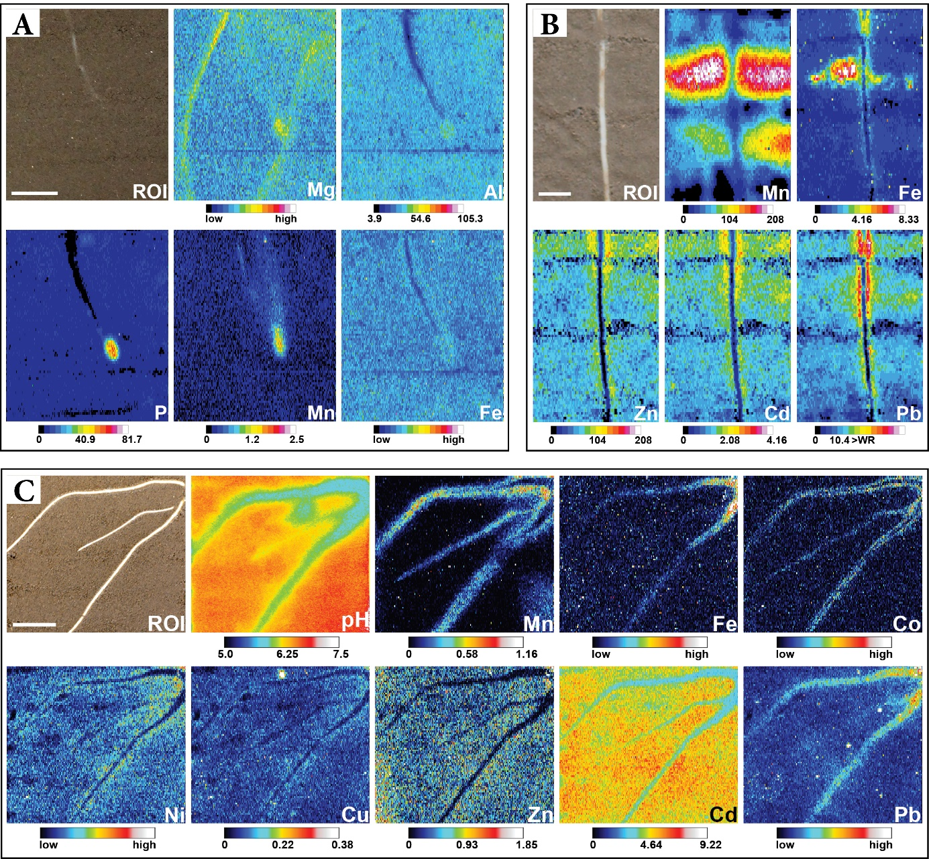
“Figure 7: Sub-mm 2D distribution of labile nutrient and contaminant species across soil-root interfaces. (A) Distribution of anionic P and cationic Mg, Al, Mn and Fe solutes around a young F. esculentum root. Co-localized sampling of anionic and cationic solutes was achieved using HR-MBG for 24 h at a soil water saturation of ~75 % WHC. The Al, P and Mn images are displayed as calibrated fDGT values (pg cm-2 s-1), whereas Mg and Fe images show 13C-normalized intensities. Scale bar represents 1 cm. Adapted from A. Kreuzeder, et al. 48. (B) Distribution of Mn, Fe, Zn, Cd and Pb around a S. smithiana root grown in soil moderately contaminated with Zn, Cd and Pb. Cationic trace metal solutes were sampled using HR-CBG for 20 h at a soil water saturation of ~80 % WHC. All images are displayed as calibrated fDGT values (pg cm-2 s-1). Scale bar represents 0.5 mm. Adapted from C. Hoefer, J. Santner, M. Puschenreiter and W. W. Wenzel 3. (C) Distribution of pH and multiple cationic solutes around S. smithiana roots grown in soil spiked with Cd. Co-localization of pH and solute dynamics was achieved using a modification of the HR-MBG protocol, allowing for simultaneous solute sampling and planar optode imaging33. The Mn, Cu, Zn and Cd images are displayed as calibrated fDGT values (pg cm-2 s-1), whereas Fe, Co, Ni and Pb images show 13C-normalized intensities. Scale bar represents 1 cm. Adapted from C. Hoefer, J. Santner, S. M. Borisov, W. W. Wenzel and M. Puschenreiter 33. The presented figures are reproduced from the cited articles3,33,48 licensed under CC BY.”
Reviewer #4
Manuscript Summary:
The manuscript describes a method for visualizing the flow of plant nutrients and contaminants in soils using diffusive gradients in thin films and LA-ICP-MS. The method is well described and detailed, and the results are interesting.

Major Concerns:
None.
Thank you for the positive feedback.
Minor Concerns:
Line 746. I believe that the authors meant "less compacted" than "compacted less".
Thank you. The grammatical typo was corrected.

References used in this response letter
Davison, W., 2016. Diffusive Gradients in Thin-Films for Environmental Measurements. Cambridge University Press, Cambridge.

Gao, Y., Lehto, N., 2012. A simple laser ablation ICPMS method for the determination of trace metals in a resin gel. Talanta 92, 78-83.

Gonzalez, J., Mao, X.L., Roy, J., Mao, S.S., Russo, R.E., 2002. Comparison of 193, 213 and 266 nm laser ablation ICP-MS. Journal of Analytical Atomic Spectrometry 17, 1108-1113.

Guan, D.-X., Williams, P.N., Luo, J., Zheng, J.-L., Xu, H.-C., Cai, C., Ma, L.Q., 2015. Novel Precipitated Zirconia-Based DGT Technique for High-Resolution Imaging of Oxyanions in Waters and Sediments. Environmental Science & Technology 49, 3653-3661.

Guillong, M., Horn, I., Günther, D., 2003. A comparison of 266 nm, 213 nm and 193 nm produced from a single solid state Nd:YAG laser for laser ablation ICP-MS. Journal of Analytical Atomic Spectrometry 18, 1224-1230.

Günther, D., A. Heinrich, C., 1999. Enhanced sensitivity in laser ablation-ICP mass spectrometry using helium-argon mixtures as aerosol carrier. Journal of Analytical Atomic Spectrometry 14, 1363-1368.

Hoefer, C., Santner, J., Puschenreiter, M., Wenzel, W.W., 2015. Localized metal solubilization in the rhizosphere of Salix smithiana upon sulfur application. Environmental Science & Technology 49, 4522-4529.

Hooda, P.S., Zhang, H., Davison, W., Edwards, A.C., 1999. Measuring bioavailable trace metals by diffusive gradients in thin films (DGT): soil moisture effects on its performance in soils. European Journal of Soil Science 50, 285-294.

Ilhardt, P.D., Nuñez, J.R., Denis, E.H., Rosnow, J.J., Krogstad, E.J., Renslow, R.S., Moran, J.J., 2019. High-resolution elemental mapping of the root-rhizosphere-soil continuum using laser-induced breakdown spectroscopy (LIBS). Soil Biology and Biochemistry 131, 119-132.

Kreuzeder, A., Santner, J., Prohaska, T., Wenzel, W.W., 2013. Gel for simultaneous chemical imaging of anionic and cationic solutes using diffusive gradients in thin films. Anal Chem 85, 12028-12036.

Kreuzeder, A., Santner, J., Scharsching, V., Oburger, E., Hoefer, C., Hann, S., Wenzel, W.W., 2018. In situ observation of localized, sub-mm scale changes of phosphorus biogeochemistry in the rhizosphere. Plant and Soil.

Kreuzeder, A., Santner, J., Zhang, H., Prohaska, T., Wenzel, W.W., 2015. Uncertainty evaluation of the diffusive gradients in thin films technique. Environ Sci Technol 49, 1594-1602.

Lehto, N.J., Davison, W., Zhang, H., 2012. The use of ultra-thin diffusive gradients in thin-films (DGT) devices for the analysis of trace metal dynamics in soils and sediments: a measurement and modelling approach. Environmental Chemistry 9, 415-423.

Lehto, N.J., Larsen, M., Zhang, H., Glud, R.N., Davison, W., 2017. A mesocosm study of oxygen and trace metal dynamics in sediment microniches of reactive organic material. Scientific Reports 7, 11369.

Luo, Y., Gao, S., Longerich, H.P., Günther, D., Wunderli, S., Yuan, H.-L., Liu, X.-M., 2007. The uncertainty budget of the multi-element analysis of glasses using LA-ICP-MS. Journal of Analytical Atomic Spectrometry 22, 122-130.

Luster, J., Göttlein, A., Nowack, B., Sarret, G., 2009. Sampling, defining, characterising and modeling the rhizosphere—the soil science tool box. Plant and Soil 321, 457-482.

Oburger, E., Schmidt, H., 2016. New Methods To Unravel Rhizosphere Processes. Trends Plant Sci 21, 243-255.

Santner, J., Larsen, M., Kreuzeder, A., Glud, R.N., 2015. Two decades of chemical imaging of solutes in sediments and soils--a review. Anal Chim Acta 878, 9-42.

Santner, J., Williams, P.N., 2016. Measurement at High Spatial Resolution. In: Davison, W. (Ed.), Diffusive Gradients In Thin-Films For Environmental Measurements. Cambridge University Press, Cambridge, 174-215.

Smolders, E., Wagner, S., Prohaska, T., Irrgeher, J., Santner, J., 2020. Sub-millimeter distribution of labile trace element fluxes in the rhizosphere explains differential effects of soil liming on cadmium and zinc uptake in maize. Science of The Total Environment 738, 140311.

Wagner, S., Hoefer, C., Puschenreiter, M., Wenzel, W.W., Oburger, E., Hann, S., Robinson, B., Kretzschmar, R., Santner, J., 2020. Arsenic redox transformations and cycling in the rhizosphere of Pteris vittata and Pteris quadriaurita. Environmental and Experimental Botany 177, 104122.

Walas, S., Miliszkiewicz, N., Telk, A., 2014. Current approaches to calibration in LA-ICP-MS analysis. J. Anal. At. Spectrom. 30.

Warnken, K.W., Zhang, H., Davison, W., 2004a. Analysis of Polyacrylamide Gels for Trace Metals Using Diffusive Gradients in Thin Films and Laser Ablation Inductively Coupled Plasma Mass Spectrometry. Analytical Chemistry 76, 6077-6084.

Warnken, K.W., Zhang, H., Davison, W., 2004b. Performance characteristics of suspended particulate reagent-iminodiacetate as a binding agent for diffusive gradients in thin films. Anal Chim Acta 508, 41-51.

Williams, P.N., Santner, J., Larsen, M., Lehto, N.J., Oburger, E., Wenzel, W., Glud, R.N., Davison, W., Zhang, H., 2014. Localized flux maxima of arsenic, lead, and iron around root apices in flooded lowland rice. Environmental Science & Technology 48, 8498-8506.

