Reviewer #1:
Manuscript Summary:
In the protocol "Preparing and injecting embryos of Culex mosquitoes to generate null mutations using CRISPR/Cas9", the authors present a clear protocol for the use of CRISPR/Cas9 in Culex pipiens (and Culex quinquefasciatus). Overall, the protocol is comprehensive and detailed. City and State/Country information for the sourcing of materials would be helpful for the final table. In addition, the strain of Culex pipiens used must be included. Also, information on the strain sharing needs to be included as to where the mosquitoes can be sourced. Below are a few minor suggestions/comments that will hopefully strengthen an already well-written protocol.
We thank this reviewer for his/her insightful comments and critiques. We have added the City, State and Country information for sourcing materials into the Excel table. We also now indicate the strain of mosquitoes that we used and where they are housed in the last paragraph of the introduction (lines 101-104).
Major Concerns:
No major concerns.
Minor Concerns:
1.1 - CHOP CHOP is great, but maybe cite it as an example of good design programs. In our lab we've sometimes had better success manually designing sgRNAs.
We appreciate the suggestion and have modified statement 1.1 to reflect that manually designing gRNAs is an option and that there are other free programs available.
1.3.1 - I would recommend against stating that ordering sgNRA is the most expensive. Genscript now offers 2ng of sgRNAs for <$30 (academic), this is actually cheaper than the cost of a forward oligo and synthesis using the NEB ENgen kit with a cleanup column.
Thank you for the tip! We have added Genescript as an option and removed the phrase that directly ordering gRNAs is the most expensive option.
1.3.2 - gRNAs are not made by PCR amplification, the templates for isothermal synthesis are. In addition, it might read confusingly for some people since in vitro synthesis is usually driven by the T7 viral promoter, or SP6.
We agree that this is a very helpful and important distinction. We have now modified this section to state gRNAs can be created in the lab using PCR amplification to generate the templates for subsequent isothermal synthesis, and then refer readers to the Port et al. and Kistler et al. manuscripts for details.
1.3.3 - In cases where a gene reference is given, please also indicate the CPIJ accession from Vectorbase.
We agree with this statement, but do not mention any specific gene in this portion of the protocol.
1.4.1 - Same comment as previously regarding cost. For a protocol, simply list the possible sources of reagents, let the user determine expense.
Thank you. We have removed the statement regarding the expense.
1.4.2 - This comment links with (1.3.3), if the use of on-plasmid sgRNA expression is considered for the protocol, then alternatives to the use of Cas9 protein should also be given, eg/ mRNA, plasmid
We agree and do state provide information on how researchers might use a plasmid to express the Cas9 protein. We now also describe how researches might inject Cas9 mRNA into embryos without getting into the details of which specific promoters work best in each species (now section 1.4.3).
1.4.3 - Cas9 is not delivered by a plasmid unless the Cas9 protein contains a sequence binding motif present on the plasmid. Consider "Cas9 may also be expressed in vivo through plasmid-based expression" or similar. Also, the vas2 promoter is characterized for An. gambiae, while in Ae. aegypti, the vasa promoter region contains a large 5'-UTR intron (>10KB), Incidentally, in our lab, we have built and used polyubiquitin Cas9 constructs (with large T antigen SV40 terminator), it is functional in embryo for knock-ins, so it must work, perhaps not as efficiently as protein for indels, but for knock-in, it may be advantageous to have plasmid-based expression of Cas9 since the donor also needs to be present at the time of cleavage (protein has NLS, plasmids rely on nuclear membrane dissolution). The timing of protein vs plasmid helper for knock-in may be due to many factors. Unless you have a characterized promoter for Cas9 expression on plasmid in Cx. quinquefasciatus, it may be best to simply mention plasmid-based expression without the discussion of promoters in other species, or to avoid mention of plasmid entirely.
Thank you very much for this important distinction. We have modified what is now 1.4.4 to state “Cas9 protein may be expressed in vivo Cas9 protein may also be expressed in vivo through plasmid-based expression. In this case, it is best to have the expression of Cas9 on the plasmid driven by an embryonic promoter that has been well-characterized in the target species.
Note: To date, embryonic promoters have not been well-characterized in Culex mosquitoes, and therefore injecting purified protein or Cas9 mRNA is recommended.”
1.5.1 - Indicate that these are final concentrations.
Thank you. We have done this.
Line 163 - City and State/Country for Sutter Instruments.
Line 198 - Company, City and State/Country for PC-10
Thank you. We have included the location for both Sutter Intstruments and Narishige Intl., which is the company that makes the PC-10.
Section 2 - Are the capillary tubes treated prior to pulling?
The capillary tubes are siliconized before they are pulled, and we have indicated this in the text. Thank you for asking!
2.3.2 - Requires an actual volume (or estimate). Note that the manual for the Sutter BV-10 recommends 1-2 drops, 13 drops is roughly 450 µL, which is considerably more than 'a little extra'.
We thank the reviewer for this comment and have indicated that the approximate value of pedestal oil is 520 uL. We have also included a photo of the BV-10 manual below, indicating that the manual does recommend applying 10 drops of oil. Therefore, adding 13 drops is slightly more than the protocol recommends.
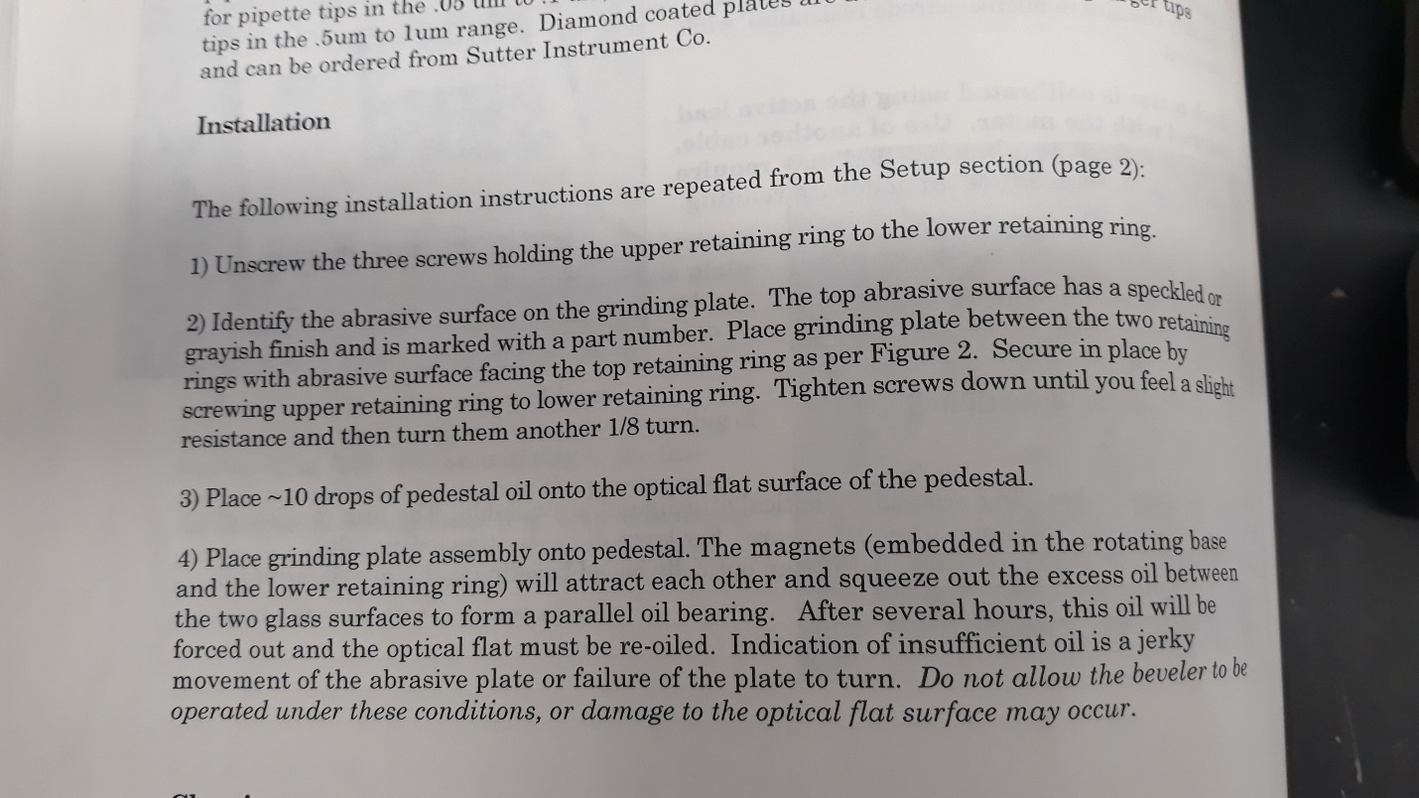
5.4.7 - Halocarbon 27? Also, estimate drops in µL.
Thank you for this good catch. We now indicate that the approximate volume is 20 ul.
6.6 - Please describe briefly how oil is washed off.
Thank you for this suggestion. We have broken 6.6 into 4 sub-steps and have provided more information on how to rinse off the Halocarbon oil without damaging the embryos (now section 6.6.1).
7.5 - Please provide approximate ratios of G0 to wild type for the backcrosses. Also, for G0 male backcrosses, one male could inseminate 5-10 females (assuming this is similar to Ae. aegypti in Helsinki and Harrington), so as males eclose, they need to go into virgin cages of females or they don't have an opportunity to mate. Please provide additional details on the backcrossing.
Thank you for this recommendation. We have added additional information to step 7.5 to clarify how we set-up the back-crosses. We did indeed use a higher ratio of virgin female mosquitoes in cages with injected male mosquitoes to increase the number of F1 progeny that were produced.
Line 489 - Outcrossing refers to a cross to an individual of a different genetic background. Backcrossing refers to a cross to an individual of the same/similar background. Why is outcrossing used here instead of backcrossing to the parental lab strain?
This is another helpful catch. Thank you! The mosquitoes were backcrossed to the non-injected parental strain, and we have corrected this in the text.
Line 540 - Please provide Vectorbase CPIJ accession number, or include the NCBI genome build version and where it can be obtained.

Thank you for this catch. We included this in the figure legend, but missed it in the results section. The cycle sequence in Cx. pipiens (KM355981) was obtained from targeted RACE and submitted to NCBI for the publication of Meuti et al. 2015 “Functional circadian clock genes are essential for the overwintering diapause of the Northern house mosquito, Culex pipiens.”

Line 557 - TALENs.
This has been changed as well. Thank you.
Reviewer #2:
Manuscript Summary:
The manuscript submitted by Meuti (Nicol) et al. describe detailed protocol for gene knockout experiment using CRISPR/Cas9 Culex pipiens mosquito. It is known that some basic operations, especially microinjection, at this mosquito genera involves technical obstacles (such as the hard chorion), which might be a reason for the far fewer number of publicated studies in which transgenic or genome editing was attempted to this mosquito compare to other mosquito genera. The manuscript by Meuti (Nicol) et al. provides detailed protocol from very setting up stage of experiments to genetic crossing to obtain desired mutants in step-by-step manner. I see many merits of this protocol accompanied by visual instructions to be available for many researchers for deep understanding of Culex mosquitoes biology.
Major Concerns:
Along with the detailed description for the method to obtain good needle. there will be huge benefit to show an example picture of that. First comers usually do not know how the ideal shape of needle-end looks like during the optimization step.
Thank you for this suggestion. We now include an image of a properly pulled and beveled borosilicate needle (new Figure 1).
A good planing of the genetic cross after injection is important to ensure retrieving mutated allele and fix it in population. Although the description about this process is well written, there seems to be more improvements needed. For instance, in Step 7.5, I do not see the reason why only females of F0 generation are used as a founder of mutant line. Male mosquito can also transmit mutated alleles, and sometime it is more effective than using female (crossing with multiple WT females is possible). Also authors should note the importance of separating each sex before or immediately after the emergence to prevent inter-crossing, and elaborate how to achieve it.
We fully appreciate this critique and suggestion. We have modified section 7.5 to make it more clear that we recommend (and did!) setting up crosses between both virgin injected male offspring and virgin un-injected (wild type) female offspring as well as virgin injected female offspring and virgin un-injected (wild type) male offspring, and include information on the ratios that we used and recommend. We have also clarified how we ensured that all adults were unmated before introducing them into their cages.
Also, in Step 8.8.3, please describe how to infer the sequence of mutated allele in heterozygous genotype in more detail.
Thank you for this helpful suggestion. We have added additional details in 8.8.1-8.8.3 to describe how to identify suspected indels. Specifically, we recommend also extracting gDNA from wild-type individuals, performing PCR and using these as a control to compare the band position and size with the PCR products that were generated in the F1 progeny.
L556 although the author say the protocol are "amenable to injecting any material into insect embryos", this argument is exaggerated. There still be difficult material to inject such as large particle and highly viscous fluids.
We greatly appreciate this point and have modified the text to state that this protocol is amenable to injecting several different materials into insect embryos. We also now point out that by increasing the bevel of the needle, one can generate needles with various opening sizes that can allow researchers to inject larger particles and more viscous materials, but that this might cause more damage to insect embryos.
Minor Concerns:
I was not able to find "sgRNA Screen Kit It kit" in lineup of TAKARA Bio products. Probably, "Guide-it"?
Thank you very much for catching this. We have fixed this in the text and table.
L566 The study cited as Ref 14 actually used a leg for genotyping.
Thank you for pointing this out. We have added this reference here.

