July 07, 2020

Dear Dr. DSouza,

We would like to thank the editor and the reviewers for reviewing our manuscript, JoVE61649. Please find our rebuttal letter and revised manuscript entitled “An efficient method to generate kidney organoids at the air-liquid interface” by Ashwani Kumar Gupta, David Z. Ivancic, Bilal Abdullah Naved, Jason A. Wertheim and Leif Oxburgh. There is no confidential information in the responses to the editor and the reviewers.

The manuscript has been revised as per suggestions. Rebuttal letter contains point-wise response to both the editor and the reviewers. I do hope that you will find this revised manuscript acceptable for publication.

I look forward to hearing from you.

Yours truly,

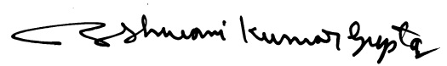

Ashwani Kumar Gupta, PhD
Research Assistant Professor,
Department of Surgery, College of Medicine,
University of Arizona, Tucson, Arizona 85724.
E mail: akgupta@surgery.arizona.edu
Phone: +1-207-213-7520

