Response letter
Manuscript: JoVE61645_R2
We would like to thank the Editor and referees for their constructive comments that have help us to improve the quality of our manuscript. We hope that this new version is now suitable for publication. Our responses to your comments can be found hereafter and the modifications in the manuscript are in blue.
Editorial comments:
1. The editor has formatted the manuscript to match the journal's style. Please retain and use the attached file for revision.
Reply: We have used the attached file for revision
2. Please address all the specific comments marked in the manuscript.
Reply: All specific comments in the manuscript have been taken into account. See below for details:
- Line 2, title reformulation: We agree with the modification
- Manuscript need a thorough proofreading: The manuscript was proof-read by a professional English reader before to submit our first revision. For this new revision, all comments by the editor and the reviewers were taken into account.
- Line 64, please describe the kerma condition or provide a citation: the kerma conditions correspond to an irradiation in air, this is now specified this point in the manuscript (page 2, line 63).
- Line 101 to 107, Please note that we need a specific experiment with specific experimental values/parameters in order to film. We cannot film a generalized protocol. Can you include a specific example film used for this protocol?: We now included a specific example with the specific parameters given in Table 1. For the film, we will use these specific parameters. We added the following sentence at the end of this paragraph: “All the parameters used in this protocol are given in table 1.”
- Line 117, How do you check this?: We check this with a tape measure. We specified this point in the manuscript page 3, Line 118).
- Line 121, What are the settings for the ionization chamber used?: We can use different type of ionization chamber and each ionization chamber has its specific calibration. In the results section (page9, line 373), we specified the ionization chamber use for this work, a 31002 (equivalent to 31010) ionization chamber calibrated in air kerma. In the section 2.3, we also specified the ionization chamber used for this work (page 3, line 122).
- Line 127, Where is the weather station? Presumably inside near the experiement?: In our case, the weather station is located inside the irradiation casemate so very close to the experiment. This is now specified it in the manuscript page 4 line 130.
- Line 160, How is this done? What is the irradiation dose?: For this example we irradiated the film during 120 seconds. We don’t need to measure the dose for this verification we only need to have a well-marked film to determine the size of the irradiation field and the area where we have a homogeneous distribution of the dose. It is the reason that we specified in the title of this section that it is not a dose estimation. To have a well-marked film, a dose of 2 Gy is widely sufficient, this is now specified in the manuscript page 4 line 166.
- Line 164, How is this done? Please include button clicks in the software: Done. Following a comment by the fourth referee, we also added a step in this section to make this section clearer
- Line 166, How do you determine this?: From the EBT3 film irradiated in the section 3 of the protocol we can know determine the size of the irradiation field and the area where we have a homogeneous dose. As we recorded the position of the support inside the irradiation enclosure and the position of the EBT3 film on it we can locate and mark the area with a homogeneous distribution of dose on the support used for irradiations and always place the cell containers inside this area.
- Line 248: Please provide the dose points here as well for greater experimental fidelity: done
- Line 421: Please expand on the limitations of the protocol: the main limitations of this protocol are explained and discussed on the discussion section. This protocol was developed in order to perform dosimetry measurement as close as possible to the real cell irradiations conditions on orthovoltage facilities. The difficulty or even the impossibility to perform beam quality index measurements have been highlighted on the second paragraph of the protocol (page 11, line 452). As the enclosure of this type of installation are small, it is not possible to follow the AAPM recommendations and some adjustments have to be made. Then the dosimetry measurements with the ionization chamber were discussed especially the influence of the shape of the ionization chamber used to be as close as possible to the cell irradiation condition. In this third paragraph we also highlight the influence of a lot of parameters on the dosimetry (filtrations, quantity of cell culture media, cell container…). Thus, dedicated dosimetry has to be set up multiplying the number of configurations. The protocol developed here may seem long and very restrictive, but once the measurements have been taken, only the daily dose rate measurements remain to be carried out with the ionization chamber. To insist in these two last critical points, we have added some comments in the fourth paragraph of the discussion. We believe that all the limitations of the protocol are highlighted.
3. Once done please ensure that the highlight is no more than 3 pages including headings and spacings.
Reply: done
4. Please address all the reviewers comments as well.
Reply: done

Reviewers' comments:

Reviewer #1:
Manuscript Summary:
This manuscript is greatly improved. Having an English reader has increased the readability greatly. It is now an acceptable manuscript. I have a few comments that should be addressed but I do not need to review again. Minor revisions with points made below.
1. Page 2 line 58: dosimetry does not appear to be - dosimetry is crucial. The attitude of the past has not worried about dosimetry. Let's no longer work with this attitude.
Reply: done
2. Page 4 line 134 I object to implying that a weather station is equivalent to a measurement using a thermometer and barometer. Change this to state that temperature and pressure needs to be measured with calibrated equipment.
Reply: done. The sentence has been modified as follow: “Take the temperature and pressure with suitable calibrated equipment placed inside the irradiation enclosure in our case (if it is not possible place it near to the experiment).”
3. It is implied in your Figure 1 but should be stated clearly in line 126 on page 4 that the filters need to cover the entire beam.
Reply: we added this information in the new version of the manuscript in the section 2.7: Place an attenuator of certain thickness above the diaphragm. The HVL set is composed of foils with different thicknesses (0.02, 0.05, 0.1, 0.2, 0.5, 1, 2, 5 and 10 mm of copper) with a dimension allowing to cover the entire beam (here 80 x 80 mm).
Reviewer #2:
The authors have sufficiently addressed all my concerns. There remain a few small comments, mostly wording errors, likely due to translation from french:
in many places:
"tension" is used in some places instead of "voltage"
Reply: done

"casemate" should be "casement" or better: "enclosure"
Reply: done
page 4 line 130 "make the zero" should be "measure background"
Reply: done
Page 4 line 132: "charge measurment" should be "charge collection"
Reply: done
page 5 line 142: does the obtained value refer to the average value? if so please note.
Reply: done
steps 2.8.1 and 2.8.2 are not worded clearly
Reply: We added some information and reworded these two sections. We hope that these steps are clear now.
step 4.1: a note to the authors unrelated to this manuscript: a soldering iron or heated scalpel is a good alternative to make holes in plasticware,
Reply: We thank the reviewer for the tip. We find appropriate to add this suggestion in the manuscript (page 5 line 191).
page 5 line 155: "dichotomy" should be "bisection"
Reply: done
page 6 line 187: again mention that you are averaging multiple readings
Reply: done
page 8 line 161: "can" should probably be replaced by "should". it is good practice to always measure the film in the same position, as recommended by Ashland.
Reply: done
Fig 1 caption: "schema" should be "scheme" or "drawing"
Reply: done
table of materials,
"quote request" is not really useful. can you provide the model instead? e.g. for the electrometer: "unidos E"
Reply: we added some information in the Jove materials table.
for the ion chamber 30010 would be the catalog number
Reply: It is an online catalog, we don’t have the catalog number but in the Jove Materials table we added the year of the catalog (2019-2020)
Reviewer #4:
Manuscript Summary:
The manuscript improved after the last revision, most of the recommendations were followed. There are couple of sentences in the manuscript which are not clear and would benefit from proofreading by a native speaker (figure legends). After these improvements I recommend the manuscript for publication.
Major Concerns:
What is still missing is the background reading for EBT3 films. Since the background of each film and even within a film varies, it is common to perform a film background scan prior to irradiation which is then subtracted from the irradiated film scan. This step is missing in the procedures. Could you please comment on this?

Reply: effectively, we have not specified this step in the protocol because we have not formally measured the background in this work. In order to reduce as much as possible the influence of the background noise on our measurements, all the EBT3 films used for a precise experiment come from the same sheet. Moreover, all the films used for the experiment are randomly distributed on the sheet (see figure). On the note at the end of the section 6, we now specified that we used the red channel method with no background subtraction.
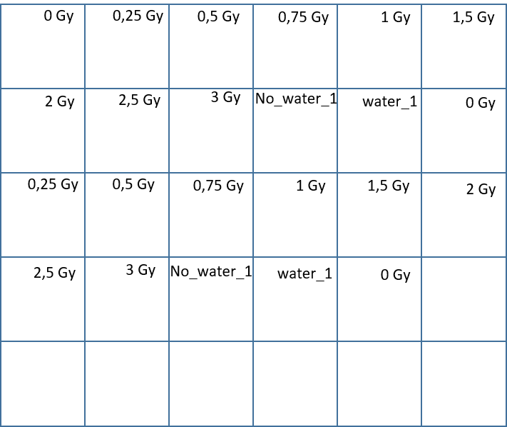

Minor Concerns:
Line 130, Section 2.4: perform zeroing
Reply: we replaced “make the zero” by measure background as recommended by the second referee.
Line 165-166: it is not clear how big the margins should be please be more specific
Reply: For our irradiations we consider only the area where we have the maximal and homogeneous distribution of dose. So, we exclude the penumbra regions to avoid heterogeneous irradiation. In this case we consider a square of about 10 x 10 cm. We added a step in this section to better explain the determination of the area used for irradiation:
  - Plot the dose profile using Image J by using the Analyze and then plot Profile option (Figure 2)
  - Determine the size of irradiation field usage for irradiation (homogeneous area, excluding penumbra regions, see figure 2)
Line 251: be more specific about the ROI size
Reply: We did not specified the size of the ROI because it depends on the size of the film used at this step.

Line 332: one digit after comma is more than sufficient 1.5%
Reply: done
Lines 343-355: English in figure legends is not clear. Often not possible to get the meaning.
Reply: The manuscript has already been proof-read by a professional English reader for the first review.

