RESPONSE TO EDITOR AND REVIEWER COMMENTS
Manuscript ID: JoVE61644
Title: Effects of halogenated agents delivered through an intensive care unit-type device in a porcine model of acute respiratory distress syndrome
Authors: Raiko Blondonnet^{1,2}, Bertille Paquette^{1,2}, Jules Audard^{1,2}, Ridvan Guler^{1,2}, François-Xavier Roman^{1,2}, Ruoyang Zhai², Corinne Belville², Loïc Blanchon², Thomas Godet¹, Emmanuel Futier^{1,2}, Jean-Etienne Bazin¹, Jean-Michel Constantin³, Vincent Sapin^{2,4}, Matthieu Jabaudon^{1,2,5}

We thank the Editor and the Reviewers for their careful read and thoughtful comments on the previous version of our manuscript. We have carefully taken their comments into consideration in preparing our revision, and we hope the manuscript has been improved. Please find below a point-by-point response to the comments and questions.

COMMENTS FROM THE EDITOR
• Please take this opportunity to thoroughly proofread the manuscript to ensure that there are no spelling or grammatical errors.
As recommended, we have carefully proofread our revised manuscript and we hope there will not be any spelling and grammatical errors left.

• Textual Overlap: Significant portions of the manuscript show significant overlap with previously published work. Please re-write the text highlighted in the attached PDF report document within the introduction and discussion using ALL original text to avoid this overlap.
In our revision, we have thoroughly tracked any kind of overlap with previous work, and have made some minor changes in the Introduction and Discussion sections, as indicated.
However, it seems that many other parts of the “text overlap” verification process that has been performed spotted some very generic expressions or sentences that we will not be able to change (for example: “alveolar inflammation and epithelial injury during ARDS”, “in a large animal model”, “Ethics committee of the French "Ministere de l’Education Nationale, de l'Enseignement Superieur et de la Recherche"”, “Centre International de Chirurgie Endoscopique, Universite Clermont Auvergne, Clermont-Ferrand, France”, etc.).

• Protocol Highlight: Add a one line space after each step. After you have made all of the recommended changes to your protocol (listed above), please re-evaluate the length of your protocol section. There is a 10-page limit for the protocol text, and a 3- page limit for filmable content. If your protocol is longer than 3 pages, please highlight ~2.5 pages or less of text (which includes headings and spaces) in yellow, to identify which steps should be visualized to tell the most cohesive story of your protocol steps.
1) The highlighting must include all relevant details that are required to perform the step. For example, if step 2.5 is highlighted for filming and the details of how to perform the step are given in steps 2.5.1 and 2.5.2, then the sub-steps where the details are provided must be included in the highlighting.
2) The highlighted steps should form a cohesive narrative, that is, there must be a logical flow from one highlighted step to the next.
3) Please highlight complete sentences (not parts of sentences). Include sub-headings and spaces when calculating the final highlighted length.
As recommended, we have added a one-line space after each experimental step. We also provided the Editor with an additional document that highlights in yellow the filmable content per se.

• Define error bars in all figures.
Thank you. In our revised manuscript, we have now defined all error bars (standard errors of the means) in all figure legends. Figure 6 has also been rearranged to better visualize these error bars.

• Discussion: JoVE articles are focused on the methods and the protocol, thus the discussion should be similarly focused. Please ensure that the discussion covers the following in detail and in paragraph form (3-6 paragraphs): 1) modifications and troubleshooting, 2) limitations of the technique, 3) significance with respect to existing methods, 4) future applications and 5) critical steps within the protocol.
We agree with this important comment from the Editor. Under its previous form, the Discussion was rather long and unfocused. We have revised this section accordingly and hope it will read better now.

• Commercial Language: JoVE is unable to publish manuscripts containing commercial sounding language, including trademark or registered trademark symbols (TM/R) and the mention of company brand names before an instrument or reagent. Examples of commercial sounding language in your manuscript are (AnaConDa, Sedana Medical, AnaConDa, (AnaConDa-S, Miller, WarmTouch, Medtronic, (IntelliVue MP40, Phillips, Seldinger, PiCCO device (Pulsion SA, (Ventilator Engström Carestation, GE Healthcare, (FlurAbsorb - Sedana Medical, Nafion, BD Preset, Epoc® Blood Analysis System, Siemens, Inview™ (ConvaTec, BD Luer-Lok, etc.
1) Please use MS Word’s find function (Ctrl+F), to locate and replace all commercial sounding language in your manuscript with generic names that are not company-specific. All commercial products should be sufficiently referenced in the table of materials/reagents. You may use the generic term followed by “(see table of materials)” to draw the readers’ attention to specific commercial names.
We apologize for including these brands in our previous manuscript.
As requested, we have deleted all commercial sounding elements from the main manuscript and have referred to the table of materials/reagents for further details and specific commercial names, if any.

• Table of Materials: Sort the list alphabetically.
In our revision, we have reorganized the list from the Table of Materials has been re-organized alphabetically. Thank you.

• If your figures and tables are original and not published previously or you have already obtained figure permissions, please ignore this comment. If you are re-using figures from a previous publication, you must obtain explicit permission to re-use the figure from the previous publisher (this can be in the form of a letter from an editor or a link to the editorial policies that allows you to re-publish the figure). Please upload the text of the re-print permission (may be copied and pasted from an email/website) as a Word document to the Editorial Manager site in the "Supplemental files (as requested by JoVE)" section. Please also cite the figure appropriately in the figure legend, i.e. "This figure has been modified from [citation]."
All figures and tables are original and have never been published previously.

COMMENTS FROM THE REVIEWERS

REVIEWER #1:
Manuscript Summary:
The manuscript is very well written and describes in great detail the procedures required for this porcine model of HCL induced lung injury.
Major Concerns:
I have no major concerns with this manuscript
We thank Reviewer #1 for his/her kind and positive comments.

Minor Concerns:
If the authors desire, they could address the following before submission. However, this in my opinion is not required prior to publication.

1) Use of the Anaconda
- The authors describe mainly a protocol of experimental porcine induced lung injury via HCl while administering volatile agents in the post exposure period. Although it is clearly matched to the investigators' clinical research with volatile anesthetic sedation via the Anaconda, it is not clear why the device needs to be used during this experiment. If the anesthetic is to be administered after endotracheal intubation, then it should be possible to use a conventional vaporizer or anesthesia machine to administer the agent. For investigators who may choose to replicate this model in future studies, perhaps without the anaconda, this possibility could be acknowledged. If the Anaconda is preferable over a conventional system, the authors should state why this would be the case
We thank Reviewer #1 for this important comment and understand his/her concern. As a matter of fact, more conventional anesthesia setups could be easily used to replicate this model.
However, our specific goal here was to develop a model in which we could induce ARDS in animals and treat them with inhaled isoflurane or sevoflurane in a manner that would match as much as possible the clinical situation of inhaled ICU sedation, i.e. through a dedicated device different from anesthesia ventilators.
In this specific setting of inhaled ICU sedation, and to the best of our knowledge, only two devices are available for clinical use: the AnaConDa (Sedana Medical) and the Mirus (MedCaptain by Anandic Medical Systems); however, the choice of the miniaturized AnaConDa-S was largely motivated by its lower instrumental deadspace volume, compared to the Mirus.
In the revised version of the manuscript, we have added these justifications and unique features of our model in order to better explain this choice.

2) sRAGE
- The assay currently does not include sRAGE. Is this because this biomarker is not available in pigs? The investigators' primary work in this area involves sRAGE, therefore it would likely be beneficial to include this biomarker in their model.
We thank Reviewer #1 for this comment. As mentioned, our team is specifically interested in the roles of the RAGE pathway in the mechanisms of acute lung injury and repair, and in the value of soluble RAGE as a biomarker of lung epithelial injury.
As a matter of fact, we have multiple translational projects ongoing, or just about to start, to test the hypothesis that at least some of the pulmonary effects of inhaled halogenated agents might be mediated by the RAGE pathway. However, this is out of the scope of the current submission, the latter being specifically focused on a clinically-relevant method to deliver inhaled sedation in large animals with ARDS, such as we would do in patients admitted to an intensive care unit.

3) 2 hit model
- It would be fairly simple to include VILI in their 2-hit models of lung injury in the future. This could be acknowledged
We again thank Reviewer #1 for this very smart comment. Unfortunately, we did not include such a second-hit (eg, VILI) in our current experimental model. As suggested, we have added a sentence in the Discussion to acknowledge this point.

4) Stability and low mortality of the model
- Although the authors state these characteristics as positive attributes of the model, there is no information available in the text or figures to back up this assertion.
Thank you very much for this important remark. This was a mistake in our previous manuscript and we have now added details on mortality data in the revised Results section.
Indeed, no fatal course was observed when we used the model as currently described.

REVIEWER #2:
Manuscript Summary:
The authors present comprehensively an animal model of hydrochloric acid-induced acute respiratory distress syndrome (ARDS) in piglets. These pigs received in addition anesthesia by inhalation with halogenated agents isoflurane and sevoflurane (but why not desflurane?). This model should be used to investigate the biological mechanisms of the potential protective effects of halogenated agents during lung injury and repair, but it is insufficiently performed.
We thank Reviewer #2 for his/her comments.
In this model, we “only” used isoflurane and sevoflurane for inhaled sedation in piglets because these are the two halogenated agents that are the most used in clinical practice, at least in Europe and in some other areas of the world.
The use of desflurane for inhaled ICU sedation is more challenging (it is only available through one device, the Mirus, because its boiling point, between 23°C and 24°C, is close to room temperature) and is associated with a much higher cost compared to isoflurane and sevoflurane. In addition, there are important concerns regarding atmospheric pollution with desflurane, to the extent that it is less and less used for general anesthesia in the operating room.
This has been added as a piece of discussion in our revised manuscript.

Major Concerns:
My first and most important comment is, that the effects of halogenated agents in the lungs are well-known for decades and these have been systematically examined (please compare to the studies by Kotani et al., already in the late nineties!). In addition, there was established a plethora of models of lung injury including VILI and different models ARDS (acid, mechanical forces, lavage; please compare to the group of Hedenstierna et al.) that has been already used in the last century.
The authors state that they developed an optimised piglet model of acid aspiration; however, I am rather reluctant to that claim. In detail, the authors failed to explain what the unique features are of their present model.
Accordingly, they shouldn't write what they already know about ARDS, they should better provide evidence regarding the outstanding aspects of their animal model. Where are the "optimized features"?
We fully agree with this analysis from Reviewer #2.
Many experimental models of ARDS have been used and published to date, including this model of intratracheal hydrochloric acid-induced lung injury in piglets (Audard et al. Scientific Reports 2019. doi: 10.1038/s41598-019-45798-5).
However, the specificity of our current protocol relies on the use of a specific system to deliver inhaled sedation, that is already available to intensive care providers and is therefore very clinically relevant.
In this perspective, the use of the Anaesthesia Conserving Device (AnaConDa, Sedana Medical), along with a strategy of lung-protective mechanical ventilation, also echoes perfectly the ongoing clinical studies of inhaled sedation such as our multicenter randomized trial (SESAR; https://clinicaltrials.gov/ct2/show/NCT04235608), among others.
We did our best to better highlight this specificity of our experimental model throughout the manuscript, and we removed the term “optimised” from the revised text.

In addition, I have major methodological concerns:
-For what reasons the authors did abstain from a tracheostomy: It is much more suitable in piglets, easy to perform, and the data are more reliable.
We thank Reviewer 2 for this interesting comment. Although we agree with Reviewer #2 that tracheostomy can be performed rather easily in piglets, our team has extensive experience and expertize in orotracheal intubation of animals and we are confident that our data are as reliable as if they were obtained using a tracheostomy. In addition, we believe the use of orotracheal intubation, which is the most frequent situation in the clinical setting of patients with ARDS, increases the translational value of our model, especially with regards to instrumental deadspace of the respiratory circuit.

-How was sufficient deep of anesthesia ensured?
We thank Reviewer #2 for this pivotal question and the opportunity we are given to better explain how the level of sedation was set in our model.
Here, the initial infusion rate of sevoflurane was set based on the instructions from the AnaConDa-S manufacturer, i.e. based on an algorithm considering minute ventilation, as reported in the following graph:

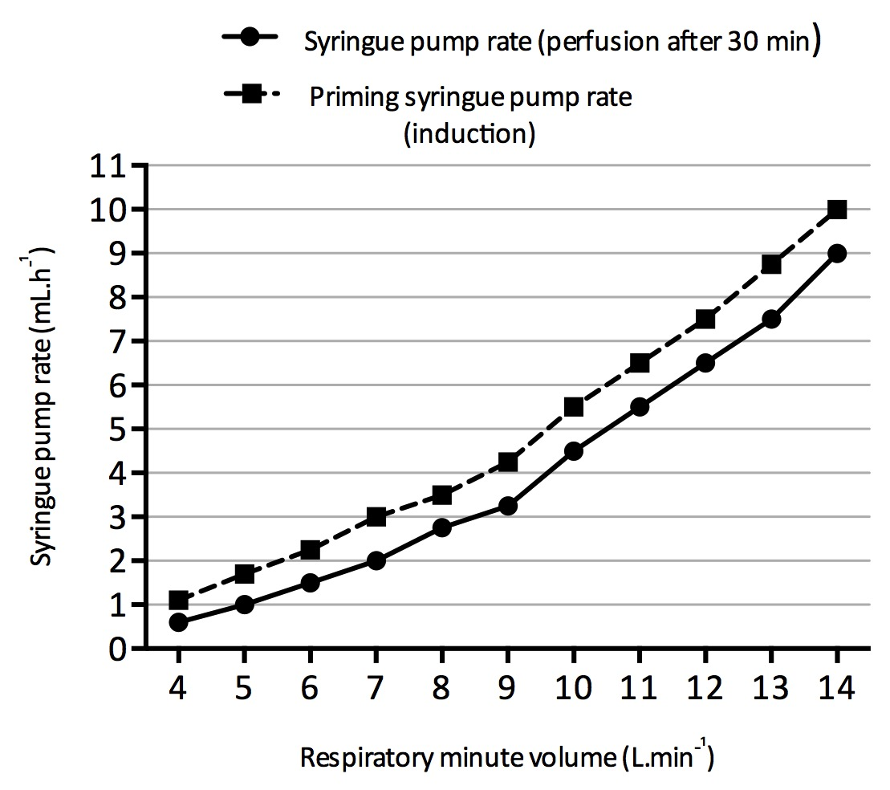

Then, the infusion rate of sevoflurane was titrated to reach a target of expired sevoflurane fraction (F_{E}sevo, which is a reliable surrogate for cerebral concentrations of sevoflurane in patients) of 0.8-1.1. In a recent publication from our team (doi: 10.1016/j.accpm.2020.04.002), F_{E}sevo values have recently been associated to the minimal alveolar concentration (MAC) of sevoflurane and, more importantly, to the Richmond Assessment Sedation Score (RASS), as the RASS is used routinely in most ICUs to monitor and titrate sedation. Briefly, in this clinical study, such F_{E}sevo (of 0.8-1.1) were associated with deep sedation levels in ≥95% of ICU patients.
We have added a sentence to better explain this point to the readers in the Discussion section of the revised manuscript.

-An ID 6mm tube is too small for sufficient measurements and interventions.
We thank Reviewer #2 for this comment, although we partially disagree with this assertion.
We believe that a 6 mm-ID tube is very adequate to use in 10-15 kg-piglets and to deliver mechanical ventilation in safe conditions, without, for example, increasing the resistance of the airways. As a matter of fact, this is what we have always been using in such animals (see Audard et al. Scientific Reports 2019. doi: 10.1038/s41598-019-45798-5). In particular, a 6 mm-ID tube allows insertion of a CH14 suction catheter (such as to perform the intracheal aid instillation or to sample pulmonary fluid). In addition, for these experiments, we used a modern ICU ventilator that easily allows the delivery of volume-controlled ventilation with such a 6 mm-ID tube.

-What is the difference to the widely used oleic-acid induced ALI model?
We thank Reviewer #2 for this question. We did not choose the oleic-acid model in our study for two reasons.
First, we chose the hydrochloric acid model because it is described as a better model of direct lung epithelial injury, which is the main topic of our research team. In contrast, the oleic acid model has often been described as a model that mimics ARDS due to fat embolism, with only little degree of alveoalr inflammation and epithelial injury; oleic acid can however induce overwhelming lung injury, but on a timescale that is very variable (from hours to days). As it does not really allow the investigation of mechanisms of lung repair and ARDS resolution (in general), we rather opted for the hydrochloric acid model as some of projects will also include the study of the later phases of fibroproliferation (such as in doi: 10.1183/09031936.00093911).
Second, hydrochloric acid-induced ARDS is, in general, associated with minimal hemodynamic compromise compared to other models (which could explain the low mortality rate), especially when injury is at its peak.
We have added a new section to the revised Discussion to better explain this choice.

-There was CV and arterial lines in the pigs; however, for this model a PAC and a PiCCo catheter are urgently needed. Without Qs/Qt, SVR/PVR, CO/CI and DO2 and VO2 calculations/ measurements the model is worthless.
Actually, we used a PiCCO system in our experiments, as described in the manuscript. We only chose to report PiCCO-derived measurements of lung edema in our model (see Figure 5 with extravascular lung water) as we thought it would best illustrate this major feature of experimental ARDS (namey alveolar-capillary permeability).
Because we also recorded the CI and SVR, we have added them to Figure 5. However, we regret we did not collect data that are required for VO2 calculation.

-In my experience, anesthesia in pigs with remifentanil (and cisatracurium!!!) is insufficient, the authors used the 100-fold dosage as compared to humans resulting in significant bias!!!
We thank Reviewer #2 for this comment. However, we are afraid there may be an important misunderstanding here.
As a matter of fact, piglets were of course not anesthetized with remifentanil and cisatracurium alone. During the first phase of our model (before lung injury is induced), piglets were under intravenous sedation with propofol, in addition to remifentanil-based analgesia and neuromuscular blockade with cisatracurium. During the second phase, the propofol was stopped and sedation switched to inhaled sedation with the halogenated agent (sevoflurane or isoflurane).
About the remifentanil doses we used, they are those recommended by the French Medicine Agency (Agence Nationale de la Sécurité du Médicament, ANSM) for pain management during general anesthesia in patients (0.25 μg.kg⁻¹.min⁻¹ (= 15 μg.kg⁻¹.h⁻¹). In addition, such doses are usually being used in piglets when combined to a hypnotic agent (see doi: 10.1186/s13028-016-0223-6).
We did our best to clarify this point in the revised manuscript by writing the two units, in order to avoid the risk of misunderstanding by the readers.

-BAL itself induces additional severe alveolar injury and must be therefore avoided in baseline/standard measurements!
We agree that performing a BAL could in itself induce a certain degree of lung injury. However, here we used a mini-BAL technique (with a maximum of 50 mL of NaCl 0.9%), which is far below the volume usually associated with acute lung injury due to surfactant depletion. In addition, BAL to measure the concentration in total protein and/or in a high molecular weight protein is considered as a very relevant parameter in order to measure the alteration of the alveolar-capillary barrier (Official American Thoracic Society Workshop Report: Features and Measurements of Experimental Acute Lung Injury in Animals. doi: 10.1165/rcmb.2009-0210ST). Furthermore, in order to limit lung effects of the instillation of saline, in our model mini-BAL was performed 4h after the acid instillation i.e., at the end of the experiment and just before the euthanasia of the piglet.
Accordingly, we have highlighted in our revision that a mini-BAL was performed in our model (as opposed to a more conventional BAL).

Taken together the present model delivers nothing useful. It exerts no advantages in comparison with the lung injury models that we have established in the last 30 years. In addition, the manuscript lacks from important data and facts and is poorly written.
This manuscript will not reach scientific priority for publication.
Although we can understand this point of view, we strongly disagree with these statements. As explained above, the strengths of our experimental model are not to describe a new model for ARDS in piglets but to deliver inhaled sedation to these injured animals using a highly clinically-relevant method that is also used in ICU patients.

REVIEWER #3:
Manuscript Summary:
The study by Blondonnet et al. demonstrated an acid induced ARDS disease model using a piglets. The model demonstrated significant difference in PaO2/FiO2 ratio, BALF protein, extravascular lung water and the efficacy of anesthetic delivery device in maintaining the anesthesia levels after induction. HCL induced acute lung injury models in piglets are already well established. However, this model shows efficacy relates to lung injury induced by HCL. Measurable differences in various lung injury parameters are statistically different. Anesthetics such as isoflurane and sevoflurane are known to ameliorate LPS-mediated or other forms of acute lung inflammation and injury. In this regard, this piglet
Major Concerns: None
Minor Concerns: None
We sincerely thank Reviewer 3 for his/her kind and positive comments.

