July 07th, 2020

Editors – JoVE
Dear Dr DSouza,
We would like to thank you for your email dated on June 10th, 2020 informing us about the editorial and peer-reviewed comments for our manuscript.

We addressed all the reviewers’ comments and performed the required editing. We included a point by point response, to address all the editor’ and reviewers’ concerns (see below).

We hope that our manuscript can now be considered for publication in JoVE.

Please contact me if any further information is required.

Sincerely yours,

Dr. Jérôme GILLERON

Response to editorial Comments:
• Please take this opportunity to thoroughly proofread the manuscript to ensure that there are no spelling or grammatical errors.
Extensive grammar and style editing was performed by a native English speaker.
• Protocol Detail: Please note that your protocol will be used to generate the script for the video, and must contain everything that you would like shown in the video. Please ensure that all specific details (e.g. button clicks for software actions, numerical values for settings, etc) have been added to your protocol steps. There should be enough detail in each step to supplement the actions seen in the video so that viewers can easily replicate the protocol.
This was corrected in the current version of our manuscript.
• Protocol Numbering: Please adjust the numbering of your protocol section to follow JoVE’s instructions for authors, 1. should be followed by 1.1. and then 1.1.1. if necessary and all steps should be lined up at the left margin with no indentations. There must also be a one-line space between each protocol step.
We corrected the formatting accordingly.
• Protocol Highlight: After you have made all of the recommended changes to your protocol (listed above), please re-evaluate the length of your protocol section. There is a 10-page limit for the protocol text, and a 3- page limit for filmable content. If your protocol is longer than 3 pages, please highlight ~2.5 pages or less of text (which includes headings and spaces) in yellow, to identify which steps should be visualized to tell the most cohesive story of your protocol steps.
1) The highlighting must include all relevant details that are required to perform the step. For example, if step 2.5 is highlighted for filming and the details of how to perform the step are given in steps 2.5.1 and 2.5.2, then the sub-steps where the details are provided must be included in the highlighting.
2) The highlighted steps should form a cohesive narrative, that is, there must be a logical flow from one highlighted step to the next.
3) Please highlight complete sentences (not parts of sentences). Include sub-headings and spaces when calculating the final highlighted length.
4) Notes cannot be filmed and should be excluded from highlighting.
We have highlighted the text accordingly.
• Discussion: JoVE articles are focused on the methods and the protocol, thus the discussion should be similarly focused. Please ensure that the discussion covers the following in detail and in paragraph form (3-6 paragraphs): 1) modifications and troubleshooting, 2) limitations of the technique, 3) significance with respect to existing methods, 4) future applications and 5) critical steps within the protocol.
We re-formatted the discussion accordingly.
• References:Please spell out journal names.
We corrected the format accordingly.
• Commercial Language:JoVE is unable to publish manuscripts containing commercial sounding language, including trademark or registered trademark symbols (TM/R) and the mention of company brand names before an instrument or reagent. Examples of commercial sounding language in your manuscript are Sigma-Aldrich, (#D6750, (#A6003, Sigma-Aldrich, Eppendorf, Falcon, #986546, Wheaton), AttoFluor chamber #A7816, ThermoFisher, IMARIS, etc. 1) Please use MS Word’s find function (Ctrl+F), to locate and replace all commercial sounding language in your manuscript with generic names that are not company-specific. All commercial products should be sufficiently referenced in the table of materials/reagents. You may use the generic term followed by “(see table of materials)” to draw the readers’ attention to specific commercial names.
We removed all the commercial language from the main text. In the current manuscript, we only mention the company in the table of materials to allow readers to reproduce our work.
• If your figures and tables are original and not published previously or you have already obtained figure permissions, please ignore this comment. If you are re-using figures from a previous publication, you must obtain explicit permission to re-use the figure from the previous publisher (this can be in the form of a letter from an editor or a link to the editorial policies that allows you to re-publish the figure). Please upload the text of the re-print permission (may be copied and pasted from an email/website) as a Word document to the Editorial Manager site in the "Supplemental files (as requested by JoVE)" section. Please also cite the figure appropriately in the figure legend, i.e. "This figure has been modified from [citation]."
Not relevant, the figures are original and unpublished.

Response to reviewer comments:
Reviewer #1:
Manuscript Summary:
The protocol by Gilleron et al. provided a detailed method for staining and clearing whole white fat pads either from human or mice. Overall, the protocol is well described. Details in each steps, necessary notes, and representative figures are sufficiently provided. However, before this protocol is published in JoVE, several points are required to be addressed.
We would like to thank the reviewer for these positive comments concerning our manuscript, especially that he/she finds it to be “well described”, and for which “details in each steps, necessary notes, and representative figures are sufficiently provided”

Major Concerns:
1. The authors failed to cite and compare their protocol with a previously published protocol in JoVE (Li X, et al. 2019. doi: 10.3791/59266). In the protocol by Li et al., they have utilized a even simpler clearing step but achieved a high-quality staining and image acquisition of adipose tissue blood vessels and nerve fibers.

The reviewer is correct that we were not comparing our protocol with the protocol of Li and colleagues in the first version of our manuscript. We agree that the protocol of Li and colleagues is even simpler and produces reasonable resolution, but their protocol is optimized and therefore limited to very small samples (around 2mm³), as clearly stated in their manuscript. This volume corresponds to a cube of tissue with 1.3 mm sides. The volume of the whole adipose tissue of mice that are fed a normal diet is around 0.6 cm³ and in mice fed a high fat diet it is close to 4cm³. Therefore, the protocol developed by Li and colleagues is not optimal for the analysis of large adipose tissues. Here, using our procedure, we manage to clear a few cm³ of mouse and human adipose tissue. We can therefore acquire the whole tissue at low magnification (e.g. 4x objective), and select several areas where to acquire higher magnification (e.g. 20x objective) 3D stacks of images representing each a volume of at least 45mm³. Such an approach allows to obtain a sampling of the tissue. We corrected the manuscript by implemented this information in the discussion.
2. Is this protocol also applied to brown fat pads?

This protocol also works well for brown adipose tissue and other tissues including liver, kidney, lung and whole embryos. In line with the reviewer’s question we decided to include a picture of cleared mouse brown adipose tissue stained for the Tyrosin Hydroxylase (TH, see new Figure 4F).

3. Have the authors stained with nerve fiber markers?
Yes, we successfully performed experiments with an anti-TH antibody. We have now included these data in the revised version of the manuscript (see new Figure 4F-G ).

Reviewer #2:
The manuscript "Exploring adipose tissue structure by clearing 3D whole-organ imaging" describes an approach for straightforward imaging of adipose tissues in mice and humans. This builds on a variety of whole mount and tissue clearing approaches that have been used to image different organs, including adipose tissue.
The manuscript would benefit from attention to the following major and minor points:
Major points:
1. The manuscript requires extensive editing for grammar and style.
We asked a native English speaker to perform extensive grammar and style editing.
2. Although the authors claim this method to be whole organ clearing and imaging, based on the described steps, this method does not have the capacity to do so. The authors should instead describe the method as "whole mount" clearing and imaging.
a. In Note 1, the authors specifically stated that they usually cut tissues into small pieces for this procedure. The staining and imaging steps in the main protocol (i.e. buffer volumes, incubation time, and antibody dilutions) are designed for handling small tissue chunks instead of whole tissue.
b. In step 5.3., the authors mentioned the z-stacks typically obtained by confocal microscopes are between 600 to 2000 micrometers. Since the authors suggested applying this method to study hypertrophy and hyperplasia in obese adipose tissue, obese fat pads easily surpass the 2 mm limit, and therefore cannot be imaged as a "whole organ" by the described method.
The method described herein successfully cleared the whole adipose tissue from mice fed either a normal or a high fat diet. There is no need to cut it into small tissue chunks for the clearing procedure.
a- We disagree with the comments of the reviewer suggesting that our procedure is designed for handling small tissue chunks instead of the whole tissue. First, a tissue with a volume of 1g – 2.5cm³ is 4 times bigger than the volume of an adipose tissue from mice fed a normal diet (250 mg - 0.6 cm³), and represent more than 2/3 of the maximal volumes that can reach a whole adipose tissue from mice fed a high fat diet (1.5 g - 4 cm³). Second, as clearly stated in our procedure, the clearing of the whole adipose tissue from mice fed a high fat diet can be easily done by linearly adapting the volume of the different buffers to the increase in adipose tissue mass. We designed the protocol to a volume of 1g because we find it sufficient to correctly appreciate the morphological changes occurring within the tissue.

b- We understand the concern of the reviewer concerning the step 5.3. This is because we were not clear enough about the imaging strategy we applied to take advantages of our ability to clear a whole organ, but taking also into account the depth limit range of around 3mm of the 20x long-distance objective we used to obtain high magnification images. Indeed, the whole organ can be imaged in 3D at low magnification (e.g. 4x objective) to appreciate its global structure (see the left image in Figure 3D). This large 3D stack can serve as a map to select several areas for imaging the tissue at higher magnification (e.g. 20x objective) spread within the tissue. We acknowledge that using the higher magnification set up to obtain images at sub-cellular resolution; we are able to obtain 3D stacks of images representing each a volume of at least 45mm³. This is far from the whole tissue, but repeating the “high magnification” acquisition at several position within the tissue could allow to obtain a correct representative sampling of the tissue (see the right images of the Figure 3D).

We corrected the title and the text to put into perspective our claim about “whole organ clearing”. We also clarified the step 5.3 by adding novel informations about our imaging strategy.

3. The authors claimed one advantage of this method over the iDISCO-based clearing protocols is its efficiency. In Figure 1, the time required for the entire protocol adds up to 8-15 days, which is not actually significantly different from the iDISCO-based methods (10-14 days).
We believe that our procedure has several advantages compared to the previously described iDisco-based protocol. The gain of time remains only one of these advantages. We agree with the reviewer that this gain is minimal (a few days). This is due to the fact that the major part of the time is used to stain the tissue, and this time is unchangeable to avoid staining artifacts. Therefore, we corrected the discussion on the differences between our procedure and the iDISCO-based method accordingly.
Moreover, we also thank the reviewer for noticing that a mistake was present in the time-line of the Figure 1 (read 7 to 11 days rather than 7 to 14 days).
4. The sample images provided in the representative results section are not compelling.
a. Figure 3B: Even after clearing, phalloidin staining showed brighter signal towards the periphery but dimmer signal towards the center of the tissue, creating a halo effect. This is usually due to problems with antibody penetrance. The authors should address this issue as a limitation.
b. Figure 5A: The fat cells segmented by Imaris appear oval along the z-axis instead of spherical. The authors should address whether this is an actual reflection of the adipocyte shape or distorted during processing and imaging.

a/ We agree with the reviewer that the phalloidin staining is brighter at the very edge of the adipose tissue (one layer of cells) compared to the rest of the tissue. We do not believe that this is due to a problem of antibody penetration within the tissue, because such an issue would be visible in the form of a full gradient from the periphery toward the center of the tissue, which is not the case here. To demonstrate this, we plotted the intensity of phalloidin from the periphery of the tissue toward its center using the image presented in Figure 3B. As described below, except for the one-cell layer at the periphery, which is highly labeled with phalloidin, the rest of the signal is homogeneous and very similar high and low peaks are found both close to the center or at the periphery (see plot below). Similar results were found when using CD301 staining (from Figure 4D) – see below (the intensity of this marker is similar when macrophages are close to the center of the tissue or at the periphery). Moreover, the Glut4 staining (Figure 4B) does not present this high intensity at the periphery of the tissue. Altogether, these results suggest that antibody penetration is not responsible for the observation that phalloidin labeling is brighter at the periphery of the tissue. This high intensity in the outer layer of adipose tissue cells could be due to a specific high expression of actin in these non-adipocyte cells. Consistently, the peripheral cell layer of human and mouse adipose tissue lobules are known to be composed by a layer of mesothelial cells^{1,2}, which highly express actin relative to adipocytes. However, we agree with the reviewer that antibodies penetration problems could occur under specific conditions and ways to avoid it should be discussed. Therefore, we corrected the discussion accordingly.

References:
- Ivanov, S. et al. Mesothelial cell CSF1 sustains peritoneal macrophage proliferation. Eur J Immunol. 49 (11), 2012-2018, (2019).
- Esteve, D. et al. Lobular architecture of human adipose tissue defines the niche and fate of progenitor cells. Nat Commun. 10 (1), 2549, (2019).

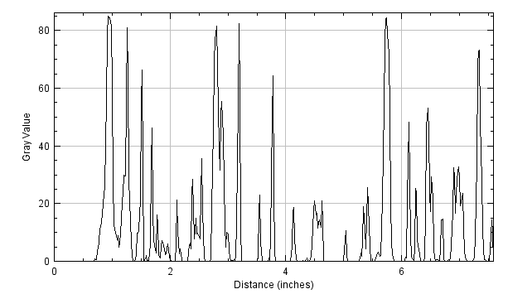
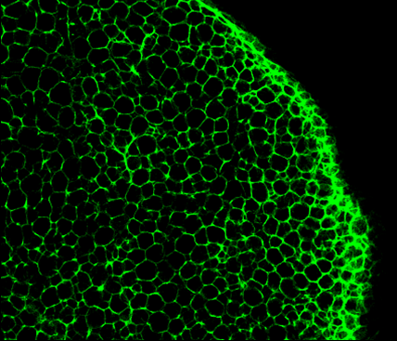Phalloidin intensity along the white arrow

Intensity of CD301 signals in macrophages at the periphery and in the center of the adipose tissue.

b/ We think that this is just a false impression from the 3D view. Indeed, when we created a planar section from the xy direction or from the xz direction, we found mostly round adipocytes (see images below).
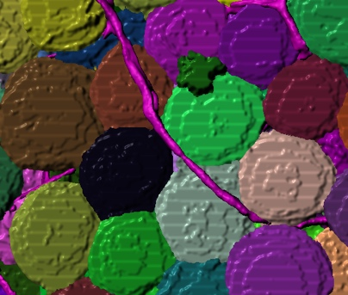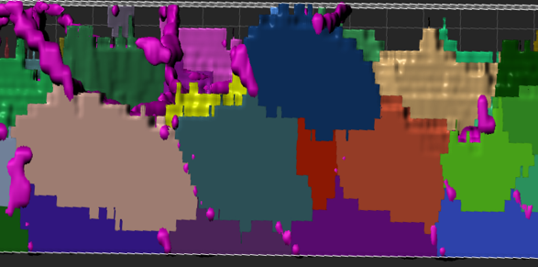
Side view
Face view

Minor points:
1. What is the advantage of using a high concentration of an antibody (10X) in a small volume of buffer? Why not use the same amount of antibody in a larger volume of buffer (1X)?
This is an interesting suggestion; we have never tested this possibility. Therefore, we are unable to predict whether having a similar amount of antibodies into a larger volume will improve, decrease or not modify the quality of the staining.
2. The authors should state which adipose depots were imaged in each figure.
We agree with the reviewer that this information is missing. We have added it to the revised version of the manuscript.
3. Tissue clearing was done with an ethanol gradient, which may cause shrinkage of tissue. Was there any shrinkage observed?
The problem of shrinkage highlighted by the reviewer is valide for all of the clearing protocols using solvents, and most likely independently of the solvents used (e.g. EtOH, methanol, DCM/DBE, etc.). Shrinkage is always difficult to estimate because one needs to compare it with native tissue, which in the case of adipose tissue is hard to image in depth without removing the lipids. Moreover, another difficulty comes from the fact that ethanol dehydration also removes lipids, starting to clear the peripheral parts of the tissues. This limits our capacity to correctly estimate the shrinkage of the tissue, although we believe that such shrinkage occurs. The reviewer correctly points out this limitation and we now discuss this in the revised version of the manuscript.
4. In Note 6, the authors described using several coverslips to prevent the tissue from floating in the chamber. Does this also prevent the tissue from moving around (sideways) during imaging?
The reviewer is correct. The coverslips also prevent tissue drift during imaging. We corrected the text accordingly.
5. The authors should provide more specifics on shaking. What speed was this done at?
We have corrected the text accordingly.

Reviewer #3:
Manuscript Summary:
This manuscript describes a relatively simple procedure for clearing white adipose tissues from mouse or human as well as suggestions for imaging via confocal microscopy and subsequent analysis in Imaris software. Unlike several recent methods that use methanol, dichloromethane, and dibenzyl ether, this method uses ethanol for dehydration and methyl salicylate for clearing.
We would like to thank the reviewer for noticing that our method is using different compounds for the clearing than the other methods previously described.

Major Concerns:
The table of required materials does not include any of the stains, dyes, or antibodies described in the 'Representative Results" section. Ideally, these should be included as well as the concentrations/dilutions/incubation times used to generate the provided image data in the manuscript.
We agree with the reviewer and have completed the table accordingly.
Minor Concerns:
If possible, describe the sample sizes within the protocol as length measures (or cubic volume) instead of weight as some researchers may not be able to visualize what 1 gram of WAT looks like (at least provide it in addition to weight).
We agree with the reviewer that this information was missing. We estimated the cubic volumes of the tissues we usually analyze and provided this information.

1 Ivanov, S. et al. Mesothelial cell CSF1 sustains peritoneal macrophage proliferation. Eur J Immunol. 49 (11), 2012-2018, (2019).
2 Esteve, D. et al. Lobular architecture of human adipose tissue defines the niche and fate of progenitor cells. Nat Commun. 10 (1), 2549, (2019).

