Custom genome GTF using StringTie¹
If a genome is missing genes of interest, a transcript guided assembly can be generated. Build gene models using STAR and StringTie as outlined below:

1. Index genome using STAR² v. 2.6.0c bby typing: STAR --runThreadN 16 --runMode genomeGenerate --genomeDir index_name --sjdbGTFfile $GENOME.GTF --sjdbOverhang $42 --genomeFastaFiles $GENOME.FASTA
Input a genome fasta file containing nucleotide sequences and genome gtf file containing coordinates for exons and coding sequences.

2. Map reads to genome using STAR by typing STAR --runThreadN 16 --genomeDir $index_name --outFileNamePrefix $SAMPLE --outSAMtype BAM SortedByCoordinate --sjdbScore 1 --readFilesIn $paired_READ1.FASTQ paired_READ2.FASTQ
Input a pair of mated FASTQ files per sample and location of STAR genome index. The output should be one sorted BAM file per sample.

3. Generate a StringTie¹ gtf file using: stringtie sample_id.sortedByCoord.out.bam -G $GENOME.GTF -o $SAMPLE.GTF -p 12 -A stringtie_id.abundance.txt.
Input: bam file (output from STAR containing mapped reads) and the genome gtf.
Output: gtf and abundance table for each sample.

4. Merge gtf files using StringTie.
stringtie <$SAMPLE.GTF(s)> --merge -G $GENOME.GTF -o $OUT.GTF -A merged_abundance.txt.
Input: genome gtf and gtf files generated by StringTie for all samples.
Output: merged gtf of the genome and all sample gtfs.

5. Extract fasta sequence for the merged StringTie assembly using cufflinks³ v. 2.2.1.
gffread -w $OUT.FASTA -g $GENOME.FASTA $MERGE.GTF.
Input: merged gtf and genome fasta file.
Output: fasta file with StringTie denoted transcripts.

To obtains a GTF from a transcriptome or genome GFF3 file use cufflinks³ v. 2.2.1.
gffread $IN.GFF3 -T -o $OUT.GTF
For a transcriptome, a GFF3 can be produced by running transdecoder as explained in the main text.

Recovering missing gene fragments from a genome
In some genomes the genes of interest may not be well annotated in terms of exon start and stop and may be missing gene beginning, middle or end. In such instances, the complete sequence can be recovered by searching the genome using homologous sequences.
- Open MEGA and import the sequences of interest.
- Align using MUSCLE as listed in the main text.
- Visually inspect sequences for large missing fragments.
- Manually complete any missing parts of the gene using orthologs or paralogs. An alternative is to search Pfam and view the alignment of the matching sequence.
- Confirm the correct complete gene sequence by using tblastn against the reference genome.
- tblastn -db $GENOME_BLAST_DATABASE -query $MANUALLY_COMPLETE_SEQ -evalue 1e-10 -out $ALIGNMENT.OUT
Input: genome database name and manually corrected index.
Output: alignment showing matches and mismatches for the manual correction.
NOTE: Check the BLAST output (FIG S3) to determine the actual sequence, which may be different from the correction done using orthologs or paralogs. If there is no match, leave the sequence as was originally. When checking output pay attention to the genome coordinates to make sure the missing exon is indeed part of the gene.

Cross sample normalization and differential expression analysis
TPMs can be normalized across samples using R v. 4.0.0 and a package called NOISeq^{4, 5}. https://www.bioconductor.org/packages/release/bioc/html/NOISeq.html

Comparisons across samples to identify differentially expressed genes can be done in R using edgeR⁶. A sample R script is below comparing Hydra hypostome (hypo) to the body column (bc).
Hydra_reads<-read.table("Hydra_tpm.txt",header = T,row.names = 1)
head(Hydra_reads)
Hydra_reads<-round(Hydra_reads)
keep<-rowSums(cpm(Hydra_reads)>1) >=2
Hydra_reads<-Hydra_reads[keep,]
head(Hydra_reads)
tissue<-factor(c("hypo","hypo","bc”, “bc”))
data.frame(sample=colnames(Hydra_reads),tissue)
design<-model.matrix(~tissue)
rownames(design) <- colnames(Hydra_reads)
list<-DGEList(counts=Hydra_reads,group=tissue)
list<-calcNormFactors(list)
plotMDS(list)
list<-estimateGLMCommonDisp(list,design)
list<-estimateGLMTagwiseDisp(list,design)
fit<-glmFit(list,design)
LRT<-glmLRT(fit,coef=2)
DEgenes<-LRT$table
head(DEgenes)
FDR <- p.adjust(LRT$table$PValue, method="BH")
DE_hydra_tissue<-cbind(DEgenes,FDR=FDR)

Figure S1.
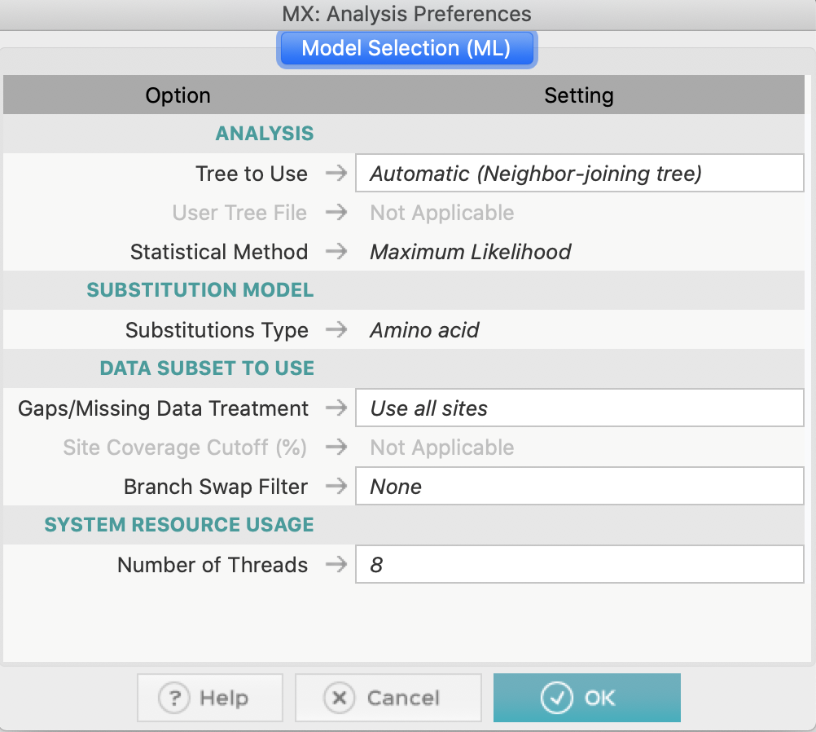
Figure S1. MEGAX Model Selection. The figure shows the interface for the MEGAX model selection tool. The figure shows the parameters and that we chose but Tree to Use, Gaps/Missing data treatment, Branch Swap Filter and Number of Threads can be changed.

Figure S2.
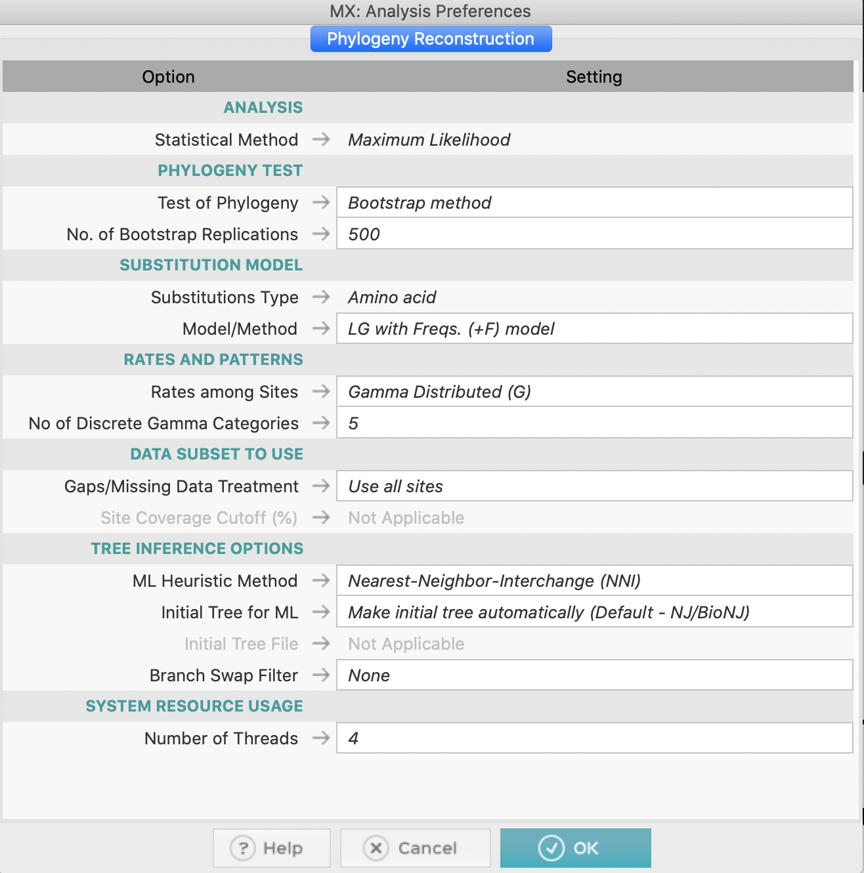
Figure S2. MEGAX Phylogeny Reconstruction. The figure shows the interface for the MEGAX phylogeny reconstruction tool. This figure has the parameters that we chose using the output of the previous step to set the substitution model and the rates among site.

Figure S3.
Figure S3. Partial gene recovery. Below the magenta line is the sequence from a closely related species that was manually added in MEGA. Above the blue line is the true sequence recovered from the genome. The in complete sequence can be corrected and used to generate a phylogeny and can also be used to repeat read-mapping if necessary.

References:
1. Pertea, M., Pertea, G.M., Antonescu, C.M., Chang, T.-C., Mendell, J.T., Salzberg, S.L. StringTie enables improved reconstruction of a transcriptome from RNA-seq reads. Nature biotechnology. 33 (3), 290–295, doi: 10.1038/nbt.3122 (2015).
2. Dobin, A. et al. STAR: ultrafast universal RNA-seq aligner. Bioinformatics. 29, 15–21, doi: 10.1093/bioinformatics/bts635 (2013).
3. Trapnell, C. et al. Transcript assembly and quantification by RNA-Seq reveals unannotated transcripts and isoform switching during cell differentiation. Nature Biotechnology. 28 (5), 511–515, doi: 10.1038/nbt.1621 (2010).
4. Tarazona, S., García-Alcalde, F., Dopazo, J., Alberto, F., Conesa, A. Differential expression in RNA-seq: A matter of depth. Genome Research. 2213–2223, doi: 10.1101/gr.124321.111.Freely (2011).
5. Tarazona, S. et al. Data quality aware analysis of differential expression in RNA-seq with NOISeq R/Bioc package. Nucleic Acids Research. 43 (21), doi: 10.1093/nar/gkv711 (2015).
6. Robinson, M.D., Mccarthy, D.J., Smyth, G.K. edgeR : a Bioconductor package for differential expression analysis of digital gene expression data. 26 (1), 139–140, doi: 10.1093/bioinformatics/btp616 (2010).

