June 9, 2020

We are pleased to submit a revision of our invited manuscript, “A photodiode-based optical imaging technique for recording network dynamics with single-neuron resolution in non-transgenic invertebrates”, by Evan S. Hill, Jeffrey W. Brown, and William N. Frost. This is an invited contribution to a Methods Collection on “Techniques for using “non-standard” animals for studying the neuronal basis of behaviors”, for which the Guest Editor is William Kristan.

All editor and reviewer points have been addressed.

Sincerely,
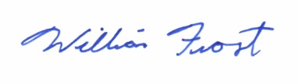
William Frost, PhD
Professor and Chair, Cell Biology and Anatomy
The Chicago Medical School
Director, Stanson Toshok Center for Brain Function and Repair
Rosalind Franklin University of Medicine and Science

