DEPARTMENT OF VETERANS AFFAIRS
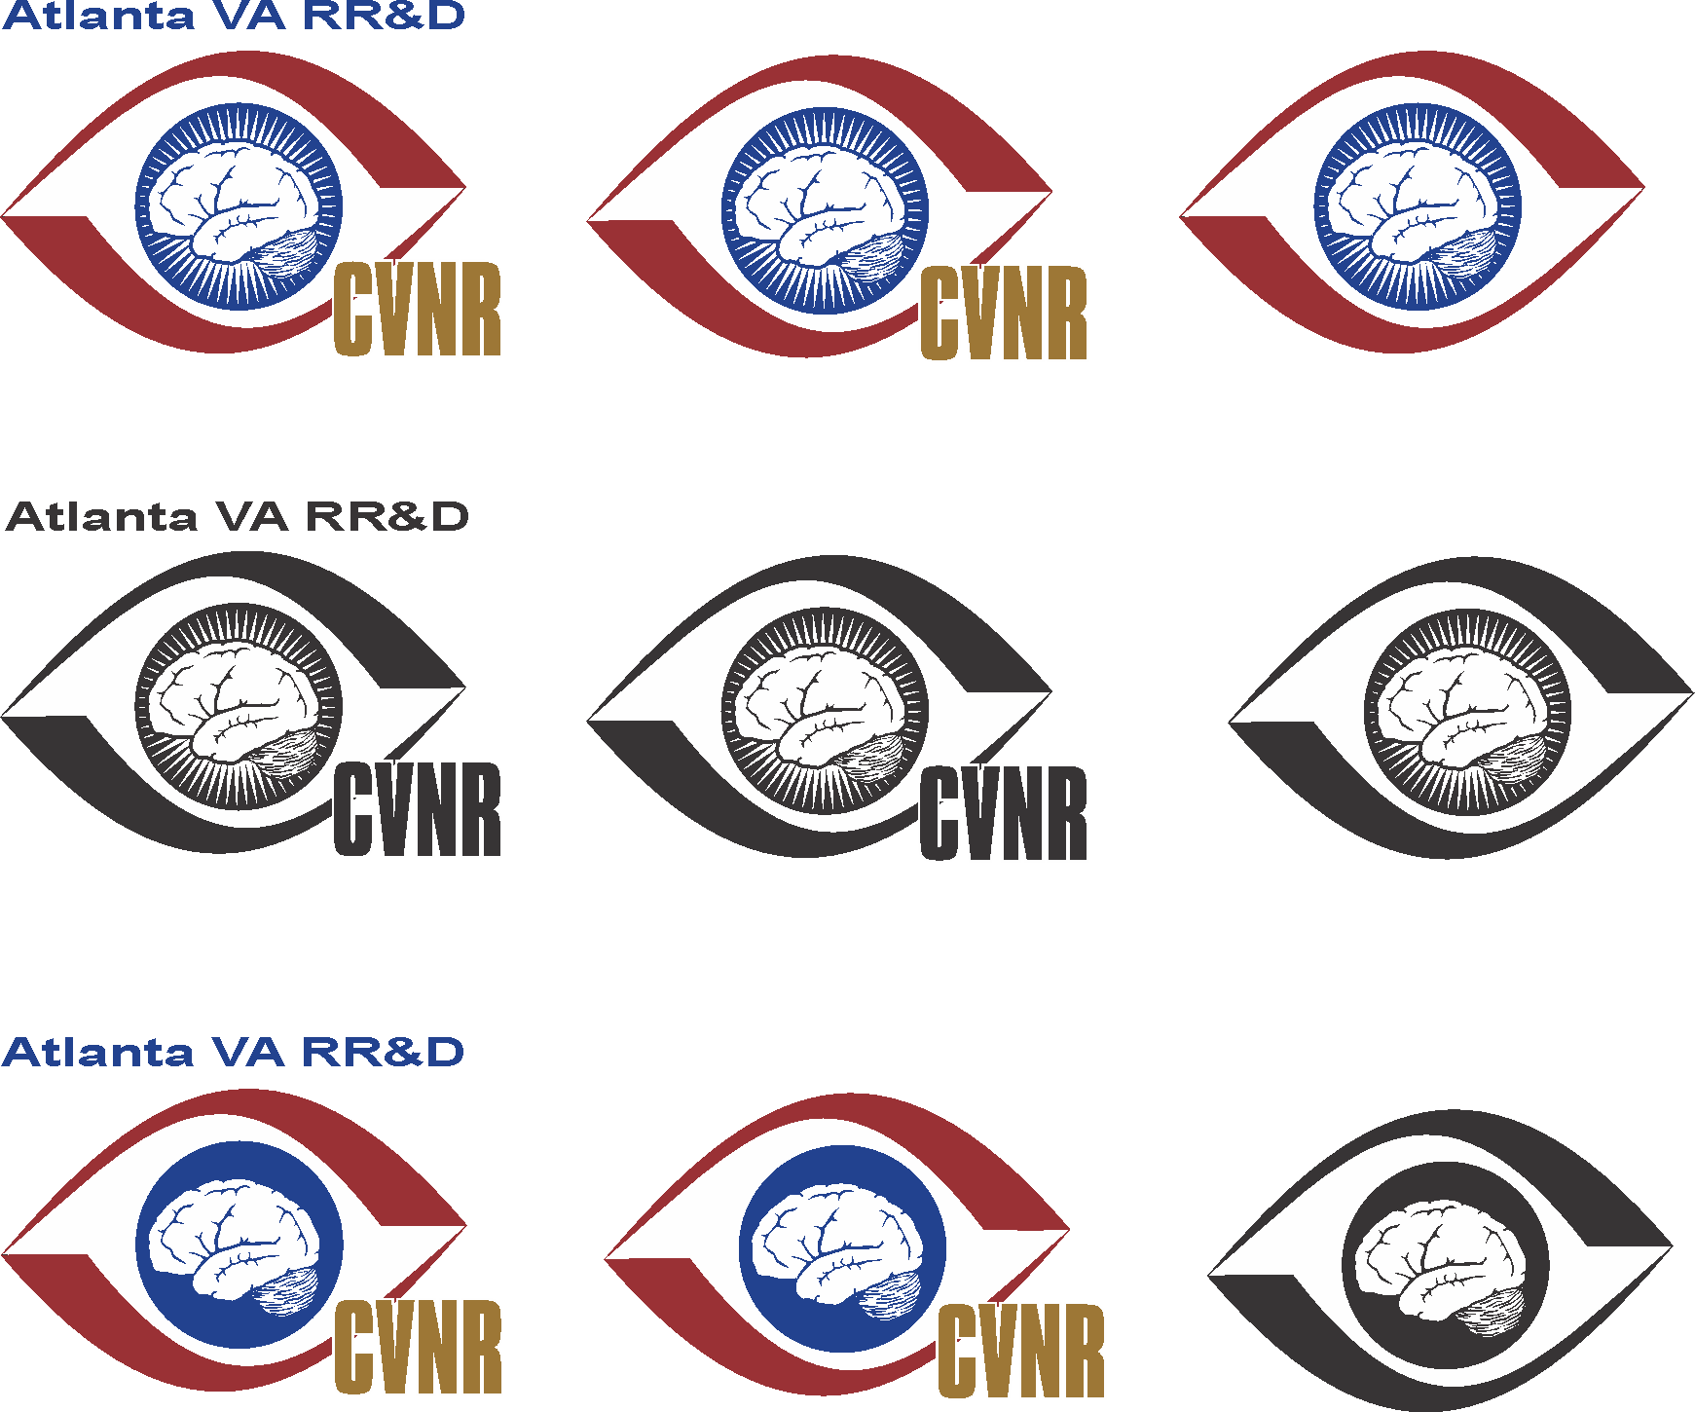
Rehabilitation R&D Service
Center of Excellence for Visual and Neurocognitive Rehabilitation
Atlanta VA Medical Center (151R)

Decatur GA 30033-4004

June 8, 2020

Dear Dr. Jewhurst,

We are very pleased to re-submit our paper, “In vivo structural assessments of ocular disease in rodent models using optical coherence tomography,” for publication in the Journal of Visual Experiments as part of the methods collection “Three blind mice: methods for assessing retinal and visual disturbances in rodent models.”

We thank the editors and reviewers for their insightful comments that have strengthened the manuscript. We are pleased that the reviewers thought the OCT process was described “clearly and comprehensively”. We have made the requested revisions to the manuscript based on the editors’ and reviewers’ suggestions and have addressed the comments in a point-by-point fashion below, with changes throughout the manuscript in tracked changes.

We hope that the manuscript is now acceptable for publication.

Sincerely,

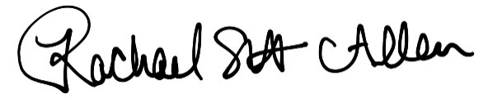

Rachael Allen, PhD
Career Development Awardee (CDA-2)
Atlanta VA Medical Center
Phone: (404)321-6111 x207570; Fax: (404)728-2847
restewa@emory.edu

Editorial Comments:
• Please take this opportunity to thoroughly proofread the manuscript to ensure that there are no spelling or grammatical errors.

Response: Thank you. We have carefully proofread the manuscript for spelling and grammar errors.
• Protocol Language:
1) Please ensure that all text in the protocol section is written in the imperative voice/tense as if you are telling someone how to do the technique (i.e. “Do this”, “Measure that” etc.) Any text that cannot be written in the imperative tense may be added as a “Note”, however, notes should be used sparingly and actions should be described in the imperative tense wherever possible.
Response: Thank you. We have adjusted all text such that it is written in the imperative voice. We have added any text that cannot be written in the imperative voice as “notes”.
2) Split up long steps (3.1) into 2-3 steps.
Response: Thank you. We have split any long steps into multiple steps.
• Protocol Detail: Please note that your protocol will be used to generate the script for the video, and must contain everything that you would like shown in the video. Please add more specific details (e.g. button clicks for software actions, numerical values for settings, etc) to your protocol steps. There should be enough detail in each step to supplement the actions seen in the video so that viewers can easily replicate the protocol.
Response: Thank you. We have described the protocol in more detail, including button clicks and settings.

• Protocol Highlight:
1) The highlighting must include all relevant details that are required to perform the step. For example, if step 2.5 is highlighted for filming and the details of how to perform the step are given in steps 2.5.1 and 2.5.2, then the sub-steps where the details are provided must be included in the highlighting.
2) The highlighted steps should form a cohesive narrative, that is, there must be a logical flow from one highlighted step to the next.
Response: We have included all relevant details in the highlighted steps. Sometimes we skipped steps because we intend to record the OCT video in rats but not mice. We have worked to ensure the highlighted steps read as a cohesive narrative.
3) Please highlight complete sentences (not parts of sentences). Include sub-headings and spaces when calculating the final highlighted length.

Response: We have highlighted whole sentences and included subheadings and spaces when calculating the final highlighted length.
4) Notes cannot be filmed and should be excluded from highlighting.

Response: Thank you. We have excluded all notes from highlighting.
• Discussion: JoVE articles are focused on the methods and the protocol, thus the discussion should be similarly focused. Please ensure that the discussion covers the following in detail and in paragraph form (3-6 paragraphs): 1) modifications and troubleshooting, 2) limitations of the technique, 3) significance with respect to existing methods, 4) future applications and 5) critical steps within the protocol.

Response: We ensured that our discussion has each of these sections. In particular, we have added to our discussion of limitations at the suggestion of one of the reviewers.

• Figures: Include scale references for images where appropriate.
Response: Thank you. We have included scale bars on our representative OCT images.
• References: Please spell out journal names.
Response: We have spelled out all journal names.
• Commercial Language:JoVE is unable to publish manuscripts containing commercial sounding language, including trademark or registered trademark symbols (TM/R) and the mention of company brand names before an instrument or reagent. Examples of commercial sounding language in your manuscript are Bioptigen 4300 SD-OCT system (Leica Microsystems, MATLAB, InVivoVueTM,
1) Please use MS Word’s find function (Ctrl+F), to locate and replace all commercial sounding language in your manuscript with generic names that are not company-specific. All commercial products should be sufficiently referenced in the table of materials/reagents. You may use the generic term followed by “(see table of materials)” to draw the readers’ attention to specific commercial names.
Response: Thank you. We have changed all mentions of commercial and trademarked materials to generic terms with a note to “see table of materials”.

• If your figures and tables are original and not published previously or you have already obtained figure permissions, please ignore this comment. If you are re-using figures from a previous publication, you must obtain explicit permission to re-use the figure from the previous publisher (this can be in the form of a letter from an editor or a link to the editorial policies that allows you to re-publish the figure). Please upload the text of the re-print permission (may be copied and pasted from an email/website) as a Word document to the Editorial Manager site in the "Supplemental files (as requested by JoVE)" section. Please also cite the figure appropriately in the figure legend, i.e. "This figure has been modified from [citation]."
Response: Thank you. We have uploaded the licensing information.

Reviewer: 1
Manuscript Summary:
The authors described protocol using Bioptigen 4300 SDOCT to acquire data from mice and rats retinas. The authors described the process clearly and comprehensively.
Major Concerns:
I don't have major concerns.
Minor Concerns:
1. In line 191: "1000 x 100 x 1, A scans, B scans, and repeated B scans" is better be written as 1000 x 100 x 1 (A scans x B scans x repeated B scans)
2. Line 234: in -> is
3. Resolution of figure 3 is low.

Response: We thank the reviewer for their careful reading of this manuscript. We have addressed each of these minor concerns.

Reviewer: 2
Manuscript Summary:
The manuscript presents in vivo morphological assessment of ocular structure in normal and diseased rodent models using OCT. It describes several protocols indlucing RNFL thickness, retinal thickness, axial lengths. Generally it is a well written manuscript.
Major Concerns:
None
Minor Concerns:
None

Response: We thank the reviewer for the positive feedback.

Reviewer: 3
Manuscript Summary:
Topic is the use of SD-OCT in visualising ocular structures. Numerous models were interrogated.
Major Concerns:
None
Minor Concerns:
Limitations were not adequately discussed
Response: We thank the reviewer for their feedback. We have added the following to our discussion on limitations: “A further limitation is the fact that hyperreflective lesions, such as exudates and hemorrhages, as well as major retinal vessels, result in shadowing of the underlying retinal structures, and thereby details of the underlying morphology are lost. In a case exhibiting choroidal neovascular membrane and diabetic retinopathy/macular edema where the retinal thickness was over 400 μm, it was hard to discern the underlying pathology and choroid²³. Additionally, SD-OCT can only be used to assess thickness at specific locations. SD-OCT also has a limited penetration depth for imaging the choroid and for imaging of whole eyes (the whole eye can be imaged in a mouse, but not in larger animals).”

