Joshua S. Sharp, Associate Professor of Pharmacology
jsharp@olemiss.edu
(662) 915-1758
Faser 417 | University, MS 38677-1848 |Phone: (662)915-7101 |Fax: (662)915-5638| jsharp@olemiss.edu
July 17, 2020

Editors of JoVE,

We thank the editor and the reviewers for their careful consideration of our article. We have addressed each editorial and reviewer comment point-by-point in our response. We believe that the process has resulted in a manuscript that is clearer and more useful to the reader and more even in tone, and we thank each reviewer for their contribution. My co-author and I are pleased to submit our revised manuscript, now entitled “Enabling Real-Time Compensation in Fast Photochemical Oxidations of Proteins for the Determination of Protein Topography Changes.”

Thank you for your consideration, and we look forward to your response.

Sincerely,
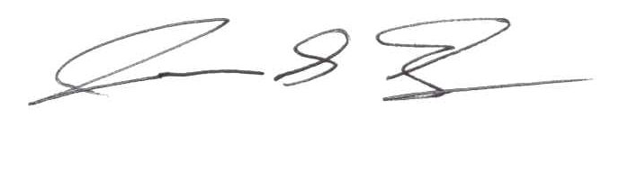
Joshua S. Sharp, Ph.D.

Associate Professor of Pharmacology
School of Pharmacy
Associate Professor of Chemistry and Biochemistry
The University of Mississippi

