Permission to re-use the figure
We re-used the “supplementatry figure 1” from our previous publication¹ to republish it as the figure 1 of our current manuscript to JoVE.

The link to the permission policy that allows to republish the figure:
https://link.springer.com/article/10.1007/s00395-019-0765-7#rightslink

a copy of the link is inserted here:
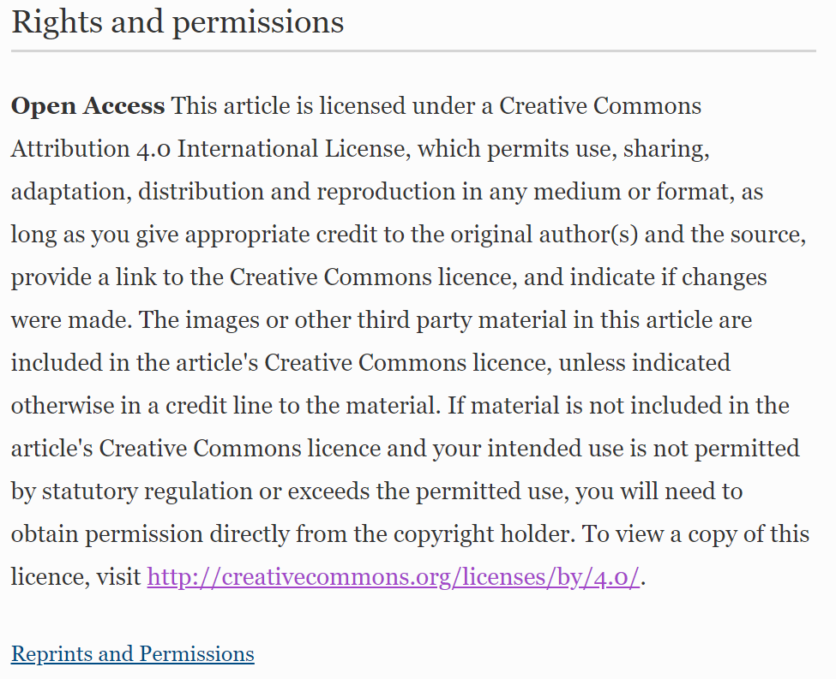

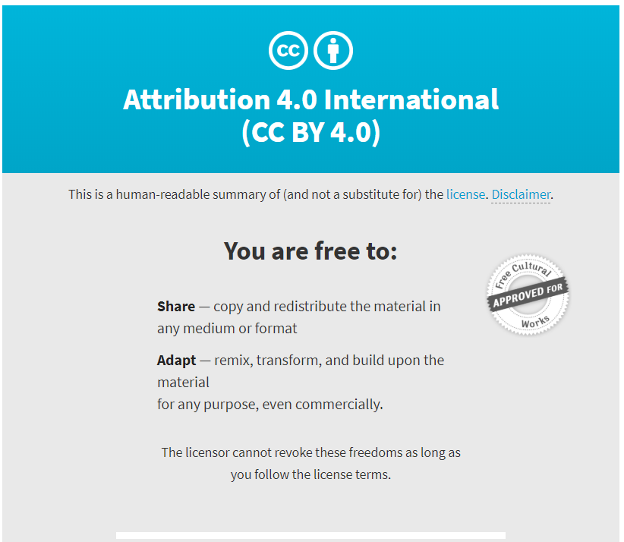

1 Haftbaradaran Esfahani, P. et al. Cell shape determines gene expression: cardiomyocyte morphotypic transcriptomes. Basic Res Cardiol. 115 (1), 7, (2019).

