
August 7, 2020

Vineeta Bajaj, Ph.D.
Review Editor


Dear Dr. Vineeta Bajaj,

Thanks a lot for reviewing our manuscript and sending it for peer review. In the revised manuscript, we have completely address editorial comments.

Please let us know if you have any question regarding our revised submission. Thanks a lot for your consideration!

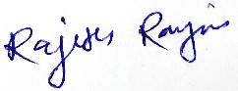
Sincerely yours and Best regards,

Rajesh Ranjan, PhD
Assistant Research Scientist
Department of Biology
Levi Hall 137
Johns Hopkins University
3400 North Charles Street
Baltimore, MD 21218-2685
Tel: 410-516-6543

