Response to Editor and Reviewers Comments on our Manuscript
Dear Editor:
We are grateful for all of your editorial work and reviewers’ efforts which we believe will certainly help improve the quality of our manuscript! We appreciate all comments from reviewers, and particularly we find a lot of comments inspiring and useful for us to further optimize our research on the novel fuel grain. Please find our responds to all editor and reviewers’ questions and comments as below. All changes in the manuscript are highlighted in red.
Responses to editor comments:
• Protocol Detail: Please note that your protocol will be used to generate the script for the video, and must contain everything that you would like shown in the video. Please add more specific details (e.g. button clicks for software actions, numerical values for settings, etc) to ALL SOFTWARE work among your protocol steps. There should be enough detail in each step to supplement the actions seen in the video so that viewers can easily replicate the protocol.
Response:
According to the editor’s reminder, we have revised the part of our manuscript in the "PROTOCOL" as “1.3.1 Open the FlowDDE software and click Communications settings from the Communication. 1.3.2 Click the corresponding connection interface and click OK. 1.3.3 Click Open communication to establish communication with the flow controller and open the measurement and control program (MCP). 1.3.4 Set the I/O channel of the multi-function data acquisition card and click Run to establish communication with the entire system.”

• Discussion: JoVE articles are focused on the methods and the protocol, thus the discussion should be similarly focused. Please ensure that the discussion covers the following in detail and in paragraph form (3-6 paragraphs): 1) modifications and troubleshooting, 2) limitations of the technique, 3) significance with respect to existing methods, 4) future applications and 5) critical steps within the protocol.
Response:
To fulfill the requirement of JoVE publication, we rewrite the "DISCUSSION" part as follows:
First, we have supplemented the "Modifications and troubleshooting" part in our manuscript, which is “Modifications and troubleshooting: When the inner surface of the shaped fuel grain was found to have cracks that could not be ignored, first, the heating temperature in the melt mixer was increased to 200°C. And then, the low-viscosity characteristics of the paraffin-based fuel were used to perform a repair pouring to fill the voids of the fuel grain. After the grain was completely cooled down, the inner hole was polished until the diameter was consistent with the original design one.”
Second, we have modified the "Critical steps" part in our manuscript, which is “because the contact area between the ABS substrate and print table is small……The infill density required to be set to 100% to reduce the printing voids in the ABS substrate and increase the printing density……In Step 1.1.3, in order to shorten the molding time……According to the actual molding quality and manufacturing experience, four or more pouring times are required for the size of fuel grain in this work.”
Third, we have revised the "Limitations of the method" part in our manuscript, which is “However, by comparing the results of the firing tests between the cracked fuel grain and the normal fuel grain……Because the low viscosity characteristics of the paraffin-based fuel make it spontaneously fill the cracks during the combustion process, this novel fuel grain is not sensitive to cracks.”
Last, we have modified the "Future applications or directions of the method" part in our manuscript, which is “We believe that this technique can effectively solve the key problem of low regression rate that currently restrict the development of the hybrid rocket engine. In addition, this technique shows great potential for improving combustion efficiency. Further optimization of parameters such as the blade structure, the number of blades, and the blade thickness is needed to maximize the combustion performance.”

• If your figures and tables are original and not published previously or you have already obtained figure permissions, please ignore this comment. If you are re-using figures from a previous publication, you must obtain explicit permission to re-use the figure from the previous publisher (this can be in the form of a letter from an editor or a link to the editorial policies that allows you to re-publish the figure). Please upload the text of the re-print permission (may be copied and pasted from an email/website) as a Word document to the Editorial Manager site in the "Supplemental files (as requested by JoVE)" section. Please also cite the figure appropriately in the figure legend, i.e. "This figure has been modified from [citation]."
Response:
We make sure that all figures in the revised manuscript are original pictures that have never been published. The newly revised figures in the "FIGURE AND TABLE LEGENDS" part are shown as below:
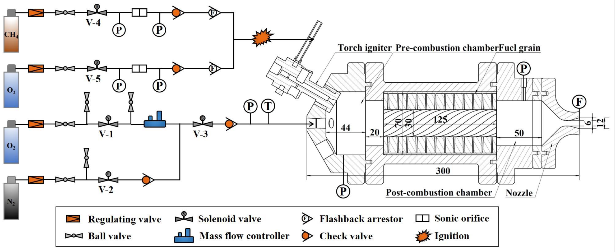
Fig 5
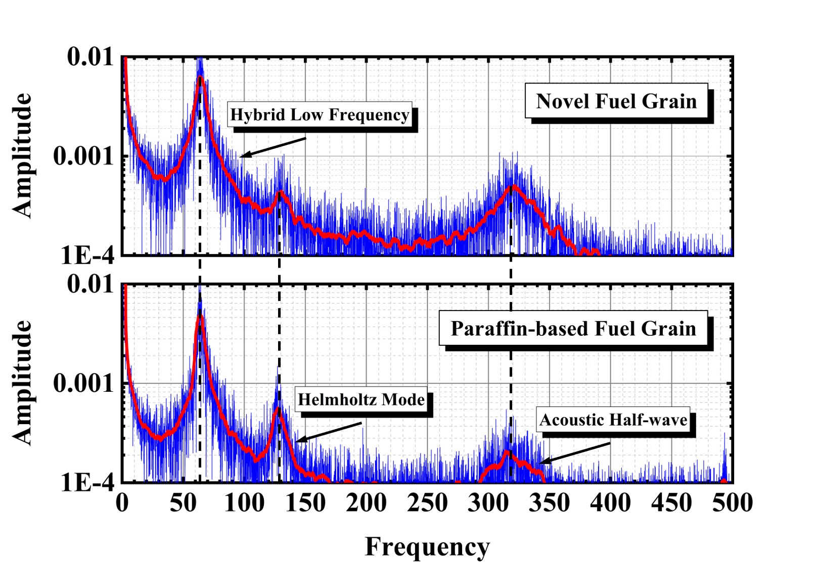
Fig 8
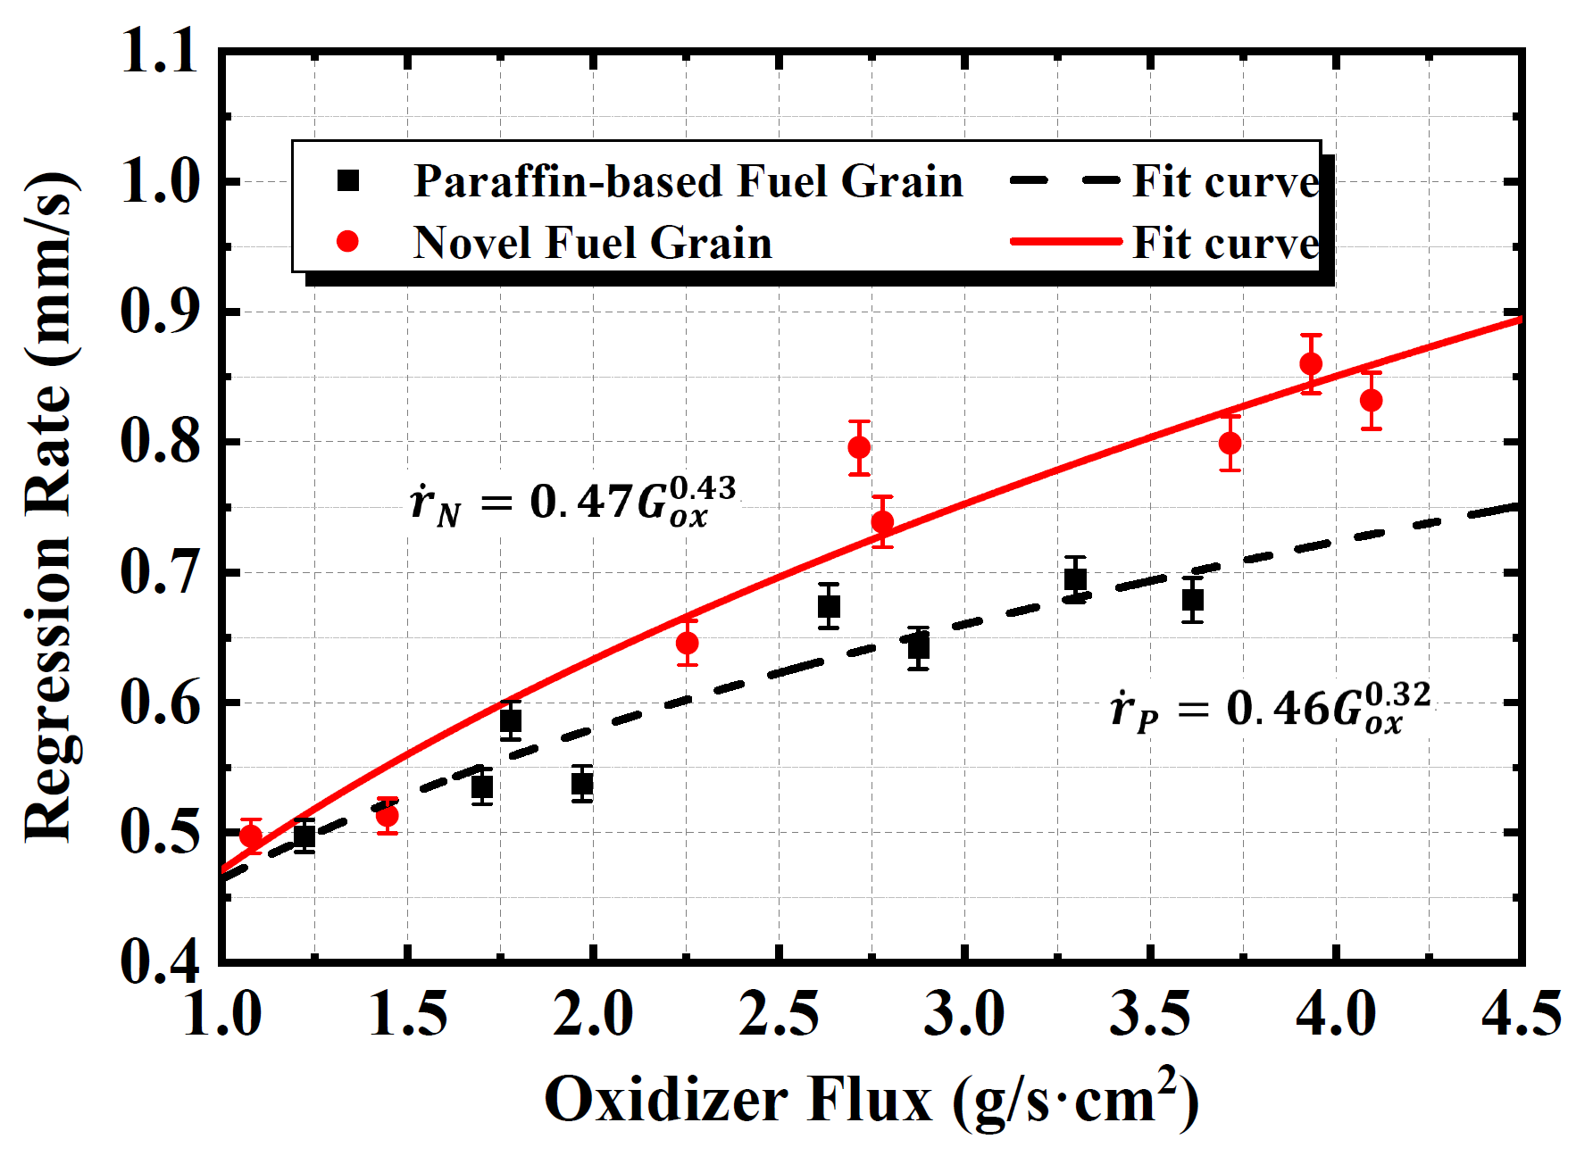
Fig 9
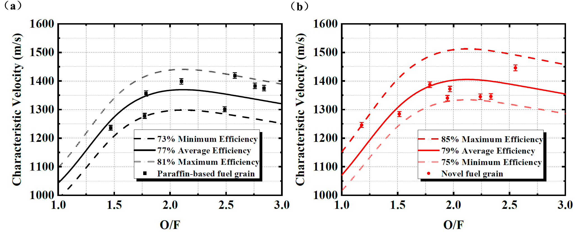
Fig 10

Responses to reviewer comments:
Reviewer #1:
Manuscript Summary: This work presents the work performed in order to improve the combustion efficiency by manufacturing a novel fuel from paraffin and ABS with 3D printing. The shape of the grain enables to increase the regression rate of the fuel compared to pure paraffin and to HTPB. However, even if the goal of this paper was to improve the combustion efficiency, this is not demonstrated in this work. This work is nevertheless interesting and the use of 3D printing could be a very promising way to improve the fuel regression rate value which is the main limitation to the development of this technology.
Response:
We appreciate your comment that “This work is nevertheless interesting and the use of 3D printing could be a very promising way to improve the fuel regression rate value which is the main limitation to the development of this technology.” Unfortunately, we cannot agree that “This work presents the work performed in order to improve the combustion efficiency by manufacturing a novel fuel from paraffin and ABS with 3D printing.” and “However, even if the goal of this paper was to improve the combustion efficiency, this is not demonstrated in this work.” The reviewer may misunderstand the keynote of our work.
In our studies, we proposed a novel scheme of helical fuel grain design. We have investigated the overall combustion performance of this novel fuel grain, including not only combustion efficiency, but also the pressure oscillations, the regression rate and even the ignition characteristics, which is detailed in our previous work³²:
32 Wang, Z., Lin, X., Li, F. & Yu, X. Combustion performance of a novel hybrid rocket fuel grain with a nested helical structure. Aerospace Science and Technology. 97, (2020).
As the most critical factor that restricts the development of hybrid rocket engines, the regression rate, for the novel fuel grain is demonstrated significantly higher than that of the paraffin-based fuel at the same oxidizer mass flow rate. In addition, under the condition of extremely low specific impulse of commercial ABS (about 140 s)³², the combustion efficiency of the novel fuel grain is still higher than that of the paraffin-based fuel grain, indicating the promising potential of this novel structure to improve the combustion efficiency without other optimization measures.

Major Concerns: - line 304: the temporal evolutions of the chamber pressure and of the oxidizer mass flow rate (or a table with these values for the tests performed) is required in order to have some ideas of the operation conditions of the hybrid engine. Chamber pressure oscillation is not sufficient for this.
Response:
Thank Reviewer to point it out! We have supplemented the temporal evolutions of the oxidizer mass flow rate in Figure 7, which is shown as follows:
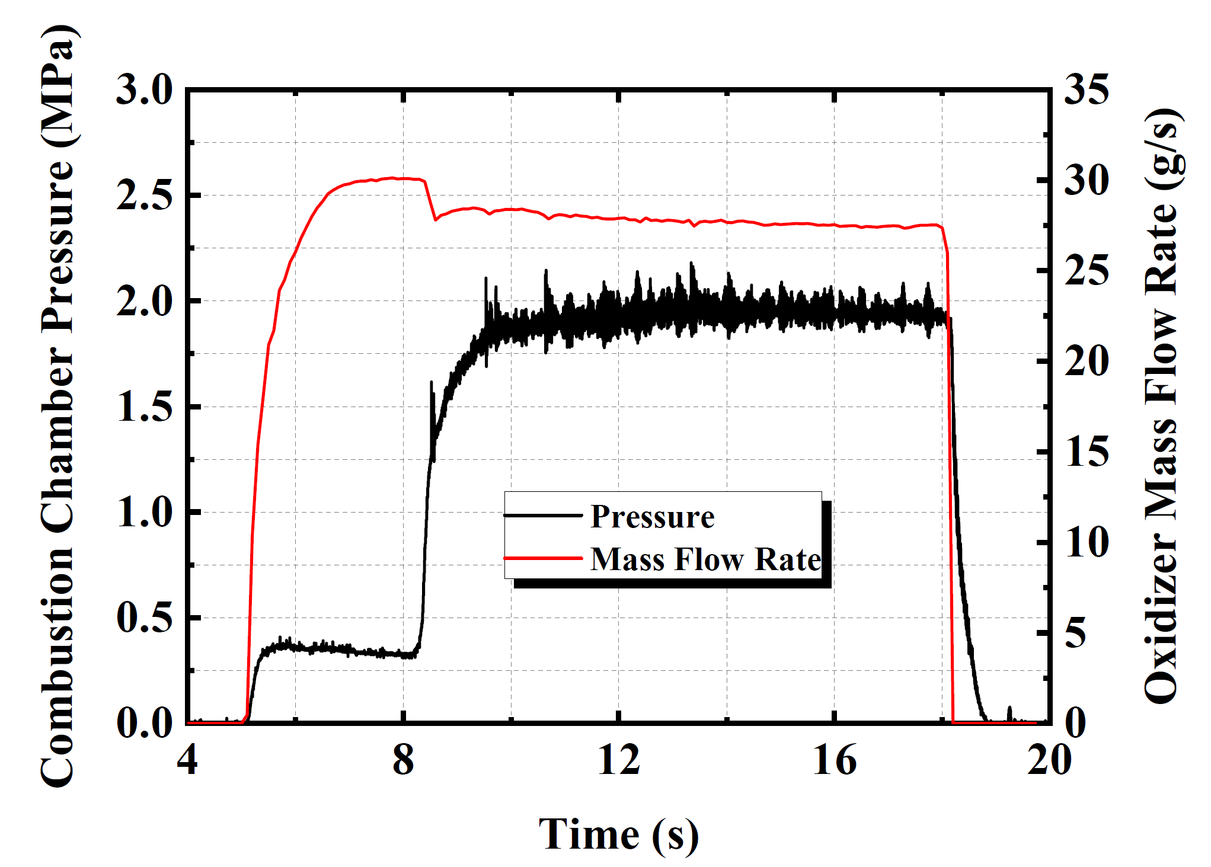
Figure 7: Change of combustion chamber pressure and oxidizer mass flow rate. During the combustion process, the mass flow rate of oxidizer and combustion chamber pressure remain relatively stable.
We have also supplemented the corresponding discussion in the “REPRESENTATIVE RESULTS” part, which is “Figure 7 shows the changes in combustion chamber pressure and oxidizer mass flow rate. To provide the necessary time for flow regulation, the oxidizer enters the combustion chamber in advance. When the engine builds pressure in the combustion chamber, the oxygen mass flow rate drops rapidly and then maintains a relatively steady change. During the combustion process, the pressure in the combustion chamber remains relatively stable.”

- line 329: I disagree with the conclusion and it is contradictory with what is written just above (line 327). The firing tests do not demonstrate the improvement of the combustion performances.
Response:
We apologize for the contradictory expressions in our manuscript due to the improper arrangement of context. We have modified our manuscript in the “REPRESENTATIVE RESULTS” part to avoid any ambiguity, which is “The results of firing tests demonstrated that the performance of the regression rate for the fuel grain with nested helical structure could be effectively improved³². Moreover, the novel structure also shows a great potential in improvement of combustion efficiency.”
On the combustion performance of the nested helical fuel grain, please refer to our response to the general comment of manuscript summary in the beginning.

Minor Concerns: - The regression rate calculates from equation 1 is a mean value. It would be well to use a back-integration method to obtain the temporal evolution of this quantity
Response:
We believe it is intrinsically difficult to accurately give the time evolution of the regression rate for hybrid rocket. Commonly used methods to obtain the time evolution of regression rate include X-ray, ultrasonic, microwave, PCG, resistance-based method and pressure methods etc.
- W. F. Obrien, Jr and H. L. Wood, "A Study of the Application of Microwave Techniques to the Measurement," 1968.
- T. Boardman, L. Porter, F. Brasfield, and T. Abel, "An ultrasonic fuel regression rate measurement technique for mixture ratio control of a hybrid motor," presented at the 31st Joint Propulsion Conference and Exhibit, 1995.
- D. Gramer and T. Taagen, "Low cost surface regression sensor for hybrid fuels, solid propellants, and ablatives," presented at the 37th Joint Propulsion Conference and Exhibit, 2001.
- B. Evans, N. Favorito, G. Risha, E. Boyer, R. Wehrman, and K. Kuo, "Characterization of Nano-Sized Energetic Particle Enhancement of Solid-Fuel Burning Rates in an X-Ray Transparent Hybrid Rocket Engine," presented at the 40th AIAA/ASME/SAE/ASEE Joint Propulsion Conference and Exhibit, 2004.
- L. Yang, E. Miner, and T. Romanos, "Application of plasma capacitance gage (PCG) for real time measurements of solid rocket motor internal insulation erosion," presented at the 26th Joint Propulsion Conference, 1990.
- C. Carmicino and D. Pastrone, "Pressure-Measurement Based Estimation of Fuel Regression Rate in Hybrid Rockets," presented at the 52nd AIAA/SAE/ASEE Joint Propulsion Conference, 2016.
These methods either increased in difficulty and cost of implementation, or are based on many assumptions. This is a very interesting direction for researchers to explore now, which is also our ongoing work to obtain a novel method for time evolution of the regression rate. But most of the current research on hybrid rocket engines still adopts the traditional differential weight method basically. To obtain the performance of the regression rate for a novel fuel grain, we believe that it is feasible to use the widely used average calculation method.

- Why calculate the theoretical characteristic with formula 5 and not with a chemical equilibrium code such as NASA CEA, RPA, etc.? The theoretical value would be more precise using such a software
Response:
We did not used the NASA CEA to obtain the calculation result because the formula calculation is a universal calculation method. For the final result, the error between the value calculated by the formula and the result calculated by CEA is less than 0.1%, which is acceptable.
However, we agree with the reviewer that the calculation of theoretical value for C* would be proper by NASA CEA, and we have revised the expression in the “PROTOCOL” part, which is “2.3.3 Calculate the theoretical characteristic velocity of paraffin fuel $C_{P}^{*}$ by NASA CEA code³³.”
We have also revised the corresponding Figure 10 in the “FIGURE AND TABLE LEGENDS” part, which is shown in our response to the general comment of editor in the beginning.

- line 301: What is the value of the specific heat ratio?
Response:
This value in the original manuscript is directly calculated by CEA. According to the modification in the above comment that “- Why calculate the theoretical characteristic with formula 5 and not with a chemical equilibrium code such as NASA CEA, RPA, etc.? The theoretical value would be more precise using such a software”, it is implied in the CEA calculation program, which does not need to be considered.

- lines 311-313: Pressure oscillations may not be an issue for hybrid rocket engine, it depends on the application
Response:
We agree with the reviewer on this point. However, the pressure oscillation of the combustion chamber is an issue that needs to be paid attention to for any rocket engine. The experimental results imply that the novel fuel grain does amplify the amplitude of the pressure oscillation. We also pointed out this phenomenon in our manuscript. In the future work, we hope to find out its specific cause and reduce it effectively.

- line 341: The combustion efficiencies range for hybrid engines is very large (from 85 to 98%). Moreover, combustion efficiency 1 or 2% lower than the other chemical propulsion system is not significant
Response:
We agree with the reviewer. According to the description in the literature⁵, in theory, the nature of the large diffusion flame results in a lower degree of mixing and, hence, a lower impulse efficiency. This loss is generally 1–2% greater than in either liquids or solids. However, as the reviewer’s comment, the combustion efficiency range of hybrid rocket engines is very large in practical applications. To address the reviewer’s concern, we have modified our manuscript in the “FIGURE AND TABLE LEGENDS” part, which is “The nature of the diffusion combustion model leads to a reduction in the degree of mixing and combustion efficiency, which ranges from 50% to 99% in practical applications^{27,35}.”
5 Kuo, K. K. & Chiaverini, M. J. Fundamentals of Hybrid Rocket Combustion and Propulsion. 10.2514/4.866876 (2007).
27 Armold, D. M. et al. in 50th AIAA/ASME/SAE/ASEE Joint Propulsion Conference 10.2514/6.2014-3754 (2014).
35 Franco, M. et al. Regression Rate Design Tailoring Through Vortex Injection in Hybrid Rocket Motors. Journal of Spacecraft and Rockets. 57 (2), 278-290, (2020).

- line 416 -417: Why not directly used the characteristic velocity value (cf. previous comment)?
Response:
We have used the calculation method suggested by the reviewer and revised our manuscript, which is shown in our response to the comment. For details please refer to our response to “- Why calculate the theoretical characteristic with formula 5 and not with a chemical equilibrium code such as NASA CEA, RPA, etc.? The theoretical value would be more precise using such a software”.

- line 442: Low combustion efficiency is not any more a problem since they are way to improve it up to 98% (use of a swirl injection, catalytic injection of H2O2, etc.)
Response:
We agree with the reviewer. But we are concerned about the improvement of the combustion characteristics of the novel fuel grain without other optimization measures (such as swirl injection). The results of firing tests show that not only the regression rate has been significantly improved, but the combustion efficiency also increases slightly under the condition of extremely low specific impulse of commercial ABS (about 140 s). This reflects the potential of the fuel grain itself. As the reviewer said, if the structure of swirl injection is added, the overall efficiency of hybrid rocket engine would be further improved.
Accordingly, we have modified our manuscript in the “DISCUSSION” part, which is “We believe that this technique can effectively solve the key problem of low regression rate that currently restrict the development of the hybrid rocket engine. In addition, this technique shows great potential for improving combustion efficiency. Further optimization of parameters such as the blade structure, the number of blades, and the blade thickness is needed to maximize the combustion performance.”

Reviewer #2:
Manuscript Summary: The manuscript provided an interesting manufacturing method of a novel propellant grain.
Response:
We appreciate the reviewer’s comment.

Minor Concerns: line 67: Boundary layer is not really laminar normally in hybrid rockets
Response:
We apologize for the improper expression in the first submission. The “INTRODUCTION” part of this paper has been revised, which is “As shown in Figure 3, when gas passes through the fuel grain, numerous recirculation zones are simultaneously created at grooves between blades. This characteristic structure on the inner surface increases the turbulence kinetic energy and swirl number in the combustion chamber, which increase the exchanges of both matter and energy in the combustion chamber.”

line 71: ones referring to combustion performances I suggest to explain which one
Response:
We have modified our manuscript in the “INTRODUCTION” part, which is “Ultimately, the regression rate of the novel fuel grain is effectively improved.”

line 76: when saying regression rate is higher than 20% to other paraffin-based propellant please add references
Response:
Thanks for your suggestion. We have modified our manuscript in the “INTRODUCTION” part , which is “The effect of improving the regression rate has been well proven: in particular, the regression rate of the novel fuel grain was demonstrated to be 20% higher than that of the paraffin-based fuel at the mass flux of 4 g/scm² ³².”
32 Wang, Z., Lin, X., Li, F. & Yu, X. Combustion performance of a novel hybrid rocket fuel grain with a nested helical structure. Aerospace Science and Technology. 97, (2020).

line 91: There or later please: A figure is provided however I suggest author provide more details on the experimental set-up used, please provide indication about the size of the engine, operative parameters (i.e. operative pressure), diagnostic available.
Response:
Thanks for your suggestion. We have modified Figure 5 to add the necessary dimensional parameters, which is shown in our response to the general comment of editor in the beginning. Moreover, we have revised our manuscript in “PROTOCOL” part, which is “The total length of the hybrid rocket engine is about 300 mm, and the inner diameter of the combustion chamber is 70 mm.” and “NOTE: With the supply pressure of 6MPa, and the range of mass flow rate of the oxidizer is between 7 g/s and 29 g/s.”

Line 117: explain what is "Raft and Skirt" function
Response:
"Raft and Skirt" function is an option in the software ideaMaker. The structure of “Raft and Skirt” is shown as below:
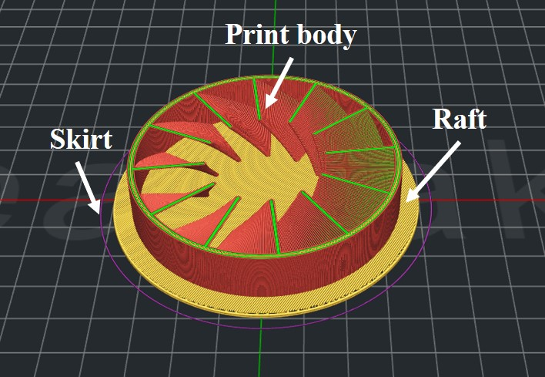
This is a screenshot from ideaMaker software that simulates the printing process. Raft can provide a larger contact area of the bottom surface to significantly improve the printing success rate. Skirt can effectively identify whether the position of the print body has changed during the printing process.

Line 120: please clarify
Response:
We have modified our manuscript in the “PROTOCOL” part, which is “NOTE: In order to improve the print quality and prevent warping, it is necessary to use a structure of print base (Raft with Skirt) to increase the contact area between the print body and the bottom plate.”

Line 133: please explain 58# paraffine what it is
Response:
58# paraffin represents paraffin with a melting point of about 58 ℃. We have modified our manuscript in “PROTOCOL” part, which is “1.1.2.1 Prepare raw materials of paraffin, polyethylene (PE) wax, stearic acid, ethylene-vinyl acetate (EVA), and carbon powder. Configure the paraffin-based fuel according to the ratio of these components as 0.58:0.2:0.1:0.1:0.02.” We have also modified our table of materials as follows:

Line 159: Please explain what means multiple-casting method
Response:
Multiple-casting is to divide the process of filling paraffin into multiple steps, rather than the original one-time pouring. This method can effectively reduce the thermal stress caused by cooling during the formation of the fuel grain, and greatly improve the success rate of the formation. We have modified our manuscript to clarify, which is “NOTE: Combined with effective cooling, a multiple-casting method, which is to divide the original one-time filling process into multiple times, is required to reduce the thermal stress.”

Line 181: (or somewhere else) please provide the overall size of the engine
Response:
We have modified our manuscript accordingly, which is shown in Figure 5.

Line 264: please explain m0, mf
Response:
we have modified our manuscript in the “PROTOCOL” part, which is “2.2.1 Calculate the regression rate of the fuel grain according to the following function:
$$\dot{r}=\frac{∆D}{2t}=\frac{\sqrt{{d_{0}}^{2}+\frac{4∆m_{f}}{πρL}}-d_{0}}{2t}$$
where $∆D$ represent the change of average inner diameters of the solid fuel grain after the firing test; $∆m_{f}$ represent the change of quality of the fuel grain; $L$ is the length of the fuel grain; $ρ$ is the average density of the solid fuel; $t$ is the working time.”

Line 279: please explain what function is Allometric1
Response:
In the hybrid rocket engine, the calculation equation $\dot{r}=aG_{ox}^{n}$ for characterizing the change of the regression rate with the flux is widely used, such as the reference:
- X. Li, H. Tian, N. Yu, and G. Cai, "Experimental investigation of fuel regression rate in a HTPB based lab-scale hybrid rocket motor," Acta Astronautica, vol. 105, no. 1, pp. 95-100, 2014.
- F. S. Mechentel, A. M. Coates, and B. J. Cantwell, "Small-scale Gaseous Oxygen Hybrd Rocket Testing for Regression Rate and Combustion Efficiency Studies," presented at the 53rd AIAA/SAE/ASEE Joint Propulsion Conference, 2017.
In order to fit the regression rate of the fuel grain, the fitting equation Allometric1 used is $y=ax^{b}$. we have modified our manuscript in the “PROTOCOL” part, which is “NOTE: The fitting function was selected as Allometric1 ($y=ax^{b}$), and the iterative algorithm was selected as Levenberg–Marquardt optimization algorithm.”

Line 328: Please compare the C* as value +- uncertainty
Response:
Thanks for your suggestion. We have modified our manuscript in the “REPRESENTATIVE RESULTS” part, which is “Correspondingly, facilitated by the nested helical structure, the average combustion efficiency of the novel fuel grain has been increased by about 2% (±0.7%).” And we have also modified the Figure 10 accordingly, which is shown in our response to the general comment of editor in the beginning.

Line 369: Please clearly explain what means printing contact surface
Response:
The “printing contact surface” refers to the part where the printed ABS helical structure contacts the print table. We have modified our manuscript in “DISSCUSSION” part, which is “In Step 1.1.1.5, because the contact area between the ABS substrate and print table is small”.

Line 409: Please explain what means that the casting process has been carried four times.
Response:
For the multiple-casting method, please refer to our response to “Line 159: Please explain what means multiple-casting method”. The reason why the number of four pourings is used depends mainly on the joint effect of the success rate of molding and the molding time, which is the value given in combination with practical experience.
We have modified our manuscript in “DISSCUSSION” part, which is “In Step 1.1.3, in order to shorten the molding time, and to avoid the problem that the fuel grain is easy cracked due to the excessive thermal stress generated during the cooling process of the one-shot molding process, increasing the number of pourings and effective cooling are necessary for rapid and high-quality molding of the fuel grain. According to the actual molding quality and manufacturing experience, four or more pouring times are required for the size of fuel grain in this work.”

Line 423: Please do explain better if the grain was affected by cracks, before test. Please clarify the whole chapter.
Response:
The results of firing tests demonstrate that the grains with fine cracks on the surface of the inner hole are basically not affected. During the combustion process, paraffin wax with low viscosity characteristics will spontaneously fill the cracks, and ABS has played a very good role as a framework to improve the overall mechanical properties. We have modified our manuscript in “DISSCUSSION” part, which is “However, by comparing the results of the firing tests between the cracked fuel grain and the normal fuel grain, it was found that the characteristic structure of the two types of fuel grains, which is shown in Figure 2, remained basically the same after combustion. No obvious phenomenon of erosive burning was observed on the inner surface of the fuel grain. Because the low viscosity characteristics of the paraffin-based fuel make it spontaneously fill the cracks during the combustion process, this novel fuel grain is not sensitive to cracks.”

Line 427: Please explain which is the structure of the inner surface of the fuel grain you do refer to.
Response:
The nested helical structure generated in the combustion process due to different regression rates between ABS and paraffin-based fuel is shown in the Figure 2:
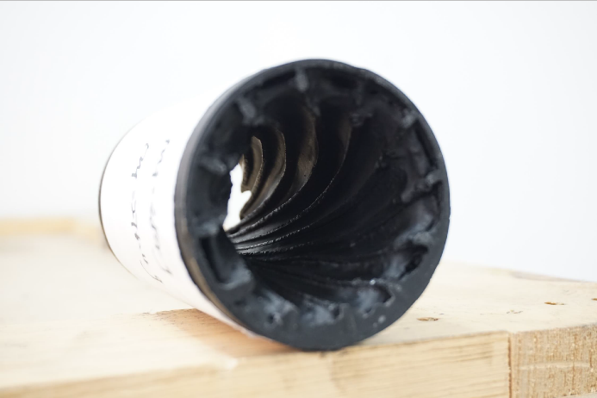
Figure 2
We have modified our manuscript in “DISSCUSSION” part, which is “However, by comparing the results of the firing tests between the cracked fuel grain and the normal fuel grain, it was found that the characteristic structure of the two types of fuel grains, which is shown in Figure 2, remained basically the same after combustion.”

Line 433 Pleas explain better how pouring is performed, please provide a clearer description of the whole molding process (number of injectors, location, size).
Response:
In order to better describe the pouring process, we have modified our manuscript in “PROTOCOL” part, which is “NOTE: The molten paraffin-based fuel flows into the initial section of mold through the pipe and the end cover with a central opening. And under the effect of gravity, the liquid fuel spreads along the axial direction of the mold.”

Reviewer #3:
Manuscript Summary: The authors present the details of a technique they developed in a previous paper (https://doi.org/10.1016/j.ast.2019.105613) to increase the performance of hybrid rocket engines. Their approach consists of combining two ideas: first, using a nested helical structure in the fuel grain to improve the heat transfer process, arguably by generating recirculating zones between adjacent blades in the helical structure; second, by filling the space between the blades with a paraffin-based fuel. On the contrary to the material used in the helical structure, this "filling" fuel presents a high regression rate. In this way, the two materials with different regression rates can be combined with synergy, since during the combustion paraffin will initially be consumed faster, creating grooves between adjacent vanes in the helical structure, which in turn increases the heat transfer.
In my point of view, the level of details about the technique and results presented in this paper justifies its publication, since it involves all aspects of the research, from the preparation of the fuel grains with 3D printers to the discussion of some results, including both the basic formulation of the properties studied and the data acquisition with adequate software. Also, the revised version had a significant improvement in this last part.
Therefore, I believe this paper provides the community with interesting techniques used in aerospace engineering and should be published in JoVE. Some minor issues and suggestions are listed below.
Response:
We are grateful for your detailed summary of all our work on the novel fuel grain. And we appreciate your comment that “I believe this paper provides the community with interesting techniques used in aerospace engineering and should be published in JoVE.” The design concept of the novel fuel grain is just as you summarized. While maintaining the structure of single-port, the advantages of the two materials are combined. Due to the different regression rate between the two fuels, the special helical structure and numerous recirculation zones are formed during the combustion process to improve the heat and matter transfer process.

Minor Concerns: -The authors do not discuss the cracking of paraffin in their paraffin-based fuel formulation or the effect of the helical structure in possible cracks and internal rips in the paraffin fuel, there is only a small commentary at the end of page 10. Perhaps the authors could improve the discussion on this point by adding a phrase or two.
Response:
Thanks for your suggestion. We have added the corresponding discussion in “DISSCUSSION” part, which is “However, by comparing the results of the firing tests between the cracked fuel grain and the normal fuel grain, it was found that the characteristic structure of the two types of fuel grains, which is shown in Figure 2, remained basically the same after combustion. No obvious phenomenon of erosive burning was observed on the inner surface of the fuel grain. Because the low viscosity characteristics of the paraffin-based fuel make it spontaneously fill the cracks during the combustion process, this novel fuel grain is not sensitive to cracks.”

-In the introduction, the authors do not comment on other ongoing approaches using paraffin-based fuels, such as those using paraffin particles dispersed in binders which potentially retains the mechanical properties of the binder and the high regression rate of paraffin (https://doi.org/10.2514/1.B36977), enhancing additives for paraffin wax grains (https://doi.org/10.2514/6.2019-3922) and/or general reviews concerning the usage of paraffin-based hybrid rocket technology (https://doi.org/10.2514/6.2019-4010).
Response:
We appreciate your efforts picking this up which we did not comment on other research on paraffin-based fuels! We have modified our manuscript in the “INTRODUCTION” part, which is “Although various techniques have been studied and developed, such as the use of multi-ports⁶, enhancing additives⁷⁻⁹, liquefying fuel¹⁰⁻¹², swirl injection¹³, protrusions¹⁴, and bluff body¹⁵, these approaches are associated with problems in volume utilization, combustion efficiency, mechanical performance, and redundancy quality.”
We have also added these references to our paper and renumbered the references:
9 Karakas, H., Kara, O., Ozkol, I. & Karabeyoglu, A. M. in AIAA Propulsion and Energy 2019 Forum 10.2514/6.2019-3922 (2019).
11 Leccese, G., Cavallini, E. & Pizzarelli, M. in AIAA Propulsion and Energy 2019 Forum 10.2514/6.2019-4010 (2019).
12 Cardoso, K. P., Ferrão, L. F. A., Kawachi, E. Y., Gomes, J. S. & Nagamachi, M. Y. Ballistic Performance of Paraffin-Based Solid Fuels Enhanced by Catalytic Polymer Degradation. Journal of Propulsion and Power. 35 (1), 115-124, (2019).

Pag 3. Line 63: ... Figure 2 (, which shows the fuel grain after the combustion,) a special …
Response:
Thanks for your suggestion. We have modified our manuscript in the “INTRODUCTION” part, which is “The special helical structure of the novel fuel grain after combustion is shown in Figure 2. When gas passes through the fuel grain, numerous recirculation zones are simultaneously created at grooves between blades, which is shown in Figure 3.”

Pag. 10 lines 386 to 391: While the discussions in this subject are for sure interesting, can then be classified as critical steps?
Response:
We agree with the reviewers' comments. This part of the discussion on the composition of paraffin-based fuel is not directly related to the fuel grain used in this article, which is not suitable as a critical step, so we have deleted the description of this part, which is “As mentioned in Step 1.1.2.1, the proportion of paraffin-based fuels can be adjusted according to the purpose of the experiment. When the difference in the regression rate between the paraffin-based fuel and the ABS fuel is to be increased, the proportion of paraffin fuel in the component can be increased. If mechanical properties of the fuel grain are to be improved, then the proportion of EVA in the formulation can be increased.”

Pag. 11 lines 421 to 417: The same issue pointed before.
Response:
Thanks for your suggestion. We have modified our manuscript in the “DISCUSSION” part, which is “In Step 1.1.3, in order to shorten the molding time, and to avoid the problem that the fuel grain is easy cracked due to the excessive thermal stress generated during the cooling process of the one-shot molding process, increasing the number of pourings and effective cooling are necessary for rapid and high-quality molding of the fuel grain. According to the actual molding quality and manufacturing experience, four or more pouring times are required for the size of fuel grain in this work.”

Pag. 10 line 354: … same (initial) inner diameter.
Response:
We have modified our manuscript in the “FIGURE AND TABLE LEGENDS” part, which is “(b) Nested helical structure of the novel fuel grain, in which paraffin-based fuel and ABS blades maintain the same initial inner diameter.”

