
June 22, 2020

Vineeta Bajaj, Ph.D.
Review Editor
JoVE

Dear Dr. Bajaj,

Thank you very much for your e-mail and the editorial comments on our manuscript entitled ‘Three-Dimensional Motor Nerve Organoid Generation’. We have carefully considered the editorial comments and made changes accordingly. Please find attached our responses in the next page. All revisions are indicated with track changes in the manuscript. Suggested parts for video filming are highlighted in yellow shade.

We believe that we have adequately addressed all comments and hope that the revised manuscript is now acceptable for publication in JoVE.

Thank you for considering our manuscript, and I look forward to hearing from you.

Sincerely,
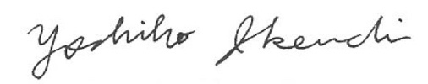

Yoshiho Ikeuchi, PhD
Associate Professor, Institute of Industrial Science, The University of Tokyo

Point-by-point response
Editorial comments:
“1. The editor has formatted the manuscript to match the journal's style. Please retain and use the attached file for revision.”

We used the provided file for revision.
“2. The protocol section is more than the upper limit of 10 pages, please adjust the protocol section to fit to 10 pages.”

We have reduced the protocol to fit to 10 pages.
“3. The highlight is more than 2.75 pages. Please adjust the highlight to fit 2.75 pages including headings and spacings.”
We have reduced the highlights to fit 2.75 pages.

“4. Please address all the specific comments marked in the manuscript.”

We have revised in the Word file with track change records.

