Editorial comments:
Changes to be made by the Author(s):
1. Please take this opportunity to thoroughly proofread the manuscript to ensure that there are no spelling or grammar issues. The JoVE editor will not copy-edit your manuscript and any errors in the submitted revision may be present in the published version.
2. Please format the manuscript as: paragraph Indentation: 0 for both left and right and special: none, Line spacings: single. Please include a single line space between each step, substep and note in the protocol section. Please use Calibri 12 points
Changed to single line spacing and used Calibri 12 for the font
3. Please provide an email address for each author.
Done
4. Please provide at least 6 keywords or phrases.
Done
5. Please do not make a separate subheading for abbreviations. Please expand all abbreviations during the first-time use.
Removed abbreviations subheading
6. For in-text formatting, corresponding reference numbers should appear as numbered superscripts after the appropriate statement(s) without brackets.
Done
7. JoVE cannot publish manuscripts containing commercial language. This includes trademark symbols (™), registered symbols (®), and company names before an instrument or reagent. Please remove all commercial language from your manuscript and use generic terms instead. All commercial products should be sufficiently referenced in the Table of Materials and Reagents.
For example: Liberase™, Kimwipes, Milteny MACS CD31 & CD45 microbeads, Gentle MACS C tubes, Falcon tube, Thermomixer, MACS Octo Dissociator, PluriSelect cell strainers, TransWell culture insert, MatriGel, etc
Removed all the trademarks
8. Please revise the Introduction to include all of the following:
a) A clear statement of the overall goal of this method
b) The rationale behind the development and/or use of this technique
c) The advantages over alternative techniques with applicable references to previous studies
d) A description of the context of the technique in the wider body of literature
e) Information to help readers to determine whether the method is appropriate for their application
9. Please ensure that all text in the protocol section is written in the imperative tense as if telling someone how to do the technique (e.g., “Do this,” “Ensure that,” etc.). The actions should be described in the imperative tense in complete sentences wherever possible. Avoid usage of phrases such as “could be,” “should be,” and “would be” throughout the Protocol. Any text that cannot be written in the imperative tense may be added as a “Note.”
10. Please adjust the numbering of the Protocol to follow the JoVE Instructions for Authors. For example, 1 should be followed by 1.1 and then 1.1.1 and 1.1.2 if necessary. Please refrain from using bullets, alphabets, or dashes.
Corrected the numbering pattern in the protocol and ensured all the test above was included in the intorduction
11. The Protocol should contain only action items that direct the reader to do something. Please use complete sentences throughout.
Modified
12. Please ensure that individual steps of the protocol should only contain 2-3 actions sentences per step.
Modified
13. Please ensure you answer the “how” question, i.e., how is the step performed?
14. The manuscript is a standalone publication. Please do not refer to the video.
Removed video reference from the manuscript.
15. 1: Please make substeps and show how the actions are performed.
16. 2.1.2: How do you visually identify visceral pleura.
Mentioned how to identify visceral pleura: A delicate membrane that covers the surface of the lung.
17. 2.2.2 Amount of tissue used?
Added: 2-3 grams of tissue in 25ml of liberase and DNase. Make sure that the amount of tissue does not exceed the 25ml mark on a 50ml conical tube to ensure efficient enzymatic digestion.
18. 2.3.2: When do you stop the digestion?
Added: 45 minutes
19. Line 151: Is it Antibody or Antigen?
Antibody. Corrected in the manuscript.
20. There is a 10-page limit for the Protocol, but there is a 2.75-page limit for filmable content. Please highlight 2.75 pages or less of the Protocol (including headings and spacing) that identifies the essential steps of the protocol for the video, i.e., the steps that should be visualized to tell the most cohesive story of the Protocol.
The isolation of cells from the proximal and distal lungs will be done simultaneously in the video. Even though the highlighted portions exceed 2.75 pages, the video will be within the allocated time. Isolation in both regions will not be showed separately, hence the video will not be long.
21. Please ensure the results are described in the context of the presented technique.
22. Please obtain explicit copyright permission to reuse any figures from a previous publication. Explicit permission can be expressed in the form of a letter from the editor or a link to the editorial policy that allows re-prints. Please upload this information as a .doc or .docx file to your Editorial Manager account. The Figure must be cited appropriately in Figure Legend, i.e. “This figure has been modified from [citation].”
We did not reuse any previously published figures
23. As we are a methods journal, please revise the Discussion to explicitly cover the following in detail in 3-6 paragraphs with citations:
a) Critical steps within the protocol
b) Any modifications and troubleshooting of the technique
c) Any limitations of the technique
d) The significance with respect to existing methods
e) Any future applications of the technique
24. Please ensure the Acknowledgements section, contains any acknowledgments and all funding sources for this work.
25. Please upload high-resolution figures.
Done
26. Please remove trademark (™) and registered (®) symbols from the Table of Equipment and Materials. Please sort the table in alphabetical order. Please combine tables 1-5. They all are essentially a table of materials.
Removed the trademarks and tables are arranged alphabetically.
27. All tables should be uploaded separately to your Editorial Manager account in the form of an .xls or .xlsx file. Each table must be accompanied by a title and a description after the Representative Results of the manuscript text.
Tables are uploaded in a separate file and accompanied with appropriate titles and descriptions.
Reviewers' comments:
Reviewer #1:
Manuscript Summary:
Konda et al, describe a protocol for isolation of epithelial cell types from different regions of the human lungs; in particular HTII280+ type II alveolar cells from the distal region and NGFR+ basal cells from the proximal region.
Both cell types have been shown to have progenitor like features in mouse. Konda et al show that they can form in vitro organoids when combined with human lung fibroblasts.
Minor Concerns:
In the abstract instead of 5000 cells/well please express as cell/surface since it's not clear yet which is the well format.
Added: 1.4 x10^4 cells/cm²
Table 1: in the text authors mention 60ml and 10ml syringes but only 30ml syringes are listed.
Added: We used 10 ml and 30 ml syringes, and I corrected it and added catalog number for 10ml
I couldn't find the composition of HBSS+, it may be helpful to add a section on buffers used for cell isolation aside from Materials and Equipment.
Added: HBSS+ buffer and FACS buffer are same. I mentioned FACS buffer composition in the table and changed the title.
Please pay attention to refer to the right tables and figures along the protocol, only table 1 and 4 are cited in the first 3 paragraphs. I would suggest this order for the tables:
Table 1: Materials for cell isolation and equipment's
Table 2: Composition of the FACS Buffer
Table 3 (was 4) : List of antibodies for FACS
Table 4 (was 3): Composition of Organoid Culture mediums
Table 5: List of antibodies for immunofluorescence
Table 6: Buffers for immunofluorescence
and cite table 2-3 and figure 2-3 when describing the FACS isolation strategy.
Modified the tables as per the suggestions and mentioned all the tables and figures in the protocol.
The MRC5 cell line seems to be an important part in the organoid preparation, please add the specifics in table 3 and explain what their function is.
Added the details of MRC5 in the table 4 and explained their function.
Line 402, "Large lumen-containing organoids were observed (Fig. 5A and 5B)": I don't think the lumen is really evident from those images.
Added: Large Lumen containing organoids were observed in Fig 5D and 5E
Added new staining’s to figure 5.
Figure 2-3: the percentages presented are derived from single experiments and single biological replicates, how much variability would you expect? Is there any advantage of running the optional depletion step? It looks like the percentage of cell of interest is lower after beads depletion, what about the actual number and/or quality of recovered cells?
- We have repeated this experiment multiple times with different biological samples. We started organoid culture with 1000 cell/well, 2000 cells/well and 5000 cells/well. The colony forming efficiency shown in figures 4 and 5 are from 2 different biological samples with three technical replicates (5000 cells/ well). The variability in %CFE can be up to 2-5% and is dependent on parameters, such as donor age and donor health. %CFE can also be affected by the time required to procure the tissue. Sometimes we receive tissue from East Coast, and it takes 24hr to procure the tissue. Cells from fresher tissue exhibit higher %CFEs.

- Running the depletion step gets rid of immune and endothelial cells, which comprise of the significant percentage of total isolated cells. This allows for shortened sorting time, thus minimizing sorting expenses. The percentage of cells of interest viz HTII 280+ cells increased from 4.3% to 30% (Figures 2A and E) and that of NGFR+ cells increased from 2.7% to 13% (Figures 3A and E). Initially we didn’t perform depletion step for the first couple of samples. We usually need to collect 200k HT II 280⁺cells for both organoid cultures and run 10x single cell RNA sequencing experiments. Depletion step saves couple of hours of sorting time and sorting goes smoothly.

- The depletion step does not have any negative impacts on cell quality. After depletion we do sorting, and we collected live Epcam⁺ and HTII-280⁺ cells for organoid culture.
Discussion-line 462: I don't think it's correct to defined these organoids as clonal given the high number of plated cells.
Organoids derived from lung progenitor cells are considered to be clonally derived structures. In our previously published study (Chen et al 2014) we show this using genetic lineage tracing approaches, where GFP negative, GFP low and GFP high lung epithelial progenitor cells self-renew to form clonally distinct organoids. (Ref:18)
Reviewer #2:
The authors present a study regarding the functional analysis of epithelial progenitor cell isolation from the human lung for organoid culture. However, the title does not represent the whole idea. The authors may think going through the title.
- Overall, the idea of the study is interesting and may be useful for further studies. However, the protocol has to be more informative.
- Headline capitalization formats (e.g., Page 2 line 91 and line 108) are not compatible among subheadings.
Fixed all headline and subheadings so that they follow the same format
- Fig2 and Fig3 need higher resolution.
- The text must be strengthened by taking into account the comments.
Page 1, line 35: Please define the abbreviation of HBSS.
Added: Hank’s Balanced Salt solution FACS buffer (HBSS+)
Page 2, line 102: This is the only place the authors referring IPF. What does IPF stand for? Is that idiopathic pulmonary fibrosis? Please define.
Changed IPF to Idiopathic pulmonary fibrosis
Page 2, lines 102,103: "However fibrotic tissue from IPF samples can require a longer incubation time of up to 60 minutes"
What is the reference for this information? Does it belong to your previous data? Please provide reference.
In our lab, we isolate cells from normal lung, Idiopathic Pulmonary Fibrosis (IPF) and Chronic Obstructive Pulmonary Disease (COPD) samples. We have isolated more than 20 samples. Based on those unpublished experiments, IPF needs more time of incubation with Liberase and the COPD samples require additional washes during the processing of lung.
Page 3, line 135: Why is this step optional? The same method is also mentioned in Page 5, line 245. So that it is a bit confusing to consider it as optional. In addition, using "and" between immune cells & endothelial cells instead of comma would be better.
I changed both lines to make the step optional. Performing the immune and endothelial cell depletion step requires access to the magnetic bead-based separation setup and kits. Although this step increases the percentage of target cells in the total pool of cells and reduces time required to sort the cells, it does not affect the quality of cells and organoids formed. Therefore, this step is considered optional.
Page 3, line 144: The capitalization format needs to be fixed. Depending on the headline pattern, it may be edited as "Cell surface staining for fluorescence associated cell sorting" or "Cell Surface Staining for Fluorescence Associated Cell Sorting"
Changed the capitalization format
Page 6, line 258: "Add 2000-5000 sorted proximal or distal epithelial cells and 7.5 x 104 MRC5 cells to a sterile 1.5mL tube"
* How did the authors select the cell ranges for proximal or distal epithelial cells?
While standardizing the organoid culture protocol, we tested various cell densities from 1000 cells/well to 10,000 cells/well. A seeding density of 5000 epithelial cells/trans well insert or 1.4 x10^4 cells/cm2 was found to robustly develop good quality organoids.
* There is no data specified regarding the colony-forming efficiency for the cell numbers used in the range of 2000≤ … <5000.
We chose 5000 cells/well for colony forming efficiency based on consistency on %CFE on different biological sample.
Page 6, line 258: "Add 2000-5000 sorted proximal or distal epithelial cells and 7.5 x 104 MRC5 cells to a sterile 1.5mL tube"
* What is the function of MRC5 fibroblast cells at this point? If the function is acting as a feeder layer, does it have to be MRC5, specifically? Or, do we have a change to use other lung fibroblasts such as CCD-34-Lu cells?
Epithelial- mesenchymal interaction is critical for the successful formation and differentiation of organoids from human lung progenitor cells. The MRC-5 cell line is convenient to use, capable of 42-45 population doublings before the onset on senescence and cells grow rapidly enough to generate sufficient quantities for generation of high-quality organoid cultures. While we have not tried CCD-34-Lu cells in particular, we have cocultured epithelial cells with primary fibroblasts isolated from adult lung tissue, as well as embryonic lung tissue in our lab and observed results consistent with the use of MRC5. However, due to the ease of culturing large quantities of cells, we have developed the current protocol with MRC5. It is possible to use another normal lung fibroblast cell line, such as CCD-34-Lu, however their efficiency to support organoid growth would have to be tested.
Page 6, line 290: "…suppress overgrowth of fibroblasts."
The authors have not indicated MRC5 cells as fibroblasts in line 258. It may be confusing. Please revise.
Mentioned MRC-5 as human fibroblasts in the manuscript.
Page 8, line 353: The authors have already given the abbreviation of alveolar type 2 as ATII, so it must be used. Please revise.
Abbreviation section was removed, and all the abbreviations are mentioned with in the brackets when used for first time.
Page 9, lines 387: The colony-forming efficiency seems quite low. What might be the reason?
I came up with two possible idea. The first one is the method of cell sorting may cause to get lower cell number. Or, the quantity of tissue used for the dissociation is not enough to get sufficient number of progenitor cells. Under either condition, the colony-forming efficiency is possibly related to the maximum cell number that has been used for the organoid culture. Do you think that it is possible to increase the efficiency for this method by increasing the cell numbers?
The colony forming efficiency is in our expected range. Only a small percentage of progenitor cells are stem cells. For example, it has been shown in previous publications that only a small percentage of ATII cells have the stem cell potential (Nabhan et al 8 Science 2018; Zacharias et al Nature 2018). Therefore, we expect only a small percentage of ATII cells to proliferate and clonally expand to form organoids.
While flow sorting can make cells sensitive, we cannot bypass this essential step; our target cells of interest form a limited percentage of the total pool of cells.
In our experience, the seeding density is critical for the formation of good quality organoids as well as for the organoid size. Seeding higher numbers of cells limits the space available for expansion of organoids, and the cells form small clusters, fail to polarize, form a lumen and differentiate into specialized cell types that can secrete surfactant or mucus into the lumen.
Page 11, lines 469: Please prepare an acknowledgement text explaining the main reasons for acknowledging Vanessa Garcia and Anika Sree Chandrasekaran.
Acknowledgments are prepared.
Reviewer #3:
General Comment:
In the manuscript, the authors described the methods of isolating distal and proximal lung epithelial stem cells and culturing the isolated cells in organoids up to 30 days. Among several methods of isolating lung stem cells, they used MACS for depleting the blood cells and endothelial cells and FACS for isolating epithelial cells, in particular, HTII-280+ cells as distal lung stem cells and NGFR+ cells as proximal lung stem cells. They also reported the methods of alveolar and airway organoid culture using the isolated distal and proximal lung stem cells, respectively. Because a lot of researchers face difficulty when they isolate human lung cells for the first time, I think the method of tissue dissociation in this manuscript is suitable for JoVE journal. On the other hand, the part of organoid culture is a little confusing. The authors reported lung organoid culture derived from human lung tissue in the previous paper (Liang J, et al, Nat Med, 2016), but compared to the article, the quality of the organoids, for example, that of immunofluorescence staining shown in this manuscript is a little low. In addition, I wonder why feeder fibroblasts for co-culture with epithelial cells changed from MLg2908 murine lung fibroblasts to MRC5 human fetal lung fibroblasts in this manuscript. It could be a great change for an epithelial cell niche. I think that the human lung organoids shown in this manuscript should be verified more in detail. I recommend the section of lung organoid culture would be investigated in another research. Instead, it might be better to describe how they identify the isolated cells as AT2 cells, basal cells, or other lineages clearly. For the further improvement, I provide comments as follows.
The MRC-5 cell line is convenient to use, capable of 42-45 population doublings before the onset on senescence and cells grow rapidly enough to generate sufficient quantities for generation of high-quality organoid cultures. We have cocultured epithelial cells with primary fibroblasts isolated from an adult lung tissue, as well as embryonic lung tissue in our lab and observed results consistent with the use of MRC5. However, due to the ease of culturing large quantities of cells, we have developed the current protocol with MRC5. It is possible to use another normal lung fibroblast cell line, such as MLg2908, however their efficiency to support organoid growth would have to be tested.
Major comments:
1. Title. What the "functional analysis" means? It might be better to change the title, because no functional data were shown in the manuscript.
Changed the title.
2. Single cell isolation of distal lung tissue. How many cells can be collected from 1cm3 pieces of human lung tissue? The number of cells in each step is one of the important information for the readers. It is desirable to exhibit the viability of collected cells.
From 1 gram of distal tissue we got around 7 million viable total cells and 130 K HT II-280 Positive cells, and from 1 gram of proximal tissue we get around 1-2 million viable total cells and 10-15 K NGFR positive cells.
3. Page 2, line 113. Did they describe the recipe of HBSS+ buffer in Table 1?
It’s mentioned in Table 2
4. Page 4, line 180-185. They should describe how to evaluate the results of HTII-280 positive and negative cell sorting. It is helpful for readers how to know the sorting is successful. Because AT2 cells express various specific markers, such as SP-C and SP-D, I recommend, for example, counterstaining with other anti-AT2 cell markers of cytospinned samples.
We stained HTII-280 positive sorted cells and Organoids generated from HTII-280⁺ with the following antibodies.
Added this figure in Figure 4
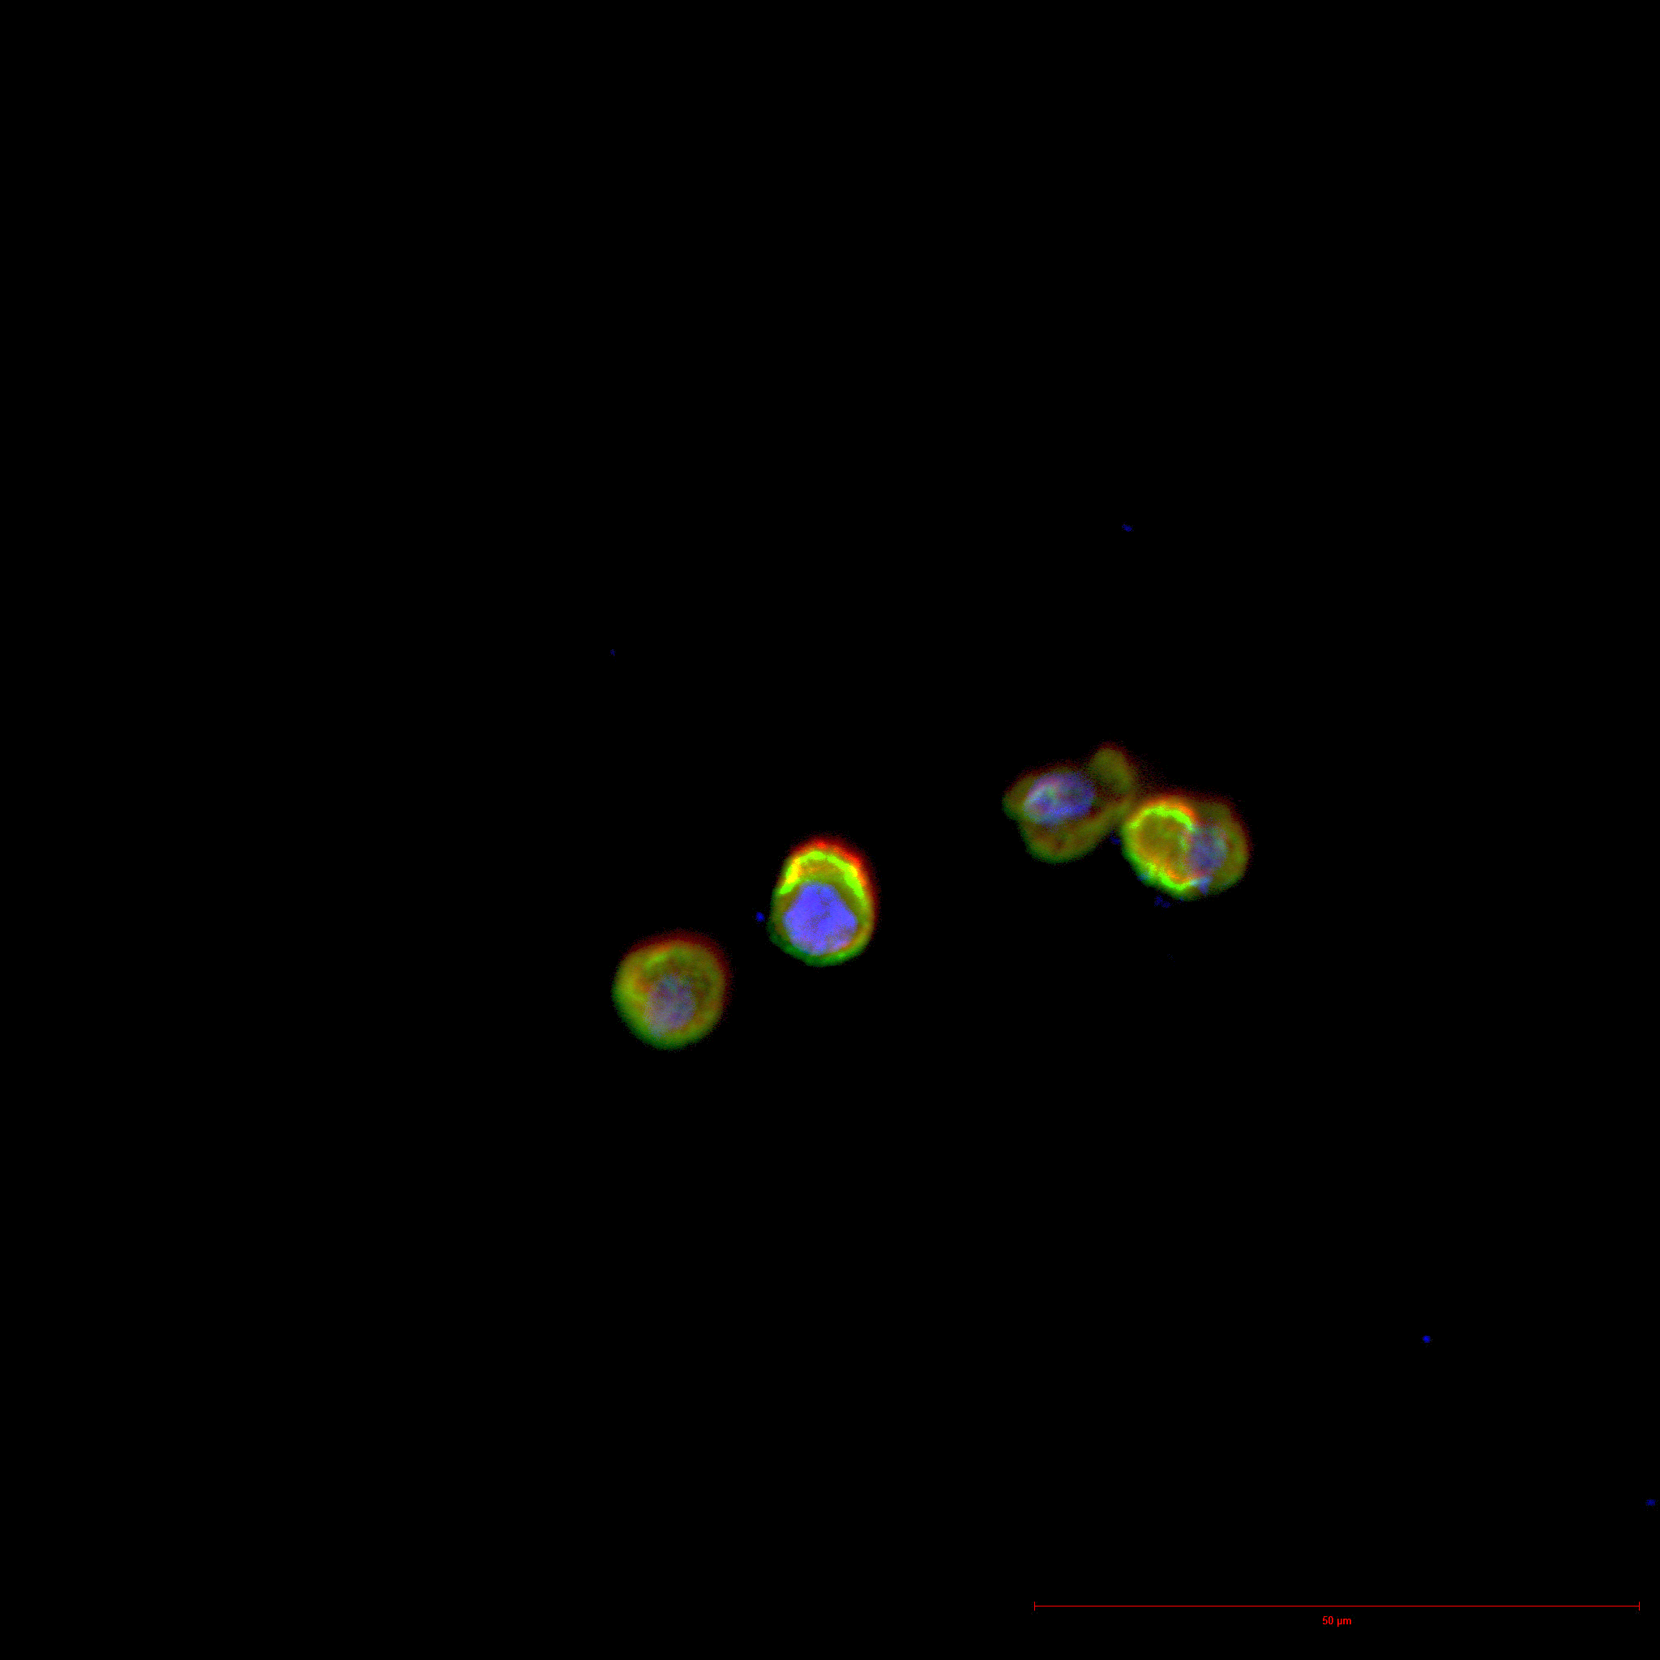
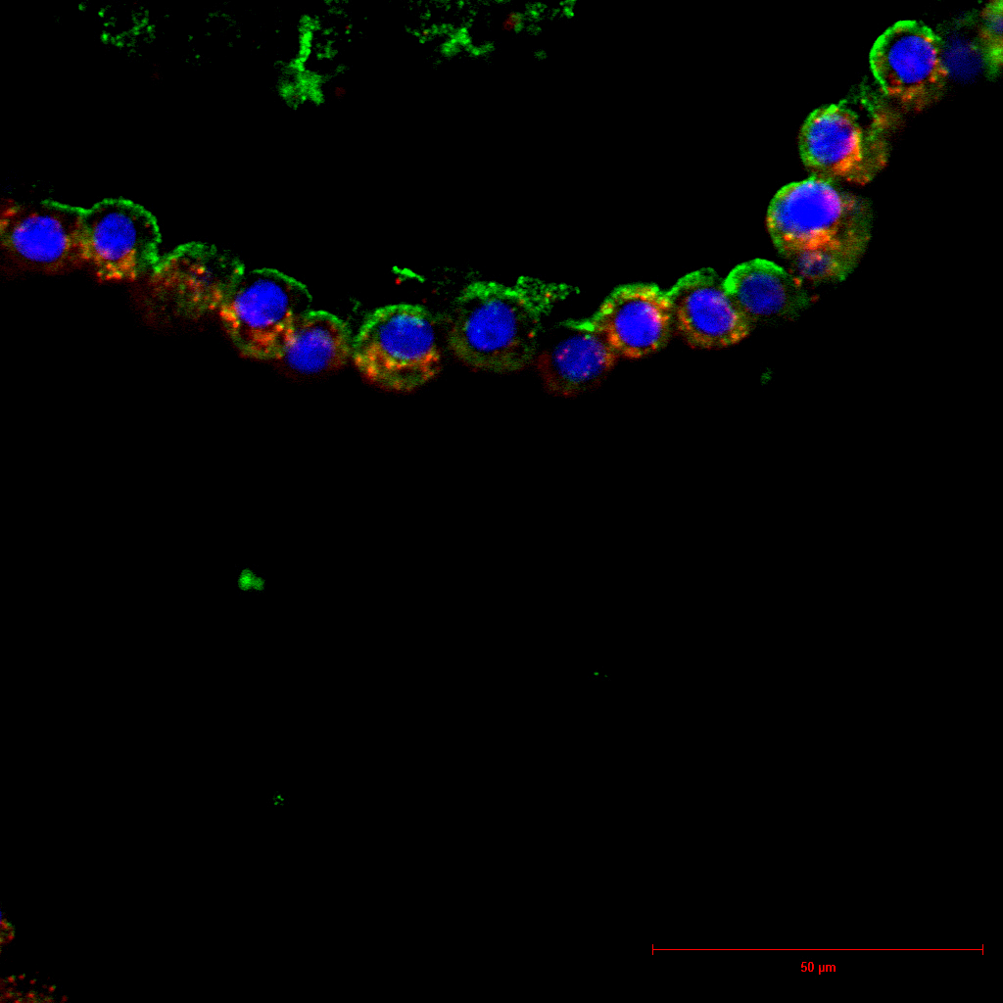
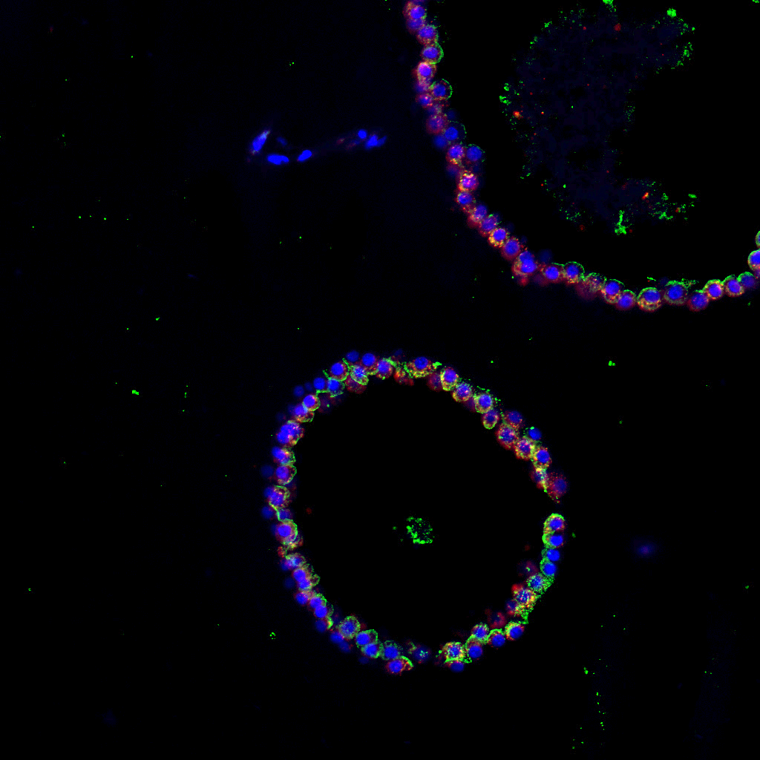
HTII-280 + SPC + DAPI
HTII-280 + SPC + DAPI
HTII-280 + SPC + DAPI

5. Page 5, line 216. What is the human lung protocol-2? Is the program specific to the gentleMACS Octo Dissociator or other machines? Is it accessible to the readers of the journal?
This is a preset protocol developed by Gentle MACS Octo Dissociator for ease of isolation of single cells from tissue of interest. Information on pre-set protocol is available on the manufacturers website
6. Page 5, lines 240-241. They mixed the isolated proximal airway cells from 3.1.4 with those from 3.2.4. Do they need to mix the two cell populations? What the approximate ratio of each isolated cell population?
The tracheal epithelium is pseudostratified consisting mainly of ciliated, secretory and goblet cells basal stem cells. Step 3.1.4 yields epithelial cells from tracheal scrapings while step 3.2.4 yields cells that are more tightly associated with the basement membrane. The protocol was optimized to allow maximal recovery of cells and therefore cells from both steps were combined. We have not looked into ratio of cells obtained from scraping vs complete digestion. However, since both cell populations are ultimately sorted based on CD326 positivity, it is practical to sort them as a single sample.
7. Page 6, lines 249-255. They should describe how the readers can evaluate the isolated NGFR positive and negative cells? Are NGFR+ cells positive for p63 and KRT5? Did NGFR negative cells include basal cells?
NGFR (CD273) is a cell surface marker for basal cells (ROCK et al PNAS 2009) and comprises of both p63 and Krt5 positive cells. It is routinely used as a marker for sorting basal cells of the proximal airways, and therefore we relied on the flow profiles to distinguish between NGFR+ and NGFR-ve cells. P63 is nuclear staining and since we are sorting live cells, we preferred NGFR.
Performed NGFR and K5 staining on proximal organoids derived from NGFR+ cells.
Proximal organoids (NGFR + K5 +DAPI) Added in the figure 5

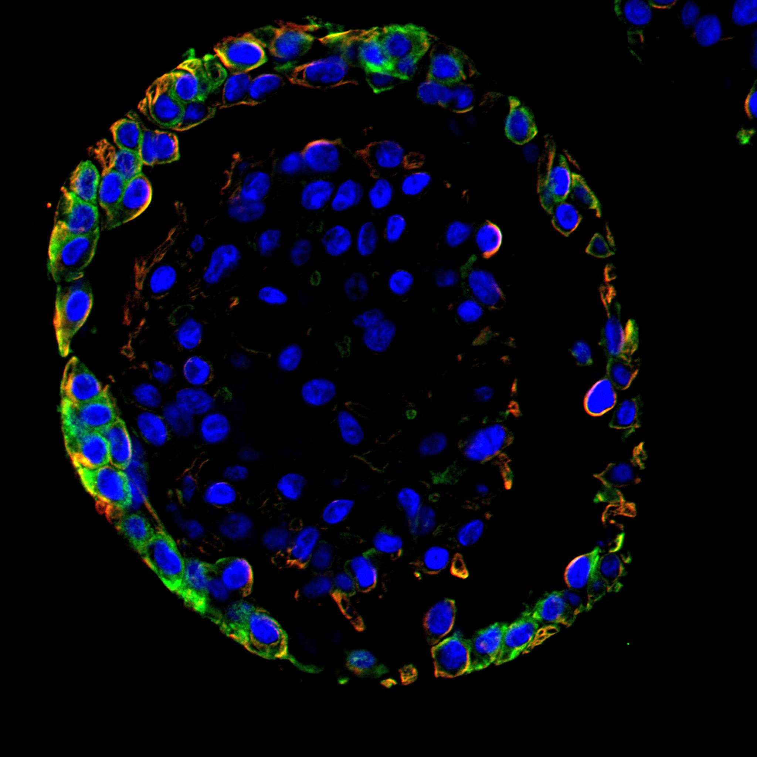
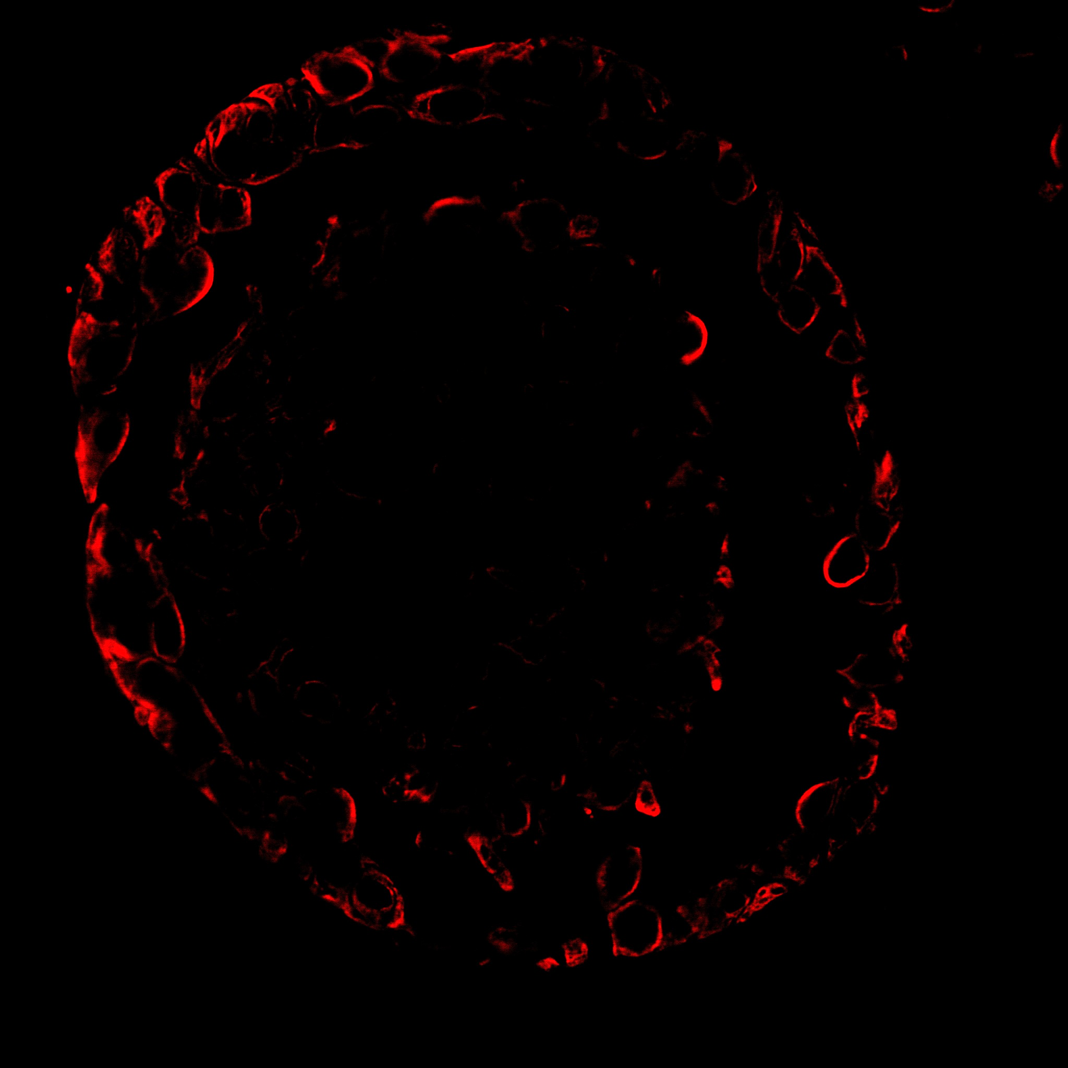
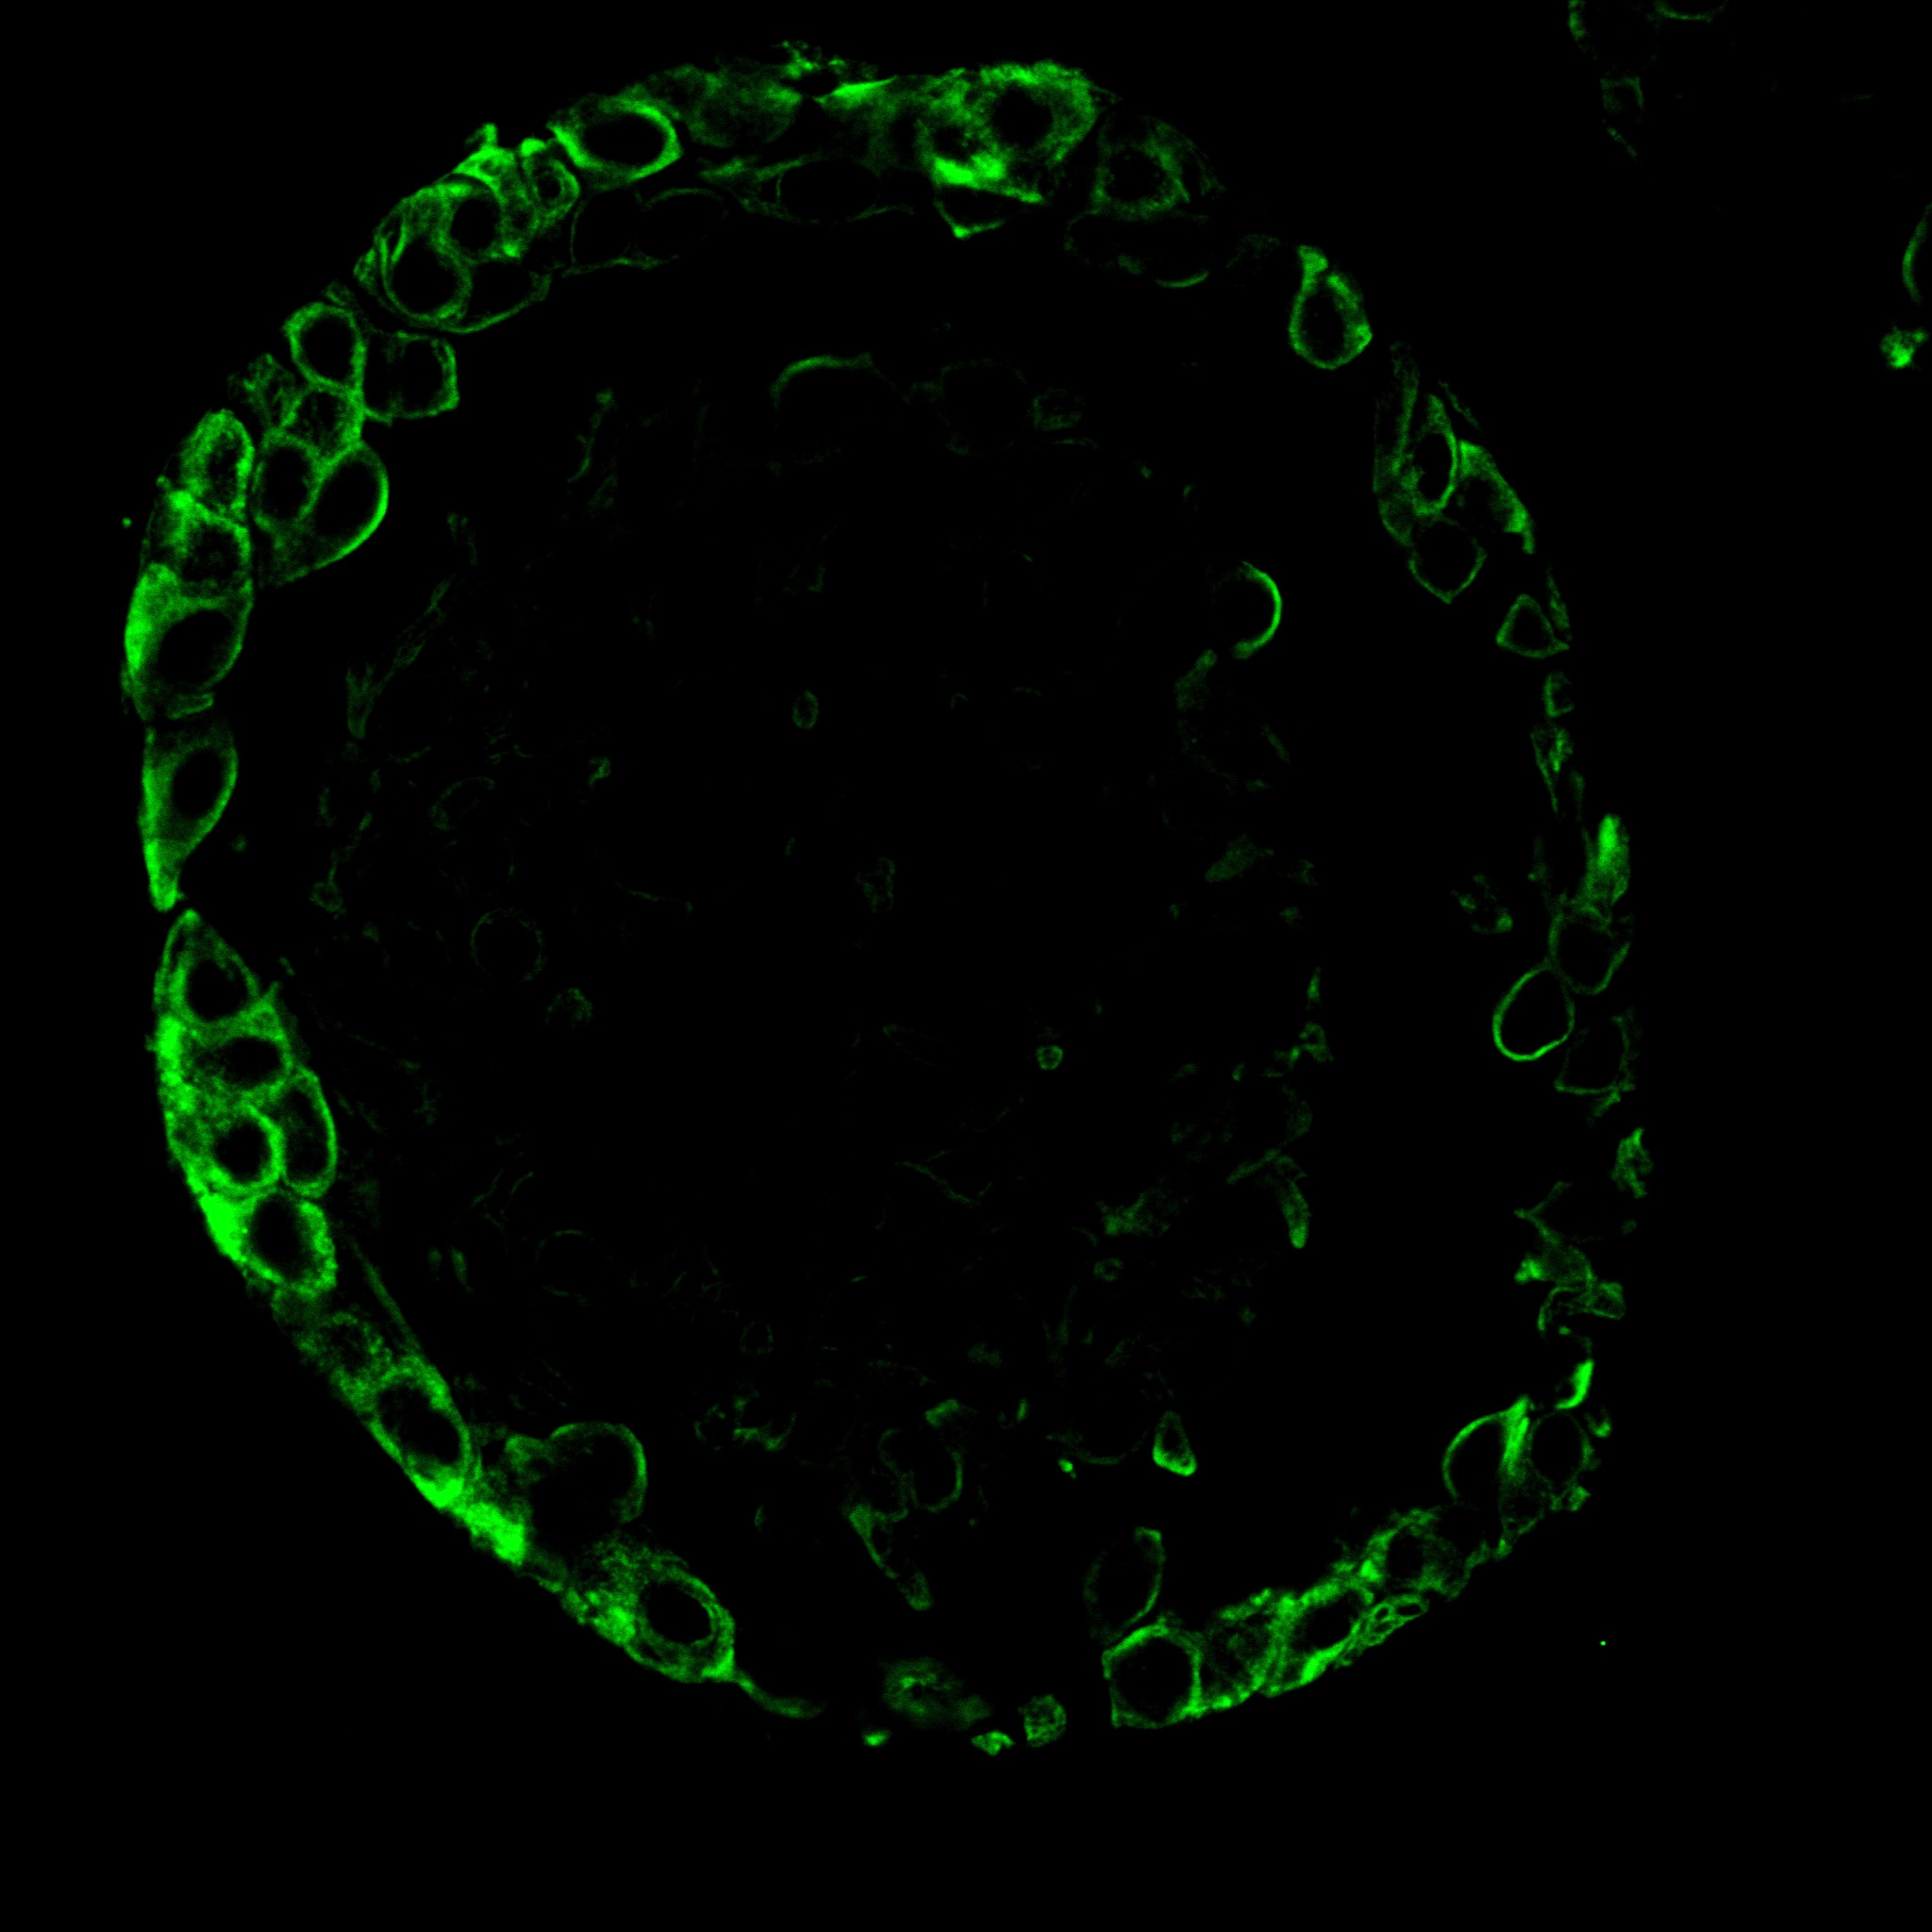

8. Page 6, Section 4, organoid culture. The step 9 (pp 6, lines 289-295) seems preliminary but is of interest. To my knowledge, supplementation of TGFbeta inhibitor to PneumaCult-ALI medium in the step 9 is the novel data for maintenance of alveolar organoids and is still challenging for the community. I think that it might be better for readers to know the advantage of TGFbeta supplementation more clearly. For example, they demonstrated only the expression of HTII-280 in their organoids in Figure 4. If the alveolar organoids are successfully maintained during 30 days, they should demonstrate the immunostaining of other alveolar markers, such as SP-C and SP-D (AT2 cell markers) and AGER and AQP5 (AT1 cell markers) as well as quantitative RT-PCR of related markers. Electron microscopy of lamellar bodies is convincing to demonstrate that AT2 cells are maintained. It's better to clarify the ratio of HTII-280+ cells in the epithelial cells of the organoids.
We performed co-staining of alveolar organoids cultured from HT II-280⁺ cells with HTII-280 antibody and SPC. We ordered AQP5 and tried staining but needed to optimize. We performed 10X single cell RNA sequencing experiment on cultured alveolar organoids, and the data need to be analyzed. We’re planning to publish the 10X data in subsequent publications.
Alveolar organoids (HT II-280 + SPC) and cytospinned cells (HT II-280 +SPC)
Added in the figure 4
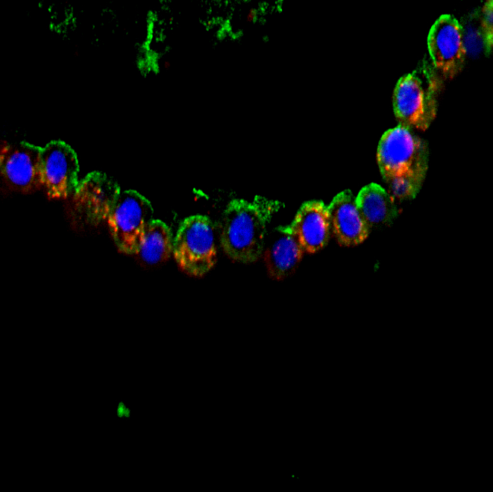
9. Page 8, lines 364-374 and 376-385. They described each ratio of cell populations. Were the ratios calculated as a mean value? How many experiments were done for each value? In general, biological replicates should be based on more than three independent experiments.
The figures 2A, 2E, 3A and 3E represent data from the same biological replicate to emphasize the value of incorporating the depletion step. As shown in the figures, depleting immune and endothelial cells raises the percentage of HTII-280+ cells from 4.3% to 30% and the percentage of NGFR+ cells from 2.7% to 13%.
However, using the described protocol with the depletion step, we have routinely and robustly cultured organoids in the same %CFE range
10. Page 9, line 382. Did they compare anti-NGFR with anti-ITGA6 for isolating basal cells? The original paper reported NGFR and ITGA6 as surface markers of basal cells (Rock et al. PNAS, 2009).
We did not use anti-ITGA6 for isolating basal cells. In our hands NGFR is sufficient for enrichment of basal cells.
11. Page 9, line 390-398. As I mentioned above, the alveolar organoid culture is still a challenging issue. They should describe the results more in detail. The immunostaining of HTII-280 is important but it does not mean that the cultured organoids are really alveolar organoids. What kind of lineage cells are involved in each of HTII-280+ and HTII-280- cell derived organoids, respectively.
We performed 10X single cell RNA sequencing experiments on organoids derived from epithelial progenitor cells. Data needs to be analyzed and will be published in subsequent publications.
12. Figure 1. I recommend the double immunostaining of NGFR and p63 as well as HTII-280 and NKX2.1(and/or SP-C) to show the methods more comprehensively.
We did NGFR and K5 staining and HTII-280 and SPC staining.
13. Page 10. Discussion. Please discuss more. How the methods described in this article outweigh the previous studies? How the authors hope to apply the methods to the future research? What is the limitation and how to improve them? In particular, alveolar organoid culture described here requires coculture with MRC5 cells. Is it possible to culture the isolated AT2 cells without such feeder cells?
We are currently working on using alveolar organoids for drug screening.
We have attempted to culture HT II-280⁺ cells and NGFR⁺ cells without stromal support (Data not shown). While NGFR⁺ can grow, albeit at a lesser %CFE without stromal support, HT II-280⁺ cells cannot grow without stromal support. To mitigate this issue, it is important to identify epithelial-mesenchymal signaling pathways that are important for maintenance of AT2 cells so that the media can be supplemented with the necessary growth factors. Although this is outside the scope of this study, we are currently working on these studies.

Minor comments:
1. Page 2, Line 95. What is the concentration of DNase in Unit? Or they should add the name of the vendor and batch number of DNase to Table 1, since weight-to-unit ratio varies by batches.
Added to the Table1
2. Page 2, Line 104. What did they specifically pay attention to in this step in order to avoid damaging the cells?
Added: After 30 mins of incubation, pipet up and down with 30ml syringe without needle to make uniform suspension without any clumps and allow uniform access of tissue to the enzyme.
3. Page 3, Line 117. Incubation on ice for 1 minute seems to be too short compared with the manufacturer's protocol (10 minutes' incubation at room temperature). Do they mean that incubation time should be extended or repeated if red blood cells are not lysed enough?
If required, the RBC lysis step can be repeated. Longer incubation is more damaging to the cells. Remaining RBCs can be fractionated using an anti-CD231 antibody during the sorting step.
4. Page 3, Line 135. As I mentioned in the general comment, please describe the approximate number and viability of cells before and after MACS per 1cm3 tissue.
5. Page 5, Line 219. How much volume is required for 2 gm of minced tissue?
We repeated cell isolation from recent lung sample, for 5gms of lung tissue. We added 35mL of Liberase and DNase. I later split that into two 50 ml tubes.
We got 45 million viable cells from 5 gm of tissue. After depletion of CD45, CD31 and Red Blood Cells, we got a totals of 18 million viable cells. We sorted 500k Epcam⁺ cells from total viable cells and feezed the rest of the cells for future experiments.

6. Page 9, Line 404. If they describe "AcT+/FOXJ1+ ciliated cells", they should show double-positive cells in Figure 5.
AcT + FOxJ1 + DAPI
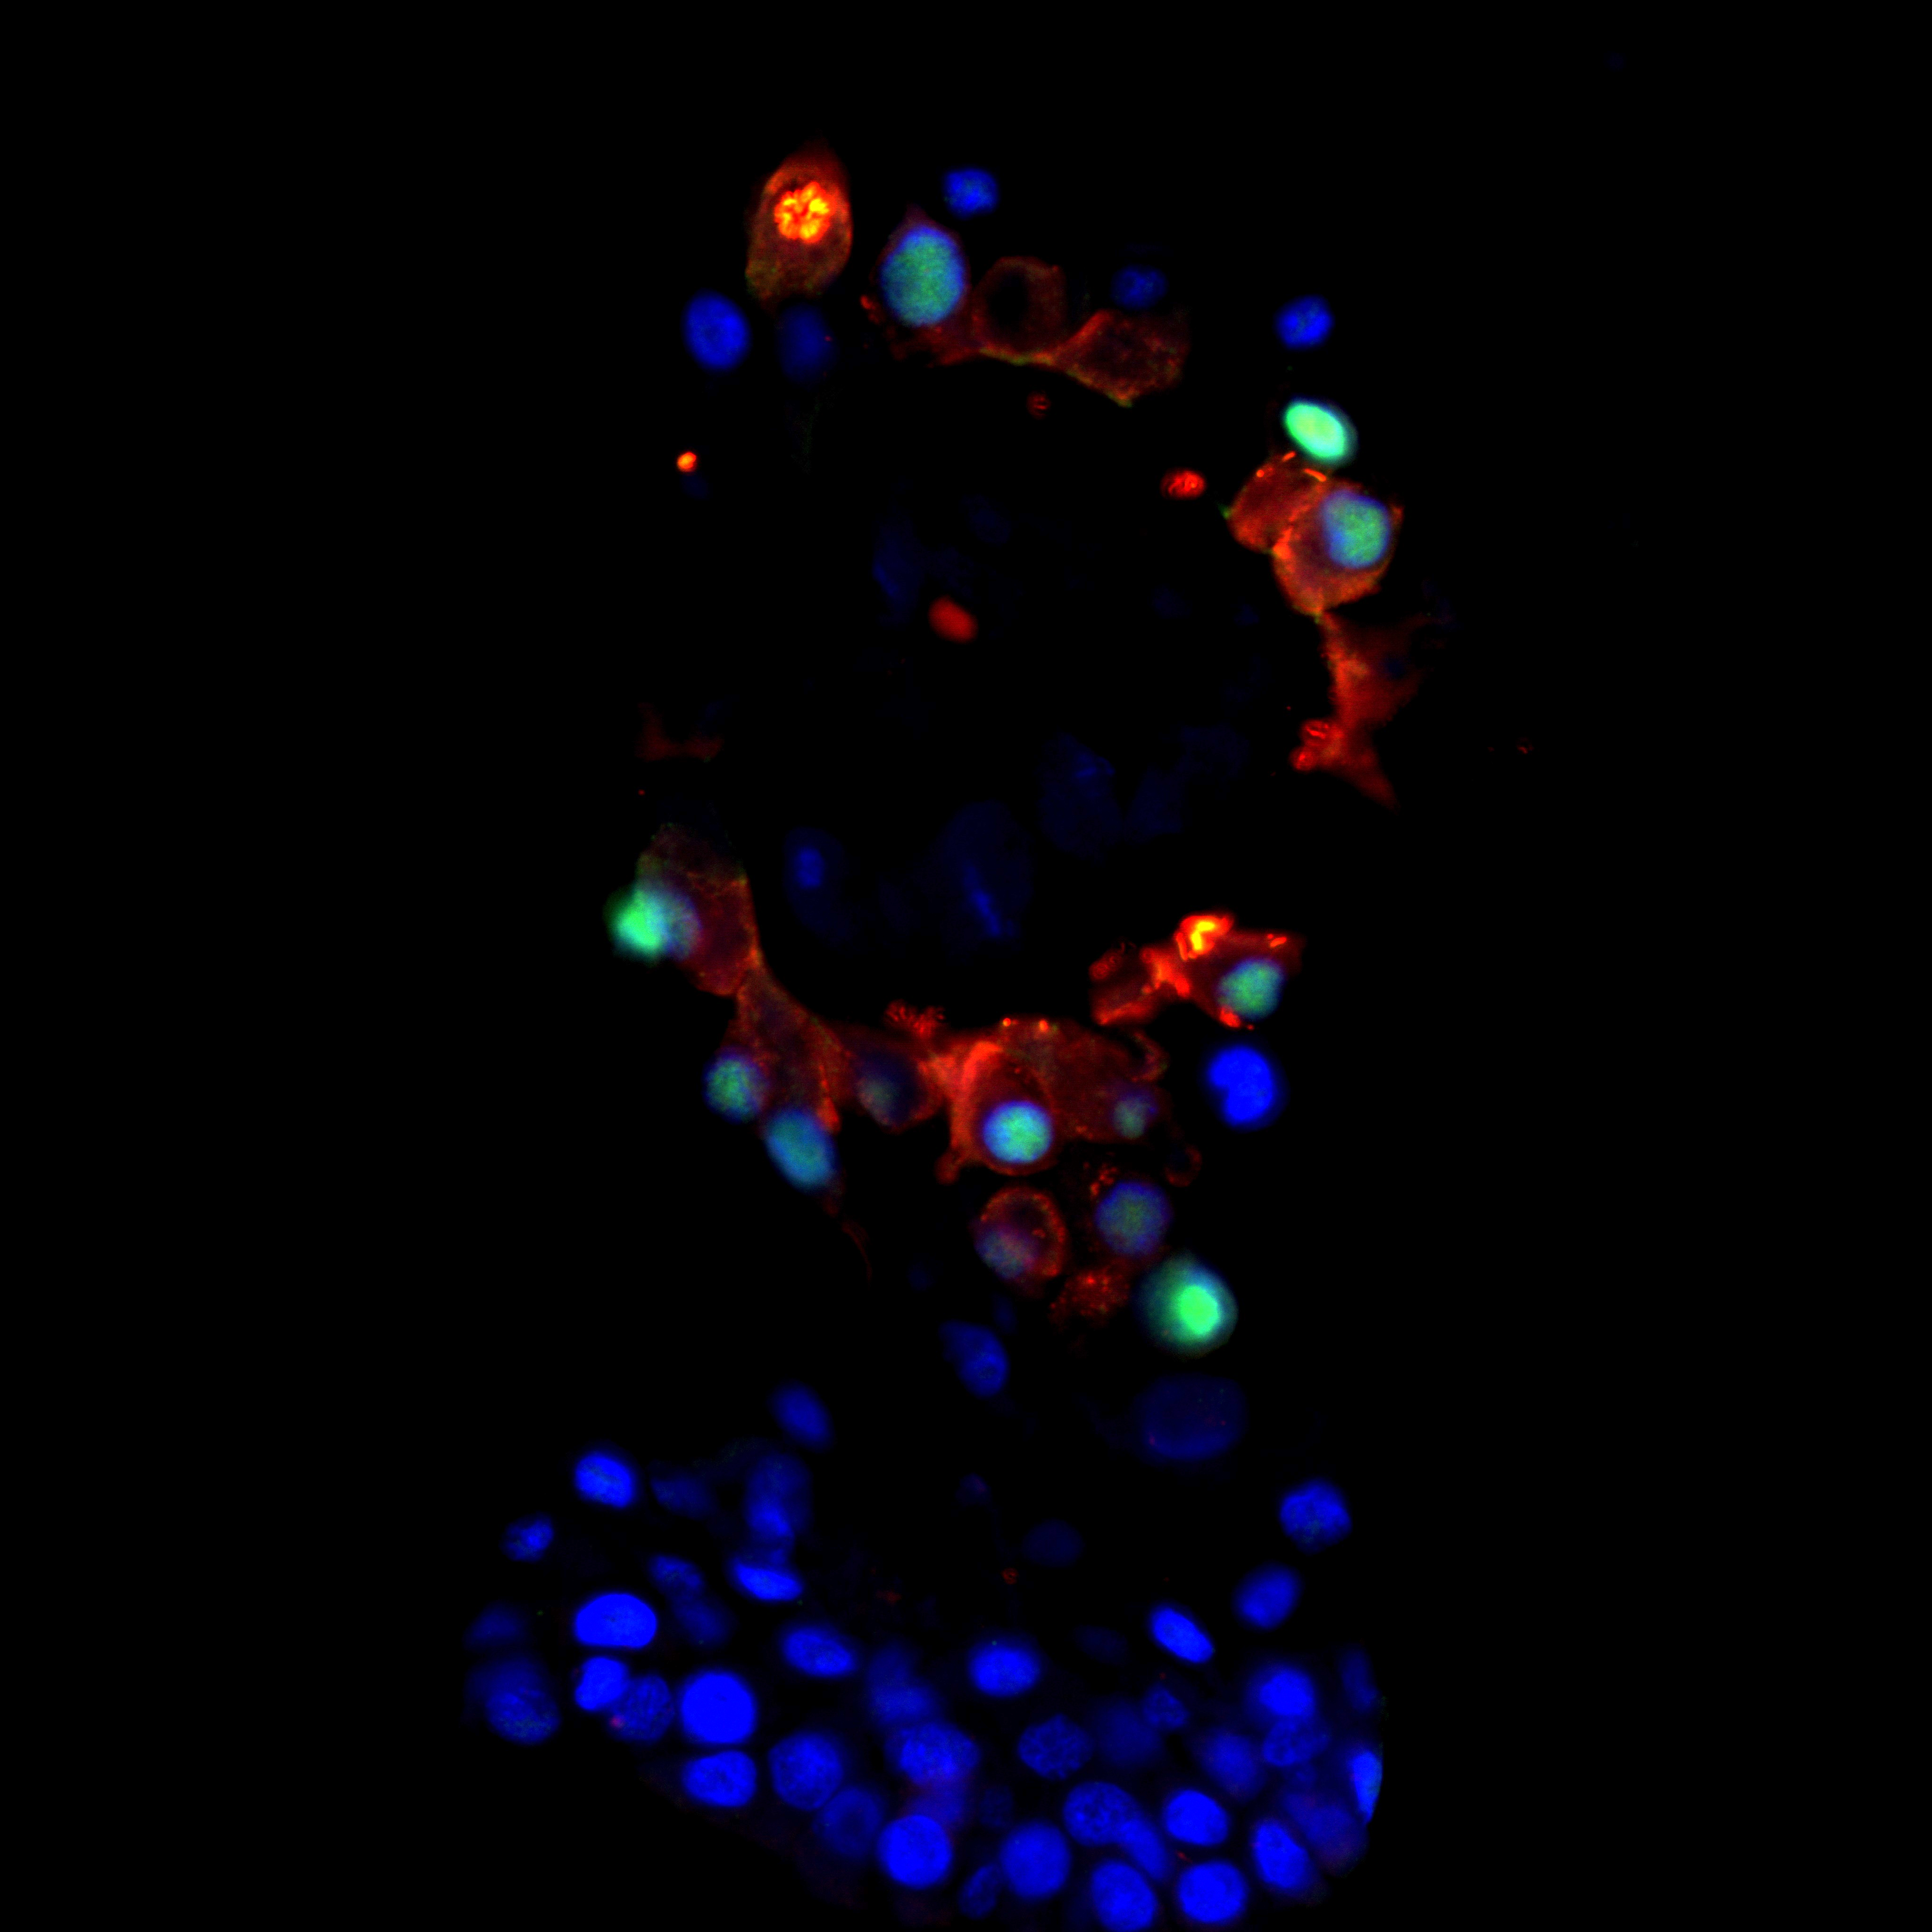
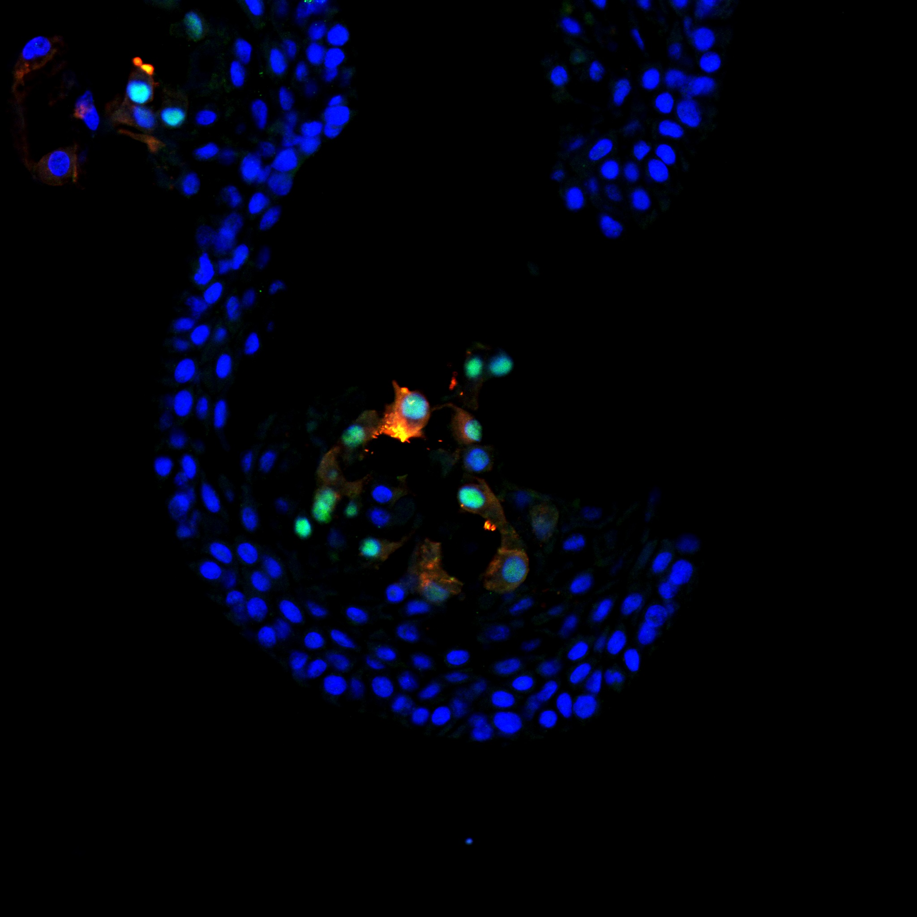
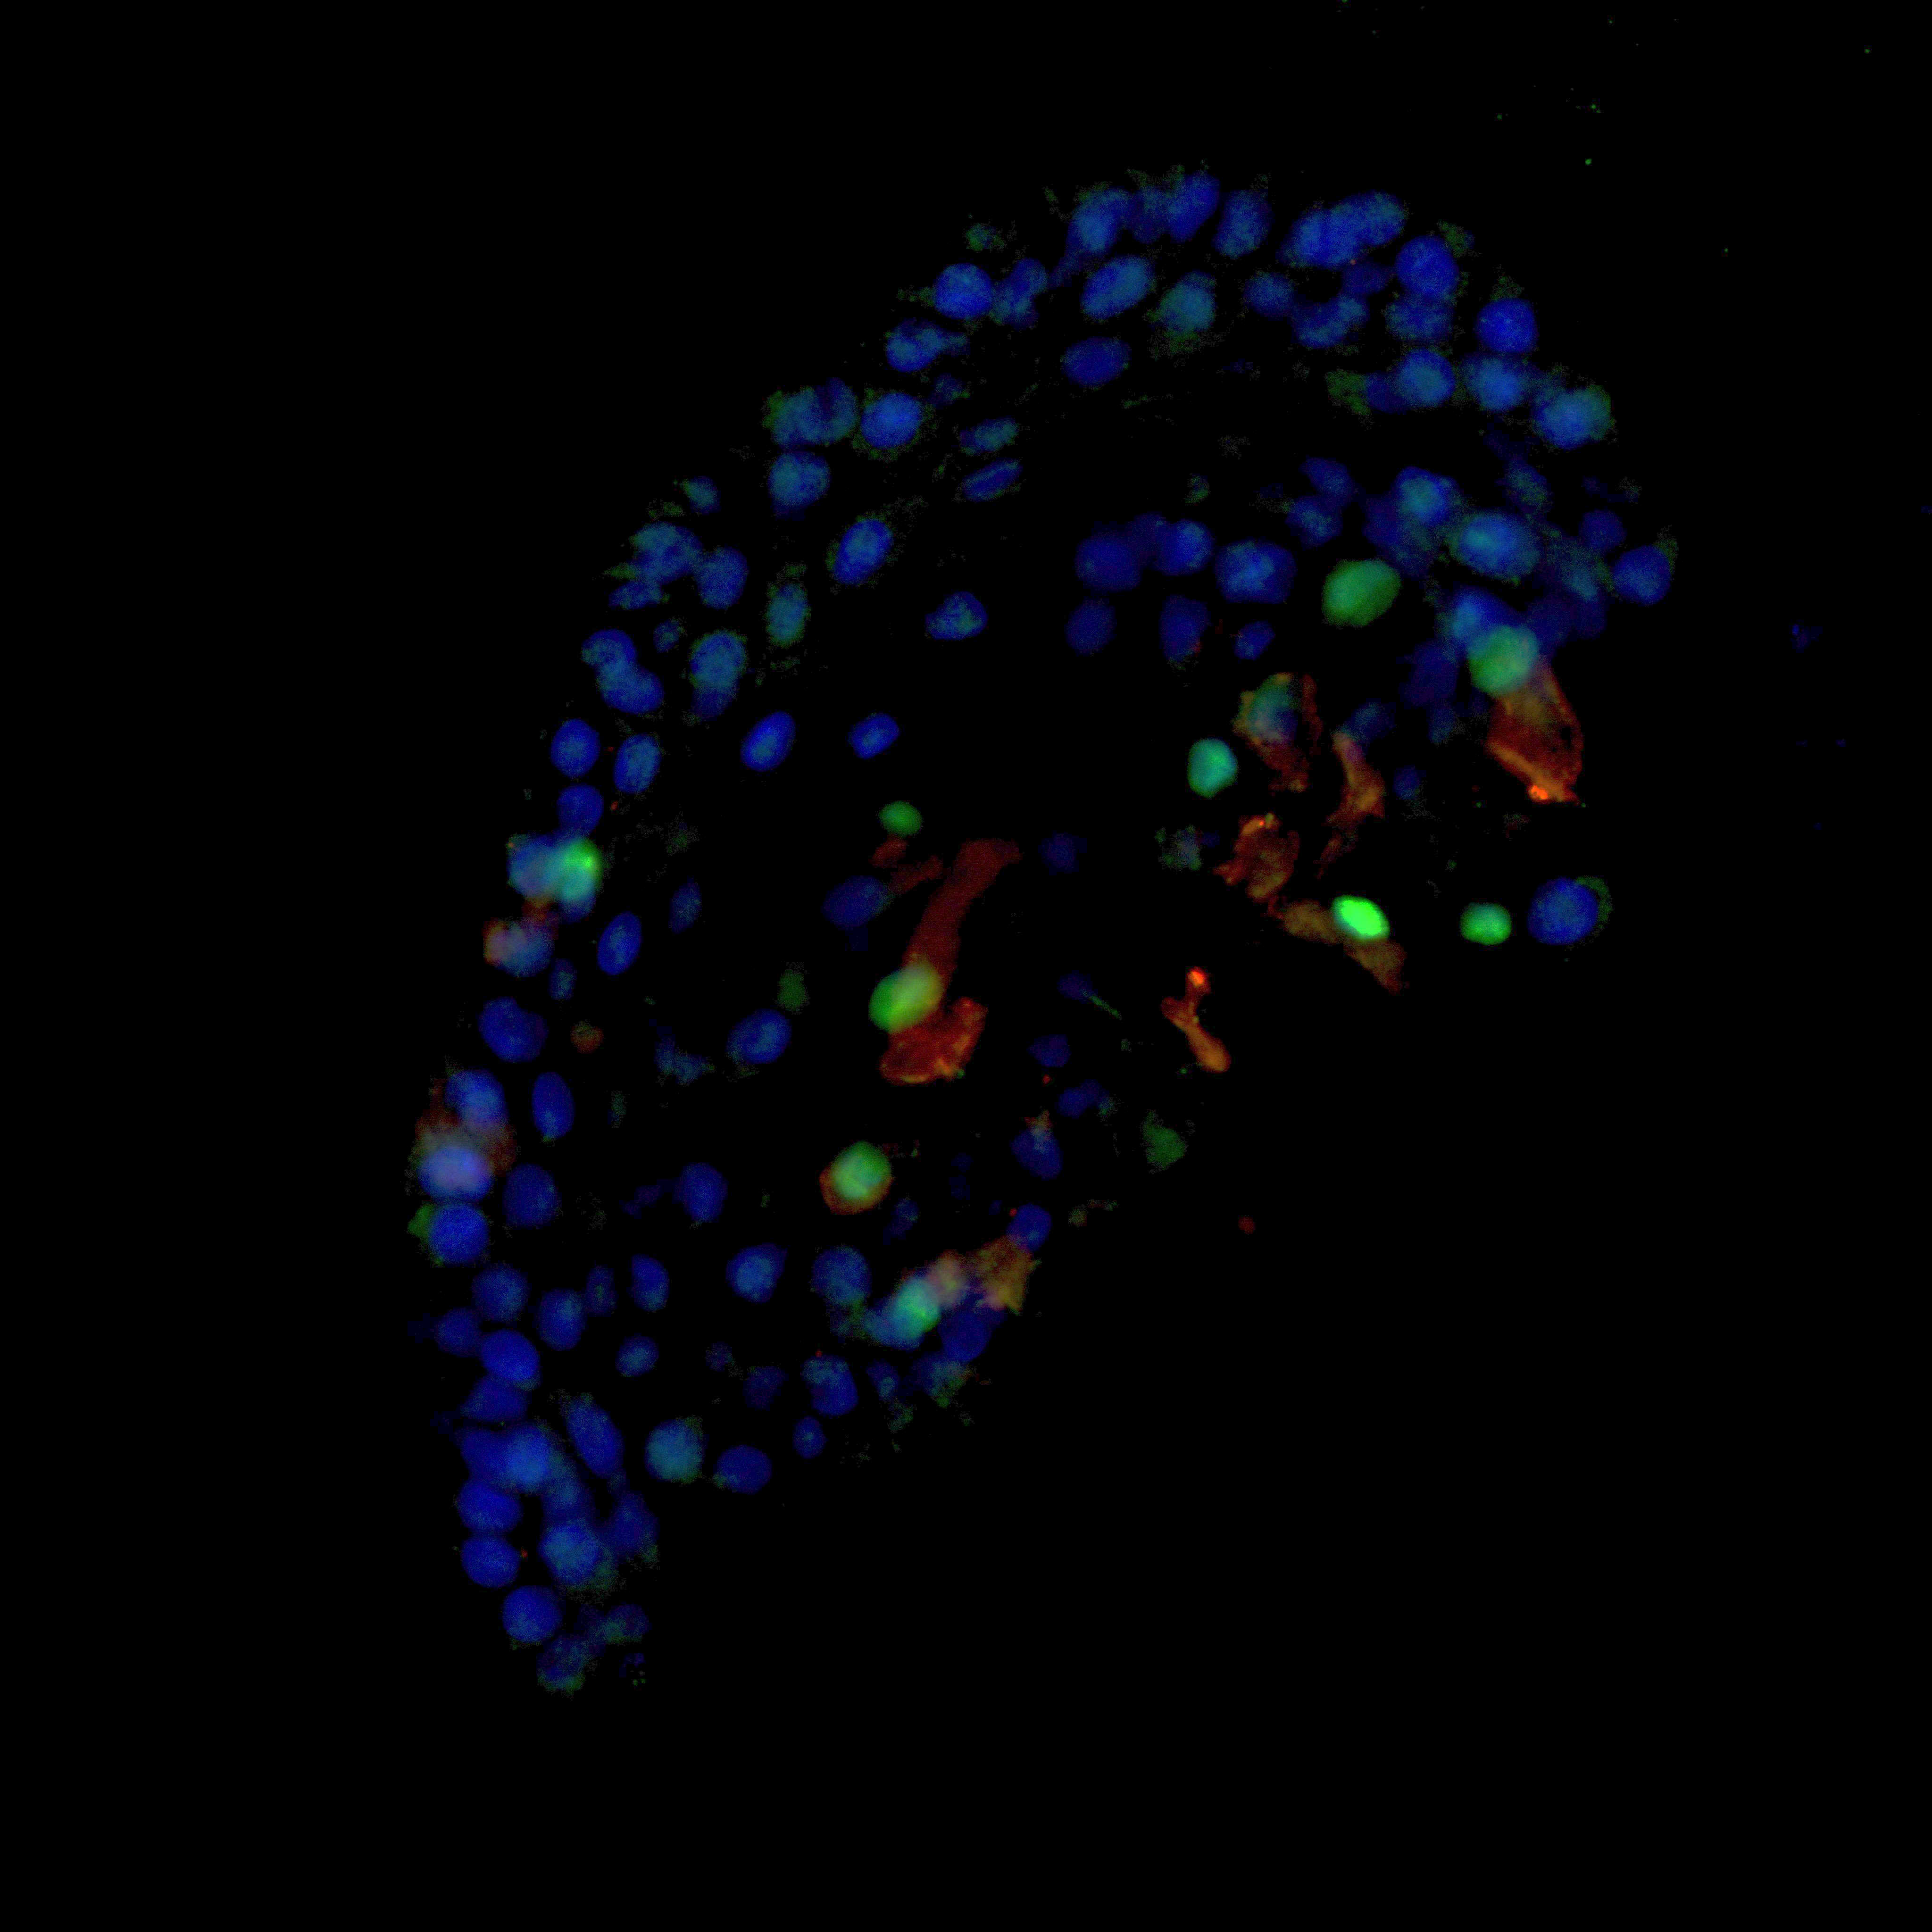

7. Figure 2 and 3 legends. (C &F) should be (C & G).
Corrected.
8. Please describe the Acknowledgments more in detail.
Fixed acknowledgments.
9. Table 2. Is the HBSS FACS buffer identical to HBSS+ buffer?
HBSS FACS buffer and HBSS+ are same and its corrected
10. Table 3. Typo. ThinCert should be corrected to Transwell, if applicable.
Corrected to Transwell
11. Table 4. Did they use PE-Cy7 conjugated antibody? It might be better readers to describe how to perform the compensation technique.
We mentioned how to make FMO controls for compensation below 2.5.7.
12. Table 6. "Immunohistochemistry Washing Solution" is not written.
Added
13. Typos.
Line 137: Miltenyi Corrected
Line 209: as finely as Corrected
Line 212, 215: gentleMACS Corrected
Lines 267, 303, 310, 311: Matrigel Corrected
Lines 273, 299, 308, Transwell Corrected
Lines 335: 0.1% Tween-20 in TBS or TBS/0.1% Tween-20 Corrected
Table 6: 3% BSA, ).1% Corrected

