Mexico City, September 9th, 2020.

Dear JoVE

By this letter, the authors of the REVISED manuscript entitled: “Predicting Amputation Using Local Circulating Mononuclear Progenitor Cells in Angioplasty-treated Patients with Critical Limb Ischemia” appreciate the opportunity of its evaluation and consideration of publication in your renowned Journal JoVE.
The authors state that there are not actual or potential conflict of interests derived from relationships with pharmaceutical companies, biomedical device manufacturers or other corporation whose products or services may be related to the subject matter of the article or who have sponsored the study.
The authors certify that each author participated sufficiently in the study conception or design, data analysis or interpretation, and drafting of revision of the manuscript. Each author had approved the final version of the manuscript. This manuscript has not been published or is being considered for publication in other journal.

Sincerely,
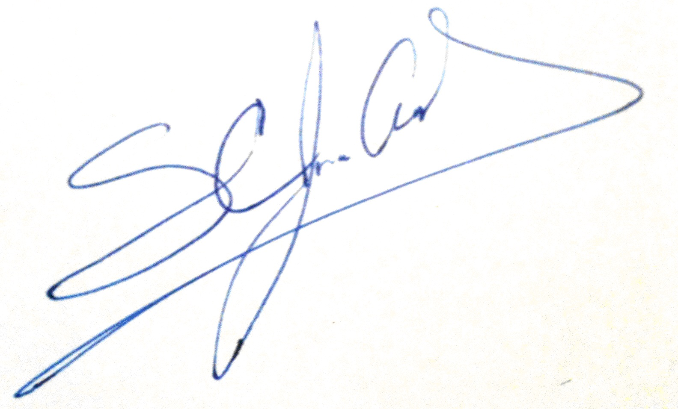

Juan Antonio Suárez-Cuenca, MD, PhD On behalf of all authors

