JoVE61496
RESPONES TO REVIEWERS

The authors would like to thank the reviewers for their time and effort in reviewing and improving this protocol. The suggestions from reviewers have been addressed as follows:
Reviewer #1:
1. Based on the study of Schwann cells, why did you choose the Young's Modulus of 1119kPa to screen proteins instead of the Young's Modulus similar to neural tissue?
PDMS (Polydimethylsiloxane) mixed with curing agent at a mixing ratio of 10:1 resulted in a surface Young’s modulus of 1119kPa. This is a common mixing ratio for PDMS in biological studies and has been used previously in many different publications¹⁻³. Furthermore, we attempted to determine how Schwann cells (SCs) would respond when seeded on substrates across a spectrum of matrix stiffness values, as opposed to a substrate with one specific stiffness value.. In addition, we went to modulus values lower than that found in peripheral nerve to cover the spectrum of peripheral nerve matrix modulus, as seen in our results where the “optimal” stiffness for Schwann cells is 8.67 kPa (ref 24 from protocol).

2. What are the criteria for screening three Young's modulus in the experiment?
This protocol describes the methods based on our recent publication⁴. In this work, we seeded SCs on substrates with Young’s modulus (E) values of approximately 1119, 502.35, 123.89, 25.51, 8.67 and 3.85 kPa. After analysis, we determined that several critical SC behaviors such as proliferation and key phenotypic protein expression can be promoted when substrate stiffness decreased from 1119 kPa to 8.67 kPa, however little change in the values from 119 kPa to 8.67 kPa was observed. In addition, SC proliferation rates and certain protein levels declined as substrates became even softer (3.85 kPa) from 8.67 kPa. These results indicated that 1119, 8.67 and 3.85 kPa are three important demarcations for Young’s moduli within our study values, so these three Young’s moduli were chosen as the representative results for the protocol.

3. In Figure 3, the protein results of the 3.85 kPa group in the experimental need to be supplemented.
We did not highlight the western blot results for the 3.85 kPa group because in our recent publication which this protocol is based upon, we performed western blot analysis for c-Jun and myelin basic protein (MBP) of SCs seeded on uncoated PDMS (PDMS that is not coated with any protein), therefore there were no available gel lanes to run electrophoresis for a 3.85 kPa group of this protein, and in the interest of rigor regarding western blots, were left out. However, fluorescent staining clearly showed c-Jun fluorescent intensity was significantly lower for 3.85 kPa group compared to 8.67 kPa, which is strong evidence that the western blot for the 3.85 kPa group would show similar results and we believe with this available data our results establish our claims.

4. The micropattern status after PDMS stamp microcontact printing is not shown in the results.
The authors agree and this oversight has been amended. The micropatterning status on cell culture substrates following printing have been added by incorporating microcontact printed fluorescent bovine serum albumin (fBSA) in new Figure 5B showing protein on the surface.

5. The abscissa in Figure 5E is incorrect.
The abscissa has been corrected.

6. In the quantification of cellular properties on tunable substrates experiment, why not culture the cells directly on the flexible PDMS stamp with the protein adsorbed?
We elected not to seed cells directly on PDMS stamps due to the following key reasons among others:
(A) By culturing cells directly on the flexible PDMS stamps, it would introduce physical barriers as a variable to cellular function. As cells would be trapped inside the channels, variability would be introduced into the tunable culture system.
(B) For a repeatable protocol, it is more difficult to scrape cells and collect cell lysates when cells are seeded onto PDMS stamps with physical barriers surrounding cells compared to cells seeded on PDMS coated petri dishes.
(C) PDMS with lower Young’s moduli such as 8.67 and 3.85 kPa are difficult to handle during experiments. The PDMS is fairly “sticky” and prone to dust attachment, which is not ideal for cell culture and can lead to user error. By making a stamp and printing onto a spincoated PDMS surface, it eliminates these variables.
(D) If SCs had been seeded on PDMS stamps, in order to preserve samples for microscopy, PDMS stamps would need to be sealed on coverslips with nail polish. This would require us to make PDMS stamps repeatedly, thereby consuming more PDMS than our current method of making a thin layer on aglass coverslip. Seeding cells on PDMS coated substrates instead of PDMS stamps is especially helpful in terms of cell micropatterning since it enables researchers to use one PDMS stamp over several experiments. Without making PDMS stamps repeatedly the patterns on the silicon master can be better preserved.

7.It may be more appropriate to use the mean pixel intensity on the unit surface to evaluate the c-jun factor.
Mean pixel intensity was used to quantify c-Jun fluorescent intensity. “MeanIntensity” which measures the mean pixel intensity of region of interest (ROI), was added to measurements (see red rectangle in Figure 1)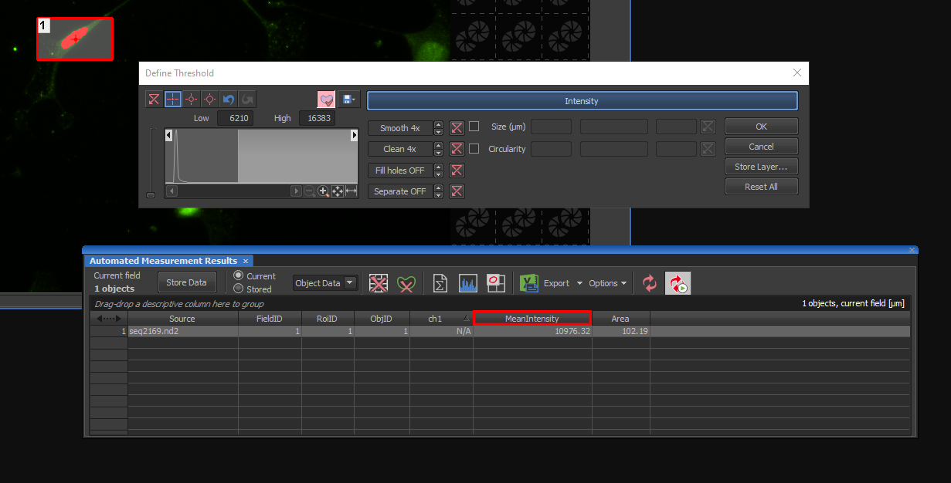
Figure 1 A screen shot shows we used mean pixel intensity to quantify c-Jun expression level across different substrates.

8. Fig.2, images of A 1119kPa-Lamin and Fig.2C Lamin-3.85kPa are the same?
Those two images represented the SCs seeded on the same chemical (laminin coated) and physical (Young’s modulus =1119 kPa) condition, so the same representative image was used. However, to resolve this issue, we have replaced the representative image for the third panel of Figure 2A.

Reviewer #2:
1. It is known that the media conditions change SC phenotype, there are no details about the media composition used for cultivating SCs, this should be added.
The media composition has been added to step 1.1.9.

2. What is a curing agent used for?
There are two components to the PDMS (Polydimethyl siloxane) system as received: one a base elastomer and the other a curing agent. During polymerization, the curing agent crosslinks with base elastomer to impart mechanical integrity to the liquid precursors. Specific to our experiment, we adjusted the crosslink ratio between base elastomer and curing agent to create PDMS with different stiffnesses to be used as cell culture substrates. The function of the curing agent has been clarified in the note following step 1.1.1.

3. The explanation on what the Pluronic solution is used for comes only during the discussion, while it should also be explained earlier in the protocol.
The function of Pluronic F-127 was explained in a note following step 1.2.13.

4. In the protocol section, even id trivial the purpose of each reagent is often missing:
PFA for fixation (lane 2.1.5), triton X-100 for permeabilization (lane 318), HCl citric acid buffer for antigen retrieval (lane 320-325), BSA…
The manuscript has been updated to explain the function of formaldehyde in step 2.1.5, the function of Triton X-100 in step 2.1.6, the function of HCl treatment within proliferation assay in the note following step 2.1.8, the function of phosphate/citric acid buffer in step 2.1.9, and the function of BSA in step 2.1.10.

5. Figure3A. It is unfortunate that the image representing increase in proliferation rates with laminin is also showing fewer cells overall, is there any cellular death? A better representative image should be used to better convey the results.
The proliferation rate of SCs was calculated using an average percentage of BrdU positive cells over 70 images for each cell culture condition, the randomly chosen representative images in Figure 3A happened to be an area with fewer cells. To address this issue, we have replaced the representative images in Figure 3A.

6. While the section 2.4 refers to the ref 32 for Western blot and protein quantification, the protein extraction method should be detailed as the obtention of a sufficient protein yield might be challenging due to the specific experimental condition of the method; with cell spreading/ low density.
The SC lysis protocol has been added to the manuscript following step 1.2.23.

7. The micropatterning technique used to study the SC nuclear elongation is not very well introduced. The authors need to speak about the bands of Büngner to clarify why creating cell adhesive lines is a great tool to mimic SC environment during nerve regeneration.
The relationship between line patterned substrates and elongated SCs inside Büngner bands has been more adequately explained in the fourth paragraph of the introduction.

References
1 Srinivasan, A. et al. Microchannel-based regenerative scaffold for chronic peripheral nerve interfacing in amputees. Biomaterials. 41 151-165, (2015).
2 Jacchetti, E., Tonazzini, I., Meucci, S., Beltram, F. & Cecchini, M. Microstructured polydimethylsiloxane membranes for peripheral nerve regeneration. Microelectronic Engineering. 124 26-29, (2014).
3 Brown, X. Q., Ookawa, K. & Wong, J. Y. Evaluation of polydimethylsiloxane scaffolds with physiologically-relevant elastic moduli: Interplay of substrate mechanics and surface chemistry effects on vascular smooth muscle cell response. Biomaterials. 26 3123-3129, (2005).
4 Xu, Z., Orkwis, J. A., DeVine, B. M. & Harris, G. M. Extracellular matrix cues modulate Schwann cell morphology, proliferation, and protein expression. J Tissue Eng Regen Med. 10.1002/term.2987, (2019).

