Dear Author(s),
This document is divided into sections in which you can add your comments to the video and voiceover. Please be aware that our policy is to do a single complimentary revision, so it is critical that all participants in this project offer their comments collectively. In addition, please make sure that your comments are easily interpreted and transparent.
Have fun!
Protocol Name: Localized Bathless Metal-Composite Plating via Electrostamping
Date: 12.14.20
Overall Comments: Great job with video editing and narration. Looks really nice.

Authors and Affiliations
Please fill in any missing author information not included in the video.
Order | Author | Affiliation
 | NONE

Video Comments
Please fill in any comments you wish to make using the table below using the example as a guide. If you need more space to write, please do so below the table. DO NOT ADD CORRECTIONS TO THE NARRATION HERE. PLEASE DO THIS IN THE AUDIO COMMENTS SECTION.
 | Time code | Comment | Requested Change
Example | 2:52 | Onscreen text says use 0.25 mM Fluo-4 | Text should say use 0.50 mM Fluo-4
1. | 00:48 | Table 1 appears | Some numbers should be either superscript or subscript. Please refer to Table 1 in text manuscript to adjust these in the video if possible. See below.

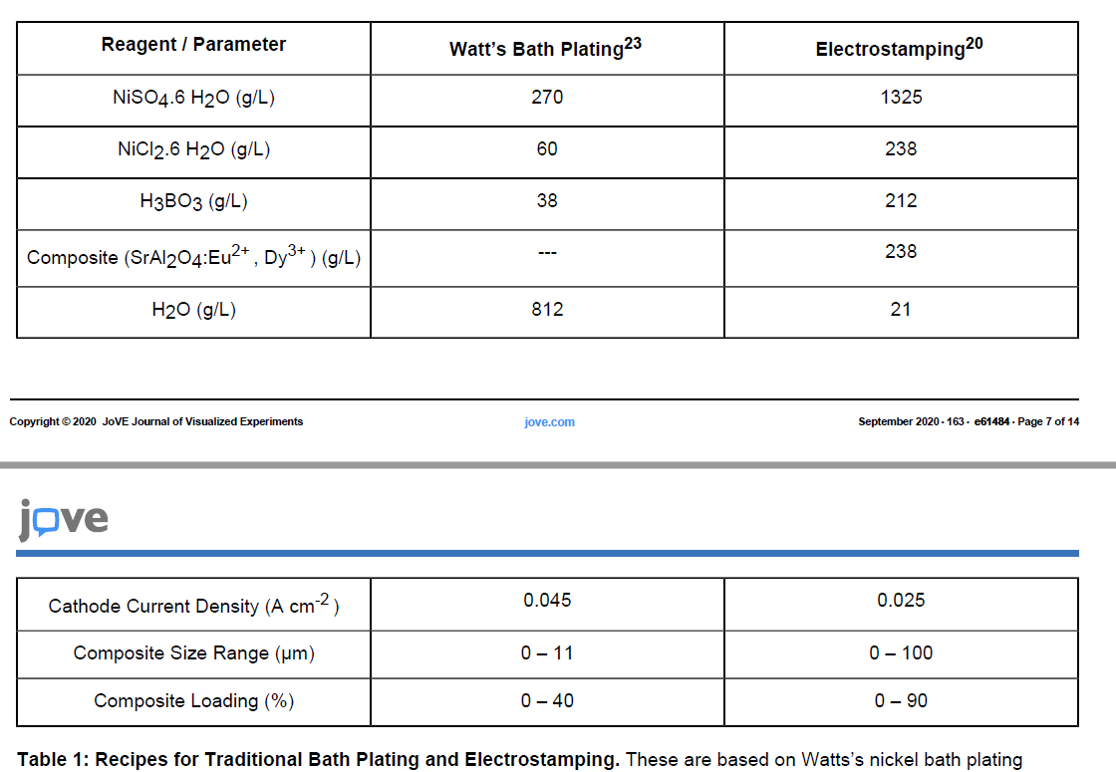

Audio Comments
This section is used to specify the changes that need to be made to the narration. Please follow the example below as a guide to list your changes. If there is a pronunciation change, please provide a phonetic pronunciation key or a web link.

 | Time code | Comment | Step(s) in Shotlist | Rewritten Text or Corrected Pronunciation (highlight in bold)
Example | 1:49 | Original Script Text:  “Then, show the participant their electromyography, or EMG patterns, which correspond to eight specific and unique polar plots.” | 2.2 | Rewritten Script Text:  “Then, show the participant the unique and specific polar plots, which correspond to their electromyography, or EMG (pronounced E-M-G) patterns.”
1.
2. |  | NONE

