 Boston Children’s Hospital  Harvard Medical School

David E. Retik Chair Associate Professor of Surgery

Rosalyn M. Adam, PhD

Urological Diseases Research Center

John F. Enders Research Laboratories, Room 1061.1

Boston Children’s Hospital

300 Longwood Avenue

Boston MA 02115

Tel: (617) 919-2019

Fax: (617) 730-0238

E-mail: rosalyn.adam@childrens.harvard.edu

Alisha D’Souza, PhD
Journal of Visualized Experiments
1 Alewife Center, #200
Cambridge, MA 02140

April 17th, 2020

Dear Dr. D’Souza,
Please find enclosed our revised manuscript entitled “A single cell dissociation approach for molecular analysis of urinary bladder in the mouse following spinal cord injury” by Atta, Hashemi Gheinani, et al. We thank the reviewers and editor for their constructive critiques. We have modified the manuscript along the lines suggested in the critiques and have attempted to respond to the comments raised by the editor and reviewers in a point-by-point rebuttal included with the revised manuscript. We have provided a clean version of the manuscript as well as a version incorporating tracked changes to illustrate the revisions made to the text. We hope these modifications render the article acceptable for publication. The manuscript is not under consideration at other journals, nor has it been submitted or published elsewhere. All authors have contributed significantly, are in agreement with the content of the article and have no conflicts to declare. In recognition of his substantial contributions I have included Dr. Hashemi Gheinani as co-corresponding author for the revised manuscript.

Thank you for consideration of our work.

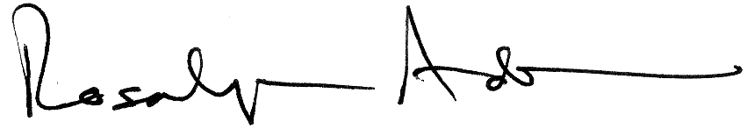
Yours sincerely,

Rosalyn M. Adam, PhD
David E. Retik Chair and Director of Urology Research, Boston Children’s Hospital
Associate Professor of Surgery, Harvard Medical School

