JoVE61455
Response to Editor and Reviewers

We thank the editor and reviewers for their comments on our manuscript. We have attempted to respond to the critiques below and/or in the body of the text. We have italicized editor and reviewer comments, and our comments are in standard font below.

Editorial Comments:

• Please take this opportunity to thoroughly proofread the manuscript to ensure that there are no spelling or grammatical errors.

We have proofread the manuscript to eliminate spelling and/or grammatical errors.

• Title: Avoid superfluous language such as “An optimized”.

We have removed ‘An optimized’ from the title.

• Textual Overlap: Significant portions show significant overlap with previously published work. Please re-write the text on lines 340-344, 350-354, 357-371, 378-391, 398-409, 415-417, 423-431, document to avoid this overlap.

We have reworded the text in the indicated sections to avoid overlap with previously published work. We have also shortened some of these sections since they refer to instructions within commercial products and/or standard protocols.

• Protocol Language: Please ensure that ALL text in the protocol section is written in the imperative voice/tense as if you are telling someone how to do the technique (i.e. “Do this”, “Measure that” etc.) Any text that cannot be written in the imperative tense may be added as a “Note”, however, notes should be used sparingly and actions should be described in the imperative tense wherever possible.
1) Steps NOT in the imperative voice: 1.1-1.2 (you can move this to the start of the protocol instead), 2.1 etc

We have revised the protocol text as requested.

• Protocol Detail: Please note that your protocol will be used to generate the script for the video, and must contain everything that you would like shown in the video. Please add more specific details (e.g. button clicks for software actions, numerical values for settings, etc) to your protocol steps. There should be enough detail in each step to supplement the actions seen in the video so that viewers can easily replicate the protocol.

We have added some additional detail related to use of software for flow cytometry, as requested.

• Protocol Numbering: Please adjust the numbering of your protocol section to follow JoVE’s instructions for authors, 1. should be followed by 1.1. and then 1.1.1. if necessary and all steps should be lined up at the left margin with no indentations. There must also be a one-line space between each protocol step. This should be adopted for the entire protocol.

We have modified the numbering as requested and have added a one-line space between each protocol step.

• Protocol Highlight: After you have made all of the recommended changes to your protocol (listed above), please re-evaluate the length of your protocol section. There is a 10-page limit for the protocol text, and a 3- page limit for filmable content. If your protocol is longer than 3 pages, please highlight ~2.5 pages or less of text (which includes headings and spaces) in yellow, to identify which steps should be visualized to tell the most cohesive story of your protocol steps.

1) The highlighting must include all relevant details that are required to perform the step. For example, if step 2.5 is highlighted for filming and the details of how to perform the step are given in steps 2.5.1 and 2.5.2, then the sub-steps where the details are provided must be included in the highlighting.
2) The highlighted steps should form a cohesive narrative, that is, there must be a logical flow from one highlighted step to the next.
3) Please highlight complete sentences (not parts of sentences). Include sub-headings and spaces when calculating the final highlighted length.
4) Notes cannot be filmed and should be excluded from highlighting.

• Discussion: JoVE articles are focused on the methods and the protocol, thus the discussion should be similarly focused. Please ensure that the discussion covers the following in detail and in paragraph form (3-6 paragraphs): 1) modifications and troubleshooting, 2) limitations of the technique, 3) significance with respect to existing methods, 4) future applications and 5) critical steps within the protocol.

We have removed some extraneous text from the Discussion on alternative methods for creation of bladder outlet obstruction as this does not add to the manuscript.

• Figures: Please increase font size in Fig 2B.

We have increased the font size in Figure 2B.

• References: Spell out journal names.

We have reformatted the references to spell out journal names.

• If your figures and tables are original and not published previously or you have already obtained figure permissions, please ignore this comment. If you are re-using figures from a previous publication, you must obtain explicit permission to re-use the figure from the previous publisher (this can be in the form of a letter from an editor or a link to the editorial policies that allows you to re-publish the figure). Please upload the text of the re-print permission (may be copied and pasted from an email/website) as a Word document to the Editorial Manager site in the "Supplemental files (as requested by JoVE)" section. Please also cite the figure appropriately in the figure legend, i.e. "This figure has been modified from [citation]."

Comments from Peer-Reviewers:

Reviewer #1:
Manuscript Summary:
Atta et al provide a detailed dissocation protocol for the bladder following spinal cord injury. A comparison of four dissociation protocols is performed and it is suggested that the formula that results in the highest viability is superior. The manuscript is very detailed and clear and will be of keen interest to the community. However, a major flaw dampens enthusiasm.

We thank the reviewer for their positive comments on the manuscript.

Major Concerns:
The authors appropriately seek the literature for evidence of collagen production by specific cell types, but don't actually analyze the effect of the different dissociation protocols on the representation of the epithelial and stroma cell types that produce the collagen - only leukocytes. Instead of focusing on leukocyte populations, the protocols should be tested on their effect of the proportions of viable Leukocytes (CD45+), epithelia (CD326+), and stroma (CD326-/CD45-). If one wanted to get more detail, fibroblasts (CD326-/CD45-/PDPN+) and smooth muscle (CD326-/CD45-/PDPN-) should be further subdivided since it is well known that muscle populations are particularly difficult to salvage during dissociation. That would truly be beneficial for the community. As the protocol stands, there isn't really meaningful differences among the formulas in regards to cell viability. The real question is not about viability, but about bladder cell populations. Leukocytes are the easiest population to dissociate so you could be underestimating the amount of time the tissue needs to be digested in order to free the epithelial and stromal populations.

Summary: repeat the experiments, but look at epithelial and stromal populations. It looks like epcam was already used (but not very well described in the figure legend) and Sca-1 is useless (just use the CD45-/CD326- gate as 'stroma' - this will contain fibroblasts, endothelia (CD31+ if you want to be accurate and remove them), and smooth muscle. If you added CD326 to all the experiments, then you don't even need to repeat. Just re-analyze the effects of the different dissociation formulas on epi and stroma proportions.

We appreciate the reviewer raising these issues and respond to specific points below as follows.

1)…. the protocols should be tested on their effect of the proportions of viable Leukocytes (CD45+), epithelia (CD326+), and stroma (CD326-/CD45-.

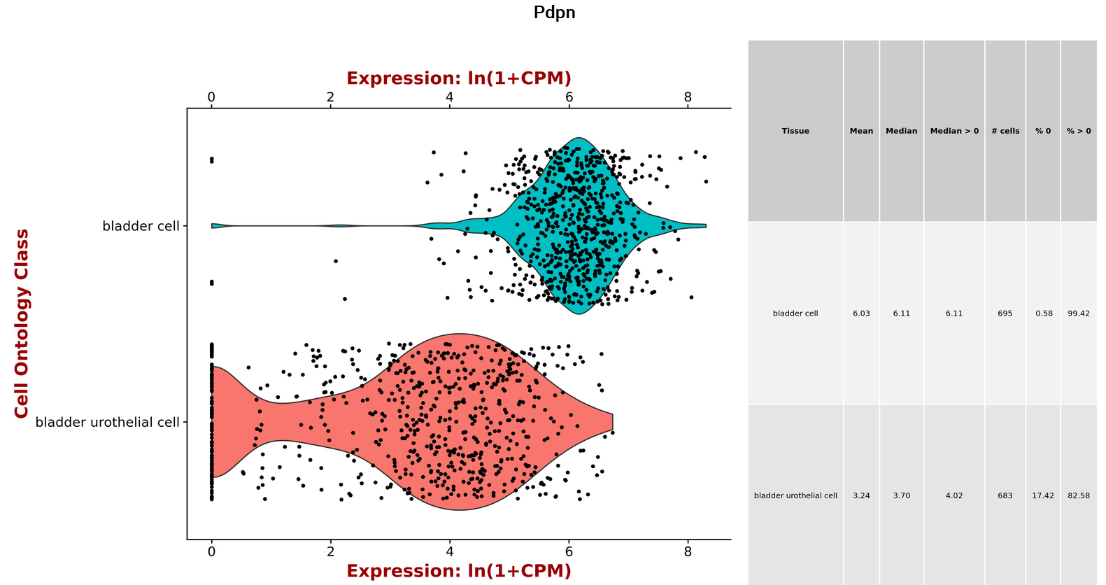
The reviewer mentions that CD326-/CD45-/PDPN- identifies smooth muscle. Although smooth muscle doesn’t express CD326 (Ep-CAM) and CD45 (PTPRC) they do express podoplanin abundantly, based on expression data from the Tabula Muris (see below). Thus, excluding cells that express PDPN will not yield the smooth muscle population.
Relative expression of Pdpn in mouse bladder using data from Tabula Muris. Bladder cell refers to smooth muscle cells.

2)…. As the protocol stands, there isn't really meaningful differences among the formulas in regards to cell viability…. The real question is not about viability, but about bladder cell populations.

Based on new information added in this revised version of the manuscript, a comparison of the 4 protocols shows variation in viability based on the specific dissociation mix. Figure 4A now shows an increased in cell viability from 83% to 93% across the 4 protocols. This is a key conclusion of the protocol, particularly given the short duration of tissue digestion, highlighting the efficiency of the dissociation procedure.

We recognize the common belief that if a given protocol leads to a proportional loss of a particular cell type among the populations represented in a given sample, then viability is unimportant. On the contrary, however, data from us and others demonstrates the fact that low viability leads to unreliable cell recovery during flow cytometry, and for downstream analysis such as single cell RNA sequencing leads to missed sequencing targets and therefore suboptimal results. Furthermore, RNA released by dead or dying cells increases background noise, compromising data quality. To maximize the amount of useful sequencing data in single cell projects, the fraction of dead cells must be minimized. Therefore, it is recommended that cell viability exceeds 90%, emphasizing the importance of the dissociation protocol we describe here, in addition to the appropriate representation of different cell populations.

3)….Sca-1 is useless….

The focus of the current manuscript is on viability of the cells obtained from bladders that are dysfunctional as a consequence of functional bladder outlet obstruction, secondary to spinal cord injury. This injury results in severe structural and functional impairment, including persistent alterations to the tissue architecture of the bladder wall rendering it poorly compliant and with altered barrier function. Our rationale to use Sca-1 is as follows:
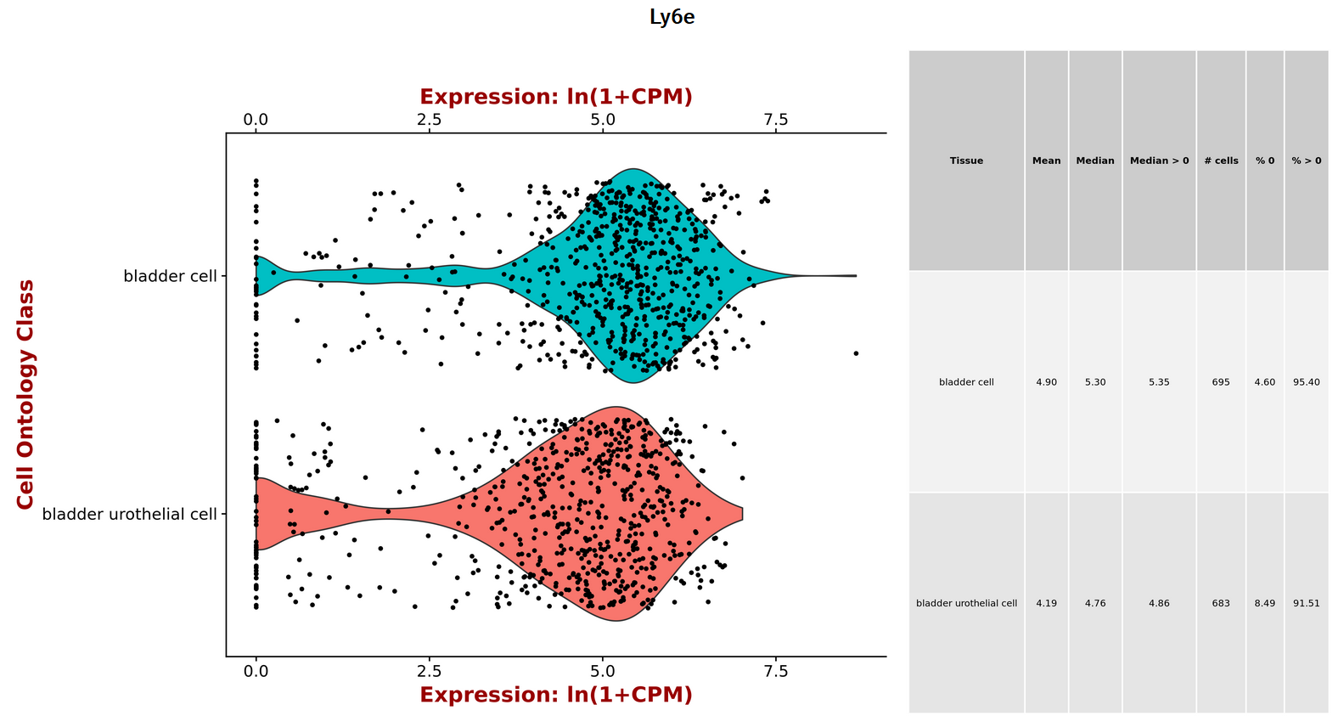
a) Sca-1 is expressed throughout the bladder wall and can provide a rough estimate of the performance of the dissociation protocol(s)(see figure below).
Relative expression of Pdpn in mouse bladder using data from Tabula Muris. Bladder cell refers to smooth muscle cells.

(b) Some studies have attempted to characterize a progenitor cell population as a first step in understanding its role in bladder fibrosis and identified a Sca-1+/lin- (PECAM-/CD45-/Ter119-) population in the adult murine bladder. Therefore, we have used Sca-1 to show that samples dissociated using this protocol include this cell population (Lilly et al., 2015, PLoS ONE 10(11): e0141437).

4) Given the restrictions as a result of COVID-19, we are not in a position to repeat experiments at the current time.

Reviewer #2:
Manuscript Summary:
The manuscript "An optimized dissociation approach for single cell analysis of urinary bladder in the mouse following spinal cord injury" , describes protocols for spinal cord injury, enzymatic dissociation of the bladder and flow cytometry. Given the many dissociation protocols used in the literature and many discrepancies in the results, this is an extremely important paper. The effort undertaken to establish a repeatable and reproducible protocol that could be used across different labs and would produce similar results is truly commendable. The manuscript is well organized and well presented. I have a number of suggestions.

We thank the reviewer for their positive comments on the manuscript.

Major Concerns:
One main concern is that it is not clear what the enzymatic protocols that were compared are and what is the final recommended protocol. In the introduction, the authors state "we describe an optimized tissue dissociation method for downstream single cell analysis in the spinal cord injured mouse bladder. Using flow cytometry we compared four enzymatic digestion protocols for their ability to yield a single cell suspension, support cell viability and maintain the correct proportion of cell populations." Where are the four protocols described? I suggest making a table to illustrate how they differ, and comment on which one is recommended to be used and why.

We thank the reviewer for this point. We now include details on all 4 dissociation protocols in Table 2, as well as a discussion as to which is recommended and why.

Minor Concerns:
1) There is significant remodeling in the bladder wall after SCI. Is the same enzymatic digestion protocol recommended for both control and SCI bladders?

We thank the reviewer for this comment. The same enzymatic dissociation protocol was used for both control and SCI bladders with no detriment to the viability of cells isolated from less remodeled control samples. The key element in the success of dissociation is the relatively short time (1 hour or less) required for tissue digestion, which greatly enhances cell viability.

2) There is also time dependent remodeling of the bladder wall. The authors do not specify what time points after SCI were the dissociations performed. Please add that information on the method section. Would there be a need for adjustments in the enzymatic digestion protocol based on the time post injury? Please comment.

The representative data shown in this manuscript were from 8 weeks after SCI. This has now been added to the protocol (1.5.5.). We have applied the dissociation protocol described here to mice at different times of injury from as early as 2 weeks up to 16 weeks after injury (unpublished observations), with comparable results in terms of viability.

3) The dissociation and staining procedures greatly depend on the quality and specificity of reagents and antibodies. In order to ensure reproducibility of the protocols, please add information for each enzyme (especially those used in Table 2), reagent and antibody used: e.g catalog number for enzymes and reagents, host, purification method and catalog # (polyclonal or mc if indicated) for antibodies. Whenever possible please use the RRIDs AB Registry ID found at https://scicrunch.org/resources.

We fully agree with the reviewer’s point about dissociation and staining being highly dependent on reagent and antibody quality. We have included the pertinent information for enzymes and antibodies in the Table of Materials that accompanies the manuscript.

4) Lines 47-49: Animals are perfused at different times after injury with phosphate-buffered saline under deep anesthesia…What are these different times?

The data shown here are from 8 weeks after SCI, therefore we have modified the text to indicate this.

5) Line 154 section 4.5. It is recommended to place gelfoam as a hemostatic between the two segments of the transected cord (Pharmacia and Upjohn Company, Kalamazoo, MI).

We thank the reviewer for this comment. In prior studies, we have used GelFoam as a hemostatic, but found that in mice, compression with a sterile cotton-tipped applicator was sufficient to stop the bleeding with no recurrence of bleeding or post-operative hematoma formation.

6) Line 219 Part 2 Step 11. Add an average time for how long the perfusion should take. Mention what are the recommendations in case of inadequate perfusion.

The average time for perfusion was 3.5 – 4 minutes. Inadequate perfusion is manifested as slow progression of blanching of tissues and usually is due to incorrect positioning of the needle in the left ventricle. Adjusting the needle and extending the duration of perfusion for 1 to 2 minutes will ensure adequate perfusion of tissues.

7) Line 281 "Centrifuge for 10 minutes at 350 x g at 4C." Please add explanations for why choosing 4C. Please comment whether this may shock the cells by changing the temperature from 37 to 4C?

We performed centrifugation at 4°C since one important application of the cell dissociation procedure would be to single cell RNA sequencing experiments. For such applications, it is critical that the dissociation procedure itself elicits minimal gene expression changes, hence the choice of 4°C for centrifugation experiments. In our experience, the use of 4°C as opposed to 37°C for centrifugation ensured high cell viability.

8) Line 297 "Count the cells." Please elaborate. Please add what the yield should and advise what to do in cases where the cells are not completely dissociated, e.g. small aggregates are still present.

The cell yield is likely to vary from experiment to experiment, but is expected to be on the order of 5 x 10⁵ cells from a single mouse bladder. We have used specific gating strategies during flow cytometry to exclude cell aggregates from analysis.

9) Line 300 "In this study to detect different immune cells in the bladder" , do the authors mean different cell types?

We thank the reviewer for pointing this out. We have corrected the text.

10) Line 320, Describe the reason for staining for Annexin V and PI. Define PI = Propidium iodide when first used.

Staining for Annexin V and PI enables the detection of apoptotic (Annexin V-positive) and necrotic (PI-positive) cells in populations subjected to flow cytometry. The ability to detect and eliminate dead and dying cells from the analysis is important for determination of the efficacy of dissociation protocols at preserving cell viability. We have now defined PI as Propidium Iodide at first use.

11) Lines 453 -455 Are there differences in collagen components between controls and SCI? Are data presented in Figures 2-4 from SCI mice? Please clarify in the figure legends.

The graphs in Figure 2 are plotted using publicly available expression data from control mice. Figure 3 provides a schematic representation of different cell populations identified by flow cytometry, strategies for assessing cell viability using annexin V and PI staining and approaches for appropriate controls. Figure 4 shows representative data from both control (uninjured) and SCI mice. We have clarified these details in the figure legends.

12) Table 1 and Table 2: please specify the volume of the solution, e.g. add 4.091 g NaCl in how much volume?

We have included these details in the protocol.

Reviewer #3:
Manuscript Summary:
This is a manuscript that describes both a method to transect the spinal cord to create an animal model of neurogenic bladder and a cell dissociation method to efficiently achieve a high rate of living single cells appropriate for scRNA-seq.

Major Concerns:
On lines 92-94 the authors describe a comparison of 4 different digestion methods in order to find the best approach, but later in the manuscript the idea of comparing different digestions is not clearly flushed out and I had to work hard to look for the details that supported the comparisons. The authors should decide if this is an important line of reasoning. If not remove the mention of comparing different methods of cell preparation.

We apologize for the omission. We have now included the details of the 4 protocols in Table 2.

In lines 354-435 there are detailed methods for FACS sorting and analysis. I believe that these methods are of general nature and don't add to the specific focus of the paper on bladder cell isolation. These methods could be found in any article on flow cytometry and this article is not about flow cytometry. So these sections should be reduced to sentences such as FACS sorting and controls are clearly described in the following article. FACS analysis using Flojo are described in the following article...

While we agree that methods for FACS are somewhat standard, there are a variety of approaches to both data generation and data analysis. The major issue in the field is that investigators gate differently and obtain slightly different results. Thus there is no guarantee that users define their own settings and obtain the same results as reported here. The findings reported here result from the machine settings outlined in the protocol. For this reason we have chosen to include a detailed protocol here.

Minor Concerns:
Line 137: please indicate that the pain medication drugs are the choice of the end user and that for example you can use the drugs you have cited.

We have noted this in the text.

Line 168: same comment as above.

We have noted this in the text.

Line 186: You comment "Complete urethral obstruction in male mice frequently culminates in bladder rupture and death." Please indicate the frequency that your lab has observed this in making neurogenic bladders. This is helpful in animal protocol applications.

In our experience the frequency of urethral obstruction in male mice that led to death was 10%.

Line 192: What is the vendor for caladryl?

Caladryl was added by mistake and has now been removed. Mice are treated with triple antibiotic ointment to minimize inflammation and skin breakdown.

Line 215: What are the details for the perfusion apparatus?

The perfusion apparatus consists of infusion pump and 50 mL syringe connected to an intravenous tubing and 23-gauge needle. This has been added to the protocol.

Line 238: should say in A clean 500mL bottle.

We have corrected the text.

