Dear Dr. Bajaj April 8 2020
We are submitting a revision to our JoVE manuscript 61428R2, now entitled: “An Emerging Target Paradigm to evoke fast visuomotor responses on human upper limb muscles” for consideration at JoVE. We thank you for your editorial comments, and hope that all is in order. If not, please feel free to contact us at your convenience.

With best regards,

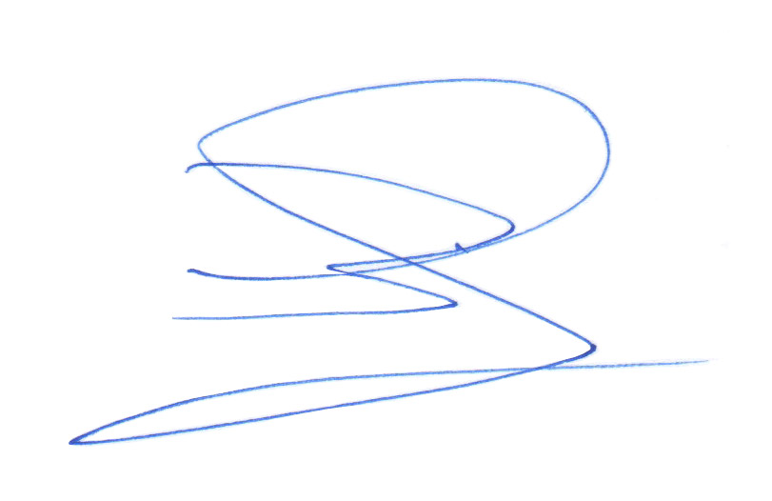

Brian D Corneil, PhD
Professor, Scientist
Dept. of Physiology & Pharmacology; Dept. of Psychology Robarts Research Institute
Brain and Mind Institute
Western University
Tel: 519-663-5777, x24132
Email: bcorneil@uwo.ca

