
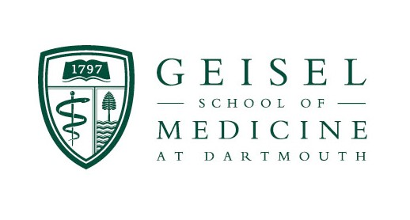


JoVE
Editor -in -Chief

---------------------------------------------------------

February 29, 2020

Re: Invited video methods manuscript

Dear Editor-in-Chief at JoVE,
Please consider this manuscript; Design and implementation of a robust magnetic nanoparticle hyperthermia delivery system for in vitro and/or in vivo experiments, for publication in JoVE. The first and corresponding author is Kayla Duval, a senior graduate student in my lab.
Please let me know if additional information would be helpful. Thank you
Sincerely,


P. Jack Hoopes, DVM, PhD
Professor of Surgery and Radiation Oncology
Director, Center for Comparative Medicine and the
Surgery and Radiation Research Laboratories
Geisel School of Medicine /Norris Cotton Cancer Center
Adjunct Professor, Thayer School of Engineering
Dartmouth College

