Fish-eye correction supplement

As described in the representative results shown in the main protocol, the use of a fisheye lens results in the recorded image being distorted. There are different approaches one can take in order to correct such distortions, if it is deemed necessary. We have implemented a proposed industrial algorithm¹ which is based on the framework proposed by Scaramuzza et al². This approach uses a linear regression model to correct for compression and expansion of pixel coordinates.

Given the fact that the center of image corresponds to the center of the fisheye lens, an intrinsic parameter for the lens (f) is defined, using image width and horizontal field of view (FOVhor):

$$f=\frac{image_width}{4sin⁡(\frac{FOV}{2})}$$
Thereafter, an intermediate parameter of image distortion (λ) is calculated:

$$λ=\sqrt{\frac{x^{2}-y^{2}}{f}}$$
Note: x and y represent the uncorrected coordinates of pixels obtained from the fish eye equipped camera. In relation to the current protocol, they more specifically represent the uncorrected coordinates obtained from DeepLabCut.

Then the final correction for coordinates (xf and yf) can then be obtained through:

$$x_{f}=\frac{(2xSin\left(\operatorname{atan}\left(\frac{λ}{2}\right)\right))}{λ}$$

$$y_{f}=\frac{(2ySin\left(\operatorname{atan}\left(\frac{λ}{2}\right)\right))}{λ}$$

As noted in the representative data for this protocol, the distortion induced by the fish eye lens is minimal within the field of view that covers the operant chamber. In line with this, correcting the path travelled and speed profile of some example data showed only minor effects (Fig. S1). Still, it is noteworthy that the correction resulted in a consistent reduction in peak speeds (Fig. S1A) and the tracked path being slightly compressed towards the image center (Fig. S1B). However, average movement speeds across 25 5CSRTT trials for four different animals show virtually no overall effect of the correction (Fig. S2). As such, impact of and need for correcting the fish eye distortion will depend on the parameters of interest and other study-specific concerns.

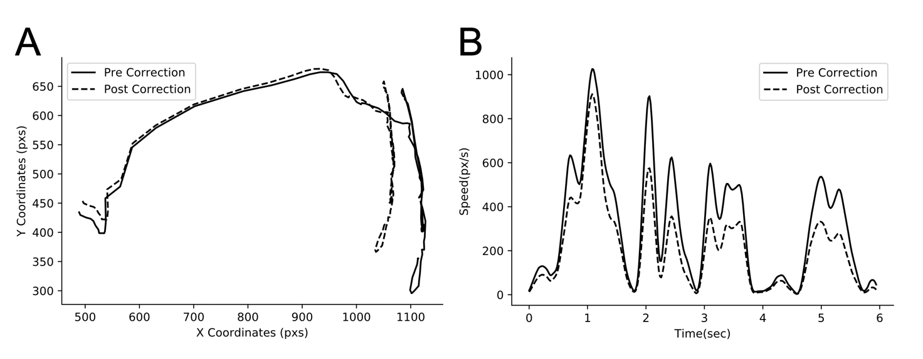
Fig. S1. Example data displaying effect of mathematical correction of fish eye distortion on plotted path during an ITI and subsequent response on a 5CSRTT trial (A), and the changes in movement speed of the animal’s head during this behavioral sequence (B). Notably, while the effects of the correction are discreet, the plotted path is more constrained horizontally, and the peak speeds are slightly reduced. Data relates to the performance of one animal on a single 5CSRTT trial either corrected or not corrected for fish eye distortion. Abbreviations: pxs: pixels.
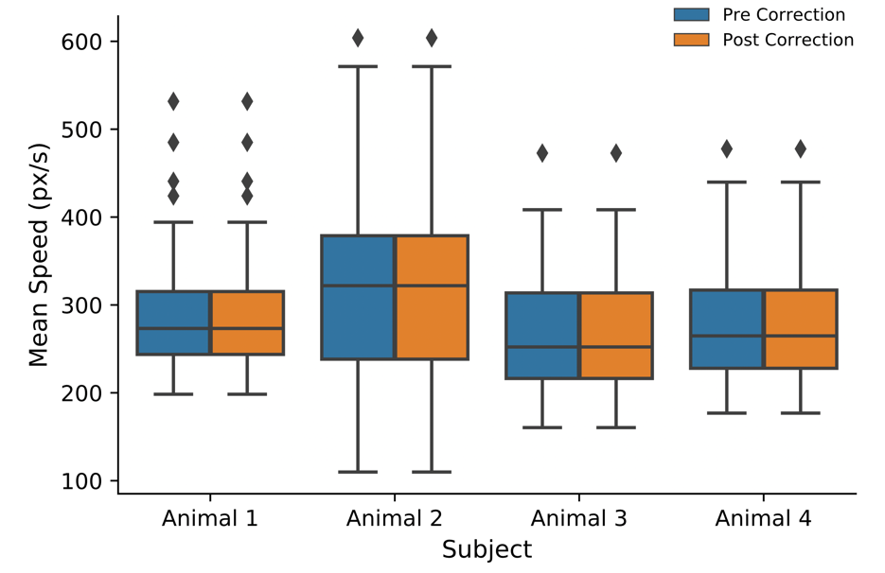

Fig. S2. Example data displaying the effect of mathematical correction of fish eye distortion on the average speed during 25 trials of the 5CSRTT, for four different rats. Box plots indicate mean and range (25 and 75 percentile). Outliers are indicated with black diamonds. Abbreviations: pxs: pixels.

- Altera corp, A Flexible Architecture for Fisheye Correction in Automotive Rear-View Cameras, White paper. https://www.intel.com/content/dam/www/programmable/us/en/pdfs/literature/wp/wp-01073-flexible-architecture-fisheye-correction-automotive-rear-view-cameras.pdf (2008)

- Scaramuzza, D., Martinelli, A., Siegwart, R. A Toolbox for Easy Calibrating Omnidirectional Cameras. Proceedings to IEEE International Conference on Intelligent Robots and Systems, (IROS). Beijing, China, October 7–15, (2006)

