RE: JoVE61408R2

Dear Editor,
As per email response from the Editor of IEEE Access, we are permitted to reuse the materials in our published paper under the CC BY license. Please see below link to the license and email correspondences for your reference.

https://creativecommons.org/licenses/by/4.0/

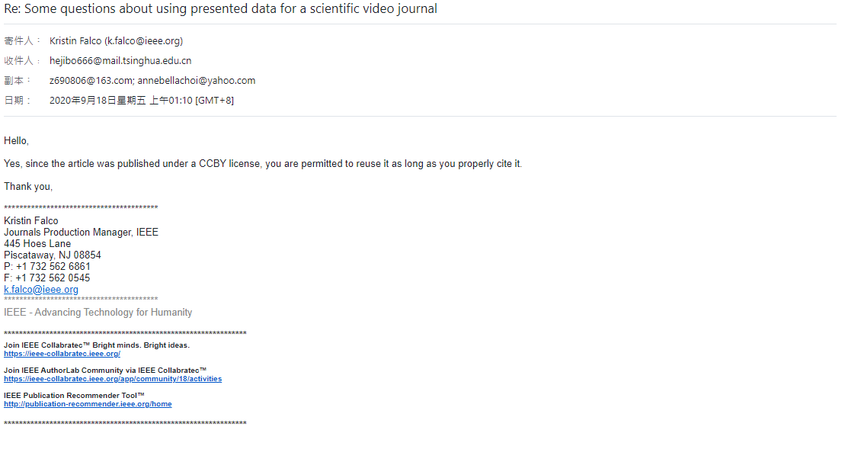

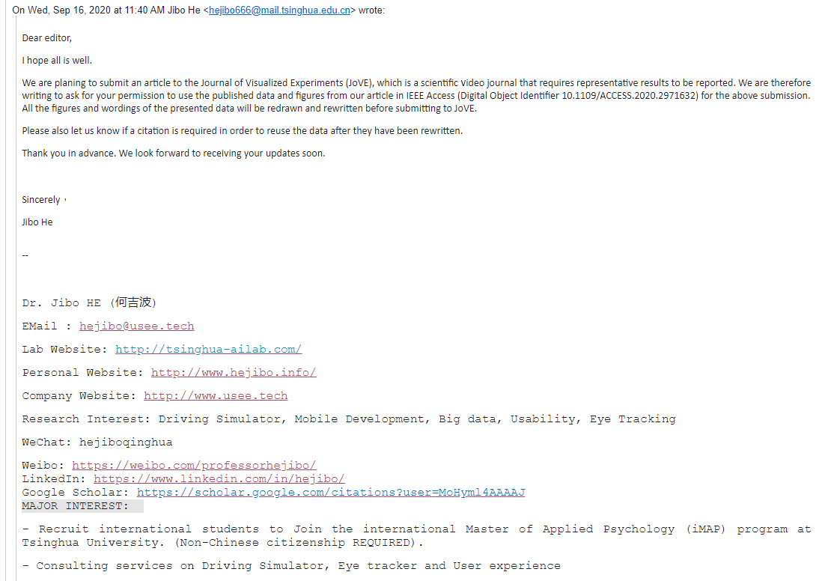
Sincerely,
Jibo He, Ph.D.

Associate Professor
Department of Psychology
Tsinghua University
Email: hejibo666@mail.tsinghua.edu.cn

