Dear Dr. Vineeta Bajaj,

We are pleased to learn that you see merit in our manuscript, and we are thankful for the opportunity for revision and re-submission. The careful analysis of our paper by the reviewers has led us to include a number of changes that we believe have improved both the quality and clarity of our paper.
Our response to each of the reviewer’s comments, as well as those from the editorial team, is given below. The reviewer’s original comments are shown in bold. Our responses to those comments are shown in italics, and text from the manuscript is in plain font. All text from the manuscript represent the final version; details of changes (new / added text) are visible in the red-lined version that was uploaded with this revision response.
Thank you for your consideration and we look forward to the final decision.

Sincerely,

Emily Kight
Iftak Hussain
Audrey Bowden

Reviewer #1 comments:
Major Concerns: None
Minor Concerns:
1. “The manuscript loosely used the term "design". In fact, the authors described a method to customize the device design to different types of dipsticks. For its intended users, it is more of customization rather than design. The protocols itself is more of a step by step description with little engineering design guidance nor discussion of such design.”
We thank the reviewer for the suggestion. We agree that our usage of the term “design” was inconsistent. In general, we updated the language to reflect the customization aspect of the device in the revised manuscript. Hence, we have replaced many instances of the word “design” with the word “customization” or alternate words. This is particularly salient for the Abstract. Use of the word design itself has been largely limited to referencing the general principle of action of the device or as part of the term “computer aided design” (CAD) software. These changes are reflected in the text in the manuscript below.
Abstract
…We describe the steps necessary to create a customizable device to perform automated urinalysis testing in any environment. The device is cheap to manufacture and simple to assemble. We describe the key steps involved in customizing it for the dipstick of choice and for customizing a mobile phone app to analyze the results. We demonstrate its use to perform urinalysis and discuss the critical measurements and fabrication steps necessary to ensure robust operation…
Representative Results
...The most accurate results were obtained when the automated urinalysis device was designed to transfer 15 μL of urine…
Discussion
To this end, critical steps in the protocol relate to the design of the device include Steps…

Reviewer #2 comments
Major Concerns:
So far I find a number of qualitative reports on the same issue are already published in different journals. This paper shows minor advancement with respect to the relevant works done previously. I would like to suggest major revision of this paper for publication in this journal. Some critical points have been mentioned here:
We gratefully acknowledge the valuable comments/suggestions received from the reviewer in correcting and revising the manuscript. It is our understanding that JoVE is a methods journal and its primary goal is to publish techniques or methodologies that are highly reproducible, regardless of their novelty. As cited on the JoVE website (https://www.jove.com/publish/faq/) “These methodologies can be previously published protocols or new techniques. Previously published protocols must be properly cited…” To our knowledge, the journal also allows publication of representative results and figures from prior publication. The current paper describes a reproducible protocol for fabricating a robust dipstick urinalysis device which we have published previously in peer-reviewed journals (see below) that we have referenced; hence it is our understanding that this manuscript is suitable for the stated scope of JoVE:
Smith, G.T., Dwork, N., Khan, S.A., Millet, M., Magar, K., Javanmard, M. and Bowden, A.K.E., 2016. Robust dipstick urinalysis using a low-cost, micro-volume slipping manifold and mobile phone platform. Lab on a chip, 16(11), pp.2069-2078.
Smith, G.T., Li, L., Zhu, Y. and Bowden, A.K., 2018. Low-power, low-cost urinalysis system with integrated dipstick evaluation and microscopic analysis. Lab on a Chip, 18(14), pp.2111-2123.
Please find below the responses to your other comments:
1. In this paper, Authors have been strongly focused on "automated urinalysis device" which is capable of controlling the volume of urine and provide accurate results, but there are no volume-related experimental data and accuracy test results.
We thank the reviewer for the correction. We have added a new figure (Fig 7) describing results from a volume-related experiment and companion text in the representative results section. We have also added data from a comparison experiment to the standard method, dip-and-wipe. These results are summarized in Table 1. The table and the figure are presented below for your convenience along with their figure captions and related texts in the representative results section.
Representative Results:
We have previously evaluated the accuracy of the automated urinalysis device by comparing with traditional dip-and-wipe methods using a commercial urine standard¹⁹. Table 1 compares the results obtained with the two tests. It can be seen that the accuracy of the system depends on the volume transferred to each dipstick pad. The most accurate results were obtained when the automated urinalysis device is designed to transfer 15 μL of urine; therefore, it is crucial that the device transfer the required urine volume accurately and consistently to the dipstick pads. Representative results to validate the consistency of our device by transferring 15 μL volume of urine samples over seven different trials are shown in Figure 7. The overall standard deviation was found to be below 0.5 μL, which is within 4% range of our target value. The results confirm that the device is able to accurately and consistently transfer microliters of urine to perform the test.
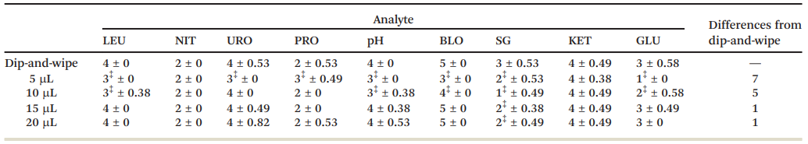
Table 1: Median values and standard deviations for analytes using various deposited volumes. The symbol ‡ indicates median values that differ from the median obtained with the dip-and-wipe method, the industry standard. The total number of analyte pads whose medians differ from the dip-and-wipe method are reported in the far right column. Note results are cumulative for all dipsticks used. LEU: leukocytes, NIT: nitrite, URO: urobilinogen, PRO: protein, BLO: blood, SG: specific gravity, KET: ketones, GLU: glucose. This table has been modified from Smith, et al.¹⁹ and reproduced with permission from the Royal Society of Chemistry.
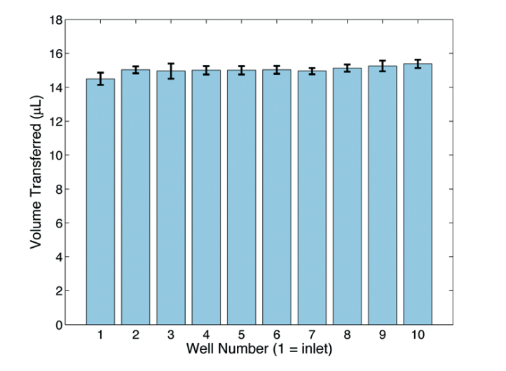
Figure 7: ﻿Well number vs. average volume transferred. Each well corresponds to a through-hole for a given test pad; the first well is closest to the inlet. This figure has been modified from Smith, et al.¹⁹ and reproduced with permission from the Royal Society of Chemistry.
2. Not enough references and the introduction part seems like a mythical story.
Prompted by the reviewer’s comment, we conducted a more thorough literature search. We have added eight papers on cell phone urinalysis applications that were published recently: they comprise references [8-15]. These papers were included in the introduction section. The new text we have added to our manuscript as relates to these papers is provided below.
Introduction
Recently, cell phones have emerged as a resourceful tool for various biological colorimetric measurements^{7,8,9,10}, including for urinalysis^{11,12,13,}. Given their remote sensing capabilities and high imaging resolution, cell phones have become effective healthcare analytical devices^{14,15}. Indeed, the FDA has cleared several smartphone-based home urine tests^{16,17,18}.
3. In line No. 105 to 112, the authors have mentioned the device fabrication procedures, I would suggest here more precisely explain the purpose, achievement, and scope of the work.
We thank the reviewer for the suggestion. According to your suggestion we have provided a short explanation of the purpose, achievement and scope of the work in the introduction section of the revised manuscript. Keeping in mind that JOVE is a methods journal, our main purpose is to describe a protocol for performing a technique (in this case, urinalysis).
Introduction
We describe a protocol for volume-controlled, automated dipstick urinalysis without the need for a manual dip-wipe step … Following description of the protocol, we provide representative results of the urinalysis test under different conditions. Comparisons with the standard dip-wipe method demonstrate reliability of the proposed method.
4. Authors doesn't mention the principle of devices just explain the device fabrication and test procedures.
We appreciate the reviewer for the suggestion. We agree the principle of the device should be clearer to readers. Our device is based on a SlipChip concept that was published previously. We have expanded the introduction section to include further description of the principle. The new text we have added to our manuscript is provided below.
Introduction
… Key to the automated process is a device¹⁹ whose underlying design is based on the SlipChip²⁰ and that transfers liquid between different layers using surface chemistry effects. In brief, the hydrophobic coating on the transfer slide and surrounding plate sleeve force the liquid to move effortlessly through the device and to release onto the dipstick pad once the slide is in its final position, at which point the bottom hydrophobic barrier is replaced with air…
5. Fig. 1, Fig. 3, and Fig. 4 are very unclear regulation and it's very confusing to find out the meaning of those images.
We thank the reviewer for the feedback. Although we are uncertain of what was exactly meant by “regulation,” we agree it is useful to further clarify the figures. As the Editor suggested the term may have been intended to mean “resolution,” we have provided new high-resolution figures for the entire manuscript. In addition, new updates to the figures we have added to our manuscript are provided in detail below.
For Figure 1, we added labeling to panel F to show where the viewing through-hole is located and where analysis is enabled. Additionally, the inlet graphic was changed to show the overlapping holes that allow the transfer of liquid critical for the SlipChip design in panel F. We have added a visible gap in the plate sleeve to visualize where the slide is slipped onto the reagent pads in panel F.
For Figure 2, we have added labels on each panel to help clarify the steps in the app to conduct the test. Screen shots are categorized by either Initiation, Alignment or Timing Control and Detection.
For Figure 4, we have taken new photos in order to improve the resolution. We also added additional labels for the “plate sleeve” and “slide” in panel A.
Figure 1
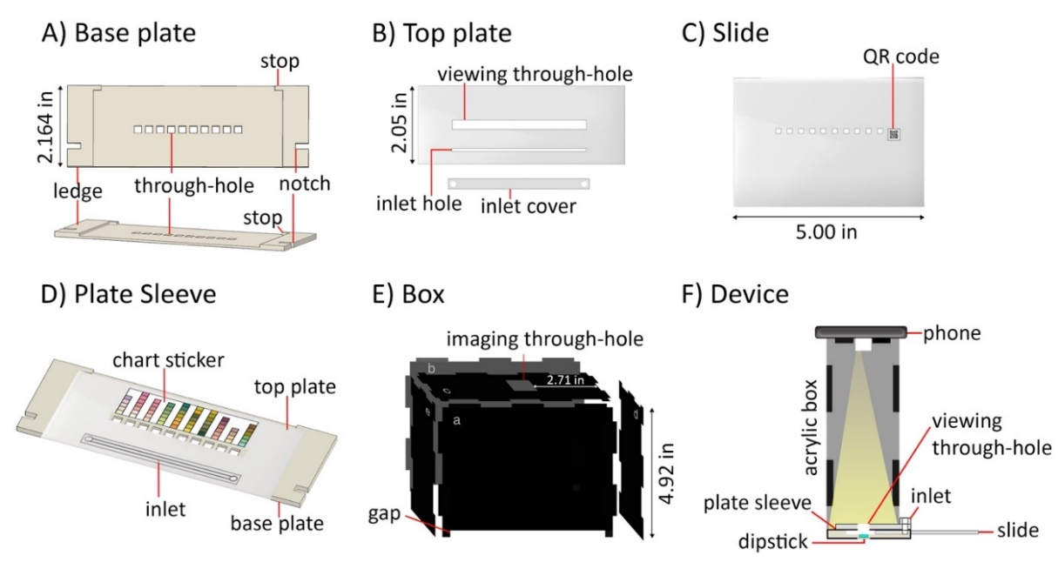

Figure 2
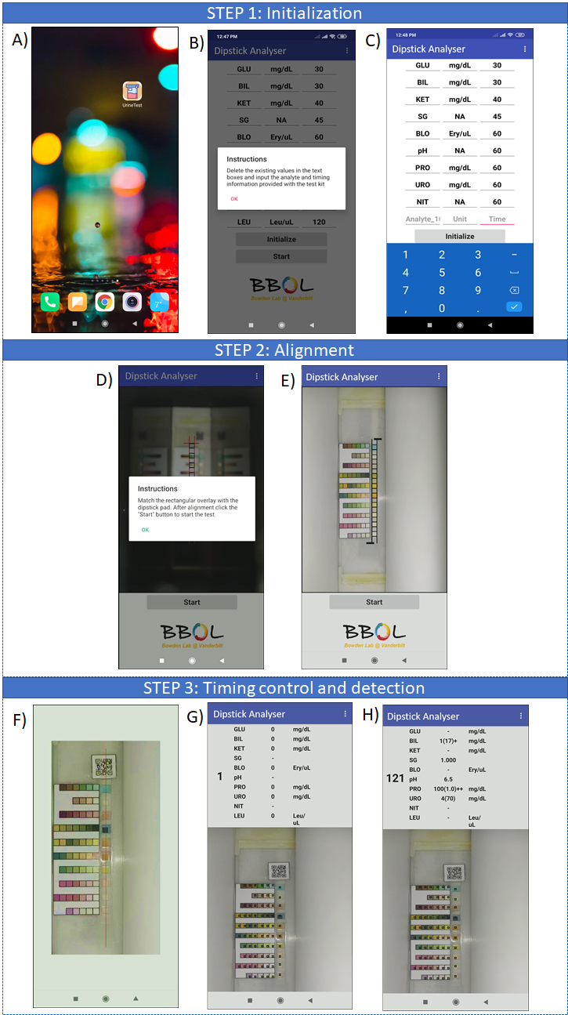
Figure 4
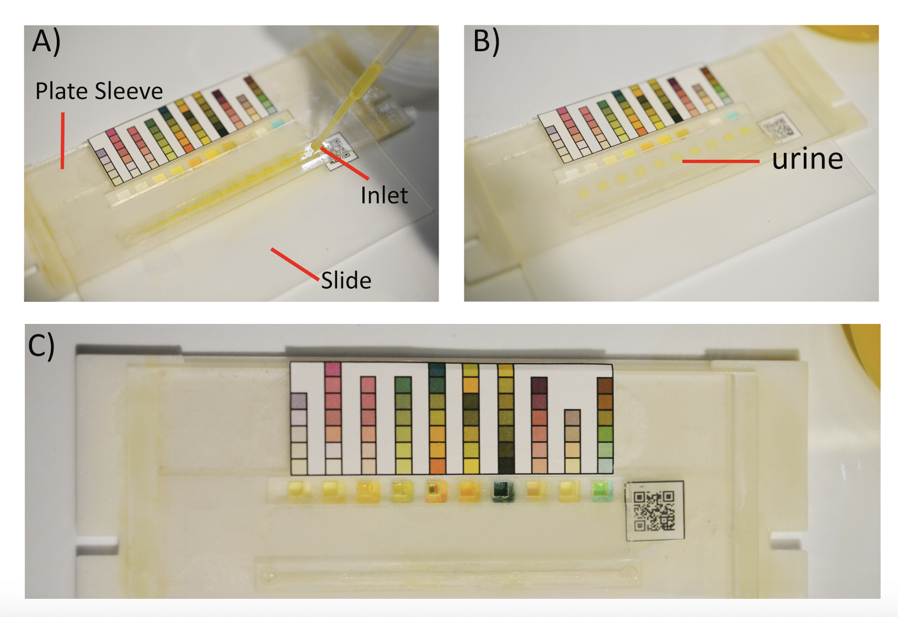
Minor Concerns:
6. Representative results section (line No. 266-333) and Figure and table legends section (line No. 339-380) Authors have explained the same things again and again.
We thank the reviewer comments on the redundancy. We have significantly modified the representative results section so that it no longer reads as a list of figure captions. Indeed, the modified manuscript better aligns with the expectations of the journal to describe the expected results of an experimental outcome based on the protocol. We have eliminated sentences which repeated the same information and changed the figure legends accordingly. As the entire Representative Results section is new, we do not repeat it here, but refer the Reviewer to the revised manuscript.

Reviewer #3:
The manuscript "A Low-Cost Device for Reliable, Automated Dipstick Urinalysis for Home-testing." By Knight et al. is an interesting work where authors have developed an approach for dipstick urinalysis along with a mobile phone app. There are certain concerns and suggestions that I believe will help in improving the quality of the manuscript.
1. The steps for fabrication and assembly of the proposed device are quite tedious and complicated for users. Also, it requires alignment and pasting at various steps which might lead to errors and contamination.
We appreciate the reviewer’s comment. Our device is intended to be easy to assemble and use. To make this clear, we believe it is useful for the reader to understand that once the device is cut, gluing is only required twice (Steps 1.5.1 and 1.5.4); the shape of the device is such that the full design fits together easily. We have updated the language in the gluing steps accordingly. While the steps seem complicated, it is our understanding that, as a methods journal, the idea of JoVE is to provide highly detailed steps, more so than would appear in a typical journal. In our protocol, this requires careful work in the device fabrication stage, so we have highlighted issues that users may encounter if steps are not done correctly and provided a new figure showing potential problems (i.e., device failings if coating is insufficient) in the Representative Results section. Specification of the critical steps that must be followed have been added to the discussion section. The new text we have added to our manuscript is provided below.
Protocol
    - Fabricate the inlet by using acrylic cement to glue the inlet cover onto the top plate where the inlet-hole is located. Wait 24-48 hours to securely bond the pieces.
1.5.4. Assemble the plate sleeve by gluing the completed top plate to the ledges of the base plate with acrylic cement. The two pieces are easy to align by visual inspection, as the bottom edge of the top plate will align with that of the base plate. Apply a clamp to the base plate ledges to secure it during drying. Wait 24-48 hours before use, as per the manufacturer’s instructions.
Representative Results
Figure 5 demonstrates a potential problem that can arise if the surfaces for transferring the urine (i.e., base pate, top plate and slide) are not sufficiently coated with hydrophobic spray. An illustration of a well and poorly coated slide is shown in Figure 5A. If poorly coated, one may observe streaks (shown by white arrows in Figure 5B) during the sliding step that decrease the accuracy of the volume transferred. In addition, one may observe failure of the slide to transfer the urine to the dipstick (Figure 5C), and urine may remain in the through-holes even when the slide is removed from the device. These steps highlight the importance of obtaining good spray coverage (Steps 1.1.8, 1.4.4, 1.5.3, and 1.5.4).
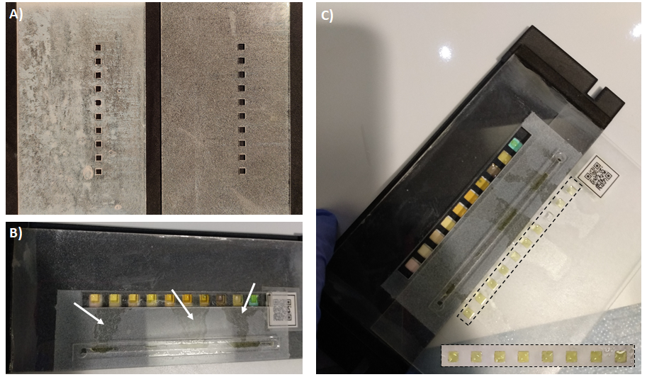
Figure 5: Potential problems associated with insufficient hydrophobicity. A) A slide with and without sufficient coating. B) Insufficiently coated slide shows leaking during the sliding step. C) An insufficiently coated slide doesn’t transfer onto the dipstick pads even after being pulled back out of the device: the liquid remains in the slide through-holes, as seen in the inset on the bottom right.
Discussion
Our protocol automates and controls several important steps involved with dipstick urinalysis (e.g., distribution of liquid to the test pads, the timing of the start, control over the lighting and quantitative comparison with the reference standard), which is necessary to obtain reliable results. To this end, critical steps in the protocol relate to the design of the device include Steps 1.4.3, 1.1.4, 1.4.7 and 1.1.5, which match the size of the through-holes to the desired volume, ensure proper placement of the stops to align the through-holes with the dipstick, ensure proper placement of the QR code used as the timing indicator and ensure that the test is not influenced by ambient light, respectively.
2. The choice of ABS as base material (line 354) for 3D printing is unclear. It would be helpful for readers if some idea of other available materials for 3D printing is presented eg. PLA, PET, PDMS, etc.
We thank the reviewer for the correction. While ABS is a standard printing material for 3D printers that is widely available, we agree that it would be beneficial to describe other types of material can be used for the 3D printed portion. Testing multiple materials is beyond the scope of this manuscript at the revision stage, but we have updated the paragraph in the Discussion to reflect that the choice of material is not limited to ABS. The new text we have added to our manuscript is provided below.
Discussion
… Although the base plate we used is 3D-printed from acrylonitrile butadiene styrene (ABS), other polymers that form a hard and rigid surface are also suitable. For example, a version of the device can be made using a plate sleeve completely fabricated from acrylic¹⁹ . Elastomeric materials such as polydimethylsilioxane (PDMS) are not desirable because their lower rigidity is less compatible with sliding a glass surface to enable the slipping action that is critical to the volume-control design.
3. A comparative study for device's performance for different smart-phones must be presented. It is required to clear doubts whether resolution of the camera, intensity of LED of different phones hamper the performance of the device.
According to the reviewer’s suggestion, a comparative study was carried out with smartphones of two different brands and the results are discussed in the representative results section of the revised manuscript. The results confirm that the method is indifferent to the camera resolution and LED variations across phones.
Representative results
We performed a urinalysis test with a Xiaomi Note 7 Pro smartphone (Image resolution: 8000-pixels x 6000-pixels). Representative results are shown in Figure 6. We conducted tests with de-ionized water and commercial urine (both standard composition and with high glucose). The color pads on the dipstick change in time in response to the colorimetric reaction of the urine with the analytes in the dipstick. The error bars in figure 6 represents the standard deviation yielded for three consecutive measurements of each sample recorded by the two smartphones. Figure 6a plots the response for the glucose pad over time for the different test conditions. For the brand of dipstick used, the recommended readout time for the glucose measurement is 30 seconds. As expected, the color of the dipstick does not change over this interval for water, the final value for the standard urine matches with the “normal” urinary glucose threshold level (160-180 mg/dL), and the final value for the “high glucose” condition is elevated above the normal value. Importantly, note that the correct value is not attained until 30 seconds, which illustrates the importance of setting the timing readout interval correctly in Step 2.8. The same experiment was performed with another smartphone brand having a lower image resolution: LG Rebel 4 (Image resolution: 3264-pixels x 2448-pixels). Due to the difference in camera resolution, a significant difference from the previous results is observed in the image color and quality while capturing images of the dipstick panel, as shown in Figure 6B. The differences in flashlight specifications also contribute to the differences in image quality. From Figure 6, it can be seen that both phones yield similar trends in the change of color over time, though the actual colors detected are different. The color matching algorithm used by the smartphone application for the urinalysis test yields the same results for the analyte concentrations, despite differences in the physical appearance of the colors of the dipstick pads. The consistency of the results is due to the use of the chart sticker as a reference chart for the analysis. Since both the chart sticker and the dipstick are captured under the same lighting conditions and image quality, the smartphone application evaluates the (R,G,B) components and the color difference of both the reference square and dipstick pad in a similar fashion for both smartphones. These results confirm that the protocol described in this manuscript is independent of the smartphone model, as long as both the reference color chart and the dipstick are imaged under the same environment.
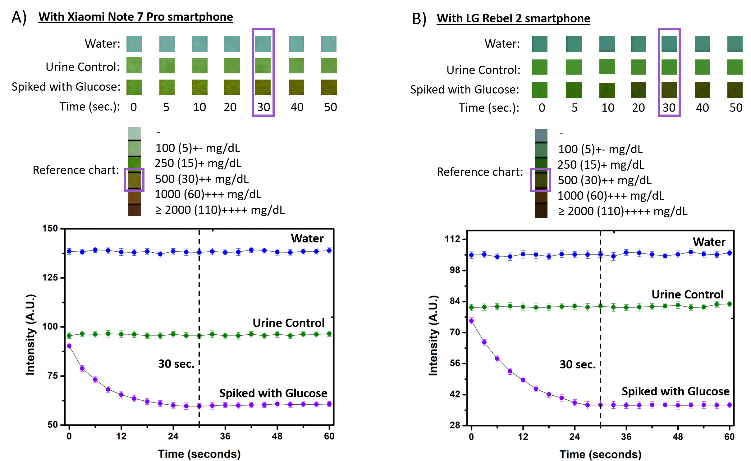
Figure 6: Urinalysis result for the glucose pad with two different smartphones for three types of samples. A) Response characteristics of the glucose pad over time for the different test conditions recorded with Note 7 Pro smartphone from Xiaomi. B) Response characteristics of the glucose pad over time for the different test conditions recorded with Rebel 2 smartphone from LG. The readout at 30 seconds corresponds with the desired timing for the manufacturer.
4. A table presenting comparative performance of proposed test against existing commercial tests must be included.
We appreciate the reviewer for their comment on validation of the device compared to standard method. We present representative results that compare our device to the traditional dip-wipe method, which is the gold standard for clinical analysis. We have made a table showing the median values and standard deviations of our device on the representative results section. The new table and text we have added to our manuscript is provided below.
Representative results
…Table 1 compares the results obtained with the two tests. It can be seen that the accuracy of the system depends on the volume transferred to each dipstick pad. The most accurate results were obtained when the automated urinalysis device is designed to transfer 15 μL of urine; therefore, it is crucial that the device transfer the required urine volume accurately and consistently to the dipstick pads. Representative results to validate the consistency of our device by transferring 15 μL volume of urine samples over seven different trials are shown in Figure 7. The overall standard deviation was found to be below 0.5 μL, which is within 4% range of our target value. The results confirm that the device is able to accurately and consistently transfer microliters of urine to perform the test.
Table 1: Median values and standard deviations for analytes using various deposited volumes. The symbol ‡ indicates median values that differ from the median obtained with the dip-and-wipe method, the industry standard. The total number of analyte pads whose medians differ from the dip-and-wipe method are reported in the far right column. Note results are cumulative for all dipsticks used. LEU: leukocytes, NIT: nitrite, URO: urobilinogen, PRO: protein, BLO: blood, SG: specific gravity, KET: ketones, GLU: glucose. This table has been modified from Smith, et al.¹⁹ and reproduced with permission from the Royal Society of Chemistry.
5. There is no idea about device's stability presented in this work. How many sample runs can be performed on the device just by cleaning the plate sleeve as mentioned under section 3.7.
We thank the reviewer for the correction. We agree that the stability should be included in the discussion. The stability of the device is a function of the nature of the hydrophobic coating used. The coating we used may peel after 3-4 uses. The new text we have added to our manuscript is provided below.
Discussion
One important limitation of the current protocol is that the hydrophobic coating applied to the slide and plate sleeve may peel with frequent use, limiting the stability of the device over time. After 3-4 test runs, the hydrophobic coatings often peel and alter the volume transferred, potentially reducing the accuracy in results. Future method modifications can include the use of more durable hydrophobic coating or materials that are naturally hydrophobic…
6. An estimate of the cost of the device should also be included. It would be helpful in calculating the total cost of each test to be performed on the proposed device.
We thank the reviewer for the correction. We agree that clearer cost estimations should be included. We have estimated the cost of the device and updated this information in the discussion section. The new text we have added to our manuscript is provided below.
Discussion
The current device combines a 3D-printed base plate and laser-cut top plate to form a plate sleeve. Both of these fabrication methods are affordable, and the material choices can be modified. Excluding the phone and dipstick, the acrylic used in the current device costs approximately $0.85, and material used in the 3D-printed base plate costs around $1.50 per device.

Editorial Comments
Changes to be made by the Author(s):
1. Please take this opportunity to thoroughly proofread the manuscript to ensure that there are no spelling or grammar issues. The JoVE editor will not copy-edit your manuscript and any errors in the submitted revision may be present in the published version.
Done
2. Please format the manuscript as: paragraph Indentation: 0 for both left and right and special: none, Line spacings: single. Please include a single line space between each step, substep and note in the protocol section. Please use Calibri 12 points
Done
3. Please provide an email address for each author.
Done
4. JoVE cannot publish manuscripts containing commercial language. Please remove all commercial language from your manuscript and use generic terms instead. All commercial products should be sufficiently referenced in the Table of Materials and Reagents. For example: The Healthy i.o, Roche Urisys 1100 analyzer, Inui, Scanwell, Android, AutoCAD, Mission Strips by Acon , Neverwet coating, Acon Mission dipsticks, etc.
Done
5. JoVE policy states that the video narrative is objective and not biased towards a particular product featured in the video. The goal of this policy is to focus on the science rather than to present a technique as an advertisement for a specific item. To this end, we ask that you please reword the title to be more focused on the science in general. Please also remain neutral in tone.
Previous Title:
A Low-Cost Device for Reliable, Automated Dipstick Urinalysis for Home-testing
Changed to:
Low-Cost Volume-Controlled Dipstick Urinalysis for Home-testing
6. Please ensure that all text in the protocol section is written in the imperative tense as if telling someone how to do the technique (e.g., “Do this,” “Ensure that,” etc.). The actions should be described in the imperative tense in complete sentences wherever possible. Avoid usage of phrases such as “could be,” “should be,” and “would be” throughout the Protocol. Any text that cannot be written in the imperative tense may be added as a “Note.”
Done
7. The Protocol should contain only action items that direct the reader to do something.
Done
8. Please ensure that individual steps of the protocol should only contain 2-3 actions sentences per step.
Done
9. Please include more details in the protocol section. Please ensure you answer the “how” question, i.e., how is the step performed? Please include all mechanical actions, button click in the software, knob turns in the instrument, scripts (if long can be included as supplementary files), command lines etc.
We have revised the protocol to comply with this instruction as best we could. Note, since JOVE specifically asked we not represent a specific software, it is impossible to provide details on “how” to use the CAD software in Step 1 to draw certain features because it will depend strongly on what software is used by the reader. We have attempted to indicate general steps that would be valid for any software that is used by the reader. Steps related to use of the device from Step 1 to run the tests in Steps 2-4 are detailed, as requested.
10. 1: Please include how each step is performed. e.g. 1.4. Click on “slide” tab in the software to design a slide measuring 2.771 in x 0.0625 in x 5.000 in. Please do this for all the steps.
There are many ways to draw lines in CAD, depending on the software chosen by the user. We have updated our manuscript to show the use of the polyline tool in order to draw lines and marked the new text with red font.
Protocol
1. Fabricate and assemble the urinalysis device
1.1.1 Use a computer-aided design (CAD) software to draw a rectangular area with dimensions 2.1641 in x 0.0547 in x 6.3828 in (W x H x L) using the polyline tool.
1.1.5 Draw a stop (0.1172 in by 0.2109 in (W x L)) using the polyline tool to facilitate alignment between the base plate and the slide. The stop should be perpendicular to the ledges and physically stops the slide from moving passed the urine dipstick pads.
1.1.6 Select the lines for the stop and ledge to make one region using the “region” command. Use the “extrude” command to raise the region up to a height of 0.0703 in. Repeat this step on the other side of the device.
1.1.7 Create a notch (0.1719 in by 0.3500 in (W x L)) on both ledges to facilitate alignment with the box. Position it 0.466 in from the bottom edge of the ledge. Use the “region” command to create one region of the rectangle and make the extrusion to the height of 0.1103 in.
1.1.8 Use the “solid subtract” command, select device, press “enter”, select the notch region and press “enter”. Repeat on the other side of the device.
NOTE: The shape will be removed from the device.
11. Please include the designing diagrams/CAD files/ etc. details as supplementary files.
Done
12. 2.1 Please provide the GitHub link.
Done
13. There is a 10-page limit for the Protocol, but there is a 2.75-page limit for filmable content. Please highlight 2.75 pages or less of the Protocol (including headings and spacing) that identifies the essential steps of the protocol for the video, i.e., the steps that should be visualized to tell the most cohesive story of the Protocol.
Done
14. Please describe the result with respect to your experiment, you performed an experiment, how did it help you to conclude what you wanted to and how is it in line with the title, how do these results show the technique, suggestions about how to analyze the outcome, etc.
We have significantly modified the “Representative Results” section to describe key experiments that show the technique and how to analyze the results. The revised submission demonstrates a full urinalysis test with the proposed device and software as well as tests to validate the its accuracy.
15. Please compare the results to already available techniques to show the efficacy of the technique presented. Also, please present some control and test results for urinalysis performed for some testing to prove that indeed this test was successful in detecting changes and to what level. Please describe the result with respect to your experiment, you performed an experiment, how did it help you to conclude what you wanted to and how is it in line with the title.
The revised Representative Results section includes a table that compares the use of our technique with the traditional dip-wipe method (Table 1). We have also added new results from a control test for glucose measurements (Fig 6) that demonstrate use of the protocol to perform a urinalysis glucose measurement within appropriate ranges with multiple phones.
16. Figures showing the experimental set-up should be referenced in the Protocol.
We have referenced Figs 1-3 in the protocol to help clarify the protocol steps associated with the device design, fabrication, and experiment.
17. Each Figure Legend should include a title and a short description of the data presented in the Figure and relevant symbols.
We have made sure that each figure contains a title and short description of the data or set-up in the figure.
18. Please obtain explicit copyright permission to reuse any figures from a previous publication. Explicit permission can be expressed in the form of a letter from the editor or a link to the editorial policy that allows re-prints. Please upload this information as a .doc or .docx file to your Editorial Manager account. The Figure must be cited appropriately in the Figure Legend, i.e. “This figure has been modified from [citation].”
We have obtained copyright permission to reuse Fig 7 and Table 1 from the respective journals and have uploaded a separate .docx file as a letter and a link.
19. Please upload high resolution figures.
The resolutions of the new figures are listed in the table below.
Figure number | Figure Resolution
Figure 1 | 3900 × 2100
Figure 2 | 725 × 1295 (PNG) & 2999 × 1687 (TIFF)
Figure 3 | 6016 × 4016
Figure 4 | 13056 × 8985
Figure 5 | 2999 × 1687
Figure 6 | 2405 × 1476
Figure 7 | 2997 × 2332
20. As we are a methods journal, please ensure the Discussion explicitly cover the following in detail in 3-6 paragraphs with citations:
We have updated the Discussion by including text for each of the following points:
a) Critical steps within the protocol:
“To this end, critical steps in the protocol relate to the design of the device include Steps 1.4.3, 1.1.4, 1.4.7 and 1.1.5, which match the size of the through-holes to the desired volume, ensure proper placement of the stops to align the through-holes with the dipstick, ensure proper placement of the QR code used as the timing indicator and ensure that the test is not influenced by ambient light, respectively. In addition, the transfer of urine through the slide and subsequent deposition onto the dipstick are highly dependent on the surface characteristics of the materials being used. Hence, if non-hydrophobic surfaces are used for the base plate, top plate and slide, it is important to apply an adequate amount of hydrophobic spray. It is especially critical to ensure that the inner surfaces of the through-holes of the slide have been sprayed so that the liquid will drop to the dipstick pad after slipping.”
b) Any modifications and troubleshooting of the technique:
Note that Troubleshooting steps are largely described as part of the critical steps of the protocol.
“The current device combines a 3D-printed base plate and laser-cut top plate to form a plate sleeve. Both of these fabrication methods are affordable, and the material choices can be modified. Excluding the phone and dipstick, the acrylic used in the current device costs approximately $0.85, and material used in the 3D-printed base plate costs around $1.50 per device. Although the base plate we used is 3D-printed from acrylonitrile butadiene styrene (ABS), other polymers that form a hard and rigid surface are also suitable. For example, a version of the device can be made using a plate sleeve completely fabricated from acrylic¹⁹.”
“… Future method modifications can include the use of more durable hydrophobic coating or materials that are naturally hydrophobic.”
“… Unlike other urinalysis apps available^{7,8,9}, our system is modifiable to any brand of dipstick test.”
c) Any limitations of the technique:
- “One important limitation of the current protocol is that the hydrophobic coating applied to the slide and plate sleeve may peel with frequent use, limiting the stability of the device over time. After 3-4 test runs, the hydrophobic coatings often peel and alter the volume transferred, potentially reducing the accuracy in results. Future method modifications can include the use of more durable hydrophobic coating or materials that are naturally hydrophobic. Additionally, the acrylic bonding may weaken during repeated testing as well. The low cost of the device, however, allows multiple prints to be made and re-glued together as needed. Thus, the slide may be considered as a disposable part.”

“Another limitation is the inability to saturate the glucose pad with urine due to the hydrophobic nature of the pad. As such, it only partially absorbs liquid with the automated device. We did not find that this reduced the accuracy of the result, but it does require careful design of Step 2.9 to ensure the camera viewing area captures data from the middle, not the edges of the glucose test pad. Future work may address this issue by incorporating a different brand of dipstick that does not feature hydrophobicity on any dipstick reagent pads on the test. “
d) The significance with respect to existing methods:
- “Our protocol automates and controls several important steps involved with dipstick urinalysis (e.g., distribution of liquid to the test pads, the timing of the start, control over the lighting and quantitative comparison with the reference standard), which is necessary to obtain reliable results.”

“Unlike other urinalysis apps available^{7,8,9}, our system is modifiable to any brand of dipstick test. The device is reusable and requires no power to use outside of power consumed by the smartphone.”
e) Any future applications of the technique:
- “In the future, we envision that the protocol could be amenable to patient self-testing. By ensuring the accuracy in dipstick test results, patients may monitor their own urine more frequently without the barriers associated with standard clinical urinalysis practice.”
21. Please expand the journal-title in the reference section.
Done
REFERENCES:
1. Lei, R., Huo, R. & Mohan, C. Expert Review of Molecular Diagnostics Current and emerging trends in point-of-care urinalysis tests. Expert Review of Molecular Diagnostics 00, 1–16 (2020).
2. Kavuru, V. et al. Dipstick analysis of urine chemistry: benefits and limitations of dry chemistry-based assays. Postgraduate Medicine 5481, (2019).
3. Pugia, M. J. Technology Behind Diagnostic Reagent Strips. Laboratory Medicine 31, 92–96 (2000).
4. Dungchai, W., Chailapakul, O. & Henry, C. S. Electrochemical detection for paper-based microfluidics. Analytical Chemistry 81, 5821–5826 (2009).
5. Van Delft, S. et al. Prospective, observational study comparing automated and visual point-of-care urinalysis in general practice. BMJ Open 6, 1–7 (2016).
6. Urisys 1100 Analyzer. https://diagnostics.roche.com/us/en/products/instruments/urisys-1100.html.
7. Filippini, D. & Lundström, I. Measurement strategy and instrumental performance of a computer screen photo-assisted technique for the evaluation of a multi-parameter colorimetric test strip. Analyst 131, 111–117 (2006).
8. Shen, L., Hagen, J. A. & Papautsky, I. Point-of-care colorimetric detection with a smartphone. Lab on a Chip 12, 4240–4243 (2012).
9. Ra, M. et al. Smartphone-Based Point-of-Care Urinalysis under Variable Illumination. IEEE Journal of Translational Engineering in Health and Medicine 6, 1–11 (2018).
10. Yetisen, A. K., Martinez-Hurtado, J. L., Garcia-Melendrez, A., Da Cruz Vasconcellos, F. & Lowe, C. R. A smartphone algorithm with inter-phone repeatability for the analysis of colorimetric tests. Sensors and Actuators, B: Chemical 196, 156–160 (2014).
11. Wang, S. et al. Integration of cell phone imaging with microchip ELISA to detect ovarian cancer HE4 biomarker in urine at the point-of-care. Lab on a Chip 11, 3411–3418 (2011).
12. Zhang, D. & Liu, Q. Biosensors and bioelectronics on smartphone for portable biochemical detection. Biosensors and Bioelectronics 75, 273–284 (2016).
13. Choi, K. et al. Smartphone-based urine reagent strip test in the emergency department. Telemedicine and e-Health 22, 534–540 (2016).
14. Kwon, L., Long, K. D., Wan, Y., Yu, H. & Cunningham, B. T. Medical diagnostics with mobile devices: Comparison of intrinsic and extrinsic sensing. Biotechnology Advances 34, 291–304 (2016).
15. Vashist, S., Schneider, E. & Luong, J. Commercial Smartphone-Based Devices and Smart Applications for Personalized Healthcare Monitoring and Management. Diagnostics 4, 104–128 (2014).
16. Inui. https://www.inuihealth.com/inui/home.
17. Healthy.io. https://healthy.io/.
18. Scanwell. https://www.scanwellhealth.com/.
19. Smith, G. T. et al. Robust dipstick urinalysis using a low-cost, micro-volume slipping manifold and mobile phone platform. Lab on a Chip 16, 2069–2078 (2016).
20. Du, W., Li, L., Nichols, K. P. & Ismagilov, R. F. SlipChip. Lab on a Chip 9, 2286–2292 (2009).

