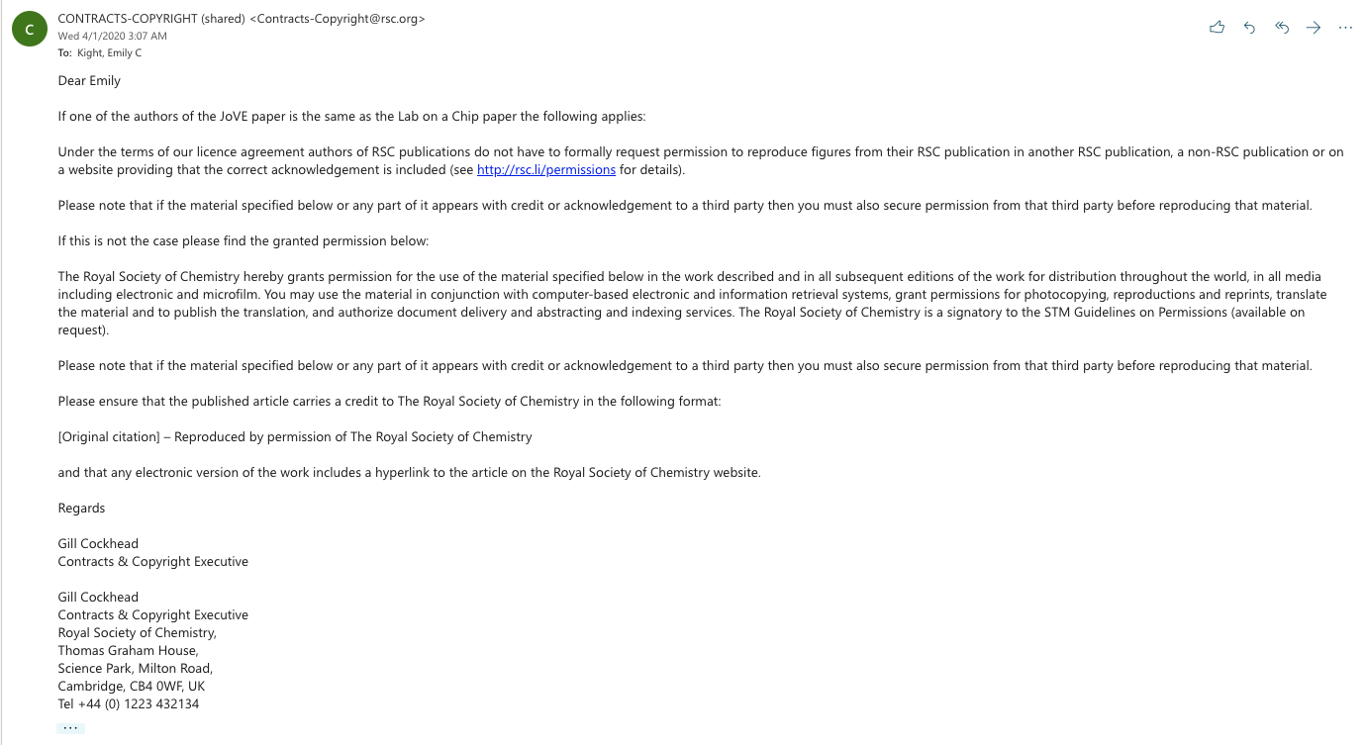

Link for permissions;
https://www.rsc.org/journals-books-databases/journal-authors-reviewers/licences-copyright-permissions/#reuse-permission-requests

