Dear Dr. Nam Nguyen,
Our manuscript, JoVE61406R1 "Low-Cost, Volume-Controlled Dipstick Urinalysis for Home-testing," has been edited to meet the following editorial directions;
1. Please reference Figure 1F, Figure 2B, Figure 2D, Figure 2E, and Figure 2H in the written manuscript.
- All the missing figure references are updated in the revised manuscript.
Updated texts:
Protocols
2. Prepare the test

2.3. Assemble the various components together and Insert the dipstick into the through-holes underneath the plate sleeve (Figure 1F).

2.8. Read the instructions to change the analyte names and reading timings (Figure 2B) to match those for the dipstick of interest (based on the manufacturer’s specifications) and insert new input via the text holder window on the screen (Figure 2C).

2.9. Read the instruction for phone alignment (Figure 2D) and align the phone accordingly so that the dipstick coincides with the boundaries of the black rectangular overlay on screen (Figure 2E).

3.2. Initiate the test by pushing the slide into the plate sleeve until it is stopped by the base plate stop.

NOTE: Urine should make contact with dipstick pad when the QR code is in the field of view of the cell phone. After reading the QR code, the application will open a window to analyze the color changes (Figure 2G) and show the results automatically within the same window (figure 2H).
2. Is Figure 2 correct? References are made to Figure 2I but Figure 2 does not have Panel I.
- The references to Figure 2 are now corrected in the revised manuscript.

3. Figure 6: Please label the panels (A and B). Currently, there are no panel labels. Additionally, do the phone brands matter? If not, the phones be referred to Phone 1 and Phone 2?
The panel labels in Figure 6 have been corrected as shown below
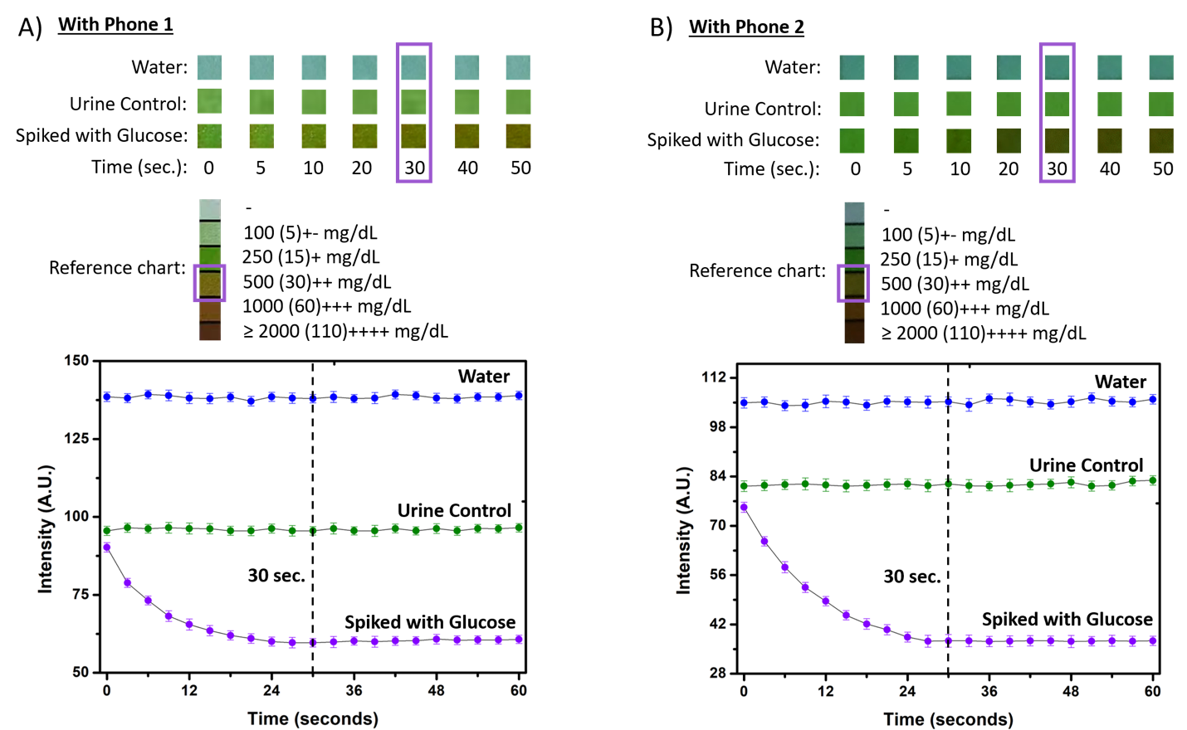
The phones are now referred as phone 1 and phone 2 and the manuscript is updated accordingly.
Updated texts:
REPRESENTATIVE RESULTS:
A urinalysis test was performed with a high-quality smartphone: phone 1 (image resolution: 8000-pixels x 6000-pixels). Representative results are shown in Figure 6. We conducted tests with de-ionized water and commercial urine (both standard composition and with high glucose). The color pads on the dipstick change in time in response to the colorimetric reaction of the urine with the analytes in the dipstick. The error bars in Figure 6 represents the standard deviation yielded for three consecutive measurements of each sample recorded by the two smartphones. Figure 6A plots the response for the glucose pad over time for the different test conditions. For the brand of dipstick used, the recommended readout time for the glucose measurement is 30 seconds. As expected, the color of the dipstick does not change over this interval for water, the final value for the standard urine matches with the “normal” urinary glucose threshold level (160-180 mg/dL), and the final value for the “high glucose” condition is elevated above the normal value. Importantly, note that the correct value is not attained until 30 seconds, which illustrates the importance of setting the timing readout interval correctly in Step 2.8. The same experiment was performed with another smartphone having a lower image resolution: phone 2 (Image resolution: 3264-pixels x 2448-pixels). Due to the difference in camera resolution, a significant difference from the previous results is observed in the image color and quality while capturing images of the dipstick panel, as shown in Figure 6B.
Figure 6: Urinalysis result for the glucose pad with two different smartphones for three types of samples. A) Response characteristics of the glucose pad over time for the different test conditions recorded with a high-camera-resolution camera phone (phone1). B) Response characteristics of the glucose pad over time for the different test conditions recorded with a low-resolution camera phone (phone 2). The readout at 30 seconds corresponds with the desired timing for the manufacturer.

