Dear editors and reviewers,
Thanks a lot for your constructive comments and suggestions concerning our manuscript entitled " Externally-heated diamond anvil cell for synthesis and single-crystal elasticity determination of ice-VII at high pressure-temperature conditions " [JoVE61389]. Following your instruction, we have prepared a point-to-point response (blue colored text) to the comments of editors and reviewers and described how the manuscript has been revised accordingly. A summary of the major changes was also included to highlight the revisions that we have made to address the comments.
We tried our best to revise the manuscript by responding the reviewers’ comments. We appreciate the comments and suggestions from editors and three anonymous reviewers earnestly, and hope that our responses and revisions are satisfactory.
Should you have any question, please do not hesitate to contact us.
With best regards,

Bin Chen (binchen@hawaii.edu, tel: 808-956-6908)
On behalf of all co-authors

A summary of the major changes
- To address the comments from reviewer 1, a 3-D model was added in Figure 1.

- To address the comments from reviewer 1 and 2, a figure of the synthesis of single crystal ice VII was added (Now Figure 3).

- To address the comments from reviewer 1, a figure of power-temperature relationship was added in the manuscript (Now Figure 4).

- To address the comments from reviewer 2, a statement of laser heating was modified (Line 71-74).

- To address the comments from editors, paragraphs about critical steps within the protocol; modifications and troubleshooting of the technique; Any limitations of the technique was added in the discussion part (Line 297-325).

Editorial comments:
General:
1. Please take this opportunity to thoroughly proofread the manuscript to ensure that there are no spelling or grammar issues.
Response: We thoroughly proofread the manuscript.
2. Please include email addresses for all authors in the manuscript.
Response: Email addresses for all authors were added in the manuscript.3. Please reduce the length of the Summary to 10-50 words.
Response: The length of the summary was reduced to 50 words.
Protocol:
1. For each protocol step/substep, please ensure you answer the “how” question, i.e., how is the step performed? Alternatively, add references to published material specifying how to perform the protocol action. If revisions cause a step to have more than 2-3 actions and 4 sentences per step, please split into separate steps or substeps.
Response: We made sure that we answered the “how” question and added the relevant references.
Specific Protocol steps:
1. 4.2.2: Please provide a reference for Brillouin spectroscopy here or otherwise provide more details about this procedure.
Response: A reference (Sinogeikin, Bass et al. 2006) for Brillouin spectroscopy was added in 4.2.2.
Figures:
1. Figure 5 is referenced in the Results section, but it is not present.
Response: Sorry for the confusion, we mislabeled the figure number. We have corrected it.
Discussion:
1. Please revise the Discussion to explicitly cover the following in detail in 3–6 paragraphs with citations:
a) Critical steps within the protocol
b) Any modifications and troubleshooting of the technique
c) Any limitations of the technique
Response: We added three paragraphs about the above aspects in the discussion part (Line 297-325).
Disclosures:
1. Please include at least a sentenced in the Disclosures section, providing information regarding the authors’ competing financial interests or other conflicts of interest. If authors have no competing financial interests, then a statement indicating no competing financial interests must be included.
Response: The statement “The authors have no conflict of interest” was added in the disclosure section.
Table of Materials:
1. Please ensure the Table of Materials has information on all materials and equipment used, especially those mentioned in the Protocol.
Response: We made sure that the Table of Materials has information on all materials and equipment used.
Reviewers' comments:
Reviewer #1:
Manuscript Summary:
The authors provide a comprehensive description for a ring-heater design. The author also propose a novel method to make a single-crystal ice in-situ at high pressure. Those are very nice contributions and worthy of publication. I have a few minor points, hopefully to help this manuscript to access broader readership, as well as convey the important aspect of this new contribution.
Minor Concerns:
1) please provide scale-bars in Figure 1.
2) It would be helpful to show a better photo for an external-heater design, particularly its inner structure.
3) Perhaps to show a 3-D file for the design of the ring-heater, plus a 2-D cross-section would be very helpful
Response: Figure 1 was modified. A 3-D model with scale bar was added in Figure 1 to show the design of ceramic micro-heater base. We find a 2-D cross-section may not provide more information in addition to the 3-D model, so we did not show it in Figure 1.
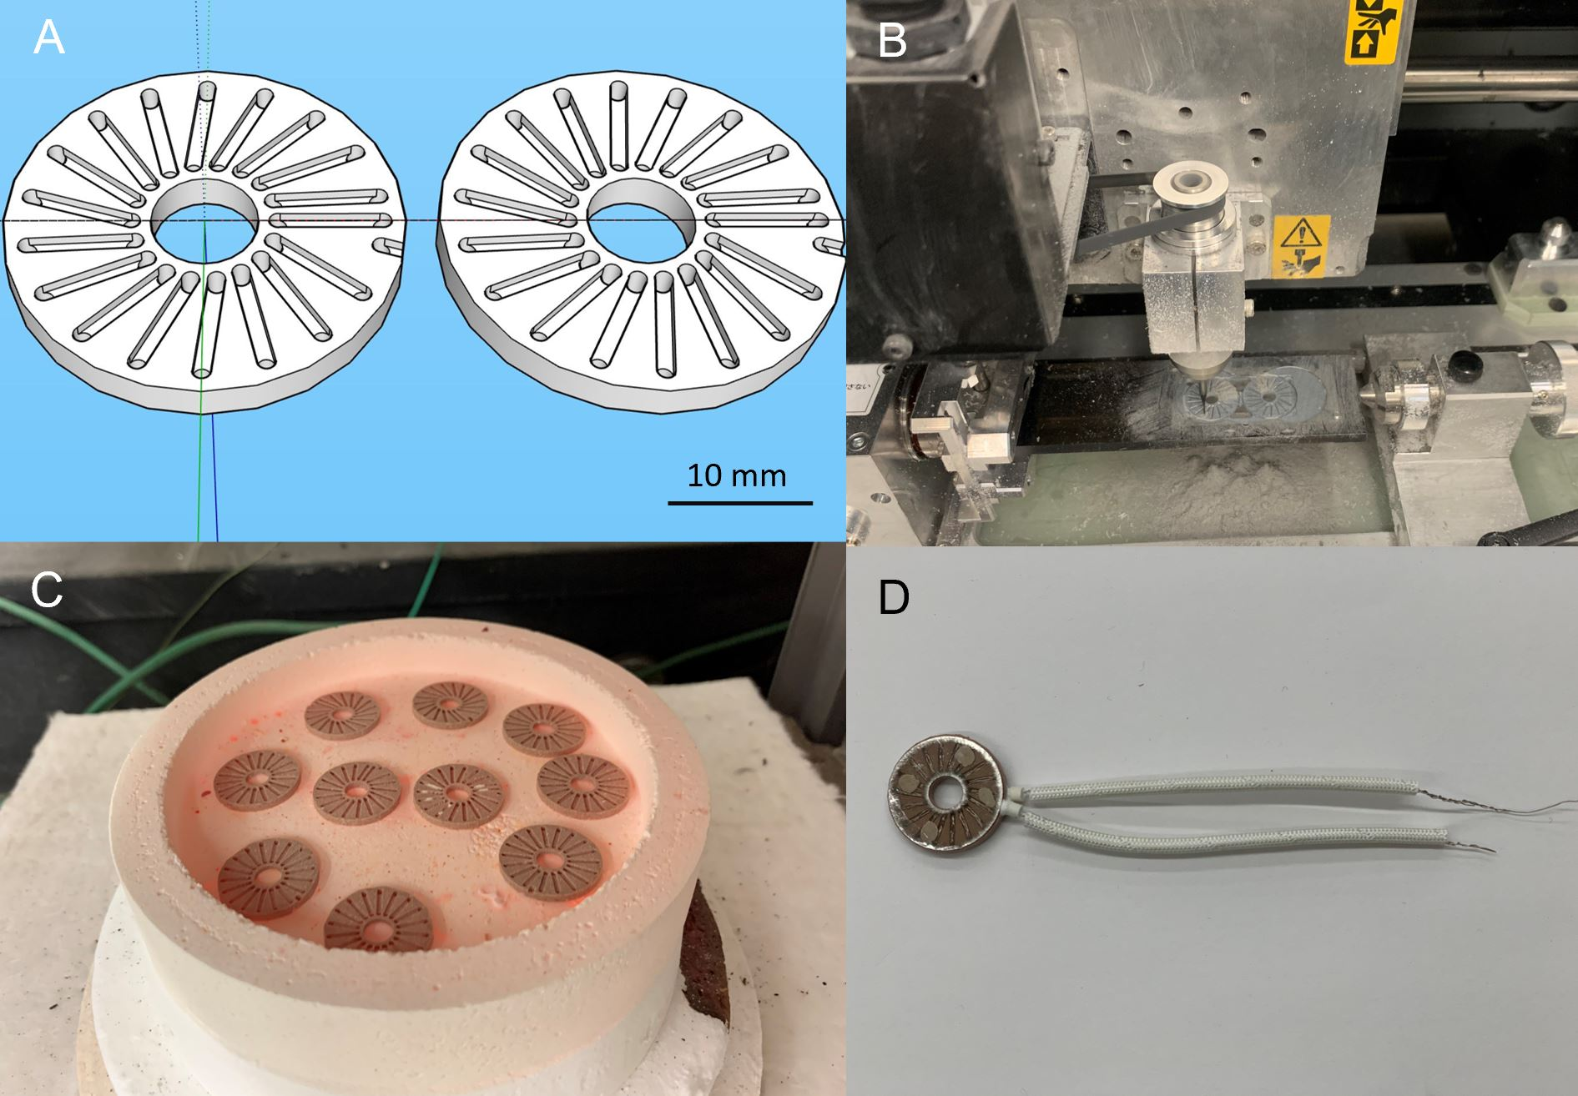
Figure 1.
4) It would nice to show a Temperature- Power relationship with this new design to compare with previous work.
Response: A temperature-power curve was added in the manuscript (Figure 4). The temperature-power relationship is similar to the one in the previous study (Du, Miyagi et al. 2013).
Figure 4 in the manuscript
5) It should be a lot clearer and of broader interest if authors can provide a serious of photos showing how water melts and crystallized, as well as how single crystals was made.
Response: We added Figure 3, which contains four figures to show the melting and crystallization of ice VII. The synthesis process of ice VII will also be presented in the video part.
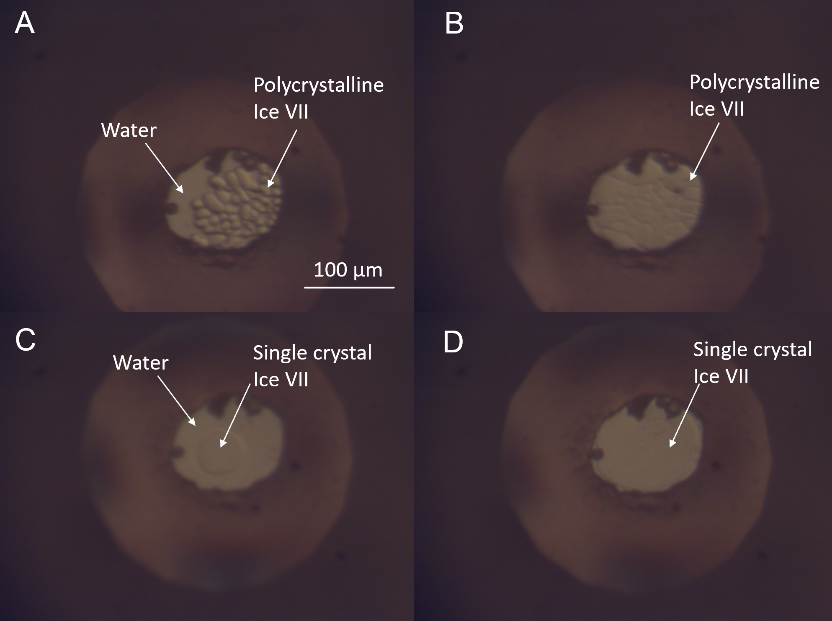
Figure 3 in the manuscript.
Reviewer #2:
Manuscript Summary:
the paper reports the protocol for improved external heating of diamond cells with large axial apertures, suitable for Brillouin-spectroscopy and single crystal X-ray diffraction. This opens new possibilities for high P-T experiments in the 10 GPa 1000K range and beyond.
Major Concerns:
none
Minor Concerns:
Some wording issues and some additional explanations at some points would help. Here is a detailed list of comments:
-> THE Externally-heated diamond anvil cell (EHDAC) can be used to generate simultaneously
Response: We corrected it.
->THE Diamond anvil cell (DAC) is one of the most important tools for high pressure research.
Response: We corrected it.
'laser heating temperature usually fluctuates'
-> Can be mitigated by feed-back coupling of thermal emission and laser power.
-> One main issue is that in multiphase assemblies the absorbance of laser light may be different for different phases
Response: We changed the statement to “The temperature during laser heating usually fluctuates but can be mitigated by feed-back coupling between thermal emission and laser power. More challenging is controlling and determining the temperature for assembly of multiple phases of different laser absorbance.” (Line 71-74)
76...well suited to be coupled with various detection and diagnostic methods, including optical
77 microscope, X-ray diffraction (XRD), Raman spectroscopy, Brillouin spectroscopy and Fourier
transform infrared spectroscopy.
Response: We added a reference (Kantor, Prakapenka et al. 2012) to strengthen our statement.
82 BX-90 type DAC is a newly developed
-> THE BX-90 …., also, explain about the aperture (90deg?)
Response: We changed the statement to “The BX-90 type DAC is a newly developed piston-cylinder type DAC with large aperture (90° at maximum) for XRD and laser spectroscopy measurements”
The U-cut
84 on cylinder side also provides room
-> 'U-shaped cut' ?
Response: We replaced “U-cut” by “U-shaped cut” .
EHDACs and demonstrated
88 single-crystal XRD as well as Brillouin spectroscopy measurements of synthesized single-crystal
-> Perhaps you should explain why this is not trivial - what is the main improvement above earlier EHDAC set ups - angular aperture? …
You seem to have succeeded in stabilizing temperature/reducing internal thermal gradients - or is it possible that you grow large crystallites because you have a gradient?
Please expound a little bit.
Response: We did not expect that our EHDAC has better control on thermal gradient than previous ones. The main advantage is that we standardize the heater and insulating parts for this BX90 DAC. The BX90 + external heater is now widely used in high-pressure community (Yang, Mao et al. 2014, Lai, Zhu et al. 2018). A standard protocol will make the preparation routine and results consistent, i.e. the power curve, the temperature gradient, the thermal pressure, etc. Another advantage is that the heater can be fabricated by a CNC machine, thus with the model we provided in the paper, other labs can easily produce the same heater at low cost.
215 'The ice-VII synthesized from the liquid H2O after several cycles of heating and cooling at 6 GPa
216 was a large single crystal
-> Only one?
Response: Yes, we performed multiple heating and cooling cycles to allow the polycrystalline ice phases melt and crystallize. The heating and cooling cycles would allow smaller grains to melt first and leave one grain in the sample chamber. Then this one grain can act as a seed to grow to a large one after we slowly lowered the temperature. Figure 3 (a new figure) shows the process of growing one single crystal of ice-VII in the sample chamber under a microscope. We checked the synthesized sample using single-crystal XRD and confirmed the ice VII piece in the whole sample has the same orientation. Sometimes, we could only grow 2-3 large grains of the single crystal ice-VII, which can still be used in single-crystal XRD and Brillouin scattering measurements.
'with little lattice stress :'
-> How do you know? What is the integral R-factor for cubic, tetragonal,…
I see no other criterion to distinguish an strained from an unstrained crystal through diffraction.
Response: We only obtained the unit-cell parameters and orientation from our single crystal XRD data and did not refine the atomic positions, so there is no R-factor. The chi^2 is about 0.013 which indicates that the cubic phase is a good model. We found the single crystal spot under pressure did not elongate (implies orientation is no longer identical as single crystal) or broaden (implies pressure gradient increases inside the detected volume), thus we inferred that the crystal retained good quality.
216 ‘ and retained its good quality after compression’
217 and heating, as indicated by the sharp Bragg diffraction peaks in synchrotron-based single crystal
218 XRD images (Figure 3).
-> Explain what the other reflections in fig 3 are!
Response: They are diamond reflections from the single-crystal diamond anvils, we explained them in figure caption in Figure 5 in the updated version.
' The diffraction pattern can be indexed with a cubic structure'
-> Usually for single crystal data one indexes peaks based on the set of quadruples , coordinates and tth, for instance by using the statistics of distance vectors.
Your statement suggests that your integrated the pattern (around 360 deg? Or along radial stripes?) and used the d-spacings for indexation.
Please explain. I was under assumption that you collected single crystal diffraction data (XRD frames collected over fixed angles/small increments at different angular settings, phi/omega/chi). Also explain the diffraction measurement strategy and geometry: I assume chi was fixed, then phi or omega changed? Chi = 90deg -> phi= omega?
Response: We collected the step scans by rotating omega angle from -110 deg to -71 deg at 0.5 deg /step and we added this information in the manuscript (Line 230-231). The step scans were used to obtain the unit cell parameters and crystal orientation of ice VII for latter Brillouin scattering data processing.
The single-crystal XRD data were collected by rotating the omega angle, along the axis perpendicular to the sample stage. The Brillouin scattering data were collected by rotating the chi angle, along the axis perpendicular to the optical window of the two diamond anvils.

' (space group
219 Pn-3m, Z = 2) with unit cell parameters a = b = c = 3.1375(6) Å at 11.2(1) GPa, 300 K and a = b = c
220 = 3.1605(3) Å at 11.2(4) GPa, 500 K. '
-> what is the integral R factor, what is R2, what GooF or did you not attempt structure analysis (if so, why?), what are the thermal displacement factors (of O at least).
Response: We did not do structural refinement since the rotation angle (39 deg) is limited, but we get the information (crystallographic orientation and also lattice parameters) required for the elasticity determination.
'The crystallographic orientation of the single-crystal ice-VII
are determined to be (-0.105,0.995,0) at 300K and 500 K. '
-> What is that? Is this a Miller index -1 10 0?
-> Usually the orientation of a crystal specimen is described with a UB matrix. On the other hand, I don't see that you need to report this.
Response: The crystal is grown with a plate-like shape within the narrow space between the two diamond anvils. (-0.105, 0.995,0) is the plane normal of the ice single crystal in the diamond anvil cell, which is parallel to the diamond anvil cell axis. The plane normal was used in the Brillouin data analysis to obtain various crystallographic directional cosines of the experimentally measured velocities. The orientation of a crystal is indeed usually described with a UB matrix (see the following figure for the UB matrix), we used the plane normal for simplicity to represent the orientation of the crystal synthesized in the diamond anvil cell.
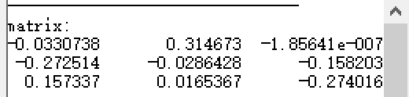
Figure R1. UB matrix of ice VII at 11.2 GPa, 300 K
-> What is the index of refraction of ice-VII at 300 and 500K and 11 GPa?
Response: It depends on the wavelength of the light. Within X-ray wavelength, the index of refraction should be quite similar and close to 1.
Reviewer #3:
In this paper by Lai et al. entitled "Externally-heated diamond anvil cell for synthesis and single-crystal elasticity determination of ice-VII at high pressure-temperature conditions", the authors describe a protocol for preparing standardized external micro-heaters for the BX-90 type diamond anvil cells and for assembly all the components in order to perform experiments at extreme conditions of pressure and temperature. According to the authors, these EHDAC cells can be routinely used to generate pressures of the order of the megabar and temperature up to 900 K in air (up to 1200 K in protective atmosphere).
The paper is well written, the title and the abstract are appropriate. The potential applications of the protocol are clear, the materials are presented in a table and the steps are well listed and described.
However, I find that the reported scientific case does not fully cover the anticipated results. In fact, one of the issues generally encountered in EHDAC is the inability of reaching "extreme" pressure, due to thermally-induced mechanical instability of the cells. Although the authors stated that megabar experiment can be routinely performed with this cells, they are reporting a single case at 11.2 GPa and 500 K. It is my opinion that this paper would gain more interest if the authors can report some scientific case showing the real potential of this protocol.
Response: We added a reference Lai et al. 2018, in which we used the same protocol and achieved higher pressure (up to 80 GPa, 700 K) (Line 295). But the main goal of the JoVE paper is to show the protocol of this method, which we felt the synthesis of ice VII crystal is a more suitable case to show the capacity of the method to a broader audience.
I therefore recommend the publication of this work after a minor revision.

References:
Du, Z., L. Miyagi, G. Amulele and K. K. Lee (2013). "Efficient graphite ring heater suitable for diamond-anvil cells to 1300 K." Review of Scientific Instruments 84(2): 024502.
Kantor, I., V. Prakapenka, A. Kantor, P. Dera, A. Kurnosov, S. Sinogeikin, N. Dubrovinskaia and L. Dubrovinsky (2012). "BX90: A new diamond anvil cell design for X-ray diffraction and optical measurements." Review of Scientific Instruments 83(12): 125102.
Lai, X., F. Zhu, J. Liu, D. Zhang, Y. Hu, G. J. Finkelstein, P. Dera and B. Chen (2018). "The high-pressure anisotropic thermoelastic properties of a potential inner core carbon-bearing phase, Fe7C3, by single-crystal X-ray diffraction." American Mineralogist 103(10): 1568-1574.
Sinogeikin, S., J. Bass, V. Prakapenka, D. Lakshtanov, G. Shen, C. Sanchez-Valle and M. Rivers (2006). "Brillouin spectrometer interfaced with synchrotron radiation for simultaneous X-ray density and acoustic velocity measurements." Review of Scientific Instruments 77(10): 103905.
Yang, J., Z. Mao, J.-F. Lin and V. B. Prakapenka (2014). "Single-crystal elasticity of the deep-mantle magnesite at high pressure and temperature." Earth and Planetary Science Letters 392: 292-299.

