STANFORD UNIVERSITY



April 13, 2020

Dear Dr. Bajaj,

I have revised the manuscript JoVE61377 "Minimizing hypoxia in hippocampal slices from adult and aging mice," per Editorial and Reviewers’ comments from the March 26 2020 decision letter. My belief is that the comments raised by both Reviewers, as well as the Editors, are fully addressed. I am grateful for the entirety of Reviewers’ comments and criticisms, as these have significantly strengthened the significance of the protocol, and ensured a proper context relative to other related methods. The rebuttal to the Editor’s and Reviewers’ comments is appended as a separate letter. The revised manuscript indicates new or altered text in red font. I hope that you will now find the manuscript acceptable for publication.

Yours sincerely,

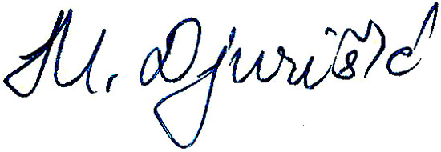
Maja Djurisic, Ph.D

