Electronic Supplementary Information
Microfluidic Fabrication Techniques for High-Pressure Testing of Microscale Supercritical CO₂ Foam Transport in Fractured Unconventional Reservoirs

Hooman Hosseini, Feng Guo, Reza Barati Ghahfarokhi, Saman A. Aryana

Correspondence to: Saman A. Aryana, Reza Barati Ghahfarokhi
E-mail: saryana@uwyo.edu, reza.barati@ku.edu

This PDF file includes:
Figure S1, S2, S3, S4 and S5

1- Photolithography and thermal bonding for borosilicate glass substrates
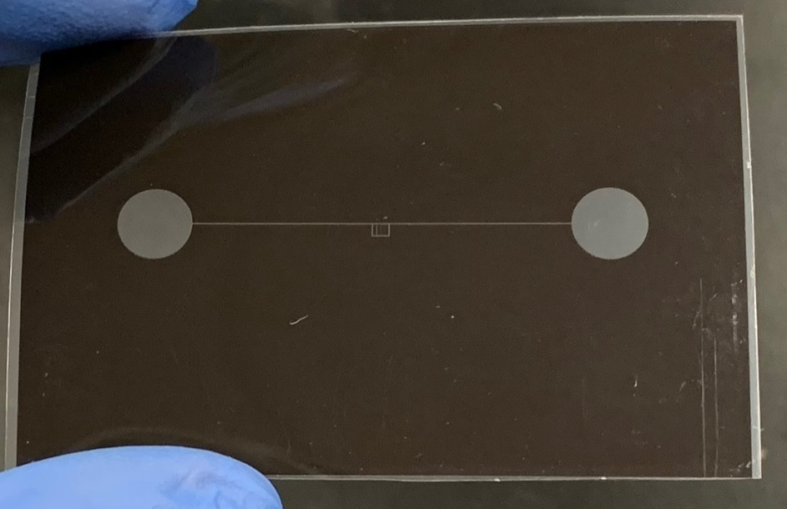
Figure S1. Photomask.
Figure S2. Schematic of the photolithography and thermal bonding fabrication process.
Figure S1 shows an example of a photomask designed for a positive photoresist. This mask is used to transfer the desired pattern onto a borosilicate glass. Figure S2 illustrates the schematic of the photolithography and thermal bonding fabrication process in 16 steps (for brevity, cascade-rinsing of the substrates with DI water is excluded): 1) obtaining borosilicate glass substrate coated with chromium and photoresist layers; 2) UV- radiation on the substrate for a pre-determined amount of time to transfer the pattern from the photomask to the photoresist layer; 3) using a developer solution to dissolve the radiated features in the positive photoresist; 4) submerging the substrate in chromium etchant (40°C) for 40 s to transfer the pattern from the photoresist to the chrome layer; 5) coating the backside of the borosilicate glass with HMDS and photoresist for protection against the etchant; 6) submerging the substrate in the etchant solution for a predetermined amount of time to etch channels with the required depth in the substrate; 7) submerging the etched substrate in NMP (organic solvent) heated to 65°C for 30 min to remove all photoresist; 8) submerging the substrate in chromium etchant heated to 40°C for 40 s to remove the remainder of the chrome layer from the substrate; 9) drying and preparing the fully etched substrate for bonding; 10) sandblasting the cover plate to create inlet/outlets holes; 11) submerging the substrate and the cover-plate in a boiling Piranha solution for 20 min to remove all contaminants; 12) submerging the substrate and the cover-plate in the etchant solution for 30 s to create clean surfaces for bonding; 13) submerging the substrate and the cover plate in a 6:1:1 by volume solution of H₂O: H₂O₂:HCl for 10 min to remove the remaining inorganic impurities; 14) submerging the substrate and the cover plate in DI water and pressing the matching sides of the two substrates firmly against each other to create a stack for the bonding process; 15) placing the stack between two ceramic and metallic plates and placing the stack in a vacuum oven (70 – 90 °C) for 30 min followed by placing the stack in a furnace and executing the thermal bonding protocol; and 16) the thermally bonded device is ready for testing.
2- In-house developed collimated UV light source
Figure S3 shows an image of in-house collimated UV light source. The LEDs emitters are mounted on a heat sink plate in a 3 × 3 square array with a pitch of 50 mm. The divergence (viewing angle) of light coming from individual LEDs are reduced from ~70° to ~12° by using a commercial light-collecting UV lens to each LED – see Figure S4. To further reduce the divergence (~5°), a 3 × 3 square array (with the same pitch of 50 mm) of nine converging polyvinylchloride (PVC) Fresnel lenses with a focal length f ≈ 180 mm are used. These lenses are mounted on a black acrylic plate. The distance between the acrylic plate and LED lights is adjustable. In order to achieve an even illumination (function of the current), three separate adjustable power supplies (30 v, 5 A) are employed to power the LED array. To adjust the illumination, the currents through the four LEDs in the corners, four LEDs at the edges, and the LED in the center are regulated separately by different power supplies.
A schematic of the optical setup of the LED UV light source is illustrated by Figure S4. Given the relatively large distance between the individual LEDs and the low beam divergence, the light source in the setup is placed at a sufficient distance from the target to achieve sufficient beam overlap, which results in uniform illumination; the distance from the LED plate to the substrate holder is 960 mm. The mounting setup includes aluminum extrusions, connecting plates and brackets, from 80/20. The design helps to align the light source with the substrate holder and adjust the distance between the Fresnel lens array and the LED array for optimal illumination.
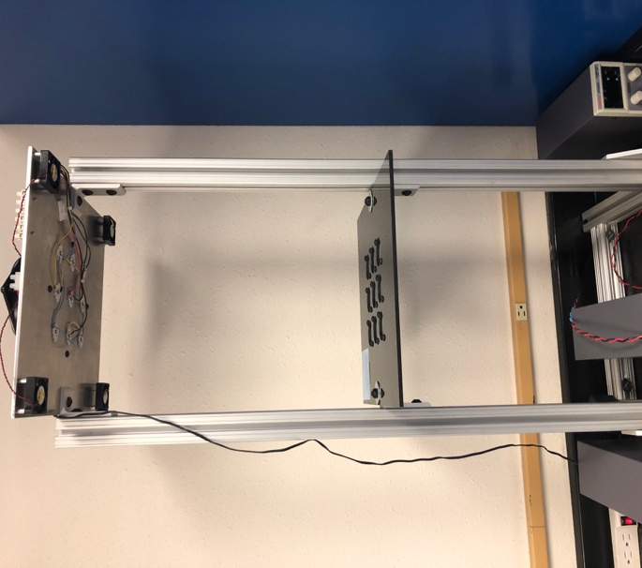
Figure S3. Image of UV LED lights source

Figure S4. Schematic of the LED UV-light source

The relative uniformity of this collimated UV light source improves the consistency of microfluidic device fabrication and reduces the deviation between fabricated pore network and designed pore network. The narrow spectrum of the LEDs, which is centered at ~365 nm, corresponding to an SU-8 2000 absorption wave length of 350-400 nm, leads to a relatively weak dependence of the optimal exposure time on the thickness of photoresist layer, which makes the fabrication process more forgiving. The exposure areas illuminated by individual LEDs provide UV illumination with a mean intensity of ~4.95 mW cm⁻² over a 100 × 100 mm² target area. In this work, a single exposure time of 2 min is used, which corresponds to a cumulative irradiation of ~240 mJ cm⁻². This collimated UV light source enables fabrication of microfluidic devices with consistent and accurate channel networks.
3- High-pressure holders for the microfluidic device
Figure S5 shows a close-up view of high-pressure holders. The holder comprises two piece made of 304 stainless steel. As shown in FigureS5, these plates feature an opening that accommodates the typical microfluidic devices built in the laboratory at the University of Wyoming. The two plates are connected via hex socket cap screws. Inlet-outlet lines are fixed in place via the threaded through-hole in each holder, which protects the ports from leaks mechanically by applying compressive force against the sandblasted hole in the device. As such, the holders also protect the microfluidic device from dislocation during high pressure injection without the need for adhesive-based sealants. The through-hole in the holder and the hex socket cap screws are shown in Figure S4. The hex socket cap screws are spaced center-to-center 35 mm apart. The top plate (Figure S5) is 43 mm x 150 mm x 12 mm thick, and the bottom plate is 43 mm x 150 mm x 5 mm thick. The housing for the microfluidic device is 112 mm x 25 mm deep x 5 mm high; it is formed in the top plate and reduces the thickness of the top plate to 7 mm.
Figure S5. High-pressure holder for microfluidic devices; a) close-up view of the holders during a flow experiment, and b) close-up view of a single holder.

