Reviewer: 1
Comments:
The manuscript presents a protocol of fabrication and optical characterizations of optical metaholograms made of hydrogenated amorphous silicon (a-Si:H), sensitive to the spin and direction of incident light. The fabrication protocol consists of film deposition, electron beam writing and subsequent etching. The fabricated device was characterized using a customized optical setup that consists of a laser, a linear polarizer, a quarter waveplate, a lens and a charge-coupled device (CCD).
The topic is relevant to the Journal (JoVE); all the materials and equipment needed are listed up; all the steps are clearly explained. However, I want the authors to add a few more information in the fabrication part.
- The authors used PMMA single layer for Cr lift-off process with sonification to dissolve the resist. I presume this could only be possible when the patterned resist profile has negative slop. Is this the case in the experiment? Also hard sonification could lead to the damage on the metal. To avoid these problems PMMA bilayers are utilized for easy liftoff.
- It would be helpful to display high magnification of patterned a-Si:H to show the verticality of the etching and edge /sidewall roughness.

Response to comments of reviewer #1
We would like to express our sincere gratitude and appreciation on essential, positive and constructive comments of the reviewers. As the reviewer raised several very good questions and comments, we address them in the following sections point-by-point by providing more detailed analysis and explanations.

Comment 1:
The authors used PMMA single layer for Cr lift-off process with sonification to dissolve the resist. I presume this could only be possible when the patterned resist profile has negative slop. Is this the case in the experiment? Also hard sonification could lead to the damage on the metal. To avoid these problems PMMA bilayers are utilized for easy liftoff.

Our response 1:
We thank the reviewer for his/her constructive comments.
Yes, as the reviewer pointed out, the single layer PMMA has a slight negative slop once the development process is conducted at low temperature. Also the hard sonication may lead to the damage on the nanostructures, particularly edges of them can be teared off. To prevent this, we used gentle sonication condition (1 min at 40 kHz).
Of course, as the reviewer suggested, the bi-layer resists consisting of two different PMMA layers with different molecular weight would be helpful for easy lift-off process.
In this study, we used the single layer PMMA because its height (~ 100 nm) is enough thick to provide easy lift off process of 30 nm-thick Cr structures.
We’ve added this information in the manuscript as below
“To prevent this problem and to provide an appropriate negative slop of photoresist, which enables ease lift-off process, we used a cold-development technique in which the development process is conducted at 2 to 4 °C. Furthermore, a bi-layer resist method can be used for easy lift-off process, where two different kinds of resists having different molecular weight and solubility in a development solution are used.”

Comment 2:
It would be helpful to display high magnification of patterned a-Si:H to show the verticality of the etching and edge /sidewall roughness.

Our response 2:
We thank the reviewer for his/her constructive comments and agree with the reviewer’s opinion. According to reviewer’s suggestion, we added SEM images of a-Si:H metasurfaces with high magnification as below.

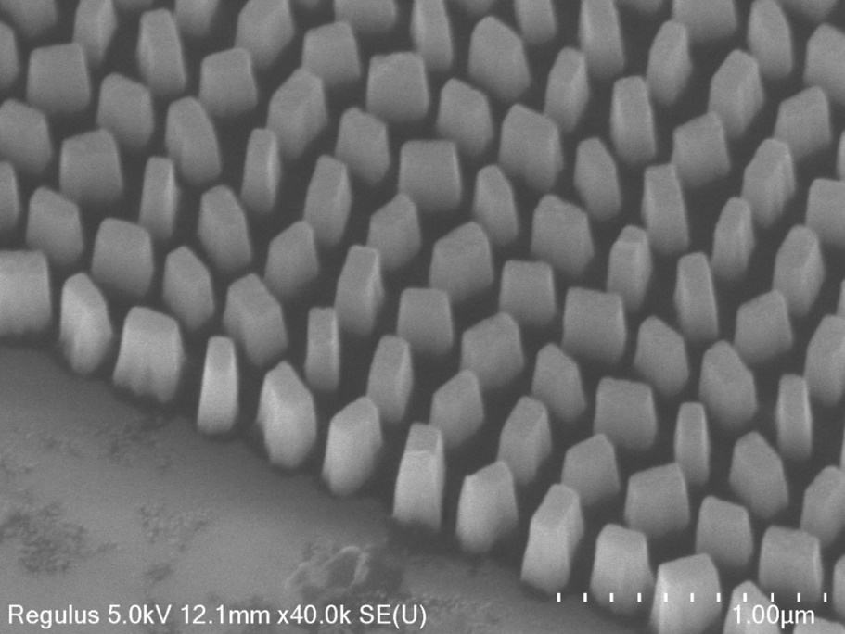
Figure 2: SEM image of fabricated device. A tilted view of SEM image of 380 nm-thick a-Si:H metasurfaces are presented. During the etching process, a slanted side-wall profile occurs.

Reviewer: 2
Comments:
Manuscript Summary:
The authors present the fabrication and characterization method for spin- and direction-multiplexed metahologram which is composed of hydrogenated amorphous silicon. This work is well written and organized, and I recommend the acceptance of this paper for the publication in Journal of Visualized Experiments after minor revision.
Minor Concerns:
The authors should provide the video of fabrication and characterization.

Response to comments of reviewer #2
We would like to express our sincere gratitude and appreciation on positive comments of the reviewers. We are delighted that the reviewer found our work “this work is well written and organized” and recommend the acceptance of this paper.

Comment 1:
The authors should provide the video of fabrication and characterization.

Our response 1:
Yes, we are about to produce a video protocol soon.

