University of Wisconsin

Caitlin A. Murphy, BSc
Graduate Research Assistant
Department of Anesthesiology

SCHOOL OF MEDICINE
AND PUBLIC HEALTH

31 March 2020

Dear Dr. Bajaj,

We thank the editor and reviewers for their insightful questions and constructive feedback regarding our manuscript. Enclosed please find our responses the assessors’ comments. We have made changes to the manuscript, as described below, and uploaded the revised version. Please note that all line references in our responses below are line references to the document showing tracked changes.

We would also like to note that we have added an author, Sean M. Grady, who has provided physical and intellectual contributions to the manuscript since the first submission.

Please contact me at caitlin.murphy@wisc.edu if you have any questions about our submission.

Sincerely
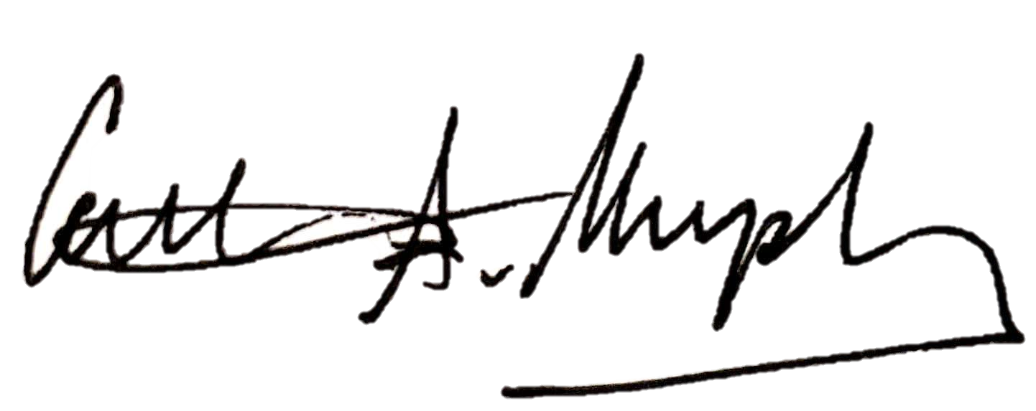

Caitlin A. Murphy
Graduate Research Assistant
Advisor: Matthew I. Banks (mibanks@wisc.edu)

Dear Dr. Murphy,
Your manuscript, JoVE61333 "Optogenetic activation of afferent pathways in brain slices and modulation of responses by volatile anesthetics," has been editorially and peer reviewed, and the following comments need to be addressed. Note that editorial comments address both requirements for video production and formatting of the article for publication. Please track the changes within the manuscript to identify all of the edits.
After revising and uploading your submission, please also upload a separate rebuttal document that addresses each of the editorial and peer review comments individually. Please submit each figure as a vector image file to ensure high resolution throughout production: (.psd, ai, .eps., .svg). Please ensure that the image is 1920 x 1080 pixels or 300 dpi. Additionally, please upload tables as .xlsx files.
Your revision is due by Mar 18, 2020.
To submit a revision, go to the JoVE submission site and log in as an author. You will find your submission under the heading "Submission Needing Revision". Please note that the corresponding author in Editorial Manager refers to the point of contact during the review and production of the video article.
Best,
Vineeta Bajaj, Ph.D.
Review Editor
JoVE
617.674.1888
Follow us: Facebook | Twitter | LinkedIn
About JoVE
____________________________________

Dear Murphy,
The revision due date for your JoVE submission JoVE61333R1 Optogenetic activation of afferent pathways in brain slices and modulation of responses by volatile anesthetics, has now been updated to Apr 01, 2020.
When you are ready to submit your revision, please go to the JoVE submission site and log in using the credentials below. We look forward to reviewing your revised manuscript. Please feel free to contact me if you have any further questions.
username: Caitlin Murphy
password: click here to reset your password
Best,
Vineeta Bajaj, Ph.D.
Review Editor
JoVE
617.674.1888
Follow us: Facebook | Twitter | LinkedIn
About JoVE

Please note that all line references in our responses below are line references to the document showing tracked changes.
Editorial comments:
Changes to be made by the Author(s):
1. Please take this opportunity to thoroughly proofread the manuscript to ensure that there are no spelling or grammar issues. The JoVE editor will not copy-edit your manuscript and any errors in the submitted revision may be present in the published version.
The manuscript has been thoroughly proofread for spelling, grammar, and syntax.
2. Please define all abbreviations during the first time use.
This addition has been made to the manuscript (line 257, line 304).
3. JoVE cannot publish manuscripts containing commercial language. Please remove all commercial language from your manuscript and use generic terms instead. All commercial products should be sufficiently referenced in the Table of Materials and Reagents.
For example: Digidata 1440A, Lynx-8 amplifiers, NeuroNexus probe, Clampex 10, Polygon400, PolyScan2, etc. Please remove th commercial term from the figure as well e.g., PolyScan 2.
All references to commercial products have been removed, and language has been adjusted to apply generically. Supplementary Figure 4 has also been removed.
4. Please revise the protocol text to avoid the use of any personal pronouns in the protocol (e.g., "we", "you", "our" etc.).
All use of the active voice, including personal pronouns, has been changed accordingly throughout the manuscript.
5. Please include an ethics statement before your numbered protocol steps, indicating that the protocol follows the animal care guidelines of your institution.
An ethics statement has been added (line 105).
6. Please ensure that all text in the protocol section is written in the imperative tense as if telling someone how to do the technique (e.g., “Do this,” “Ensure that,” etc.). The actions should be described in the imperative tense in complete sentences wherever possible. Avoid usage of phrases such as “could be,” “should be,” and “would be” throughout the Protocol. Any text that cannot be written in the imperative tense may be added as a “Note.”
The protocol steps have been reviewed to ensure all verbs are written in the imperative form. A note has been added to Step 1.1 on line 113.
7. Please ensure you answer the “how” question, i.e., how is the step performed?
Steps have been reviewed to ensure each answers “how” question.
8. There is a 10-page limit for the Protocol, but there is a 2.75-page limit for filmable content. Please highlight 2.75 pages or less of the Protocol (including headings and spacing) that identifies the essential steps of the protocol for the video, i.e., the steps that should be visualized to tell the most cohesive story of the Protocol.
The limitations outlined here have been fulfilled as instructed. The protocol is ~9 pages, and the highlighted portion just under 2.75 pages total.
9. Please obtain explicit copyright permission to reuse any figures from a previous publication. Explicit permission can be expressed in the form of a letter from the editor or a link to the editorial policy that allows re-prints. Please upload this information as a .doc or .docx file to your Editorial Manager account. The Figure must be cited appropriately in the Figure Legend, i.e. “This figure has been modified from [citation].”
Figure 2 (previously Figure 1, see Reviewer 2 comments) has been modified with permission from a previous publication from our lab in the British Journal of Anaesthesia. Permission has been granted as instructed and uploaded to the Editorial Manager.
10. As we are a methods journal, please ensure that the Discussion explicitly cover the following in detail in 3-6 paragraphs with citations:
a) Critical steps within the protocol
Critical steps within the protocol are emphasized in the discussion: correct calculation and preparation of anesthetic bags (line 791), care in preserving relevant local connections when preparing slice (line 773)
b) Any modifications and troubleshooting of the technique
Modifications and troubleshooting at multiple points during the protocol are described in the discussion: properties of opsins (line 780), slice geometry (line 773), accounting for viral expression (line 787)
c) Any limitations of the technique
Limitations of the technique are described in the discussion: choice of opsins and reporters with respect to their excitation/emission spectra (paragraph beginning with line 779), diffusion profiles of intravenous anesthetics (line 801).
d) The significance with respect to existing methods
Significance with respect to existing methods is described in the discussion: activation of long-distance afferents, simultaneous recording of intra- and extracellular activity (paragraph beginning with line 748).
e) Any future applications of the technique
Future applications are described in the discussion: alternative opsins, cell targets, and anesthetics (described throughout discussion section, reiterated line 807).
Reviewers' comments:
Reviewer #1:
Manuscript Summary:
This is a well written and beautifully illustrated paper describing state-of-the-art techniques for studying anesthetic effects on selected circuit pathways and cell populations using brain slice preparations. I could only find a few minor improvements:
"even for a careful geometer" should be deleted, since 'geometer' is not commonly used and this statement is not needed.
This statement has been removed from line 80.
"demonstrates block of synaptic responses" should be "demonstrates depression of synaptic responses"
This change has been made to line 712.
"changes in temperature than aqueous EC50 concentrations31" Ref 31 Franks, N. P. & Lieb, W. R. is a general review, you should cite Hagan et al 1998 for actual temperature, aqueous concentration and electrophysiologic measures using brain slices.
This change has been made accordingly (line 799).
Major Concerns:
None
Minor Concerns:
None
Reviewer #2:
Manuscript Summary:
The authors demonstrate an experimental approach in which they combined optogenetics with brain slice electrophysiology to study the neural circuits involved in anesthetic action. Although anesthesia is a behavioral state that can be best studied in normal intact subjects, brain slices offers a much simpler models system that compliments the behavioral studies.
Major Concerns:
None
Minor Concerns:
This is a very well-written manuscript and outlines complex procedures that can be of immense help to new users. One of the main suggestions I have is that addition of a schematic to illustrate the major steps/timelines (starting from breeding to end of recording session) would be helpful to the readers and users.
This is a helpful recommendation. A figure depicting the timeline of important steps in the protocol has been included as Figure 1. Figures originally titled 1-4 have been shifted to Figures 2-5.
Some of the other comments I have are as follows:
1. Line 98-100: It will be helpful to mention some sources of cre mice so that researchers who want to use a different phenotype know where to get these. Does the author perform genotyping? Tail snip or any other method?
Animals used are bred from parents homozygous for both cell-specific Cre recombinase and Cre-dependent tdTomato reporter (ordered from Jackson labs). As such, all offspring are heterozygous for both alleles and genotyping is unnecessary. A slight addition to the protocol (lines 115-118) has been made to clarify this.
As per JoVE policy, we have avoided making commercial references to sources of mice, but have included their sources in the Excel spreadsheet of materials. We can make adjustments accordingly if the editors see fit.
2. Line 106-108: What's the diameter of the glass tube? Is it smaller than a 30 or 32 G steel tubing? If not, perhaps it's much easier and less damaging to use a steel cannula that can be cut using any regular drill with a circular blade. The authors may have standardized the pulled glass methodlogy for their experiments but I think they can at least allude to the possibility of using a steel cannula.
We agree that the details of the injection pipette should be included; they have been added (line 125-126).
However, given the size of the micropipette used in our experiments and the acute nature of the viral injections, we believe steel canulae are almost 10 times larger in diameter and would be much more damaging than the current method; it is likely best to avoid their use for this purpose.
If the editors prefer mention of steel canulae be included, we are happy to revisit this comment.
3. Line 117-119: It is also of value to confirm periodically (every 15 min) if the anesthesia is too deep. The color of mucosal membranes and breathing is generally a good indicator and should be listed as such in any surgical procedure.
Comments describing evaluation of maintenance of appropriate levels of anesthesia have been added (line 156-157).
4. Line 128-129: I would assume that perioxide and saline won't be applied at the same time and likely be alternated. Can the authors please include if this is the case and how many time they alternate peroxide with saline and if saline step is always the last one?
The text has been changed to more accurately reflect protocol for these surgeries (line 167).
5. Line 131-135: Do the authors use Brema? If yes, then please include the description.
This addition has been made (line 171).
6. Line 137-138: The "dorso-ventral arm" of the stereotax is called Electrode Manipulator. Please use this term.
This change has been made (line 179, 182).
7. Line 144-147: Is there a pace (e.g., 1mm over a few minutes or so) at which the electrode is advanced?
This information has been added (line 186).
8. Line 149-150: Bilateral or unilateral injection?
This detail has been added to Step 2 (line 120).
9. Line 202: Is it 34 degrees or 4 degrees?
This step is written correctly – tissue is placed very briefly in cold sACSF before collecting slices. Then, tissue slices are transferred to warm sACSF. The language “briefly while step 3.8.4 is conducted” has been added for clarity (line 286).
10. Line 207: Please expand eACSF at the first use. Same for sACSF.
This change has been made (see #2 from editorial comments above).

