March 2, 2020

Thank you for the review of our manuscript. We have addressed all comments and suggestions as detailed below.
We edited the manuscript as follows to address the editorial comments:
- The document was carefully proofread for spelling and grammatical issues.
- Six keywords were provided. An ethics statement was provided at the beginning of the protocol section.
- The age, sex, and strain of rat was specified. Labels were added to each panel of the figure and referenced in the manuscript.
- Table titles were removed from uploaded tables and include in manuscript text.
- Table of Materials was alphabetized. Surgical tools were specified throughout dissecting portion of the protocol.
We edited the manuscript as follows to address the reviewer comments:
- The shelf-life for storing sections in PBS at 4C before staining procedures was specified.
- The catalogue number and supplier for isopentane is located in the Table of Materials.
- Rather than including a figure of flash-freeze tissue with isopentane, we refer the reader to a detailed published JoVE article that thoroughly demonstrates fresh-freezing muscle tissue with isopentane.
Thank you again for considering our manuscript. We look forward to moving forward with the recording.
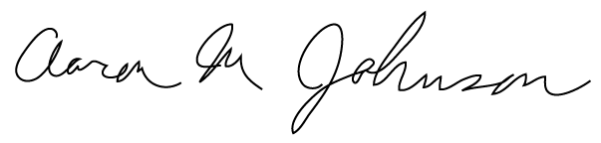
Sincerely,

Aaron M. Johnson, M.M., Ph.D., CCC-SLP
Assistant Professor
Department of Otolaryngology-Head and Neck Surgery
New York University School of Medicine

