Journal: Journal of Visualized Experiments (ISSN 1940-087X)
Manuscript ID: JoVE61285
Type: Article
Title: Evaluating Cell Death using Cell-Free Supernatant of Probiotics in Three-Dimensional Spheroid Cultures of Colorectal Cancer Cells
Authors: Jina Lee^{1,*}, Joo-Eun Lee^{2,*}, Seil Kim^{1,3}, Dukjin Kang¹ and Hee Min Yoo¹
We thank the Reviewers for their thoughtful comments. We tried to address the comments with additional experimental data and our manuscript underwent extensive English editing. We sincerely hope that the revisions will render this manuscript suitable for publication in Journal of Visualized Experiments.

Response to Editorial Comments
We are profoundly grateful for your valuable comments on our manuscript.

Editorial comments:

1. Please take this opportunity to thoroughly proofread the manuscript to ensure that there are no spelling or grammar issues. The JoVE editor will not copy-edit your manuscript and any errors in the submitted revision may be present in the published version.
Our manuscript underwent extensive English editing by English editing service during revision for checking grammar, spelling and some improvement of style. We appreciate the kind comments made by the editor.

2. Please revise lines 259-261, 265-267, and 286-287 to avoid textual overlap with previously published work.

We corrected the sentence in the manuscript according to your kind comments

Lines 291-293: However, 2D cultures have several disadvantages, such as the disruption of cellular interactions as well as alterations in cell morphology, extracellular environments, and the approach of division.

Lines 293-300: 3D scaffolding was developed for tissue engineering. It acts as a surrogate loss of ECM, representing the available space of tumor cells. In addition, the scaffolding provides physical interactions for cell adhesion and proliferation and causes cells to form appropriate spatial distributions and cell-ECM or cell-cell interactions.

Lines 319-320: Western blotting using spheroids can lead to quantitative insights into the state of various signaling molecules.
3. Keywords: Please provide at least 6 keywords or phrases.

We added the keywords in the manuscript according to your kindly comments.

Keywords: Probiotics, Lactobacillus fermentum, Colorectal cancer, Spheroid, 3D culture, Cell-free supernatant (CFS)

4. JoVE cannot publish manuscripts containing commercial language. This includes trademark symbols (™), registered symbols (®), and company names before an instrument or reagent. Please remove all commercial language from your manuscript and use generic terms instead. All commercial products should be sufficiently referenced in the Table of Materials. You may use the generic term followed by “(Table of Materials)” to draw the readers’ attention to specific commercial names. Examples of commercial sounding language in your manuscript are: Perkin Elmer, LAMBDA, falcon, CellTiter 96 Aqueous, EnSpire, iTaq™ Universal SYBR®, StepOnePlus, etc.

We removed all commercial language from our manuscript according to your comments.

5. Please add more details to your protocol steps. There should be enough detail in each step to supplement the actions seen in the video so that viewers can easily replicate the protocol. Please ensure you answer the “how” question, i.e., how is the step performed? Alternatively, add references to published material specifying how to perform the protocol action. See examples below.

We have now added more details to our protocol steps based on your kind comments and suggestions.

6. 1.2, 1.5: Please specify the incubation temperature.

- 1.2: “Pre-incubate the MRS agar plate in an anaerobic chamber at 20 ppm Oxygen, H2.” has been changed to “Pre-incubate the MRS agar plate in a H₂ anaerobic chamber at 37 ℃ and 20 ppm oxygen.”
- 1.5: “Incubate the bacteria for 4-6 days in an anaerobic chamber and passage every 2 days until single bacteria colonies are obtained.” has been changed to “Incubate the bacteria for 2-3 days in a H₂ anaerobic chamber at 37 ℃ and 20 ppm oxygen and passage every 2 days until single bacteria colonies are obtained.”

7. 1.5: Is the chamber the same as that used in step 1.4?

We used the same anaerobic chamber as described in 1.4. In addition, we have been changed the sentence as “Incubate the bacteria for 2-3 days in a H₂ anaerobic chamber at 37 ℃ and 20 ppm oxygen and passage every 2 days until single bacteria colonies are obtained.”

8. 1.6: Please describe how to sterilize the tube.

Thank you for the valuable comments. As suggested, we added more detailed information.

Additions

1.6. Wash and dry the hungate tube
1.7. Incubate the hungate tube in a H₂ anaerobic chamber at 37 ℃ and 20 ppm oxygen to exclude oxygen
1.8. Place 2-3 mL of MRS broth into the tube
1.9. Seal the tube with a buthyl rubber stopper and screw the cap
1.10. Autoclave the hungate tube at 121 ℃ for 15 min.
1.11. After autoclaving, incubate the hungate tube in a H₂ anaerobic chamber at 37 ℃ and 20 ppm oxygen

9. 1.11: What volume of RPMI 1640 is used to resuspend the pellet?

1.17: Separate the bacterial pellets and the conditioned media using a centrifuge for 15 min at 1000 x g. Wash the collected bacterial pellets (with PBS) and resuspend in 4 mL RPMI 1640 containing 10 % fetal bovine serum without antibiotics.

10. 3.4: Each well of what? Please specify.

- 3.4: “Remove as much of the growth medium as possible from each well using a 200p pipette.” has been changed to “Remove as much of the growth medium as possible from each of the wells containing the spheroids using a 200 μL pipette.”

11. 5.4-5.6: Please provide more details here. For PCR, please specify primers and
conditions used.

Thank you for the valuable comments. As suggested, we added more detailed information

5. Quantitative real-time polymerase chain reaction analysis for spheroids.

5.1. For each condition, prepare 10-15 spheroids in a 2 mL tube and centrifuge for 3 min at 400 x g
5.2. Discard the supernatant and wash the spheroids twice in 1 mL of ice-cold 1X PBS (note: avoid centrifugation, let the spheroids settle down).
5.3. Aspirate as much of the 1X PBS as possible and isolated the RNA
5.4. Synthesize cDNA from 1 μg of RNA
5.5. Prepare a master mix to run all samples in triplicate (refer to the Table of Materials)
5.6. Perform the cDNA synthesis by placing 20 µL of the template master mix into each qPCR plate well.
5.7. Mix reactions well and spin if necessary.
5.8. Run samples as per the recommendations of the instrument manufacturer.

Table 1. PCR reaction mixture

Table 2. Primer sequences used in qRT-PCR analysis.

Table 3. qRT-PCR conditions

12. 2.1.4, 5.1, 6.1, 6.6, 8.6, 8.10, etc.: Please list all centrifugation speeds in terms of
centrifugal g-force (x g) instead of rpm.

We have all changed as recommended centrifugation speed in terms of centrifugal force g- (x g).

-2.1.4: Transfer the dissociated cells to a 15 mL conical tube and centrifuge for 3 min at 300 x g.
-5.1: For each condition, prepare 10-15 spheroids in a 2 mL tube and centrifuge for 3 min at 400 x g.
-6.1: For each condition, prepare 30-40 spheroids in a 2 mL tube.
-6.6: Centrifuge the protein lysates for 15 min at 15000 x g and 4 °C.
-8.2 : For each condition, prepare 30-40 spheroids in a FACS tube and centrifuge for 3 min at 400 x g and RT.
- 8.6: Centrifuge the dissociated cells at 400 x g and 4 °C for 3 minutes (note: FACS buffer = 1X PBS + 2.5% FBS, filtered using a 0.22um top filter).
-8.10: Centrifuge the dissociated cells at 400 x g for 3 min

13. After you have made all the recommended changes to your protocol section (listed above), please highlight in yellow up to 2.75 pages (no less than 1 page) of protocol text (including headers and spacing) to be featured in the video. Bear in mind the goal of the protocol and highlight the critical steps to be filmed. Our scriptwriters will derive the video script directly from the highlighted text.

We are grateful for your comments. As suggested, we highlighted the protocol text to be featured in the video in yellow.

14. Please upload each Figure individually to your Editorial Manager account as a .png, .tiff, .pdf, .svg, .eps, .psd, or .ai file.

We are grateful for your comments. As suggested, we uploaded each Figure individually as .tiff files.

15. Figures: Please include a space between all numbers and the corresponding unit: 20
ppm, 37 °C, 24 h, etc.

We thank the reviewer for their helpful comment. As suggested, we included a space between all numbers and the corresponding unit.

16. Figure 4: Please submit multipanel figures (A, B, C, etc.) as a single image file that
contains the entire figure.

We are grateful for your comments. As suggested, we submitted a single image file

17. Table of Materials: Please remove any ™/®/© symbols. Please sort the materials
alphabetically by material name.

We are grateful for your comments. As suggested, we removed symbols from the table.

Response to Reviewer 1 Comments
We are profoundly grateful for your valuable comments on our manuscript.
Reviewer #1:
Manuscript Summary:
Anew approach to cancer cell and probiotic bacteria association in 3D models, Good working

Major Concerns:
N/A
Minor Concerns:
Maybe it can be tried a bifidobacterium culture models next time

Thank you for the valuable comments. As you recommended, we will develop a bifidobacterum culture model for the next study.

Response to Reviewer 2 Comments
We are profoundly grateful for your valuable comments on our manuscript.

Reviewer #2:
Manuscript Summary:
ABSTRACT
L 36-37 "The use of Lactobacillus cell-free supernatant (LCFS) could potentially be a better option", …The sentence needs to be rephrased as it is missing the meaning…..LCFS IS A BETTER OPTION THAN WHAT?

We corrected the sentence in the manuscript according to your kind comments

Lines 37-39: The use of Lactobacillus cell-free supernatant (LCFS) in spheroids could potentially be a better option than testing in 2D monolayers, especially as L. fermentum is able to produce anti-cancer effects within the gut.

L 43 it is not clear what abbreviation CLC stands for

We truly apologize for using incorrect abbreviation. We have corrected our English language errors based on your kind comments and suggestion
-Lines 43: “CLCs” has been changed to “CRCs (colorectal cancer cells).”

PROTOCOL
L 78 misspelled word "Lactobacillus"

We truly apologize for using incorrect wording. We have corrected our English language errors based on your kind comments and suggestion
-Lines 7: “Lactibacillus” has been changed to “Lactobacillus”

L 79 the growing condition is not clear: it should be overnight or for 2 days?
Why is so important to have 20ppm O2, H2? Lactobacillus strains don't need strict
anaerobic conditions. They will grow in CO2 incubator and there is no need to pre-incubate
MRS plate in anaerobic chamber.

We sincerely appreciate the reviewer’s thoughtful comments. As the reviewer pointed out, Lactobacillus strains are facultative anaerobic bacteria that do not require strict anaerobic conditions. Oxygen concentrations in the lumen of the human intestine are known to affect the spatial distribution and metabolism of gut flora [1]. Most intestinal bacteria are obligate anaerobes, many of which fail to grow at oxygen concentrations greater than ~0.5% [2]. Lactic acid bacteria (LAB) are anaerobic, aerotolerant (not aerophilic) microorganisms that lack the capability to synthesize active electron transport chains [3]. Therefore, a more in vivo-like intestinal tissue microenvironment including anaerobes significantly influences the composition of microbial metabolism [4]. Interestingly, lactic acid bacteria are generally used in the food industry for anaerobic fermentation to produce anaerobic metabolite [5,6]. In summary, we used anaerobic conditions when growing Lactobacillus to mimic in the vivo-like microenvironment.

1. Flint, H.J.; Scott, K.P.; Louis, P.; Duncan, S.H. The role of the gut microbiota in nutrition and health. Nat. Rev. Gastroenterol. Hepatol. 2012, 9, 577–589.
2. Jalili-Firoozinezhad, S.; Gazzaniga, F.S.; Calamari, E.L.; Camacho, D.M.; Fadel, C.W.; Bein, A.; Swenor, B.; Nestor, B.; Cronce, M.J.; Tovaglieri, A.; et al. A complex human gut microbiome cultured in an anaerobic intestine-on-a-chip. Nat. Biomed. Eng. 2019, 3, 520–531.
3. Maresca, D.; Zotta, T.; Mauriello, G. Adaptation to aerobic environment of Lactobacillus johnsonii/gasseri strains. Front. Microbiol. 2018, 9, 1–11.
4. Costa, J.; Ahluwalia, A. Advances and Current Challenges in Intestinal in vitro Model Engineering: A Digest. Front. Bioeng. Biotechnol. 2019, 7, 1–14.
5. Ricciardi, A.; Zotta, T.; Ianniello, R.G.; Boscaino, F.; Matera, A.; Parente, E. Effect of respiratory growth on the metabolite production and stress robustness of lactobacillus casei N87 cultivated in cheese whey permeate medium. Front. Microbiol. 2019, 10, 1–14.
6. Hao, T.; Xie, Z.; Wang, M.; Liu, L.; Zhang, Y.; Wang, W.; Zhang, Z.; Zhao, X.; Li, P.; Guo, Z.; et al. An anaerobic bacterium host system for heterologous expression of natural product biosynthetic gene clusters. Nat. Commun. 2019, 10, 1–13.

L81 now it is even more confusing. In line 79 we should incubate for 2 days, in next step
author suggests incubation for another 4-6 days? Why? To obtain single colonies there is
no need to passage bacteria for almost 6 days, but using streaking microbiological
technique it can be obtain even after first incubation period.

We truly apologize for using an inconsistent sentence that could confuse respectful readers. We have corrected the sentence as follows.

Lines 82: “Incubate the bacteria for 4-6 days in an anaerobic chamber and passage every 2 days until single bacteria colonies are obtained.” has been changed to “Incubate the bacteria for 2-3 days in a H₂ anaerobic chamber at 37 ℃ and 20 ppm oxygen and passage every 2 days until single bacteria colonies are obtained.”

L88 I would suggest placing the bacteria to CO2 incubator.

We sincerely appreciate the reviewer’s thoughtful comments.
-Lines 97: “ Incubate the MRS broth media in a shaker incubator for 2 days (37°C, 200rpm)” has been changed to “Incubate the MRS broth media in a shaker incubator for 2 days (37 °C, 5 % CO₂, 200 rpm)”

L89-91 measurement of OD is not clear, author suggest monitoring bacterial growth curves
AFTER incubation?

We sincerely appreciate the reviewer’s thoughtful comments. We suggest monitoring bacterial growth curves before and after incubation to obtain a consistent amount of LCFS.

L103 missing information about cultivating temperature (presence /absence CO2)

Thank you for the valuable comments.

-Lines 111: “ Grow DLD-1, HT-29, and WiDr cell lines as monolayers until 70-80 % confluency RPMI containing 10 % fetal bovine serum (FBS) and 1 % penicillin-streptomycin.” has been changed to “Grow DLD-1, HT-29, and WiDr cell lines as monolayers until 70-80 % confluency and incubate the plate at 37 °C in a 5 % CO₂ incubator (growth medium: RPMI containing 10 % fetal bovine serum (FBS) and 1 % penicillin-streptomycin).”

L110 the sentence needs to be rephrased PLACE THE TUBE WHERE?
We truly apologize for using an inconsistent sentence that could confuse respectful readers.
- Lines 119: “ Place the 15 ml conical tube containing the dissociated cells and centrifuge for 3 min at 1200 rpm. “ has been changed to “ Transfer the dissociated cells to a 15 mL conical tube and centrifuge for 3 min at 300 x g.”

L117 wrong sentence from gramma point of view
We truly apologize for using the incorrect sentence.

Lines 125: Dilute the cells in a 15 mL conical tube to obtain 1-2 x 10⁵ /mL.

L118-120 the procedure is not clear at all. Do we need to determine methylcellulose density? Methylcellulose must be 0,2 % in each well? I don't understand this step. Please make it more clear.

Thank you for your comments. We apologize for using incorrect methylcellulose concentration. We have corrected the sentence.
.
Lines 126: “Add 0.2 % methylcellulose and transfer the diluted cells to a sterile reservoir. Use a multichannel pipette to dispense 200 µl/well into an ultra-low attachment 96-well round bottom microplate. (Each cell line and methylcellulose density should be determined. (Figure 1B (iii))” has been changed to “Add final concentration of 0.6 % methylcellulose and transfer the diluted cells to a sterile reservoir. Use a multichannel pipette to dispense 200 µL/well into an ultra-low attachment 96-well round bottom microplate. Each cell line and methylcellulose density should be determined (Figure 1B (iii))”

L130 /L194 200p pipette - what is „p"?

We truly apologize for using incorrect abbreviation. We have corrected our English language errors based on your kind comments and suggestion
- Lines 138: “Remove as much of the growth medium as possible from each well using a 200p pipette.” has been changed to “ Remove as much of the growth medium as possible from each well using a 200 μL pipette.”
- Lines 139: “Add 1 ml of FACS buffer and gently dissociate the spheroids using a 200p pipette.” has been changed to “ Add 1 mL of FACS buffer and gently dissociate the spheroids using a 200 μL pipette.”

L131 no information about volume of added growth media with LCFS / need more detailed specification. It is also not clear how long was the incubation time for different analyses.

Thank you for the valuable comments. As suggested, we added more detailed information.

Additions

-Lines 139: “ Add the growth media with LCFS and incubate at 37 °C in a 5 % CO₂ incubator for 24-48 h. NOTE: The volume to be used will depend on the plate size as follows: 2 mL for 6-well cell culture plates; 200 μL for 96-well cell culture plates.

L135 incubation time in step 3.5 is stated 24-48h. Here we should perform viability assay
after 24-72h (?) Please clarify this.

Thank you for your comments. We apologize for using the incorrect incubation time for the experiments. To investigate whether the cells underwent apoptosis, LCFS-treated cells and untreated cells were incubated at 37 °C for 48 hours before a significant portion of the cell populations died.

Correction

-Lines 143: “Prepare 8-10 LCFS-treated colorectal cancer spheroids in an ultra-low attachment 96-well round bottom microplate (cell viability assays are performed 24-72 hours after LCFS treatment)” has been changed to “Prepare 8-10 LCFS-treated colorectal cancer spheroids in an ultra-low attachment 96-well round bottom microplate (cell viability assays are performed 48 hours after LCFS treatment)”

L153 What was measured by RT-qPCR - not stated

Thank you for the valuable comments. We measured BAX, BAK and NOXA. To clarify, we added more detailed information

5. Quantitative real-time polymerase chain reaction analysis for spheroids.

5.1. For each condition, prepare 10-15 spheroids in a 2 mL tube and centrifuge for 3 min at 400 x g
5.2. Discard the supernatant and wash the spheroids twice in 1 mL of ice-cold 1X PBS (note: avoid centrifugation, let the spheroids settle down).
5.3. Aspirate as much of the 1X PBS as possible and isolated the RNA
5.4. Synthesize cDNA from 1 μg of RNA
5.5. Prepare a master mix to run all samples in triplicate (refer to the Table)
5.6. Perform the cDNA synthesis as a 20 µL of the template master mix into each qPCR plate well.
5.7. Mix reactions well and spin if necessary.
5.8. Run samples as per the recommendations of the instrument manufacturer.

Table 1. PCR reaction mixture

Table 2. Primer sequences used in qRT-PCR analysis.

Table 3. qRT-PCR conditions

L161 missing the information about time of incubation on ice. However, spheroids are after
centrifugation, aren't they settled down? What is the point of this step?

We truly apologize for using an incorrect sentence. We have corrected the sentence.

Correction

-Lines 167-168
6.1. For each condition, prepare 30-40 spheroids in a 2 mL tube.
6.2. Place the tube on ice and let the spheroids settle down to the bottom of the 2 mL tube.

L168 Is the centrifugation step final step in Western blotting procedure?

Thank you for your comments. More detailed method was described as bellow;

Addition

-6.7. Determine the protein concentration for each cell lysate
-6.8. Boil each cell lysate in the sample buffer at 100 °C for 10 min.
-6.9. Load equal amounts of protein into the wells of the SDS-PAGE gel and run the gel for 1-2 h at 100V.
-6.10. Transfer the protein from the gel to the PVDF membrane.
-6.11. After transferring, block the membrane for 1 h at room temperature using a blocking buffer (5 % skim milk + TBS with 0.05 % Tween-20).
-6.12. Incubate the membrane with 1:1000 dilutions of primary antibody in TBST with 5 % BSA buffer at 4 °C overnight. Refer to the Table of Materials.
-6.13. Wash the membrane three times with TBST, 15 min for each wash.
-6.14. Incubate the membrane with 1:2500 dilutions of secondary antibody in the blocking buffer at room temperature for 2 h. Refer to the Table of Materials.
-6.15. Wash the membrane three times with TBST, 15 min for each wash.
-6.16. Prepare the membrane for HRP detection with a Chemiluminescent substrate. Refer to the Table of Materials.
-6.17. Acquire chemiluminescence images.

L208 "several groups" …does it mean each spheroid was prepared by different group?

We truly apologize for using incorrect word. We have corrected our English language errors based on your kind comments and suggestion
“In the present study, several groups developed spheroid cultures from diverse cancer cell types” has been changed to “In the present study, several research groups developed spheroid cultures from diverse cancer cell types”

L213-L214 in the section 2.2.3 is stated to use 0,2 % methylcellulose, but now it is between 0 and 1,2%. So again, very confusing.

Thank you for your comments. We apologize for using an incorrect methylcellulose concentrations. We have corrected the sentence.
.
2.2.3.: “Add 0.2 % methylcellulose and transfer the diluted cells to a sterile reservoir. Use a multichannel pipette to dispense 200 µl/well into an ultra-low attachment 96-well round bottom microplate. (Each cell line and methylcellulose density should be determined. (Figure 1B (iii))” has been changed to “Add final concentration of 0.6 % methylcellulose and transfer the diluted cells to a sterile reservoir. Use a multichannel pipette to dispense 200 µL/well into an ultra-low attachment 96-well round bottom microplate. Each cell line and methylcellulose density should be determined (Figure 1B (iii)).”

L235-238: “ As shown in Figure 2A, concentrations of methylcellulose between 0 and 1.2 % transform the compactness and morphology of the spheroids. This result indicates that our methylcellulose protocol may be capable of obtaining consistent spheroids from several types of colorectal cancer.” has been changed to “As shown in Figure 2A, a methylcellulose concentration of 0.6 % transforms the compactness and morphology of the spheroids. This result indicates that our methylcellulose protocol may be capable of obtaining consistent spheroids from several types of colorectal cancer.”

L217 "we treated the spheroids with LCFS" ..... spheroids treated with what concentration of methylcellulose - how did you obtain spheroids?

Thank you for your comments. When we generated spheroids we added 0.6 % methylcellulose in the growth media that contained 1-2 x 10⁵ml diluted cells. We then dispensed 200 μl/well into an ultra-low attachment 96-well round bottom microplate and incubated the plate at 37 °C in a 5 % CO2 incubator for 24-36 hours. After 24-36 hours, the generated spheroid was treated with 25 % LCFS and we measured the morphology after 48 hours using a light microscope. To clarify, we corrected the sentence as below:

Line 238-239:
“Next, we treated the spheroids with LCFS and measured the morphology after 48 hours using a light microscope.” has been changed to “Next, we treated the spheroids with 25 % LCFS and measured the morphology after 48 h using a light microscope.”

L220 "dosages of 0,6, 12.5, 25"….missing the unit. In step 3.3 is stated also dosage of 50.
It will not be used?

We truly apologize for the confusion. Although the LCFS experiment was performed with dosages of 50 %, only 25 % LCFS was determined as there was no difference in cell death between 50 % and 25 % LCFS. To clarify the method, we deleted the 50 % LCFS part in Step 3.3.

Correction

-Lines 136. Inoculate the LCFS stock solution into a growth medium. Dilute to 25 %, 12.5 %, and 6 % in the growth medium (i.e., 25 % LCFS = 150 µL growth medium + 50 µL LCFS)

L222-224 in 4.1 is stated that viability was tested after 24-72 hours. Here after 48 hours only. Please clarify this.

Thank you for your comments. We apologize for using the incorrect incubation time for the experiments. To investigate whether the cells underwent apoptosis, LCFS-treated cells and untreated cells were incubated at 37 °C for 48 hours before a significant portion of the cell populations died.

Correction

-Lines 143: “Prepare 8-10 LCFS-treated colorectal cancer spheroids in an ultra-low attachment 96-well round bottom microplate (cell viability assays are performed 24-72 hours after LCFS treatment)” has been changed to “Prepare 8-10 LCFS-treated colorectal cancer spheroids in opaque-walled multi-well plates (cell viability assays are performed 48 h after LCFS treatment).”

L228 "including BAX, BAK, and NOXA" authors did not state in the methods that they detected these markers.

Thank you for the valuable comments. To clarify, we added more detailed information

Additions

5. Quantitative real-time polymerase chain reaction analysis for spheroids.

5.1. For each condition, prepare 10-15 spheroids in a 2 mL tube and centrifuge for 3 min at 400 x g
5.2. Discard the supernatant and wash the spheroids twice in 1 mL of ice-cold 1X PBS (NOTE: avoid centrifugation, let the spheroids settle down).
5.3. Aspirate as much of the 1X PBS as possible and isolated the RNA
5.4. Synthesize cDNA from 1 μg of RNA
5.5. Prepare a master mix to run all samples in triplicate. Refer to the material table.
5.6. Perform the cDNA synthesis as a 20 µL of the template master mix into each qPCR plate well.
5.7. Mix reactions well and spin if necessary.
5.8. Run samples as per the recommendations of the instrument manufacturer..

Table 1. PCR reaction mixture

Table 2. Primer sequences used in qRT-PCR analysis.

Table 3. qRT-PCR conditions

Addition

6.6. Centrifuge the protein lysates for 15 min at 15000 x g and 4 °C.
6.7. Determine the protein concentration for each cell lysate
6.8. Boil each cell lysate in a sample buffer at 100 °C for 10 min.
6.9. Load equal amounts of protein into the wells of the SDS-PAGE gel and run the gel for 1-2 h at 100V.
6.10. Transfer the protein from the gel to the PVDF membrane.
6.11. After transferring, block the membrane for 1 h at room temperature using a blocking buffer (5 % skim milk + TBS with 0.05 % Tween-20).
6.12. Incubate the membrane with 1:1000 dilutions of primary antibody in TBST with 5 % BSA buffer at 4 °C overnight. Refer to the Table of Materials.
6.13. Wash the membrane three times with TBST, 15 min for each wash.
6.14. Incubate the membrane with 1:2500 dilutions of secondary antibody in the blocking buffer at room temperature for 2 h. Refer to the Table of Materials.
6.15. Wash the membrane three times with TBST, 15 min for each wash.
6.16. Prepare the membrane for HRP detection with a Chemiluminescent substrate. Refer to the Table of Materials.
6.17. Acquire chemiluminescent images..

Table 4. Antibodies used in western blot analysis.

L238/L242 (n=3) what „n" stands for? Is it the number of experiments or number of wells per one experiment. Please clarify it.

We sincerely appreciate the reviewer’s thoughtful comments. We apologize for using incorrect nomenclature. It refers to the number of experimental replicates for each experiment. To clarify, we edited the sentence as follows.
Additions
- “n=3” has been change to “ n=3 for each experiment”
L244 Fig 3D ht-29 cells: how can be viability more than 100%? different blue colours are percentage of what?? also data are represented as MEAN?? +/- SD? SEM? Moreover, MTS assay is not mentioned anywhere apart from line 222 (but NOT in methods)

We sincerely appreciate the reviewer’s thoughtful comment. As recommended by the reviewer, we represented the LCFS % in blue colors, and the statistical analysis within the figure legend and MTT was replaced with a cell viability assay.
Additions
- Figure 3: Evaluation of LCFS concentration and spheroid morphology. (A) Representative images of HT-29 treated with LCFS for 48 h. Scale bar 100 μm. (B) HT-29, DLD1, and WiDr spheroids treated with increasing doses of LCFS for 48 h. All spheroids had disrupted edges at 12.5-25 % LCFS. Scale bar 20 μm (n=3 for each experiment) (C) Spheroid morphologies of HT-29, DLD1, and WiDr spheroids treated with 25 % LCFS for 24 and 48 h. Scale bar 20 μm (n = 3) (D) Measured cell viability, shown as mean ± SEM. ***, P < 0.05 (n=3 for each experiment).
- Lines 246: After 48 h, the samples were assessed through a cell viability assay, and we found that apoptosis in spheroid colorectal cancers depended on the dosage of LCFS (Figure 3D).

L246 why authors did not show PI staining in spheroids from other cell types?

Thank you for your comments. As suggested, we performed PI staining in spheroids from other cell types. The data indicated that LCFS induced apoptosis not only in HT-29 spheroids but also in DLD1 and WiDr spheroids. We added these results in Figure 4.

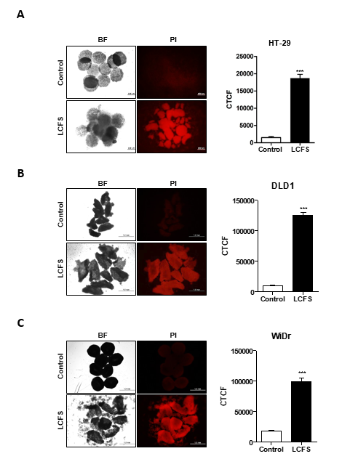
Figure 4: Propidium iodide staining of the spheroids. Representative images of PI staining in (A) HT-29, (B) DLD1, and (C) WiDr spheroids after 48 h of LCFS treatment. The images were identified using a fluorescence microscope and the increase in PI intensity was measured using Image J. Scale bar 10 μm. The mean ± SEM is shown. ***, P < 0.05 (n=3 for each experiment).

Additions
- Description of the results in the text: line 247-250
- Data: Figure 4A, B, C

L248/249 „Quantification of apoptosis markers, measured through qRT-PCR". data are represented as MEAN?? +/- SD? SEM? statistical analysis? *** is p < ????

We sincerely appreciate the reviewer’s thoughtful comment regarding this important statistical issue. As recommended by the reviewer, we added this information within thefigure legend.
Additions
Figure 5: Apoptosis markers were identified using qRT-PCR. Apoptosis markers, such as BAX, BAK and NOXA, were quantified. mRNA is presented as a relative expression normalized to (A) β-actin and (B) 18s rRNA. The mean ± SEM is shown. ***, P < 0.05 (n=3 for each experiment).
L252 Why authors don't show FACS analysis of apoptosis in spheroids of other cell types?

Thank you for your comments. As suggested, we performed FACS analysis of apoptosis for DLD1 and WiDr spheroids.

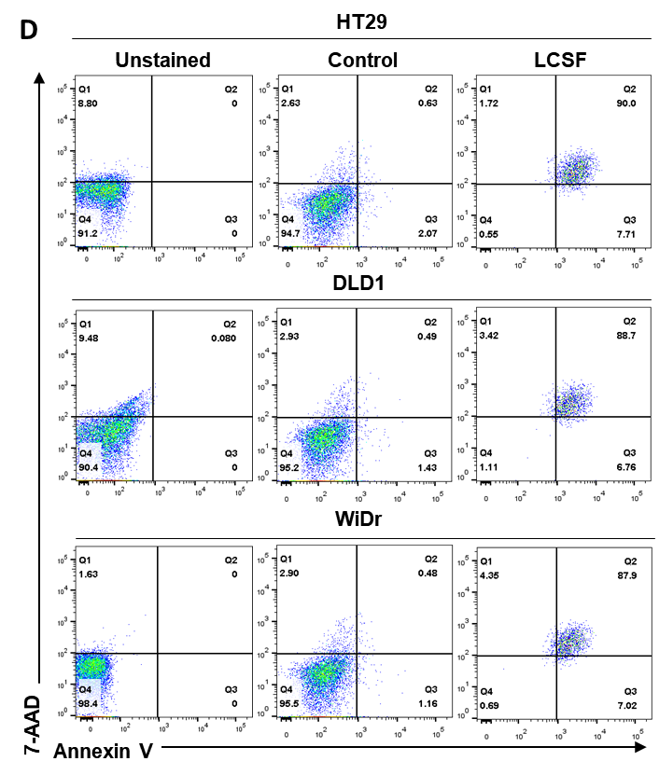
Figure 6. Apoptosis markers were determined via Western blotting and FACS analysis of the spheroids. Shown in the figure are Western blots of (A) HT-29, (B) DLD1, and (C) WiDr cells after LCFS treatment. The antibodies that were detected were PARP1, Bcl-xL, and p-IκBα. β-actin expression was used as an internal control. (D) FACS analysis of apoptosis in HT-29, DLD1, and WiDr spheroids incubated with LCFS. Apoptotic cells were detected by the increase in the fluorescence intensity of Annexin V-FITC.

Additions
- Description of the results in the text: line 251-252
- Data: Figure 6D

Major Concerns:
Majority of steps listed in the procedure are not clearly explained and thus very confusing.

We thank the Reviewer for their thoughtful comments. We tried to clearly explain the majority of steps with additional experimental data and reviewer comments, and the manuscript underwent extensive English editing.

Minor Concerns:
English language need to be improved.
Our manuscript underwent extensive English editing by English editing service during revision for checking grammar, spelling and some improvement of style. We appreciate for reviewer kindly comments.

Response to Reviewer 3 Comments
We are profoundly grateful for your valuable comments on our manuscript.

Reviewer #3:
Manuscript Summary:
The manuscript aim the generation of a protocol to study the impact of probiotics in cancer
spheroids. I recommended the following improvements.

Major Concerns:
1. The authors used MTS as viability assay (Figure 3). MTS is commonly used, however MTS has many limitations, I'd recommended additionally the use of CellTiter-Glo® Luminescent Cell Viability Assay optimized for spheroid analysis ratifying the findings of MTS assay.

We sincerely appreciate the reviewer’s comments. As pointed out by the reviewer, we performed viability assay for HT-29, DLD1, and WiDr spheroids using the CellTiter-Glo® 3D Cell Viability assay to examine the anti-cancer effects of Lactobacillus fermentum. The CellTiter-Glo® 3D Cell Viability assay kit is more suitable for determining the number of viable cells in 3D cell cultures as it depends on the quantitation of ATP present and is based on the original CellTiter-Glo® Luminescent Cell Viability Assay chemistry suggested by the reviewer. We have changed the results of the cell viability assessment to those obtained using the CellTiter-Glo® 3D Cell Viability assay in Figure 3D.

4. Cell viability assay for spheroids
4.1. Prepare 8-10 LCFS-treated colorectal cancer spheroids in opaque-walled multi-well plates (cell viability assays are performed 48 h after LCFS treatment).
4.2. Thaw the cell viability reagent at 4 °C overnight. Refer to the material table.
4.3. Equilibrate the cell viability reagent to room temperature before use.
4.4. Before observing the assay, remove 50 % of the growth media from the spheroids.
4.5. Add 100 µL of cell viability reagent to each well.
NOTE: The volume to be used will depend on the plate size as follows: 100 μL for 96-well cell culture plates.
4.5. Mix the reagent vigorously for 5 min to promote cell lysis.
4.6. Incubate for 30 min–2 h at 37 °C.
4.7. Record the luminescence.

Additions
- Description of the method in the text: line 141-150

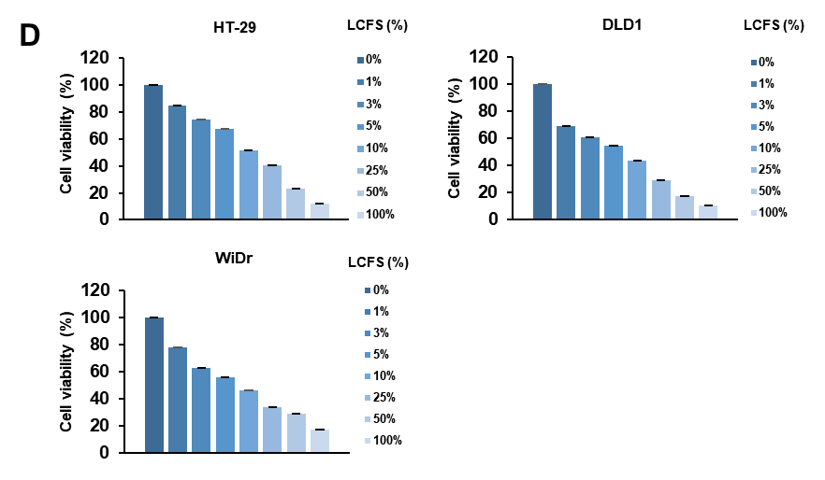
Figure 3: Evaluation of LCFS concentration and spheroid morphology. (A) Representative images of HT-29 treated with LCFS for 48 hours. Scale bar 100 μm. (B) HT-29, DLD1, and WiDr spheroids treated with increasing doses of LCFS for 48 h. All spheroids had disrupted edges at 12.5-25 % LCFS. Scale bar 20 μm (n=3 for each experiment) (C) Spheroid morphologies of HT-29, DLD1, and WiDr spheroids treated with 25 % LCFS for 24 and 48 h. Scale bar 20 μm (n = 3) (D) Measured cell viability, shown as mean ± SEM. ***, P < 0.05 (n=3 for each experiment).

Changes
- Description of the results in the text: line 246-247
- Data: Figure 3D

2. The authors does not describe the cat#, company and sequence of BAX, BAK, NOXA primers. Please provide full details of the primers used in the study.

Thank you for the valuable comments. To clarify, we added more detailed information

5. Quantitative real-time polymerase chain reaction analysis for spheroids.

5.1. For each condition, prepare 10-15 spheroids in a 2 mL tube and centrifuge for 3 min at 400x g
5.2. Discard the supernatant and wash the spheroids twice in 1 mL of ice-cold 1X PBS (note: avoid centrifugation, let the spheroids settle down).
5.3. Aspirate as much of the 1X PBS as possible and isolated the RNA
5.4. Synthesize cDNA from 1 µg of RNA
5.5. Prepare a master mix to run all samples in triplicate (refer to the Table)
5.6. Perform the cDNA synthesis as a 20 µL of the template master mix into each qPCR plate well.
5.7. Mix reactions well and spin if necessary.
5.8. Run samples as per the recommendations of the instrument manufacturer.

Table 1. PCR reaction mixture

Table 2. Primer sequences used in qRT-PCR analysis.

Table 3. qRT-PCR conditions

3. The Authors does not describe the housekeeping genes used to normalize the qPCR data. Please provide at least two housekeeping genes.

We sincerely appreciate the reviewer’s thoughtful comments and helpful suggestions. We normalized qPCR using Actin and 18s rRNA. LCFS-treated spheroids exhibited similar effects when normalized with Actin or 18s RNA. Therefore, LCFS effectively induced apoptosis in the 3D model. We added the results of the cell death assessment by qPCR in Figure 5.

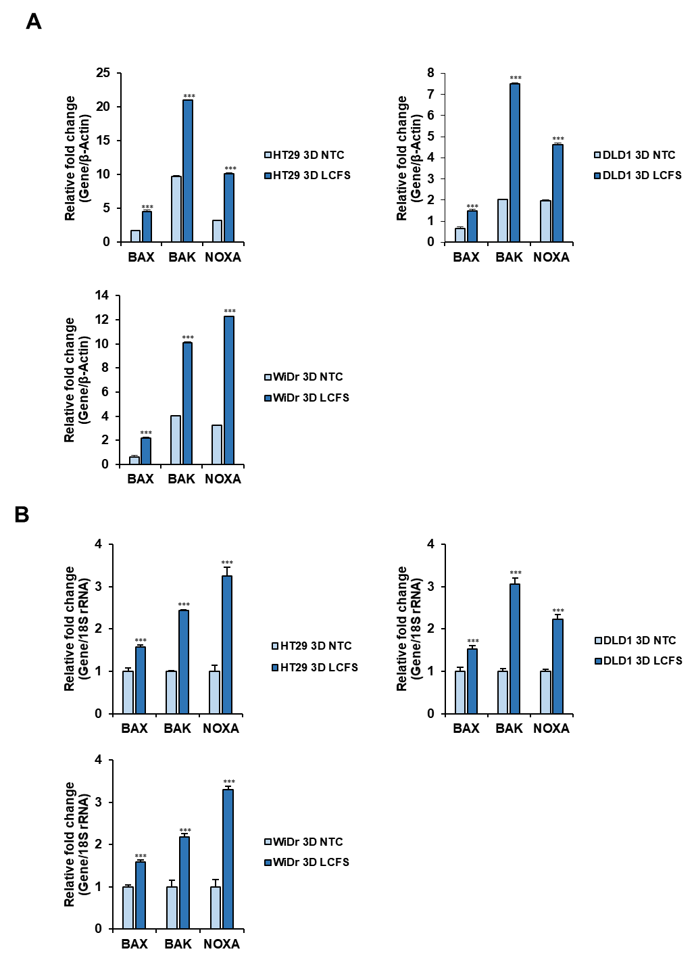

Figure 5: Apoptosis markers were identified using qRT-PCR. Apoptosis markers, such as BAX, BAK and NOXA, were quantified. mRNA is presented as a relative expression normalized to (A) β-actin and (B) 18s rRNA. The mean ± SEM is shown. ***, P < 0.05 (n=3 for each experiment).

Additions
- Description of the results in the text: line 250-251
- Data: Figure 5A, B

4. Please provide a non-stained sample plot from each condition depicted in the FACS dot plot (Fig. 4F).

We sincerely appreciate the reviewer’s comments. As pointed out by the reviewer, we added a non-stained sample plot from each condition.

Figure 6. Apoptosis markers were determined via Western blotting and FACS analysis of the spheroids. Shown in the figure are Western blots of (A) HT-29, (B) DLD1, and (C) WiDr cells after LCFS treatment. The antibodies that were detected were PARP1, Bcl-xL, and p-IκBα. β-actin expression was used as an internal control. (D) FACS analysis of apoptosis in HT-29, DLD1, and WiDr spheroids incubated with LCFS. Apoptotic cells were detected by the increase in the fluorescence intensity of Annexin V-FITC.

Additions
- Description of the results in the text: line 251-252
- Data: Figure 6D

Minor Concerns:
1. I would rewrite the sentence "Probiotics are the most advantageous microorganisms in the gut that improve the host". Although the authors describe "what" probiotics "improve the host" in the next sentences, it does not sound appropriated to end this sentence with a unclear and general idea that probiotics "improve the host". I'd recommended include in the same sentence the benefits of probiotics as described in the lines 53-57.

We truly apologize for the vague expression. “Probiotics are the most advantageous microorganisms in the gut that improve the host” has been changed to “Probiotics are the most advantageous microorganisms in the gut that improves immune homeostasis and host energy metabolism.”

Response to Reviewer 4 Comments
We are profoundly grateful for your valuable comments on our manuscript.

Reviewer #4:
Manuscript Summary:
Clear and well drafted

Major Concerns:
None

Minor Concerns:
None

