Please note that the manuscript has been modified to include line numbers and minor formatting changes. The updated manuscript is attached and please use this updated version for future revisions. ​
Editorial comments:
Changes to be made by the Author(s):
1. Please take this opportunity to thoroughly proofread the manuscript to ensure that there are no spelling or grammar issues. The JoVE editor will not copy-edit your manuscript and any errors in the submitted revision may be present in the published version.
2. Please revise the table of the essential supplies, reagents, and equipment. The table should include the name, company, and catalog number of all relevant materials in separate columns in an xls/xlsx file. Please sort the Materials Table alphabetically by the name of the material.
3. Please confirm the filming location.
4. Pleas provide email addresses for each author.
5. Please provide at least 6 keywords or phrases.
6. Please revise the text to avoid the use of any personal pronouns (e.g., "we", "you", "our" etc.).
7. For in-text formatting, corresponding reference numbers should appear as numbered superscripts after the appropriate statement(s).
8. What is the gender/strain of the mouse used?
9. JoVE cannot publish manuscripts containing commercial language. This includes trademark symbols (™), registered symbols (®), and company names before an instrument or reagent. Please remove all commercial language from your manuscript and use generic terms instead. All commercial products should be sufficiently referenced in the Table of Materials and Reagents.
10. The Protocol should contain only action items that direct the reader to do something. Please move the discussion about the protocol to the Discussion.
11. Please add more details to your protocol steps. Please ensure you answer the “how” question, i.e., how is the step performed? Alternatively, add references to published material specifying how to perform the protocol action.
12. 2.3.1: What tool is used to make the incision?
13. 3.4: nanoliters? What is the accuracy/precision of the syringe?
14. Please be consistent with the figure labeling. The figures have the panel labels in capital letters but the manuscript text has the panel labels in lowercase.
15. Please highlight 2.75 pages or less of the Protocol (including headings and spacing) that identifies the essential steps of the protocol for the video, i.e., the steps that should be visualized to tell the most cohesive story of the Protocol. Remember that non-highlighted Protocol steps will remain in the manuscript, and therefore will still be available to the reader.
16. Please ensure that the highlighted steps form a cohesive narrative with a logical flow from one highlighted step to the next. Please highlight complete sentences (not parts of sentences). Please ensure that the highlighted part of the step includes at least one action that is written in imperative tense.
17. Please provide a title for each figure.
18. As we are a methods journal, please revise the Discussion to explicitly cover the following in detail in 3-6 paragraphs with citations:
a) Critical steps within the protocol
b) Any modifications and troubleshooting of the technique
c) Any limitations of the technique
d) The significance with respect to existing methods
e) Any future applications of the technique
We have made these adjustments.
Reviewers' comments:
Reviewer #1:
Manuscript summary:
Methods that employ AAV tracers expressing fluorescent reporters or opsins are commonly used for neural circuit tracing and manipulation in rodents. In the current manuscript, Shrestha and colleagues describe a protocol in which they use AAV5-CaMKIIa-ChR2-eYFP to label glutamatergic neurons in the VTA and optogenetic approaches to activate labeled neurons. They show that axonal terminals of labeled VTA glutamatergic neurons is layer-specific in the hippocampus and photoactivation of these neurons induced firing of hippocampal CA1 neurons.
Major Concerns:
(1) The title of the manuscript is too broad and general. A more specific title is recommended.
We have adjusted the manuscript title to reflect the circuit that was traced in this protocol.
(2) The discussion part is a bit cursory and needs to be extended.
The discussion has been extended and organized to reflect concepts and limitations.
(3) Although the use of short promoters to label specific subtypes of neurons is commonly used, their specificity in different brain regions needs to be confirmed. Here the authors should provide evidence that CaMKIIa promoter in the current scheme labels only or mostly glutamatergic neurons in the VTA.
The AAV labels CaMKII positive neurons that are mostly glutamate neurons.
Below, we showed an image with co-labelled TH and AAV-CaMKII
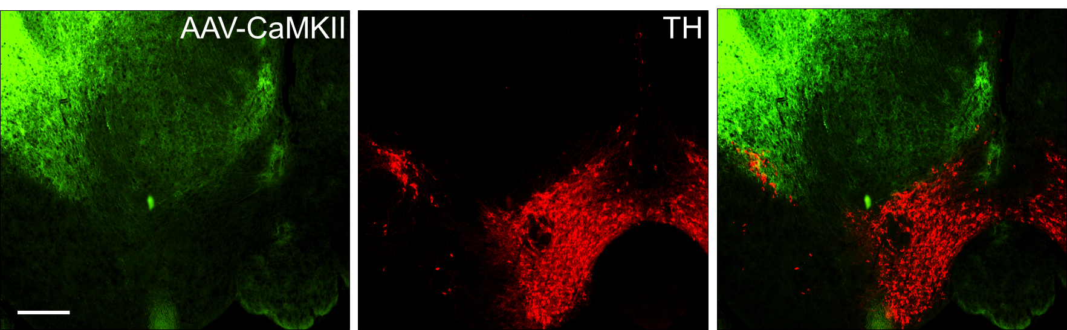
(4) A table of materials should be provided to include information of all used materials and reagents.
This was included as a separate Excel file as per journal instructions. The list has now been updated.
Minor Concerns:
(1) In line 81 part 2.2, a heat pad is commonly used to keep the animal warm.
We have made this correction.
(2) In line 102, it is not clear what an "AAV cocktail" is. There is only one virus injected, why is it called a "cocktail"?
We have made this correction.
(3) hChR2 should be provided with a full name at its first appearance.
We have made this correction.
(4) In line 123, it is "ChR2-eYFP", not "ChR2-eGYP".
We have made this correction.
(5) Line204：The test conditions for the electrodes need to be listed. Such as "at 1 kHz in artificial cerebrospinal fluid".
We have made this correction.
(6) Line231: The stimulation mode (10 ms duration pulses at 50Hz) is not commonly used for optogenetics, especially for the activation of CaMKIIa-ChR2 positive neurons. This frequency is too high and the duration is too long to evoke frequency dependent responses of the target neurons. Besides, the power density of the blue light used also needs to be listed.
The light ON phase doesn not imply that the light was left parmently on. 50Hz pulses were delivered to elicit the response and turned off thereafter. The duration and frequency of pulse will be determined by the scientist based on the goal of the experiment. This is a trial demonstration and the selected range produced a decent response in this case (movie 1).
(7) In Figure 2, an atlas picture or the contour of target region will help identify anatomical structures.
We have now added an atlas image.
Reviewer #2:
Manuscript Summary:
In this manuscript, the authors described the protocols for testing neuroanatomical connections between two brain areas using optogenetic techniques. In particular, they traced the projections of VTA glutamatergic neurons to the hippocampus as the example of this technique. The protocol is decent and it will be of interest to other scientists in the field.
Minor Concerns:
- Line 180, "Use an acute neural probe with 15-50µm thick shank, measuring at least 5mm in length": Using a probe with 5-mm length might be short for recording from VTA of mice. I would suggest longer probes.
In the text we recommended using a probe that is at least 5mm and not exacty 5mm. In the current study, we used a probe with 20mm shank length. We have added a note to this section to make this clear.
- Line 216~, "7. In vivo optogenetic recording and settings": It would be useful if information of typical light intensity for optogenetic stimulation is indicated.
We have now added this information.

