Dr. Nam Nguyen
Manager of Review
Journal of Visualized Experiments

Ref.: submission JoVE61251
A novel right ventricular volume and pressure loaded piglet heart model for the study of tricuspid valve function

June 3, 2020

Dear Dr. Nguyen,

Thank you for this opportunity to further readdress the reviewer comments and resubmit the above-named manuscript to the Journal of Visualized Experiments.

In this latest revision, we have included representative data that outlines some changes to the tricuspid valve due to our model. We hope these additional revisions are satisfactory and look forward to your review and reply.

Yours sincerely,

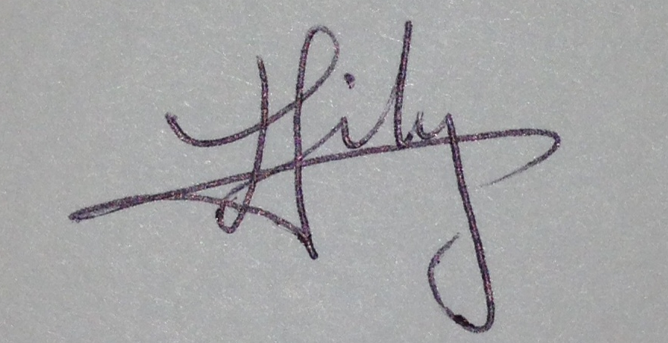

Lily Lin, MD, FRCPC (corresponding author)
Pediatric Cardiology
Stollery Children’s Hospital
University of Alberta, Edmonton, Canada
Email: lily.lin@ualberta.ca

