Xiaoyan Cao, Ph.D.
Review Editor
Journal of Visualized Experiments (JoVE)

February 28, 2020

Dear Cao:

I am submitting to JoVE our revised manuscript, JoVE61239-R1, entitled “A Loop-Mediated Isothermal Amplification Method for Screening Salmonella in Animal Food and Confirming Salmonella from Culture Isolation.” All changes are tracked and a separate rebuttal letter is attached.

We hope these modifications resulted in a manuscript that is suitable for publication in JoVE. We greatly appreciate your time and assistance in refining this manuscript, and look forward to hearing from you soon.

Sincerely,

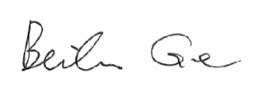
Beilei Ge, Ph.D.
Research Microbiologist
Center for Veterinary Medicine
U.S. Food and Drug Administration

