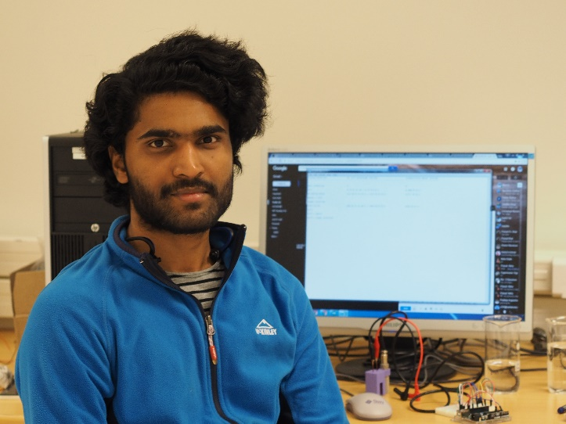

Miracle Israel Nazarious has a strong engineering background having graduated his bachelors in Aeronautical engineering and masters in Space science and technology with specialization in space instrumentation. He is very much interested in areas where engineering aids scientific research. He is currently a PhD candidate within the Group of Atmospheric Science (GAS) at Luleå University of Technology (LTU), Sweden focusing on instrumentation for Mars exploration, with an emphasis on their interest to habitability, in-situ resource utilization, and astrobiology. He is participating in the calibration activities of the HAbitability: Brines, Irradiation and Temperature (HABIT) instrument, a part of ExoMars 2020.

