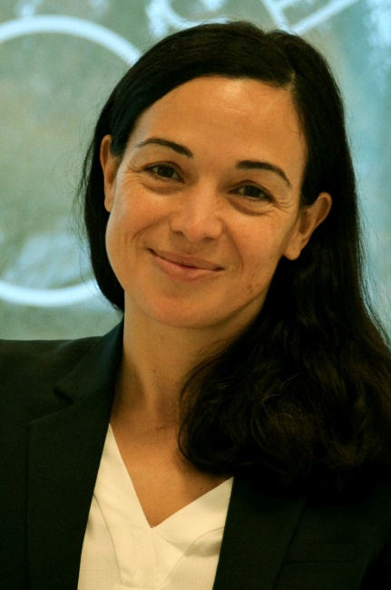
Dr. María-Paz Zorzano is a theoretical physicist, Professor in Atmospheric Science at the Luleå University of Technology (LTU) and Research Scientist at INTA (National Aerospace Technology Institute) working on planetary exploration, atmospheres, astrobiology and instrument design. She obtained her PhD in 1999, as European Doctorate at DESY and the UCM, her postdoctoral experience continued at CERN and as project manager in BULL. She is co-PI of the HABIT instrument for the ESA ExoMars mission, science team of the ESA Trace Gas orbiter and co-I of the NASA Curiosity rover. She is member of the COSPAR Planetary Protection Panel.

