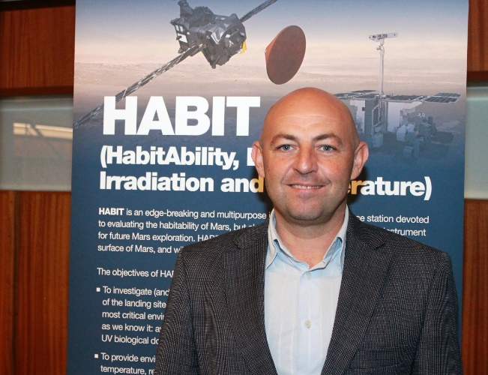
Javier Martín-Torres is Chaired Professor of Atmospheric Science at the Luleå University of Technology in Sweden. He is also Visiting Professor at the School of Physics and Astronomy, at the University of Edinburgh, U.K., at the Spanish Research Council, in Spain, and Specially Appointed Professor at the University of Okayama in Japan. He is the principal investigator of HABIT on the ExoMars mission, and co-I of Curiosity, Trace Gas Orbiter and Exomars rover and lander. He has worked for CalTech, Lunar and Planetary Laboratory, and ten years for NASA, from which he has received seven awards.

